Photo set (2)
a) Fundus and red-free photograph, spectral-domain OCT, and autofluorescence at baseline of our report (early 2010).
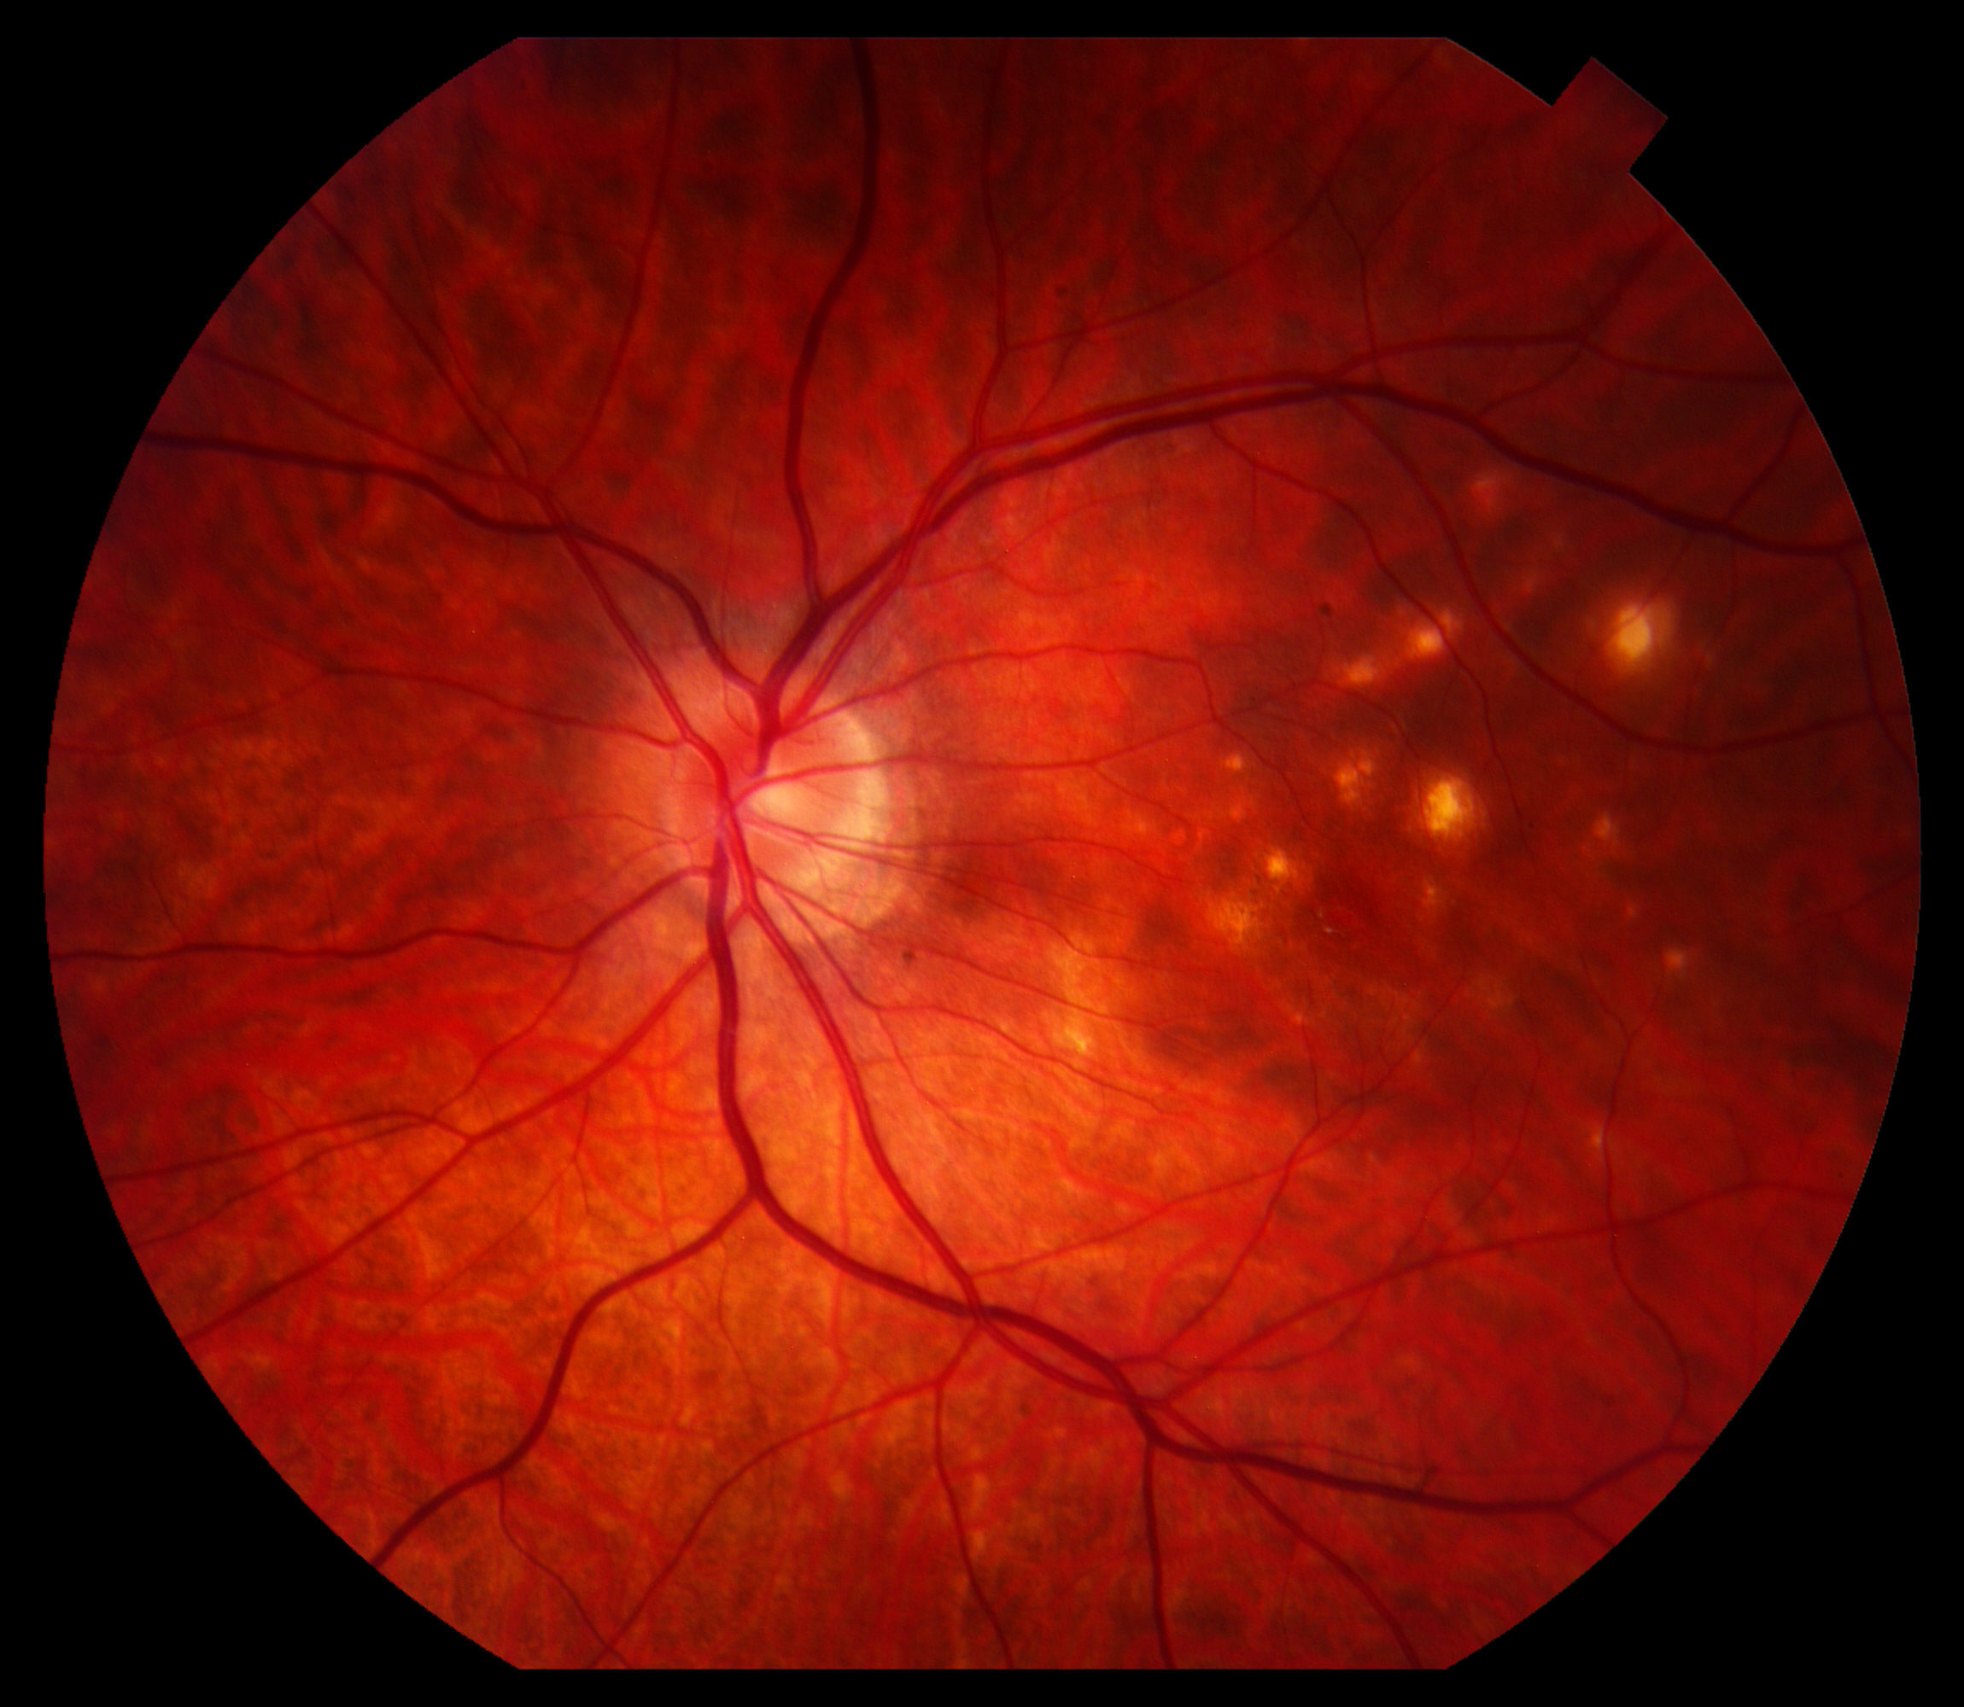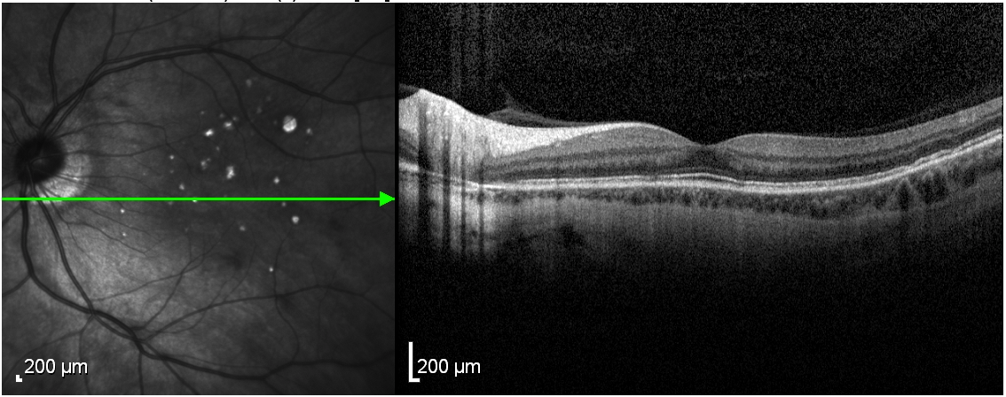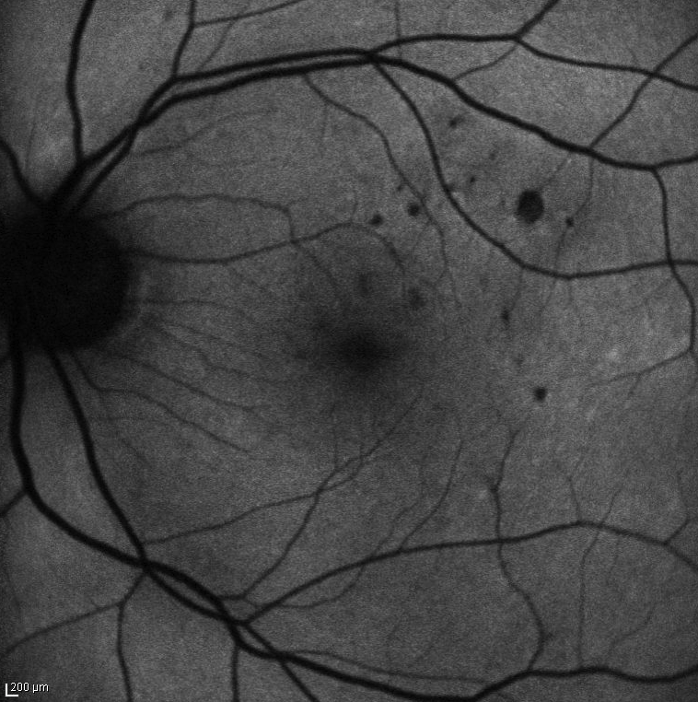
- Active disease with multiple new lesions in the left eye 3 months later – Note new lesions on color photograph and autofluorescein image, and RPE/photoreceptor alterations on SD-OCT image during active disease. No optic nerve edema or hyperemia is noted.
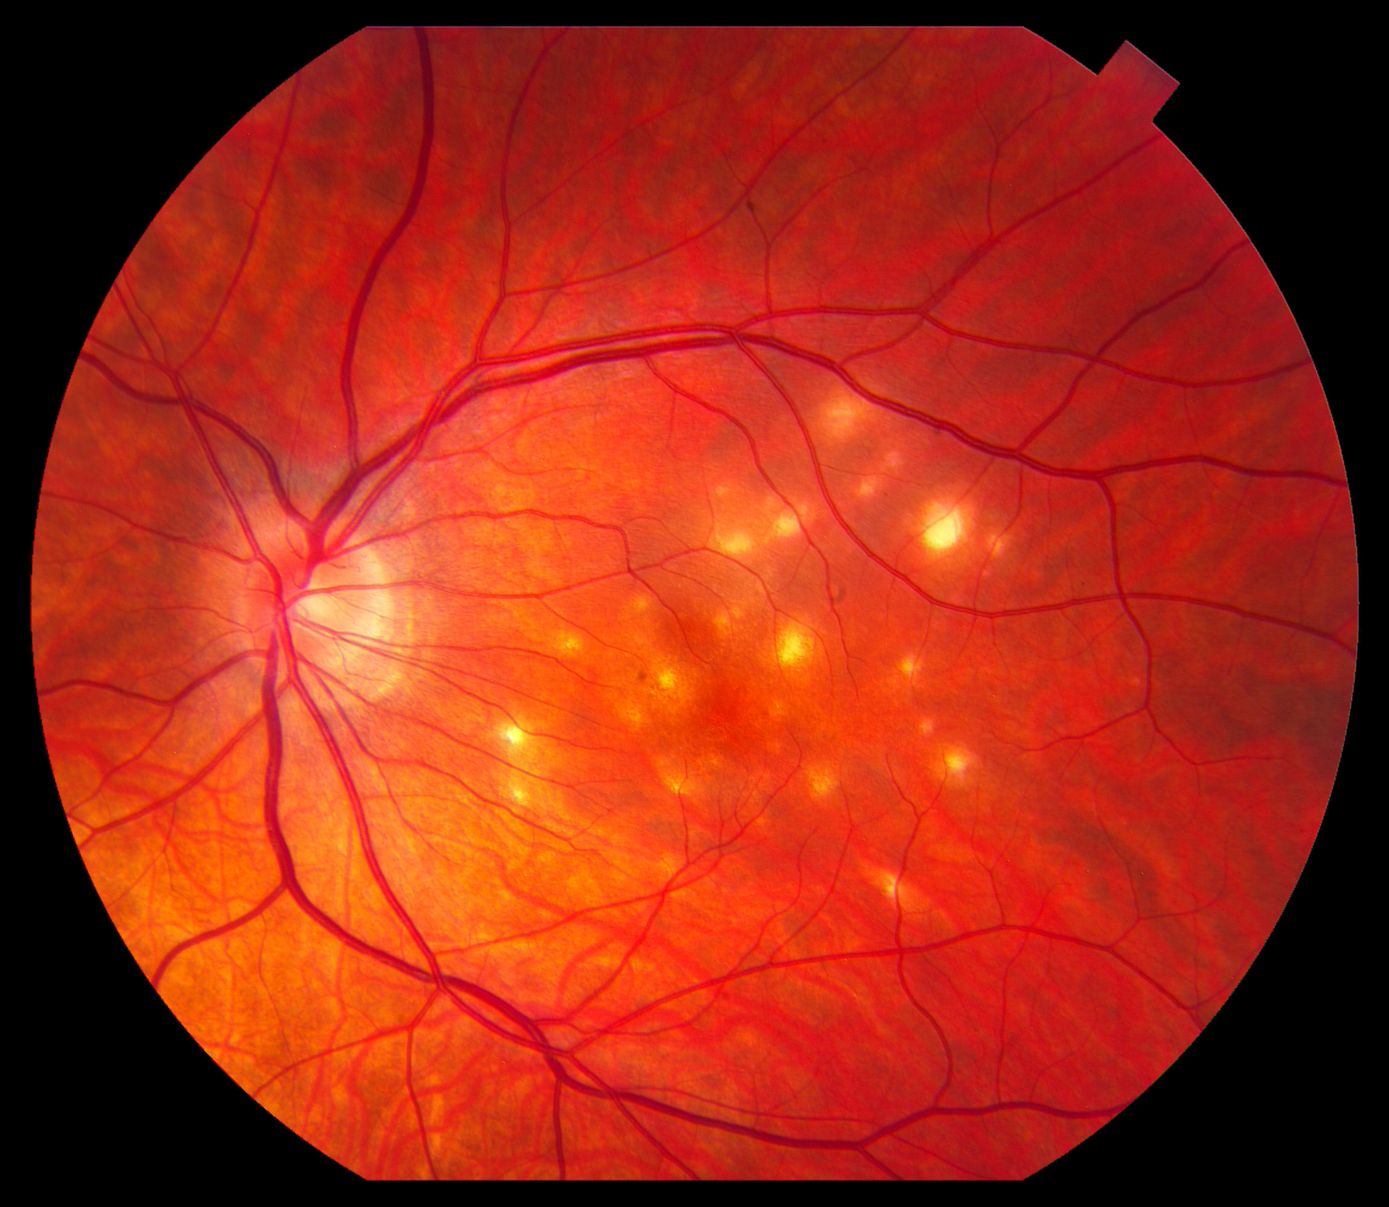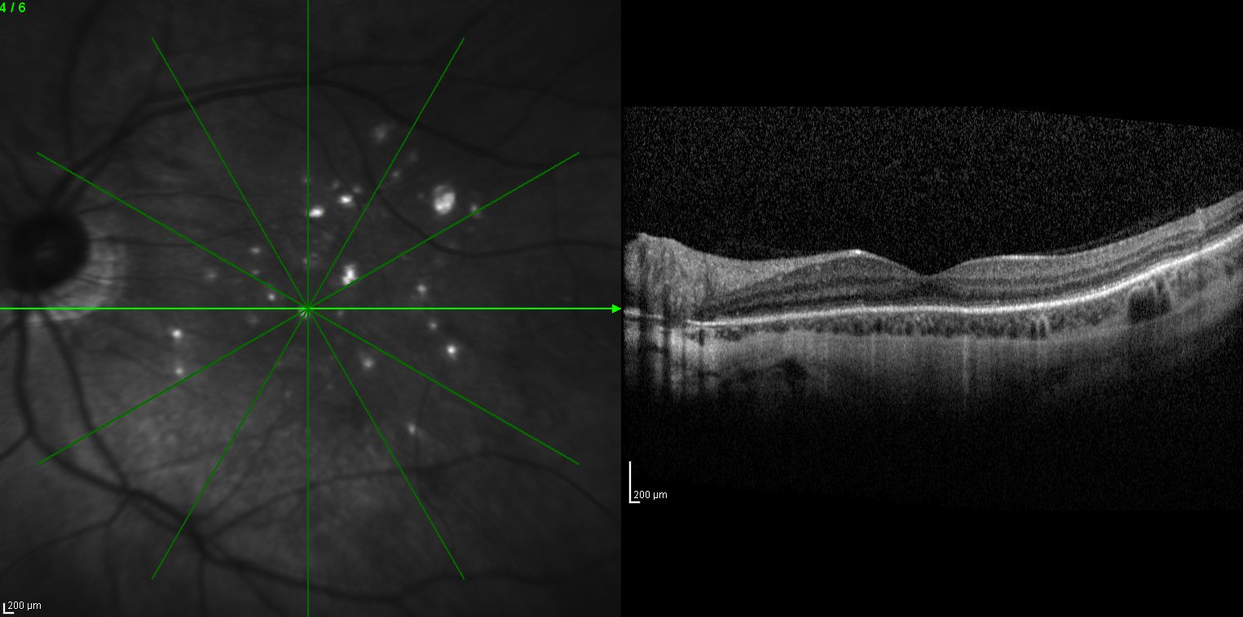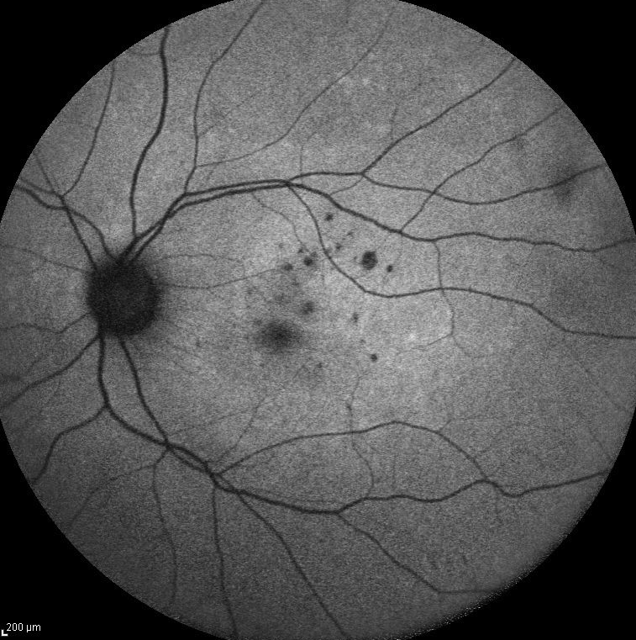
c) Most recent images following treatment demonstrating regression of some of the smaller lesions and enlargement of others. SD-OCT image showing RPE/photoreceptor loss in the areas of previously active lesions.
