Supplementary Information
Herein we present supplementary numerical results for two potentially important factors that have been neglected in the discussion presented in the main text. The one factor is mantle depletion effect and the other is sediment effects. Then, we verify that the conclusions remain essentially unchanged despite considering these two factors.

(1) Effects of progressive mantle depletion of major elements by melt extraction
In our model, we neglect the effects of progressive mantle depletion of major elements by melt extraction on subsequent melting. Herein, we present a calculation, in which we incorporate the mantle depletion effects on melting calculation by integrating instantaneous melt extraction based on the same method used by Zhu et al. (2013) and calculate the melt amount and distribution. Fig.S1 shows the calculated distribution of melt (cf. Fig.2c for the case without “mantle depletion effect” in the main text). This distribution is similar to that in Fig.2c in terms of spatial distribution and the melt fraction, and the conclusions discussed in the main text, which are based on the model calculation without “mantle depletion effects,” are robust. Although a slight decrease in the average melting degree may affect the trace element compositions of melt by an order, most of the incompatible elements are absorbed into the boundary layer solid, and the melt produced does not acquire an arc-like signature unless disequilibrium trace element transport (such as channel flow through fracture system as proposed in this study) occurs.

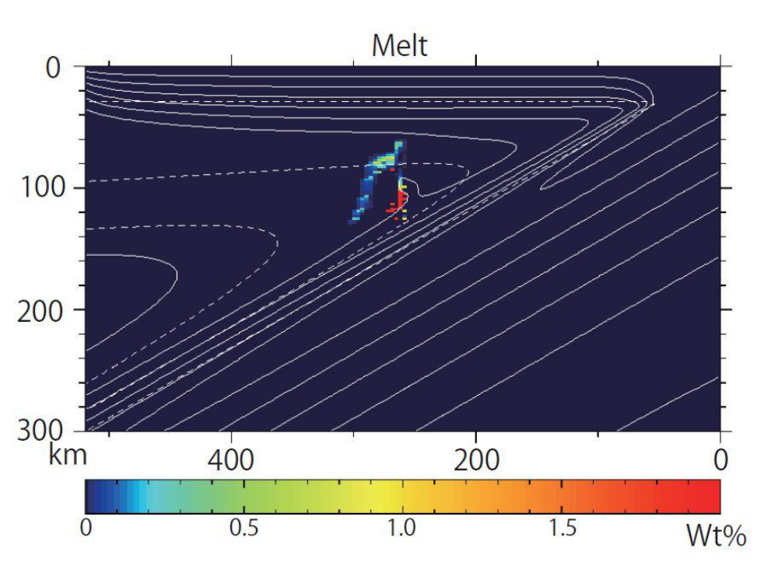

Fig.S1: Calculated distribution of melt, taking into account the mantle depletion effects on melting.

(2) Compositional effects of subducted sediments
In our model, we neglect sediments of the subducting slab because they are too thin to be reproduced accurately as a distinct isolated layer for the simulation algorithm that we have used in this study. However, it is possible that the sediments, which are in general enriched in incompatible elements, affect the results and conclusions. Herein, we present a calculation result, according to which subducting oceanic crusts initially (just before subduction) possess trace element compositions calculated as a mixture of 95% oceanic basaltic crust and 5% sediment (in this case, “Japan Trench sediment”, Plank and Langmuir, 1998); such a result helps evaluate approximately the sediment effect.

Fig.S2 shows the calculated distribution of Pb in solid (cf. Fig.4a for the case without sediments in the main text). The result shows that, although the overall Pb concentration is higher in Fig.S2 than in Fig.4a due to the high Pb concentration in subducted sediments, the wedge mantle still absorbs all Pb in the aqueous fluid expelled from the subducting slab. Accordingly, the produced melt still lacks the arc basalt signature, confirming that the conclusion is robust irrespective of the assumption with/without sediment.

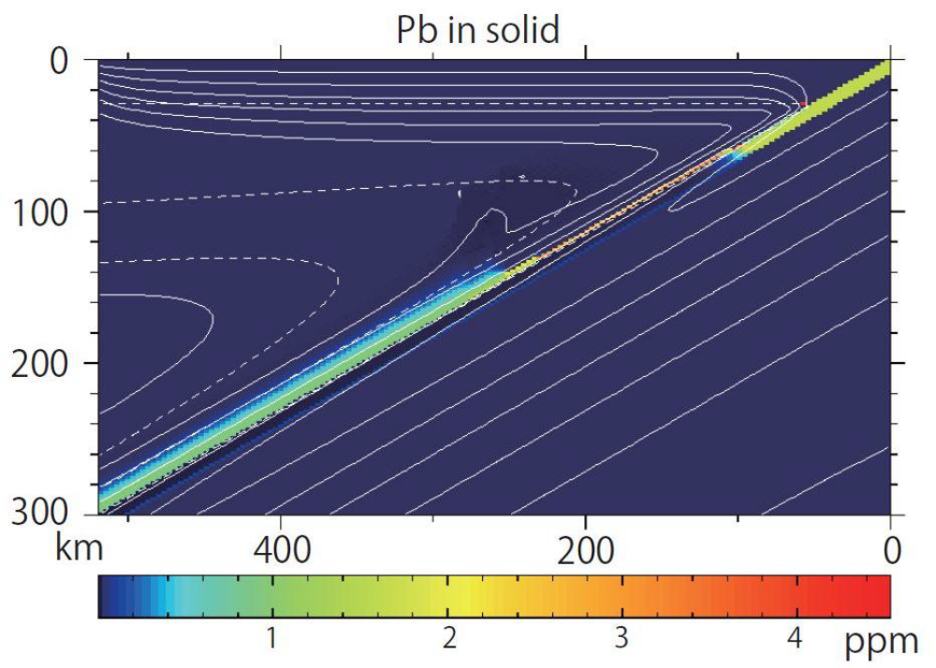

Fig.S2: Calculated distribution of Pb in solid, taking account of subducting sediments.
References

Plank T, Langmuir CH (1998) The chemical composition of subducting sediment and its consequences for the crust and mantle. Chem Geol 145: 325-394.
Zhu GZ, Gerya TV, Tackley PJ, Kissling E (2013) Four-dimensional numerical modeling of crustal growth at active continental margins. J Geophys Res 118: 4682-4698. doi: 10.1002/jgrb.50357

