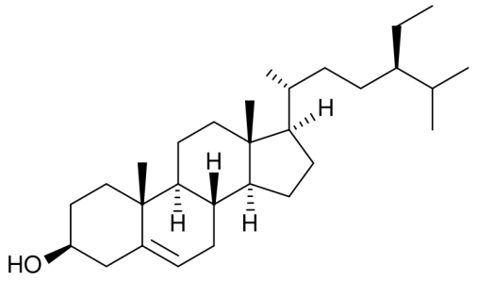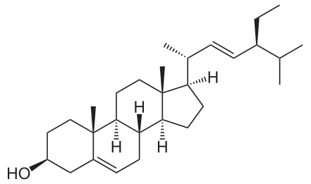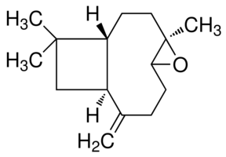
(5): R= O-β-glucose: quercetin 3-O-β-glucoside
(6): R= O-β-galactose: quercetin 3-O-β-galactoside
(7): R= H: luteolin
stigmasterol (2)
caryophyllene oxide (3)
β-amyrin (4)
β-sitosterol (1)

Figure 2 - Isolated compounds from D. littoralis Smith subsp. hyrcanicus Rech.f.

