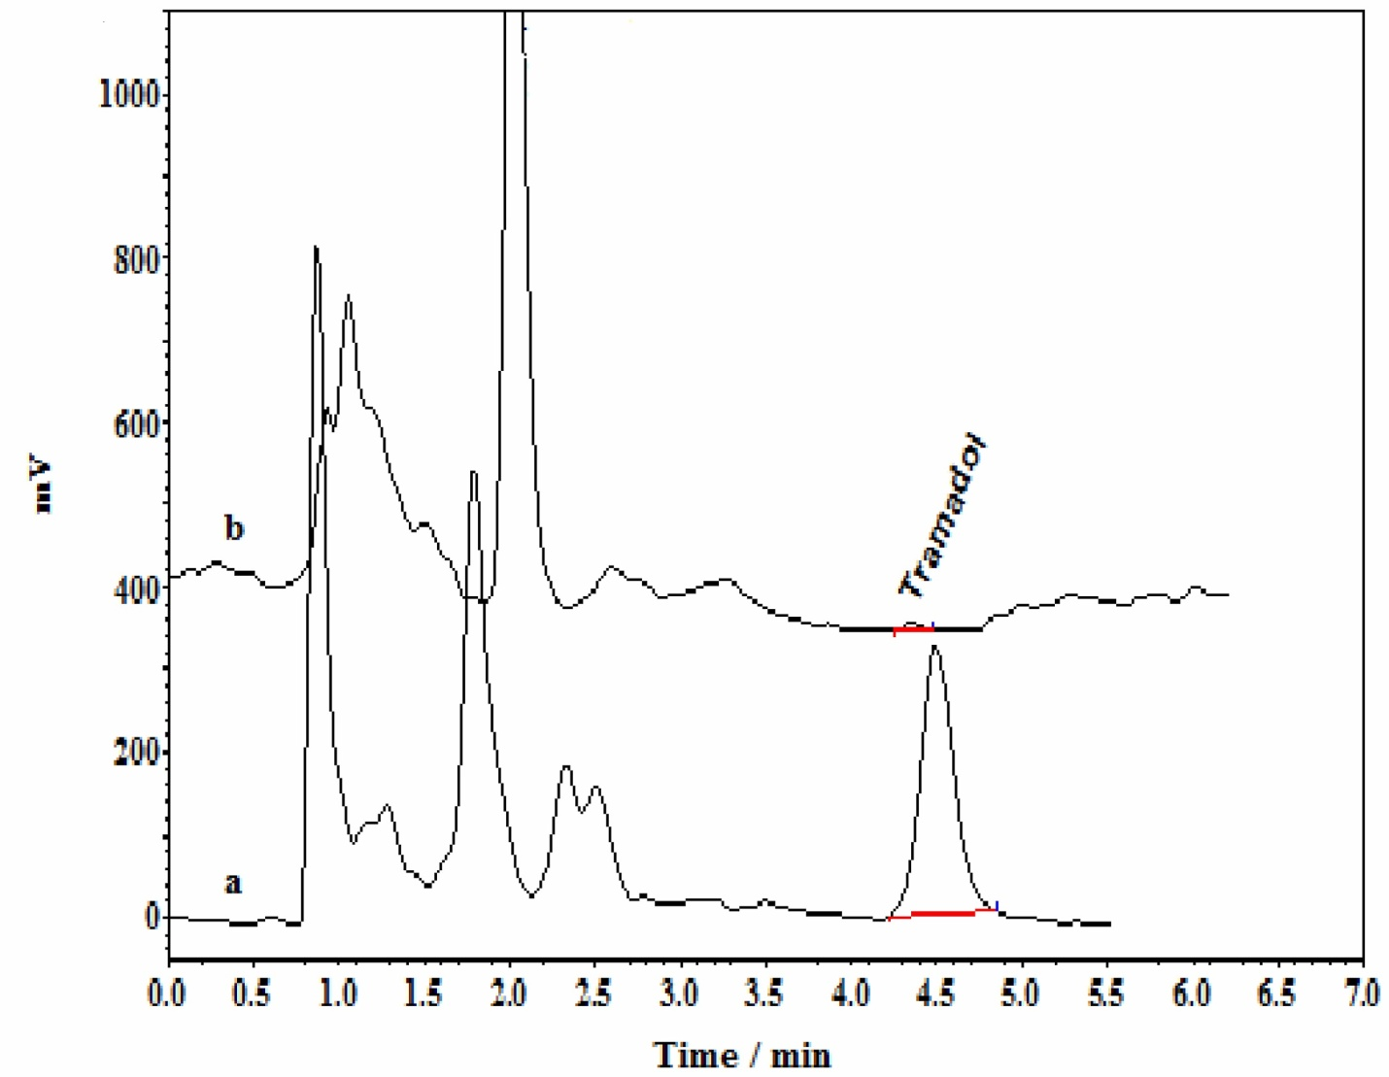
Figure9 - Chromatograms for the analysis of tramadol in urine sample: (a) HPLC chromatogram of urine spiked with tramadol at concentration level 60 µg L⁻¹ after employing BS-DLLME, (b) HPLC chromatogram of blank urine after performing BS-DLLME

