Figure S1: Validation of RRBS data by traditional (Sanger) bisulfite sequencing. One loci from each brain region that showed both testosterone-affected and sex-specific methylation differences at PN60 was selected for validation (for the striatum: Micall1; BNST/POA: Fzd9). n=2-3 per group.
Figure S2: qPCR validation of genes that were detected as significantly differentially expressed between XX and XY in the BNST/POA at PN4. Error bars represent the standard error of the mean from 3-4 biological replicates from each group. Expression is relative to GAPDH and is normalized to XX.

Supplementary Figure 1: Validation of RRBS data by traditional (Sanger) bisulfite sequencing.
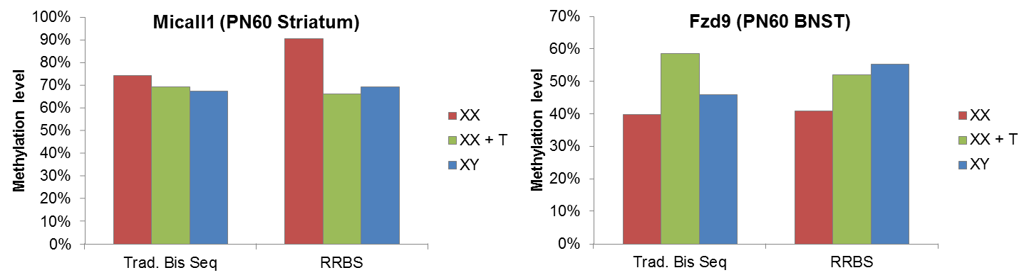

Supplementary Figure 2: qPCR validation of genes that were detected as significantly differentially expressed between XX and XY in the BNST/POA at PN4.
