Additional file 1

Additional file 1: Table S1 Simplified literature search performed for databases with limited support for compound search phrases or Boolean queries. Each search string was used as an individual query, rather than being combined into compound queries (c.f. Table 2, main article). Boolean syntax follows the ISI Web of Knowledge template. Strings were truncated to include characters preceding the first AND operator in cases where Boolean searching was not possible.

Group | Search string
(i) Outbreeding related strings | Outbreeding
(i) Outbreeding related strings | Outcrossing
(i) Outbreeding related strings | Outmating
(i) Outbreeding related strings | Heterosis AND population
(i) Outbreeding related strings | Hybridisation AND population
(i) Outbreeding related strings | Hybridization AND population
(ii) Search strings related to the movement of individuals for conservation purposes | Translocation AND conservation
 | Reinforcement AND conservation
 | Augmentation AND conservation
 | Restoration AND conservation AND genetic
 | Genetic rescue AND conservation
(iv) Catch-all search strings | Distance-dependent fitness
(iv) Catch-all search strings | Distance-dependent crossing success
(iv) Catch-all search strings | Distance-dependent mating success

Additional file 1: Text S2 Description of explanatory variables (sources of heterogeneity), justification for variable choice, and methods for variable assessment

We recorded taxon category to allow us to determine whether differences in outbreeding responses existed among different sorts of organisms. In principle, such differences in outbreeding response might arise because of taxonomically-correlated differences in life-history, behaviour or mating system that influence the relative degree of genetic isolation between populations. Understanding these differences would be important from a practical perspective, because they would allow a straightforward route for prediction of the expected outbreeding response. Organisms within each study were categorized as either: amphibian, crustacean, bony fish, gastropod, insect, mammal, bivalve, nematode, plant (spermatophyte), reptile or tunicate.

A categorical measure of lifespan (lifespan category) was recorded for study species within each relevant article. An organisms’ lifespan may influence the effective isolation of its populations, since a greater number of generations may elapse for a given quantity of among-population migration. This may in turn influence the extent of the outbreeding response when individuals from different populations hybridise. We classed individual species as either short-lived (≤ 2 years) or long-lived (> 2 years). Where articles did not provide this information, additional literature searches were carried out to determine longevity. In the set of papers that we reviewed, lifespan category was highly correlated with reproductive strategy as defined by whether an organism was semelparous or iteroparous. Short-lived species were almost always semelparous, whilst long-lived species were iteroparous. In this review we present only the meta-analysis for lifespan.

We determined and recorded physical distance between populations contributing to outbreeding events. Physical separation influences the effective current and/ or historical isolation of populations and hence may influence outbreeding responses as described above [e.g. 1]. Most studies specified the separation of hybridising populations, and in this case, the measure was converted to a value in kilometres and recorded. Other studies presented maps, tables, or a description of population locations. In these cases, we used ImageJ, or created our own maps to estimate population separation.

We recorded hybrid generation of outbred crosses as either F1 (first hybrid generation), F2 (second hybrid generation), or F3 etc. F1 are hybrid offspring of parental populations/ lineages whereas F2 are offspring from crosses amongst F1, and the F3 are derived from F2 individuals, and so on. This design therefore excludes backcrosses between hybrids and individuals from either parent lineage. Hybrid generation influences the expected magnitude and direction of the outbreeding response, by changing the relative importance of different genetic effects on phenotype [2]. In principle, hybrids could show a phenotypic benefit in the F1 followed by a phenotypic cost in the F2. However, the reverse could apply for traits determined maternally (F2 > F1 phenotype), due to the one-generation lag of maternal traits behind other traits that have pure zygotic determination [3, 4]. For these reasons hybrid generation was a key source of heterogeneity in this review.

We categorised phenotypic measures of outbreeding according to their trait type, in order to understand variation in the outbreeding response among these categories. “Defence” traits included pathogen resistance or defence, predator defence and herbivore defence. “Development” traits were measures of developmental success, including metamorphosis and success at reaching developmental markers such as specified instars in insects. “Fecundity” traits were measures of hybrid reproductive output, effort or success such as offspring number, number or mass of reproductive structures created, probability of reproduction, mating success. “Fitness” traits were integrated (or multiplicative) measures of overall fitness that included both survival and reproductive components. “Growth rate” traits were measures of growth rate such as gain in mass or body length per unit time. “Physiology” traits were a small group of traits including cardiac performance and measures of biophysical performance. “Size” traits were absolute measures of an organism’s mass, volume, length or biomass. “Survival” traits were estimates of survival rate and number and longevity/ lifespan traits, and were limited to the “mid” and “late” stages of life history (see below). “Viability” traits described offspring viability or survival in “early” life-history stages and included germination and hatching rate, early survival and clutch size. Inclusion of clutch size as a viability trait assumes that differences in clutch size are controlled by differences in viability and are not under maternal control. “Other” traits were a set of phenotypic measures indirectly linked to fitness that could not be easily placed into one of the categories listed above. Assessing the variation of outbreeding responses with trait type is important, since responses in some traits (e.g. reproductive or survival traits) may drive population-level responses to outbreeding. We note that there is some potential overlap among “fecundity” and “viability” trait types since offspring number may be a late-acting fecundity phenotype in an F_{N} generation or an early-acting viability phenotype in the F_{N+1} generation.

We aggregated the trait types listed above into two fitness classes that described whether individual traits were components of fitness or not. The aim of this was to understand whether fitness traits as a group would be any more likely to manifest outbreeding benefits or costs than other trait types. The “fitness component” category included fecundity, survival, viability trait types, and fitness measures that were multiplicative functions of two or more of fecundity, survival or viability. The remaining trait types, less directly linked with fitness, included defence, development, growth rate, physiology, size and other trait types.

In order to understand whether outbreeding responses varied with life-history stage, we categorised the trait timing of different phenotypic measures. Trait timing categories were not absolute but were relative to the life-history of a given species. Traits were categorised as acting either “early”, “mid” (in the middle stages) or “late” in the life history. Allocation to these categories was partly subjective, since life-history form differs among species. Traits with an early timing included traits measured up to and including the life-history stage occurring immediately after birth, hatching or germination. For example seedling survival or mass (plants), alevin survival (fish), cub survival (mammals) all counted as early traits. In addition all viability traits listed above also counted as early traits. In semelparous species, traits measured in the period between the first life-history stage and the reproductive episode preceding death were defined as occurring in the middle of the life history (trait timing = “mid”; excluding survival to the final reproductive episode). All traits in semelparous species associated with survival to, or performance in this ultimate reproductive episode were defined as occurring with late timing. In iteroparous species traits were classed as having a “mid” timing where they were taken at a point in the life history after which there was clear potential for further reproduction and survival. Traits associated with a known terminal reproductive episode were classed as late acting.

We categorised the mating system of study taxa in order to understand whether outbreeding responses differed among species with different breeding or mating systems. The mating system influences the quantity of standing variation in populations and the rate at which the genetic architecture of populations can diverge by drift or selection. This in turn may influence the extent to which outbreeding costs or benefits may be observed upon population admixture. Taxa were classed as “inbreeding” if they were known to be highly inbreeding (self fertilising; our review included only plant species as members of this category). Taxa were classed as having a “mixed” mating system if there was evidence for offspring production by both selfing and outcrossing (plants, gastropods, nematodes). “Outbreeding” taxa were those with mechanisms enforcing outcrossing (separate sexes, various self-incompatibility mechanisms), or where evidence existed demonstrating outcrossing as the reproductive mode. In cases where individual papers did not provide sufficient information on breeding system, additional literature searches were conducted to locate this information. In some instances taxa were categorised as having an “unknown” mating system because the information could not be found.

We recorded the observation environment in which traits were expressed and observed, in order to understand whether outbreeding responses might differ between natural field environments and experimental environments such as common gardens or arenas and labs. For traits observed in the field (natural populations and native habitat) the observation environment was coded as “natural”. Non-natural observation environments that were outdoors and utilised ambient lighting and temperature regimes were classed as “common gardens”, and these included fisheries, common gardens, mesocosms, ponds and experimental gardens. Observation environments that were either indoors or utilised lighting or temperature conditions that differed from the ambient environment were classed as “lab” environments. These included glasshouses, laboratories, lab aquaria and terraria.

Additional file 1: Text S3 Detailed methods for article assessment

Articles were identified as relevant on the basis of the presence of the desired subject (natural populations), intervention (outbreeding between populations), and the comparator (non-outbred individuals). Initial literature scoping searches indicated that publications with particular types of subject yielded few or no relevant articles. Thus we specifically excluded articles using the following rules:

• Articles that described only habitat-level conservation or restoration projects were excluded.
• Articles reporting molecular markers linked to loci controlling specific traits were excluded.
• Articles describing a species mating system, or the genetic characteristics of a species mating system were excluded.
• Articles reporting between-species comparisons (e.g. comparative biology, comparative ecology or taxonomy) were excluded.

Pre-assessment removal of non-relevant medical literature

Trial searches using the search terms in Table 2 (main article) picked up a significant number of non-relevant medical articles (cancer studies) and non-relevant articles whose studies used in-situ hybridization techniques. These were removed from the review by querying the endnote library database (Additional File F2; “Whitlock_outbreeding_review_audit_file.xlsx”) with the terms specified below and deleting the resulting hits. The validity of this approach was confirmed by carrying out the searches on a randomly-selected 400 reference subset of the database and counting the number of relevant references that were recovered based on title assessment. Relevance was assessed as described in sections 5.4.2 to 5.4.4. No relevant references where found with these terms.

Searches in ‘Journal’/ ‘Secondary Title’
• Cancer

Searches in ‘Any Field’
• In situ hybridisation
• In-situ hybridisation
• In-situ-hybridisation
• In situ hybridization
• In-situ hybridization
• In-situ-hybridization
• HPV
• Carcinoma
• Oncology

Assessment of article relevance by title

During assessment of the titles in the review database we relaxed the criteria for inclusion and exclusion (Section 5.4) to avoid excluding articles containing relevant data. Specifically, we retained articles relating to both quantified outbreeding and inbreeding effects. Where there was reasonable doubt as to the content of an article based on its title, we retained the article until its abstract or full-text could be assessed. Meeting abstracts, theses or book sections were assessed for relevance in the same way as journal articles. RW and J. Brodie determined the repeatability of the title assessment process by each assessing independently a 600 article random subset (6.2%) of the review database. The congruence of these independent assessments was assessed by kappa analysis.

Assessment of relevance by abstract

We assessed the abstracts of articles against the criteria for the inclusion and exclusion of articles specified above. When an article lacked an abstract, the article was retained as possibly relevant until its full-text could be assessed. RW and H. Hipperson determined the repeatability of the abstract assessment process, by each assessing independently the same 200 article random subset (28.0%) of the relevant articles identified by title assessment. The congruence of these independent assessments was assessed by kappa analysis.

Assessment of relevance by full-text

Full-texts were assessed against the inclusion criteria given above. RW and S. Allen tested the repeatability of the full-text assessment process by each independently assessing the same 40 article random subset (14.5%) of the set of relevant articles identified by abstract assessment. The congruence of these independent assessments was assessed by kappa analysis.

Additional file 1: Text S4 Additional text on statistical analysis

The model we employed can be expressed as [5, 6]:

Ε [y] = Xβ + Zu + m + e [eqn 6]
u ~ N (0, σ_{u}²I) [eqn 7]
m ~ N (0, σ_{m}²M) [eqn 8]
e ~ N (0, σ_{e}²I) [eqn 9]

Where Ε [y] is the predicted response, X and Z are design matrices for the fixed effects and study random effects respectively, β and u are parameter matrices for fixed effects and study random effects respectively, m are the study-specific measurement errors, and e are the residuals. Equation 7 states that the study random effects u are normally distributed with mean 0 and variance σ_{u}². The study variance component σ_{u}² (describing contextual variation in outbreeding responses) is treated as unknown and is estimated by the model. “I” stands for the identity matrix, and in this context represents the assumption that the study random effects are identically and independently distributed. Equation 8 states that the effect size-specific measurement error m is normally distributed with mean 0. Variances for m are given by σ_{m}²M, where M is a square matrix with the study error variance estimates (SEV; equation 2, main article) on the diagonal. σ_{m}² is set to 1. Thus the model assumes that the distributions of the measurement errors are known, and that these are independently distributed. Note that [eqn 7] does not imply that the measurement error estimates themselves are assumed to be normally distributed, but that the process generating scatter of each observed effect size around its unobserved true value is normal. Equation 9 states that the residuals are normally, identically and independently distributed with mean 0 and variance σ_{e}². The residual variance component σ_{e}² is estimated during model fitting.

Some of the articles included in this review that studied more than two parent lineages presented parent lineage phenotypic data as a mean across these multiple lineages (within-population phenotypic mean). These articles usually also presented the corresponding hybrid lineage phenotypic data as a mean across hybrids from separate crosses derived from these parent lineages [7]. This design still allows our effect size metric to capture deviation of the hybrid phenotype from the expected parent phenotype. However, we expect that this will result in a less sensitive analysis than would be possible if the data could be separated into component between-population crosses. This may be particularly so where there is wide variation in mean phenotype among sampled parent populations.

We used DIC to discriminate among alternative nested models containing differing fixed effects specifications. In the context of the MCMCglmm package, models with lower DIC are preferred. However, a general problem with DIC-based model-choice is that there is no accepted guideline for how much difference in DIC is “enough” to decide between two models. DIC also needs to be “focussed” at the right hierarchical level, for inference in hierarchical models [8]. In MCMCglmm DIC is based on deviance at the lowest level of the model hierarchy [5]. Some of our predictors were study-level variables (i.e. at a higher level in the model hierarchy). Therefore our overall approach in interpreting our results was to treat DIC as a guide only, and not as an absolute threshold for inference on model structure.

Additional file 1: Figure S5 Funnel plots for study-level (mean) outbreeding response effect sizes. Outbreeding responses are given as log response ratio effect sizes (x-axis; n = 98). Study-level error variance was taken to be the median measurement error variance within studies. (a) Effect size data plotted against their standard error (square root of measurement error variance). (b) Effect size data plotted against precision, where precision is the reciprocal of the standard error on the effect size. The vertical line indicates the pooled effect size for a random-effects model with an intercept as the only fixed effect (this model was fitted using the R package metafor[9]). Shaded areas of the funnel give pseudo-confidence interval regions: grey shading, 95% pseudo-confidence interval region; dark grey shading, 99% pseudo-confidence interval region. The pseudo-confidence regions incorporate between-effect size heterogeneity.

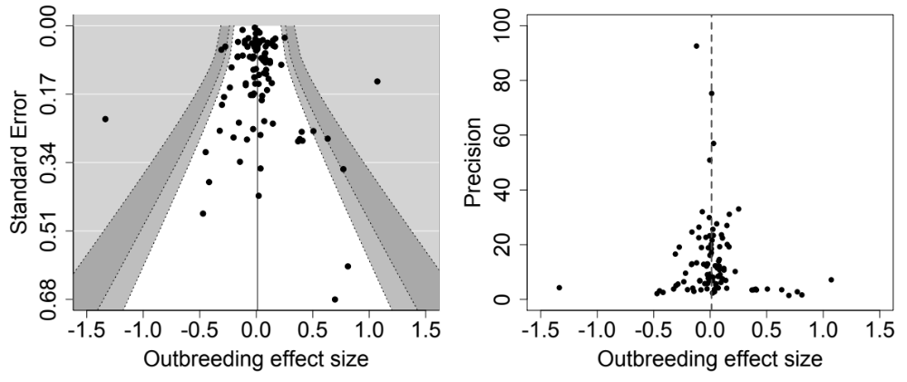

Additional file 1: Figure S6 Funnel plots for outbreeding response effect sizes, using the full dataset (n = 528). (a) The full funnel plot. (b)–(d) Successive zooms onto the apex of the funnel-plot. Outbreeding responses are given as log response ratio effect sizes (x-axis). Other details as in Figure S5.

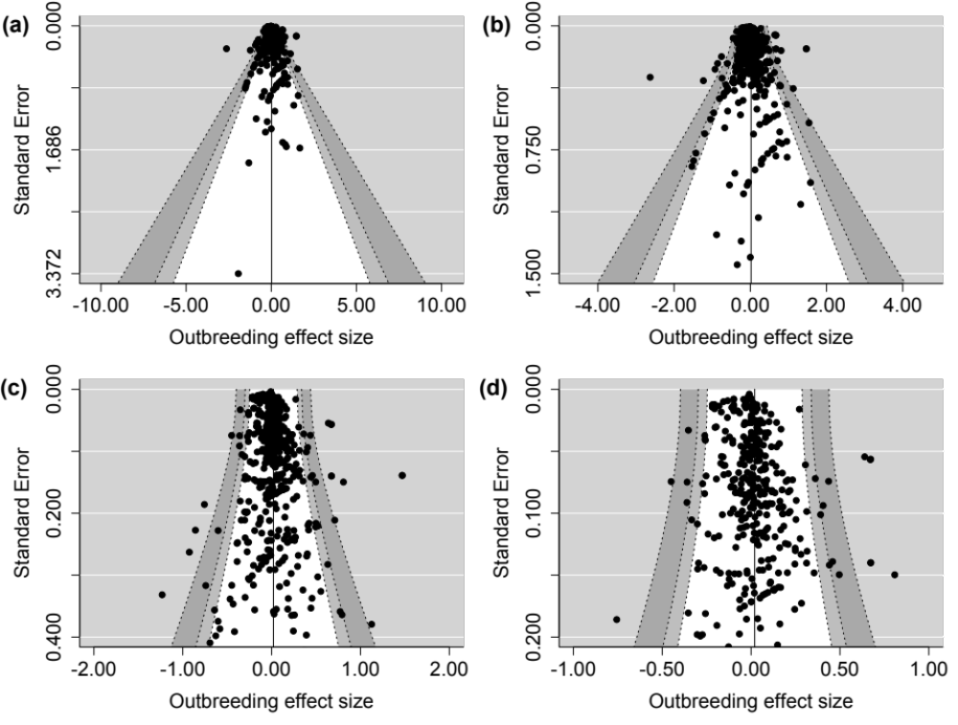

Additional file 1: Text S7 Model checking by posterior predictive simulation

Our meta-analyses of phenotypic responses to outbreeding made a number of assumptions about the underlying probability model, distributions of parameters, the hierarchical structure of the data, and the availability and nature of prior information (Main Article; Text S4). In order to test the assumptions of our model we used posterior predictive simulation to ask whether the observed data are plausible under our assumed model for outbreeding responses [10].

Replicate simulated datasets

We sampled replicate datasets from the posterior predictive distribution of our best-fitting model (Model 4, Table 6; main article). We simulated 98 new study effects by drawing them from a normal distribution with mean 0 and standard deviation equal to the square root of a draw from the posterior distribution of the among-study variance parameter. These new study estimates represent study effects that we might observe in new data collected in the future if our model is a good one. Study estimates were combined with the random effects design matrix of our model so that the structure of simulated datasets was identical to the observed datasets (528 observations). We added model predictions for the fixed effects (trait types) to the new study effects, making a separate draw for each predicted dataset from the posterior distributions of the fixed effects. We also added within-study errors to each simulated datapoint, drawing 528 of these from a normal distribution with mean 0 and standard deviation defined by a draw from the posterior distribution of the residual variance parameter (one draw from the posterior per simulated dataset). Finally we added normal errors to each simulated datapoint that depended on the within-effect-size measurement error variance (mev). Since we fixed the value of the mev in our analysis (assuming them to be known without error) we have no posterior from which to draw from to make simulations. We tested three alternative specifications for the mev in our simulations. First we fixed the mev for each simulation at their observed values. Second, we simulated mev from a normal distribution. Our observed mev were lognormally distributed with mean -4.36, standard deviation 2.26 on the log scale, so we simulated mev as exponentiated draws from this distribution. Third, we fixed the mev at their median value (resulting in zero variation in mev among simulated effect sizes).

Test quantities

For each of 1000 simulated datasets (and each of three specifications for the mev) we computed the minimum effect size, the maximum effect size, the number of effect sizes < -1, the number of effect sizes > 1 and the kurtosis of the effect size distribution. We also calculated these quantities for the observed effect sizes and compared observed values to the simulated distributions.

Results and conclusion

Posterior predictive simulation indicated that the observed data were plausible under the meta-analytic model that we used; when we fixed the mev at their observed values, and when we simulated the mev from a distribution identical to the observed distribution for these error variance parameters (Figure S8). We conclude that the meta-analytic model that we employed is a reasonable one for our dataset of effect-sizes and mev.

Additional file 1: Figure S8 Results from posterior predictive simulations. Each plot shows a histogram of test quantities from new datasets simulated from the posterior distribution of our best fitting model. A red vertical line indicates the observed test quantity. Vertical dashed lines indicate the area containing the central 95% of the simulated distribution. The model is taken to fit the observed data adequately when the observed test statistic (the red line) lies within the dashed lines describing the new data simulated from the model. (a)–(e) Results for simulations in which study measurement area variance (mev) were fixed at their observed values. (f)–(j) Results for simulations in which mev were drawn at random from a lognormal distribution with parameters identical to those of the observed mev. (k)–(o) Results for simulations in which mev were fixed at their median value (no variance in mev among simulated effect sizes).

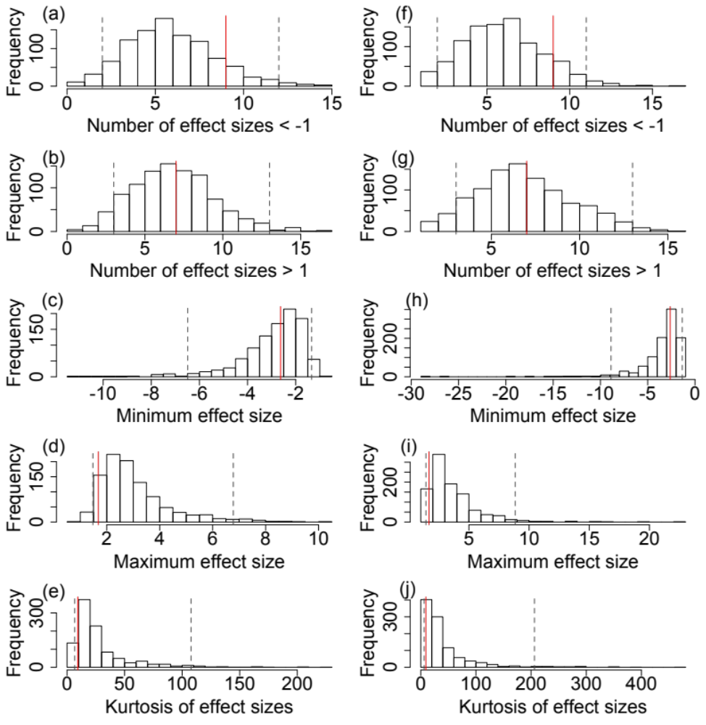

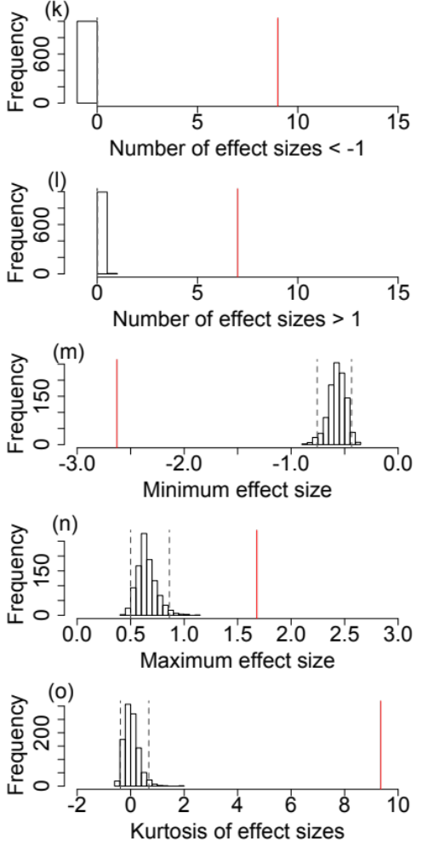

Additional file 1: Table S9 Parameter estimates and MCMCglmm model summary tables for meta-analyses fitting only a single explanatory variable.

Model | Parameter | Posterior mean | Lower-95% CI | Upper-95% CI | pMCMC | Effective samples | Auto-correlation
~ 1 | Study variance | 0.0200 | 0.0119 | 0.0294 | - | 1000 | 0.027
~ 1 | Residual variance | 0.0110 | 0.0083 | 0.0139 | - | 889 | 0.058
~ 1 | Intercept | 0.0254 | -0.0104 | 0.0620 | 0.156 | 1000 | -0.011
~ Generation | Study variance | 0.0204 | 0.0122 | 0.0293 | - | 1199 | -0.019
~ Generation | Residual variance | 0.0110 | 0.0080 | 0.0138 | - | 1000 | 0.027
~ Generation | Intercept (F1) | 0.0360 | -0.0011 | 0.0698 | 0.064 | 1000 | 0.007
~ Generation | F2 | -0.0846 | -0.1391 | -0.0281 | <0.001 | 1000 | -0.016
~ Generation | F3 | -0.2091 | -0.3944 | 0.0083 | 0.054 | 1000 | -0.014
~ Fitness class | Study variance | 0.0187 | 0.0110 | 0.0281 | - | 1000 | 0.044
~ Fitness class | Residual variance | 0.0102 | 0.0076 | 0.0132 | - | 1000 | 0.008
~ Fitness class | Intercept (Fitness components) | 0.0001 | -0.0373 | 0.0357 | 0.982 | 1000 | 0.020
~ Fitness class | Other traits | 0.0633 | 0.0318 | 0.0956 | <0.001 | 1000 | -0.034
~ Trait type | Study variance | 0.0145 | 0.0076 | 0.0213 | - | 909 | -0.032
~ Trait type | Residual variance | 0.0099 | 0.0073 | 0.0131 | - | 1000 | -0.016
~ Trait type | Intercept (Defence) | -0.0819 | -0.2164 | 0.0488 | 0.248 | 1000 | 0.020
~ Trait type | Development | 0.1286 | -0.0354 | 0.2803 | 0.102 | 1000 | -0.012
~ Trait type | Fecundity | 0.1213 | -0.0218 | 0.2597 | 0.098 | 1000 | 0.022
~ Trait type | Fitness | 0.1809 | 0.0214 | 0.3517 | 0.040 | 1000 | -0.002
~ Trait type | Other | 0.3371 | 0.1588 | 0.5438 | <0.001 | 1000 | -0.005
~ Trait type | Growth rate | 0.2487 | 0.0833 | 0.4018 | <0.001 | 1000 | 0.032
~ Trait type | Physiology | 0.1556 | -0.0376 | 0.3375 | 0.120 | 1000 | 0.008
~ Trait type | Size | 0.1334 | 0.0041 | 0.2782 | 0.054 | 1000 | 0.011
~ Trait type | Survival | 0.0683 | -0.0639 | 0.2046 | 0.360 | 1000 | 0.016
~ Trait type | Viability | 0.0611 | -0.0761 | 0.1957 | 0.426 | 1000 | 0.014
~ Trait timing | Study variance | 0.0196 | 0.0115 | 0.0295 | - | 1000 | -0.011
~ Trait timing | Residual variance | 0.0107 | 0.0079 | 0.0135 | - | 1105 | -0.050
~ Trait timing | Intercept (Early) | -0.0123 | -0.0518 | 0.0317 | 0.562 | 1000 | -0.005
~ Trait timing | Mid | 0.0496 | 0.0086 | 0.0815 | 0.006 | 1000 | -0.006
~ Trait timing | Late | 0.0573 | 0.0193 | 0.1010 | 0.004 | 1000 | 0.020
~ Taxon category | Study variance | 0.0187 | 0.0116 | 0.0277 | - | 1000 | 0.001
~ Taxon category | Residual variance | 0.0111 | 0.0082 | 0.0141 | - | 1000 | 0.033
~ Taxon category | Intercept (Amphibian) | -0.0551 | -0.2936 | 0.2053 | 0.672 | 911 | 0.046
~ Taxon category | Crustacean | 0.0360 | -0.2645 | 0.2875 | 0.804 | 1000 | 0.026
~ Taxon category | Bony fish | 0.0358 | -0.2204 | 0.2790 | 0.784 | 1000 | 0.041
~ Taxon category | Gastropod | 0.0945 | -0.2793 | 0.4025 | 0.588 | 1070 | 0.059
~ Taxon category | Insect | 0.2308 | -0.3888 | 0.8146 | 0.486 | 1000 | 0.029
~ Taxon category | Mammal | 0.4167 | 0.1451 | 0.7557 | 0.010 | 1000 | 0.025
~ Taxon category | Bivalve | 0.0339 | -0.3018 | 0.4113 | 0.850 | 1000 | 0.002
~ Taxon category | Nematode | 0.1488 | -0.2637 | 0.5420 | 0.504 | 1000 | -0.003
~ Taxon category | Plant | 0.0914 | -0.1606 | 0.3527 | 0.500 | 884 | 0.061
~ Taxon category | Reptile | -0.0064 | -0.3761 | 0.3893 | 1.000 | 1000 | 0.004
~ Taxon category | Tunicate | -0.0706 | -0.4513 | 0.3254 | 0.712 | 1000 | 0.008
~ Physical distance | Study variance | 0.0246 | 0.0141 | 0.0357 | - | 1000 | 0.004
~ Physical distance | Residual variance | 0.0107 | 0.0079 | 0.0142 | - | 1000 | 0.017
~ Physical distance | Intercept | 0.0549 | -0.0112 | 0.1103 | 0.076 | 1000 | 0.042
~ Physical distance | log (distance) | -0.0050 | -0.0166 | 0.0055 | 0.368 | 857 | 0.077
~ Lifespan category | Study variance | 0.0194 | 0.0119 | 0.0287 | - | 1000 | -0.019
~ Lifespan category | Residual variance | 0.0110 | 0.0081 | 0.0139 | - | 1000 | 0.003
~ Lifespan category | Intercept (Long) | 0.0393 | -0.0009 | 0.0760 | 0.052 | 1637 | 0.014
~ Lifespan category | Short | -0.0544 | -0.1295 | 0.0145 | 0.170 | 1000 | 0.028
~ Mating system | Study variance | 0.0205 | 0.0117 | 0.0300 | - | 1000 | -0.036
~ Mating system | Residual variance | 0.0110 | 0.0084 | 0.0140 | - | 1000 | 0.035
~ Mating system | Intercept (Inbreeding) | -0.0959 | -0.2794 | 0.0931 | 0.302 | 1000 | -0.015
~ Mating system | Mixed | 0.1237 | -0.0695 | 0.3185 | 0.222 | 1000 | -0.023
~ Mating system | Outbreeding | 0.1298 | -0.0388 | 0.3423 | 0.186 | 1000 | -0.019
~ Mating system | Unknown | 0.0120 | -0.3459 | 0.3489 | 0.928 | 1237 | -0.044
~ Population status | Study variance | 0.0201 | 0.0120 | 0.0296 | - | 1000 | 0.031
~ Population status | Residual variance | 0.0109 | 0.0079 | 0.0137 | - | 1108 | 0.011
~ Population status | Intercept (Mixed) | 0.0195 | -0.0553 | 0.0925 | 0.620 | 802 | 0.026
~ Population status | All natural populations | 0.0080 | -0.0727 | 0.1027 | 0.850 | 771 | 0.041
~ Observation environment | Study variance | 0.0178 | 0.0099 | 0.0262 | - | 1000 | -0.017
~ Observation environment | Residual variance | 0.0110 | 0.0082 | 0.0140 | - | 1000 | 0.002
~ Observation environment | Intercept (Lab) | -0.0138 | -0.0586 | 0.0360 | 0.598 | 840 | 0.086
~ Observation environment | Common Garden | 0.0483 | -0.0177 | 0.1131 | 0.140 | 1000 | 0.040
~ Observation environment | Natural | 0.1210 | 0.0426 | 0.1970 | 0.002 | 904 | 0.050
~ Quality score | Study variance | 0.0200 | 0.0116 | 0.0300 | - | 1000 | 0.012
~ Quality score | Residual variance | 0.0109 | 0.0082 | 0.0140 | - | 1000 | -0.012
~ Quality score | Intercept | -0.0755 | -0.2469 | 0.0840 | 0.342 | 1000 | 0.024
~ Quality score | Quality score | 0.0221 | -0.0155 | 0.0539 | 0.210 | 1000 | 0.032

Additional file 1: Table S10 Summary of model reduction procedure. Predictor variables were retained only if their removal resulted in a decrease in model fit (relative to the previously best-fitting model) that was beyond the range in DIC among replicate model runs. *** indicates the best fitting model within each backwards elimination step. § indicates the best-fitting minimal model.

Backwards elimination step | Model name | Model fixed effects† | Mean DIC | Range in DIC
0 | Maximal | ~ 1 + 2 + 4 + 5 + 8 + 9 + 12 | -596.1 | 1.0
1 | M-1 | ~ 2 + 4 + 5 + 8 + 9 + 12 | -605.0 | 2.0
1 | M-2 | ~ 1 + 4 + 5 + 8 + 9 + 12 | -573.2 | 1.1
1 | M-4 | ~ 1 + 2 + 5 + 8 + 9 + 12 | -610.6*** | 1.9
1 | M-5 | ~ 1 + 2 + 4 + 8 + 9 + 12 | -603.1 | 2.4
1 | M-8 | ~ 1 + 2 + 4 + 5 + 9 + 12 | -600.1 | 2.2
1 | M-9 | ~ 1 + 2 + 4 + 5 + 8 + 12 | -607.1 | 1.5
1 | M-12 | ~ 1 + 2 + 4 + 5 + 8 + 9 | -602.6 | 1.9
2 | M-4-1 | ~ 2 + 5 + 8 + 9 + 12 | -613.0 | 1.4
2 | M-4-2 | ~ 1 + 5 + 8 + 9 + 12 | -565.3 | 2.2
2 | M-4-5 | ~ 1 + 2 + 8 + 9 + 12 | -611.2 | 1.5
2 | M-4-8 | ~ 1 + 2 + 5 + 9 + 12 | -608.6 | 1.3
2 | M-4-9 | ~ 1 + 2 + 5 + 8 + 12 | -615.6*** | 2.2
2 | M-4-12 | ~ 1 + 2 + 5 + 8 + 9 | -611.6 | 3.2
3 | M-4-9-1 | ~ 2 + 5+ 8 + 12 | -618.5*** | 1.3
3 | M-4-9-2 | ~ 1 + 5+ 8 + 12 | -568.7 | 0.5
3 | M-4-9-5 | ~ 1 + 2 + 8 + 12 | -615.6 | 2.6
3 | M-4-9-8 | ~ 1 + 2 + 5 + 12 | -612.7 | 1.0
3 | M-4-9-12 | ~ 1 + 2 + 5 + 8 | -615.8 | 0.2
4 | M-4-9-1-2 | ~ 5 + 8 + 12 | -571.2 | 0.8
4 | M-4-9-1-5 | ~ 2 + 8 + 12 | -618.1*** | 1.1
4 | M-4-9-1-8 | ~ 2 + 5 + 12 | -615.7 | 0.6
4 | M-4-9-1-12 | ~ 2 + 5 + 8 | -616.7 | 0.4
5 | M-4-9-1-5-2 | ~ 8 + 12 | -575.6 | 1.0
5 | M-4-9-1-5-8 | ~ 2 + 12 | -617.6*** | 2.9
5 | M-4-9-1-5-12 | ~ 2 + 8 | -617.1 | 1.6
6 | M-4-9-1-5-8-2 | ~ 12 | -575.8 | 0.6
6 | M-4-9-1-5-8-12 | ~ 2 | -617.2***§ | 1.9
7 | M-4-9-1-5-8-12-2 | ~ Intercept | -576.0*** | 1.3
† 1, Generation; 2, trait type; 4, trait timing; 5, taxon category; 8, lifespan category; 9, mating system; 12, quality score

Additional file 1: Table S11 Parameter estimates and MCMCglmm model summary for minimal model produced by backwards elimination of fixed-effects predictors (Table S10). The minimal model included the trait type predictor only. Levels of the trait type predictor were fitted as user-specified orthogonal contrasts. Deviance information criterion, DIC = −618.2.

Parameter | Posterior mean | Lower-95% CI | Upper-95% CI | pMCMC | Effective samples | Auto-correlation | Potential scale reduction factor (PRSF) | Upper 95% CI for PRSF
Study variance | 0.0144 | 0.0076 | 0.0209 | - | 1000 | 0.034 | 1.000 | 1.010
Residual variance | 0.0101 | 0.0073 | 0.0131 | - | 1000 | -0.012 | 1.000 | 1.000
Intercept | 0.0625 | 0.0253 | 0.0967 | 0.002 | 1000 | -0.037 | 1.000 | 1.003
Fitness components vs. all remaining traits | 0.0238 | 0.0032 | 0.0453 | 0.024 | 1000 | -0.016 | 1.002 | 1.008
Survival and viability vs. other fitness components | -0.0442 | -0.0781 | -0.0170 | 0.004 | 1000 | -0.015 | 1.002 | 1.010
Fecundity vs. compound fitness measures | -0.0308 | -0.0807 | 0.0213 | 0.262 | 1000 | -0.021 | 1.001 | 1.003
Survival vs. viability | -0.0031 | -0.0237 | 0.0174 | 0.798 | 1000 | -0.013 | 1.001 | 1.004
Growth rate, size and development vs. defence, physiology and other traits | 0.0023 | -0.0371 | 0.0478 | 0.914 | 1000 | 0.017 | 1.003 | 1.019
Growth rate and size vs. development | 0.0207 | -0.0079 | 0.0528 | 0.190 | 1000 | 0.002 | 0.999 | 1.000
Growth rate vs. size | 0.0580 | 0.0109 | 0.1048 | 0.016 | 1000 | -0.027 | 1.011 | 1.037
Defence and physiology vs. other traits | -0.0878 | -0.1421 | -0.0320 | 0.002 | 1000 | 0.007 | 0.999 | 0.999
Defence vs. physiology | 0.0784 | -0.0091 | 0.1837 | 0.100 | 1000 | 0.012 | 1.001 | 1.004

Additional file 1: Figure S12 Outbreeding responses for different explanatory variables, by hybrid generation. Point estimates and credible intervals were estimated by fitting explanatory variable × hybrid generation interactions. Outbreeding responses are given on the relative phenotypic scale (as in Figure 4, main article). All other details are as in Figure 4, main article.

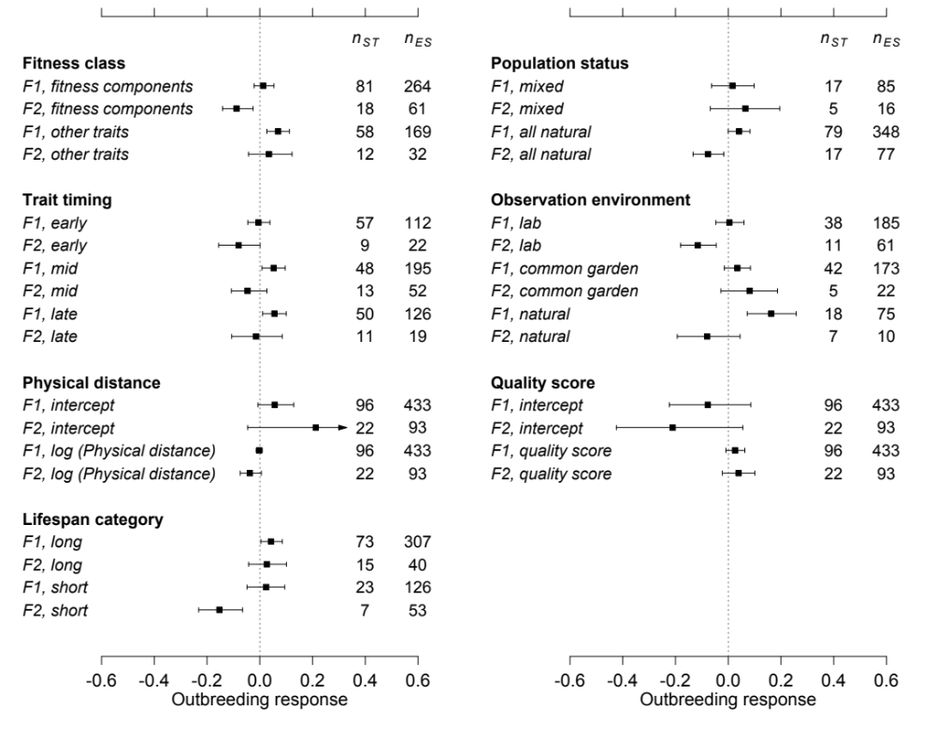

References

1. Edmands S: Heterosis and outbreeding depression in interpopulation crosses spanning a wide range of divergence. Evolution 1999, 53:1757-1768.
2. Lynch M: The genetic interpretation of inbreeding depression and outbreeding depression. Evolution 1991, 45:622-629.
3. Falconer DS, Mackay TFC: Quantitative Genetics. Harlow, England: Prentice Hall; 1996.
4. Roberts RC: The effects on litter size of crossing lines of mice inbred without selection. Genet Res 1960, 1:239-252.
5. Hadfield JD: MCMC methods for multi-response generalized linear mixed models: the MCMCglmm R package. Journal of Statistical Software 2010, 33:1-22.
6. Hadfield JD, Nakagawa S: General quantitative genetic methods for comparative biology: phylogenies, taxonomies and multi-trait models for continuous and categorical characters. J Evol Biol 2010, 23:494-508.
7. Bailey MF, McCauley DE: The effects of inbreeding, outbreeding and long-distance gene flow on survivorship in North American populations of Silene vulgaris. J Ecol 2006, 94:98-109.
8. Spiegelhalter DJ, Best NG, Carlin BP, van der Linde A: Bayesian measures of model complexity and fit. Journal of the Royal Statistical Society of London B 2002, 64:583-639.
9. Viechtbauer W: Conducting meta-analyses in R with the metafor package. Journal of Statistical Software 2010, 36:1–48.
10. Gelman A, Carlin JB, Stern HS, Rubin DB: Bayesian Data Analysis. London, New York, Washington, D. C.: Chapman & Hall/CRC; 2004.

