Additional file

Box-plot of total sample (n=18) showing difference between AM7164 and GT1M outputs in mcpm (%). With a median difference of 11.7% between monitors case number 10 and 11 are extreme outliers showing about 50% difference between AM7164 and GT1M outputs of total physical activity. Data from these cases were therefore disregarded.
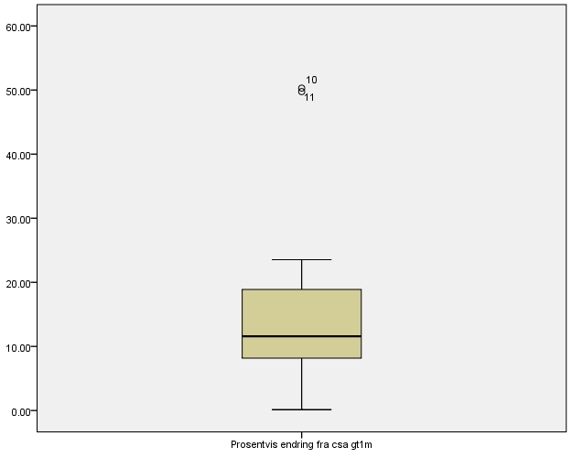
Difference between AM7164 and GT1M in mcpm
%
Figure 1 Box-plot of total sample (n=18) showing difference between AM7164 and
GT1M outputs in mcpm (%). Case number 10 and 11 are defined as extreme outliers.

