SUPPLEMENTARY INFORMATIONS

Identification of the factors affecting co-localization precision for quantitative multicolor localization microscopy

Paolo Annibale, Marco Scarselli, Mattia Greco and Aleksandra Radenovic

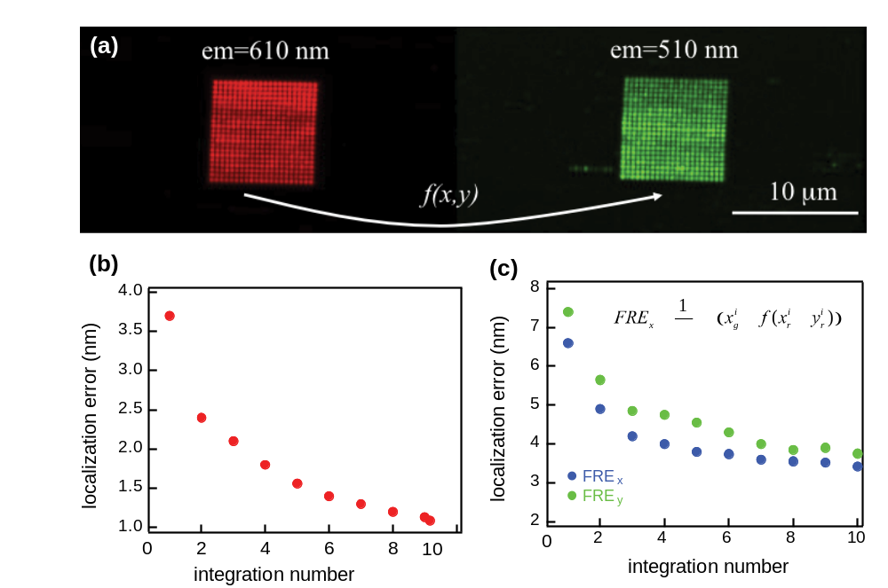
SI Figure 1. Registration protocol. (a) Dual-color image of the grid obtained by integrating the images of a fiducial fluorescent bead scanned across a square matrix of approximately 10 μm side. (b) Average localization precision of the individual fiducial nanoparticles as a function of the number of integrated frames (equivalent to multiples of the exposure time). (c) Average Fiducial Registration Error following the Local Weighted Mean mapping of all the coordinates of the fiducial marker in the red channel and subtraction from the corresponding coordinates in the green.
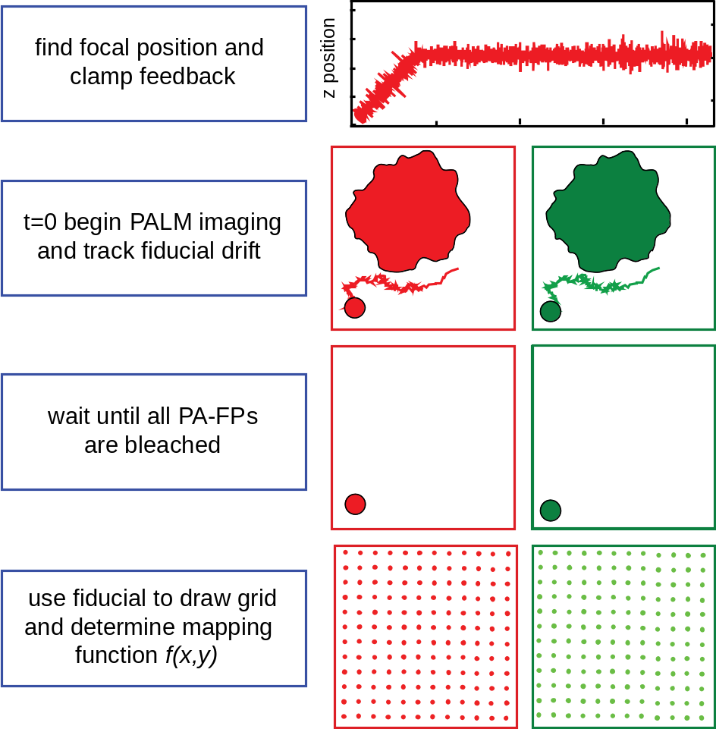
SI Figure 2. Schematic of the protocol employed in a dual-color imaging experiment applicable to any laboratory or commercial localization microscopy measurement.

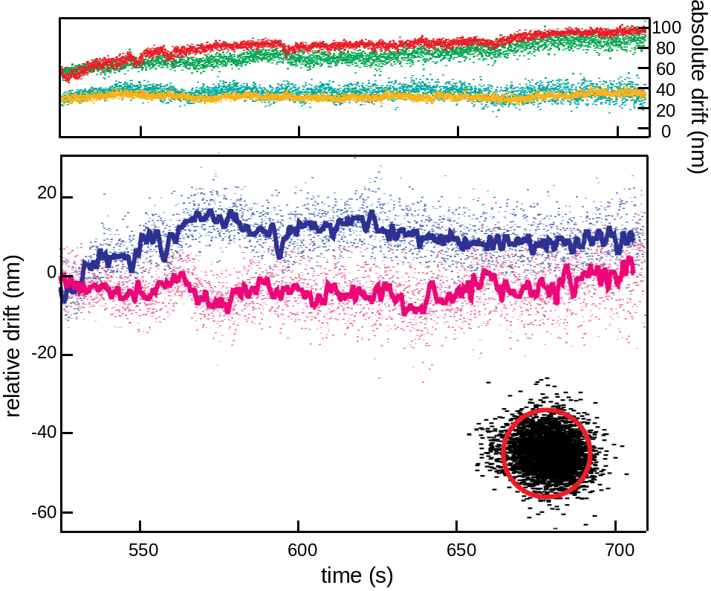
SI Figure 3. Measurement of the lateral drift. Upper graph: absolute drift, in the red and green channel, of one fiducial nanoparticle in a mEos2-psCFP2 sample. Bottom graph: relative drift in the x and y directions. Lower inset: scatter plot of the residual offset between the green and red channel after approximately 520 s from the beginning of the acquisition till the end. The red circle has a radius of 10 nm.

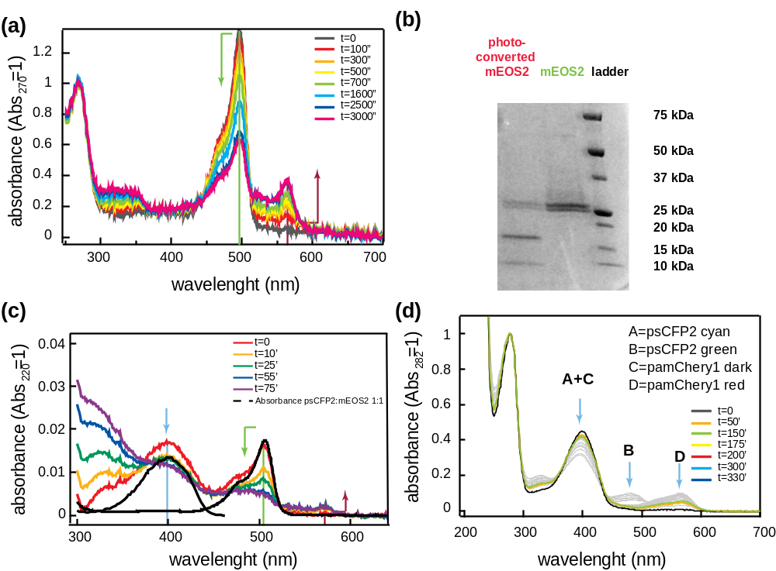
SI Figure 4. (a) Evolution of the absorption spectrum of mEos2 upon 405 nm irradiation, at pH 7.9. It is important to notice that the photoconversion of the red form reaches a saturation before that the green form (488 nm band) has completely disappeared. The ratio between the concentration of the green species and the red one at saturation is approximately 1.8. (b) mEos2 bands before and after photoconversion (1h) in a 4-15% gradient denaturing Blue Coomassie gel. (c) Absorption spectrum of
psCFP2-mEos2 fusion (after detrending to remove an exponential background). The evolution of the absorption spectrum is displayed in a color code up to 75 minutes of 405 nm irradiation, when no further increase of the absorbance of the mEos2(R) form is observed. The dashed line represents the theoretical psCFP2-mEos2 spectrum (prior to photoconversion) at the expected 1:1 stoichiometry, normalized in order to match the peak mEos2(G) absorbance. An excess (1.3x) of psCFP2 is observed. (d) Ensemble spectroscopic characterization of psCFP2-pamCherry1 fusion protein. Evolution of the absorption spectrum upon 405 nm laser light irradiation. Extinction coefficients for each species are quoted, and allow to reconstruct the final concentration of activated species.

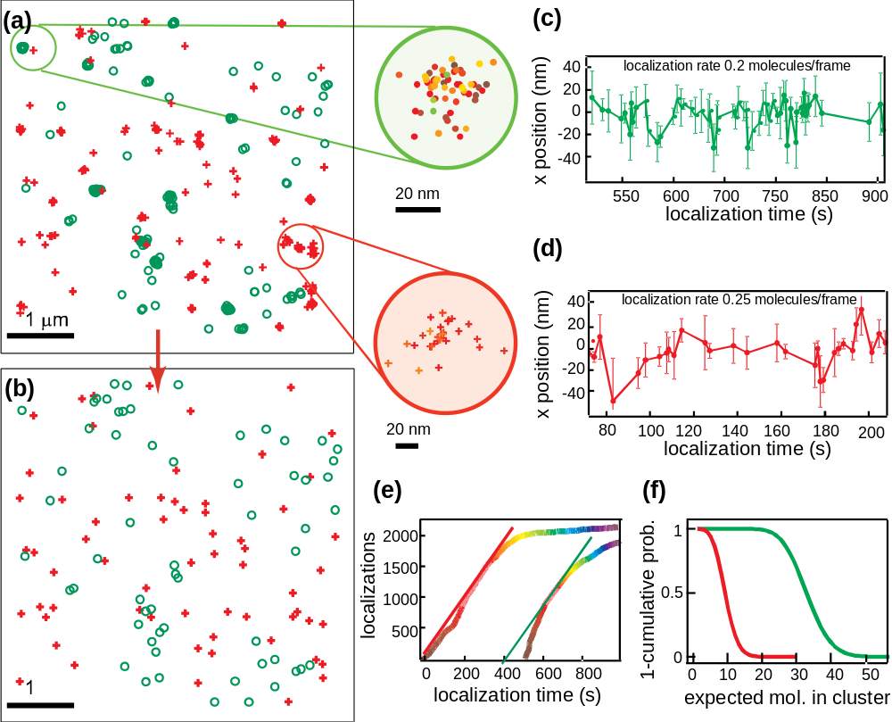
SI Figure 5. (a) Map of the localized centers for mEos2 (red) and Dronpa (green) molecules activated in PAGE at low concentration. (b) Two arbitrary clusters are selected and their kymographs displayed. (c) and (d). (e) The number of molecules activated in time for each species is displayed. Linear guide for the eye outlines the linear activation regime where the assumption of a Poisson flow for the arrival time of the localization events hold. (f) Cumulative Distribution Functions for a Poisson Distribution calculated for the two clusters displayed in b. m_mEos = 9 and m_Dronpa = 23.

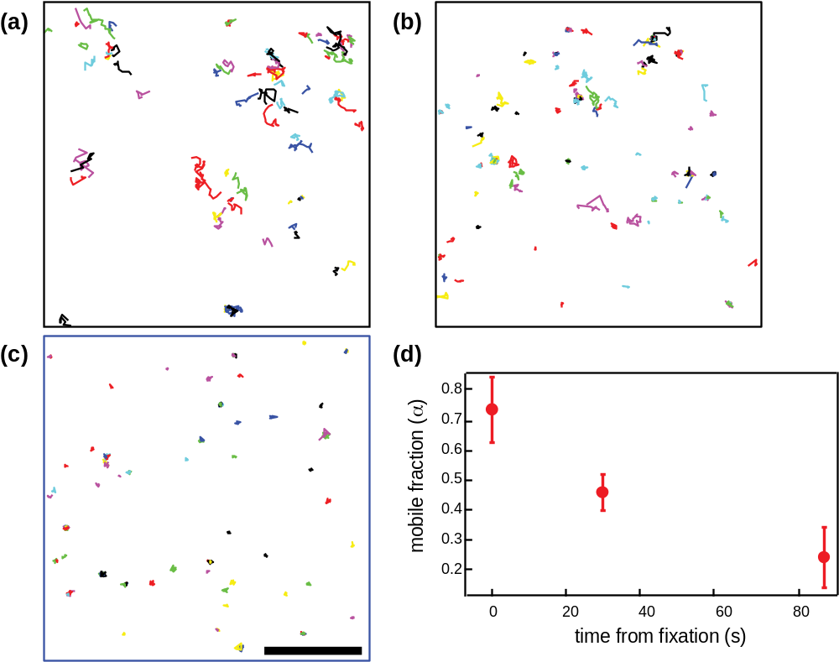
SI Figure 6. (a) β2-mEos2 traces before fixation on the plasma membrane of a HeLa cell. (b) After an average of 30 s after fixation. (c) After an average of 90 s after fixation. Scale bar 5 μm. (d) Evolution of the mobile fraction of β2-ARs on the plasma membrane of a HeLa cell as a function of the time from fixation.

