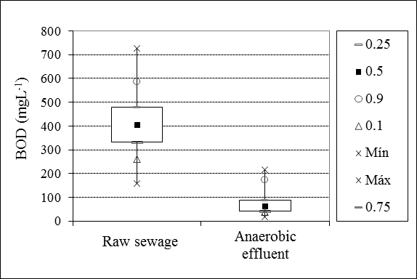
Figure 4 Average BOD of the raw sewage and effluent from anaerobic filters.

