Fig. S2
- Chromosome 4
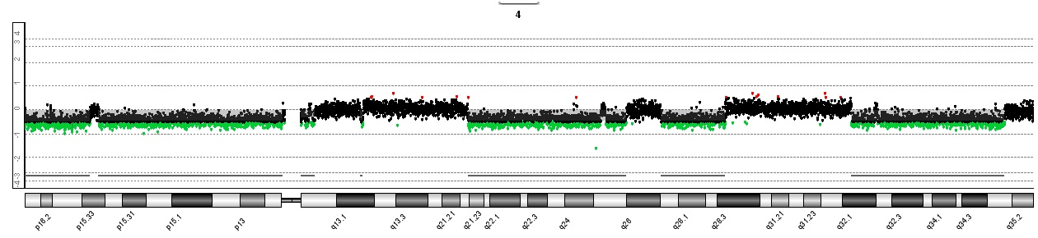
- Chromosome 6
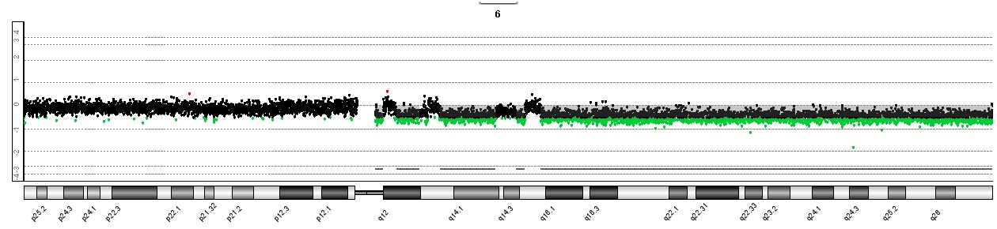
- Chromosome 17
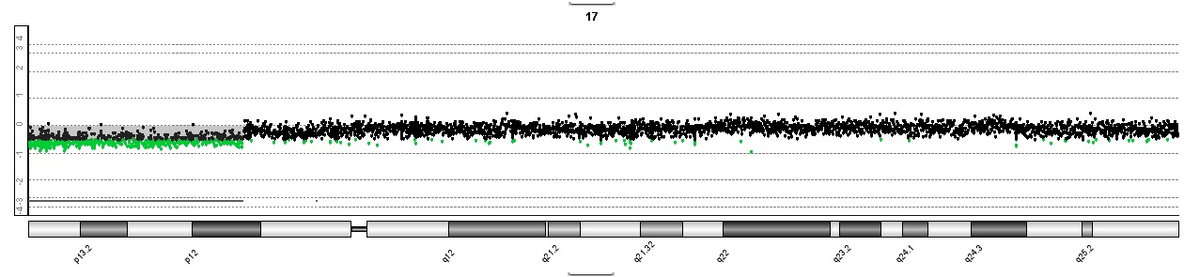
- Chromosome 22
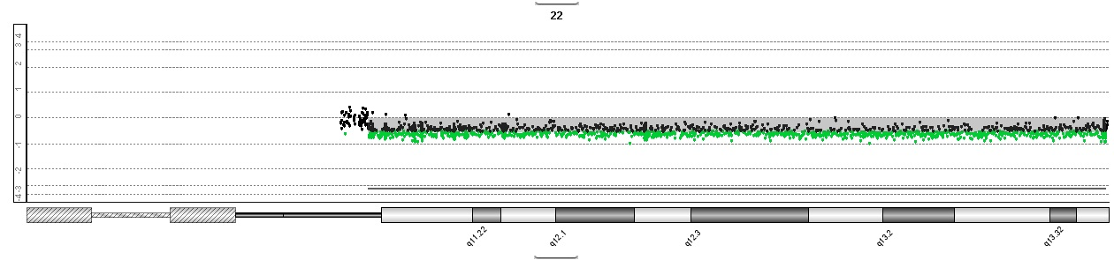
- Chromosome 13
