Supplementary Fig. 2
a
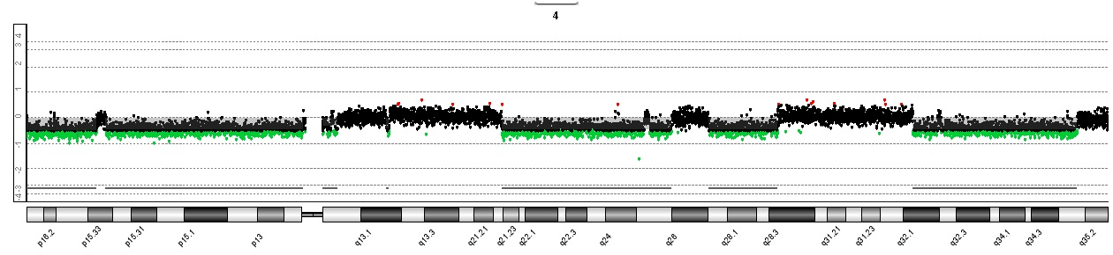
b
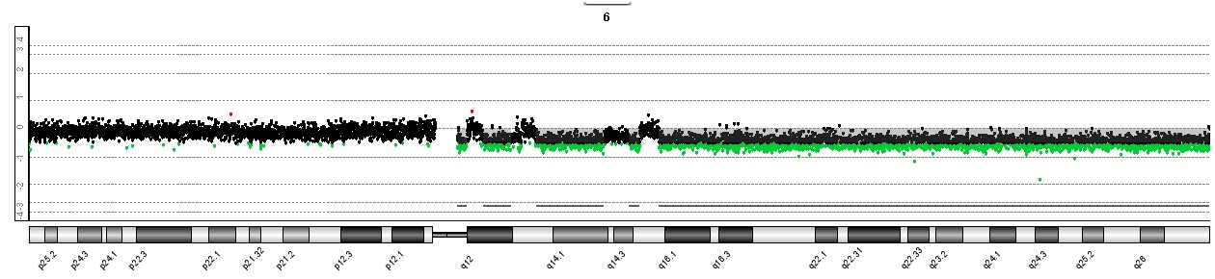
c
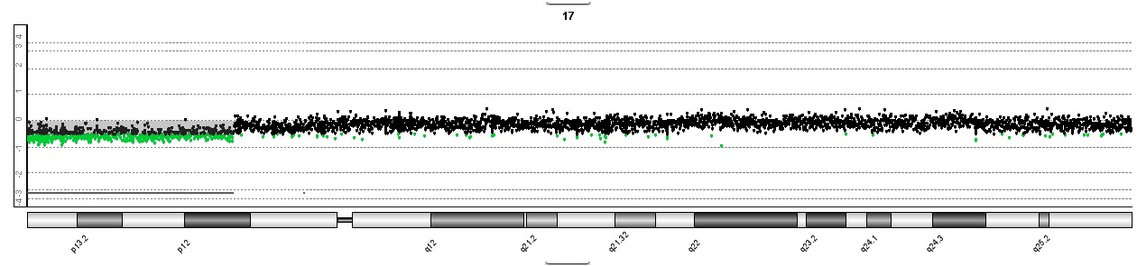
d
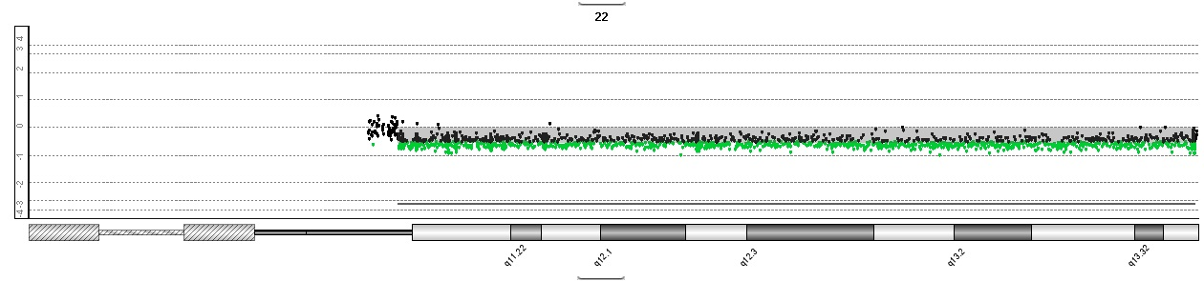
e
