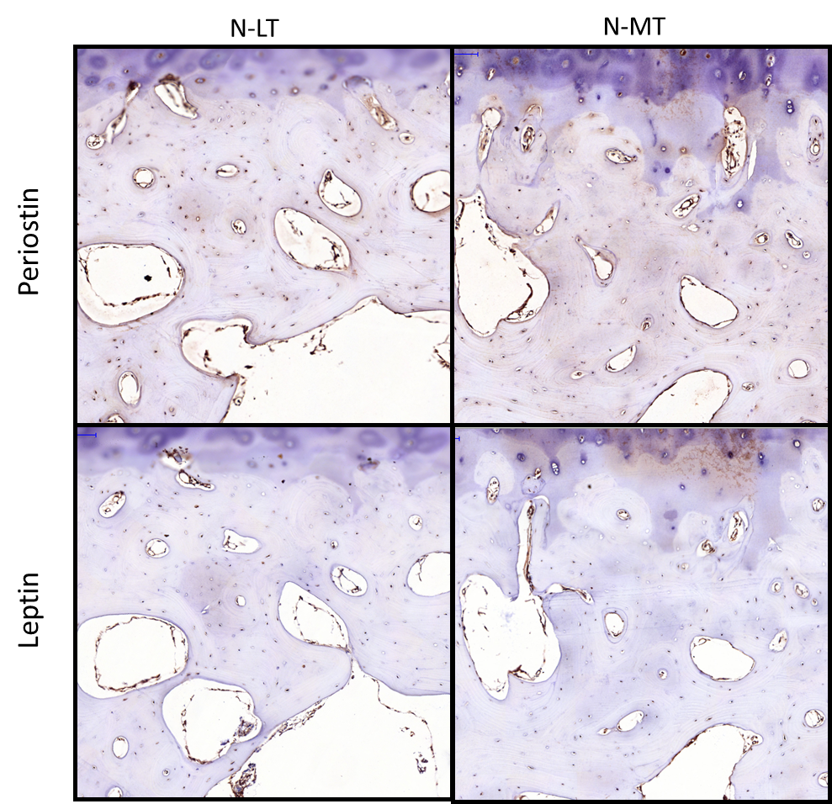

Additional File 10. Validation of protein expression in human non-OA knee samples.
Antibodies against POSTN, LEP and p-AKT were used to detect protein expression (dark brown staining) by Immunohistochemistry in human non-OA knee subchondral bone. No differences in protein expression were observed between lateral tibial (N-LT) and medial tibial (N-MT) regions.

