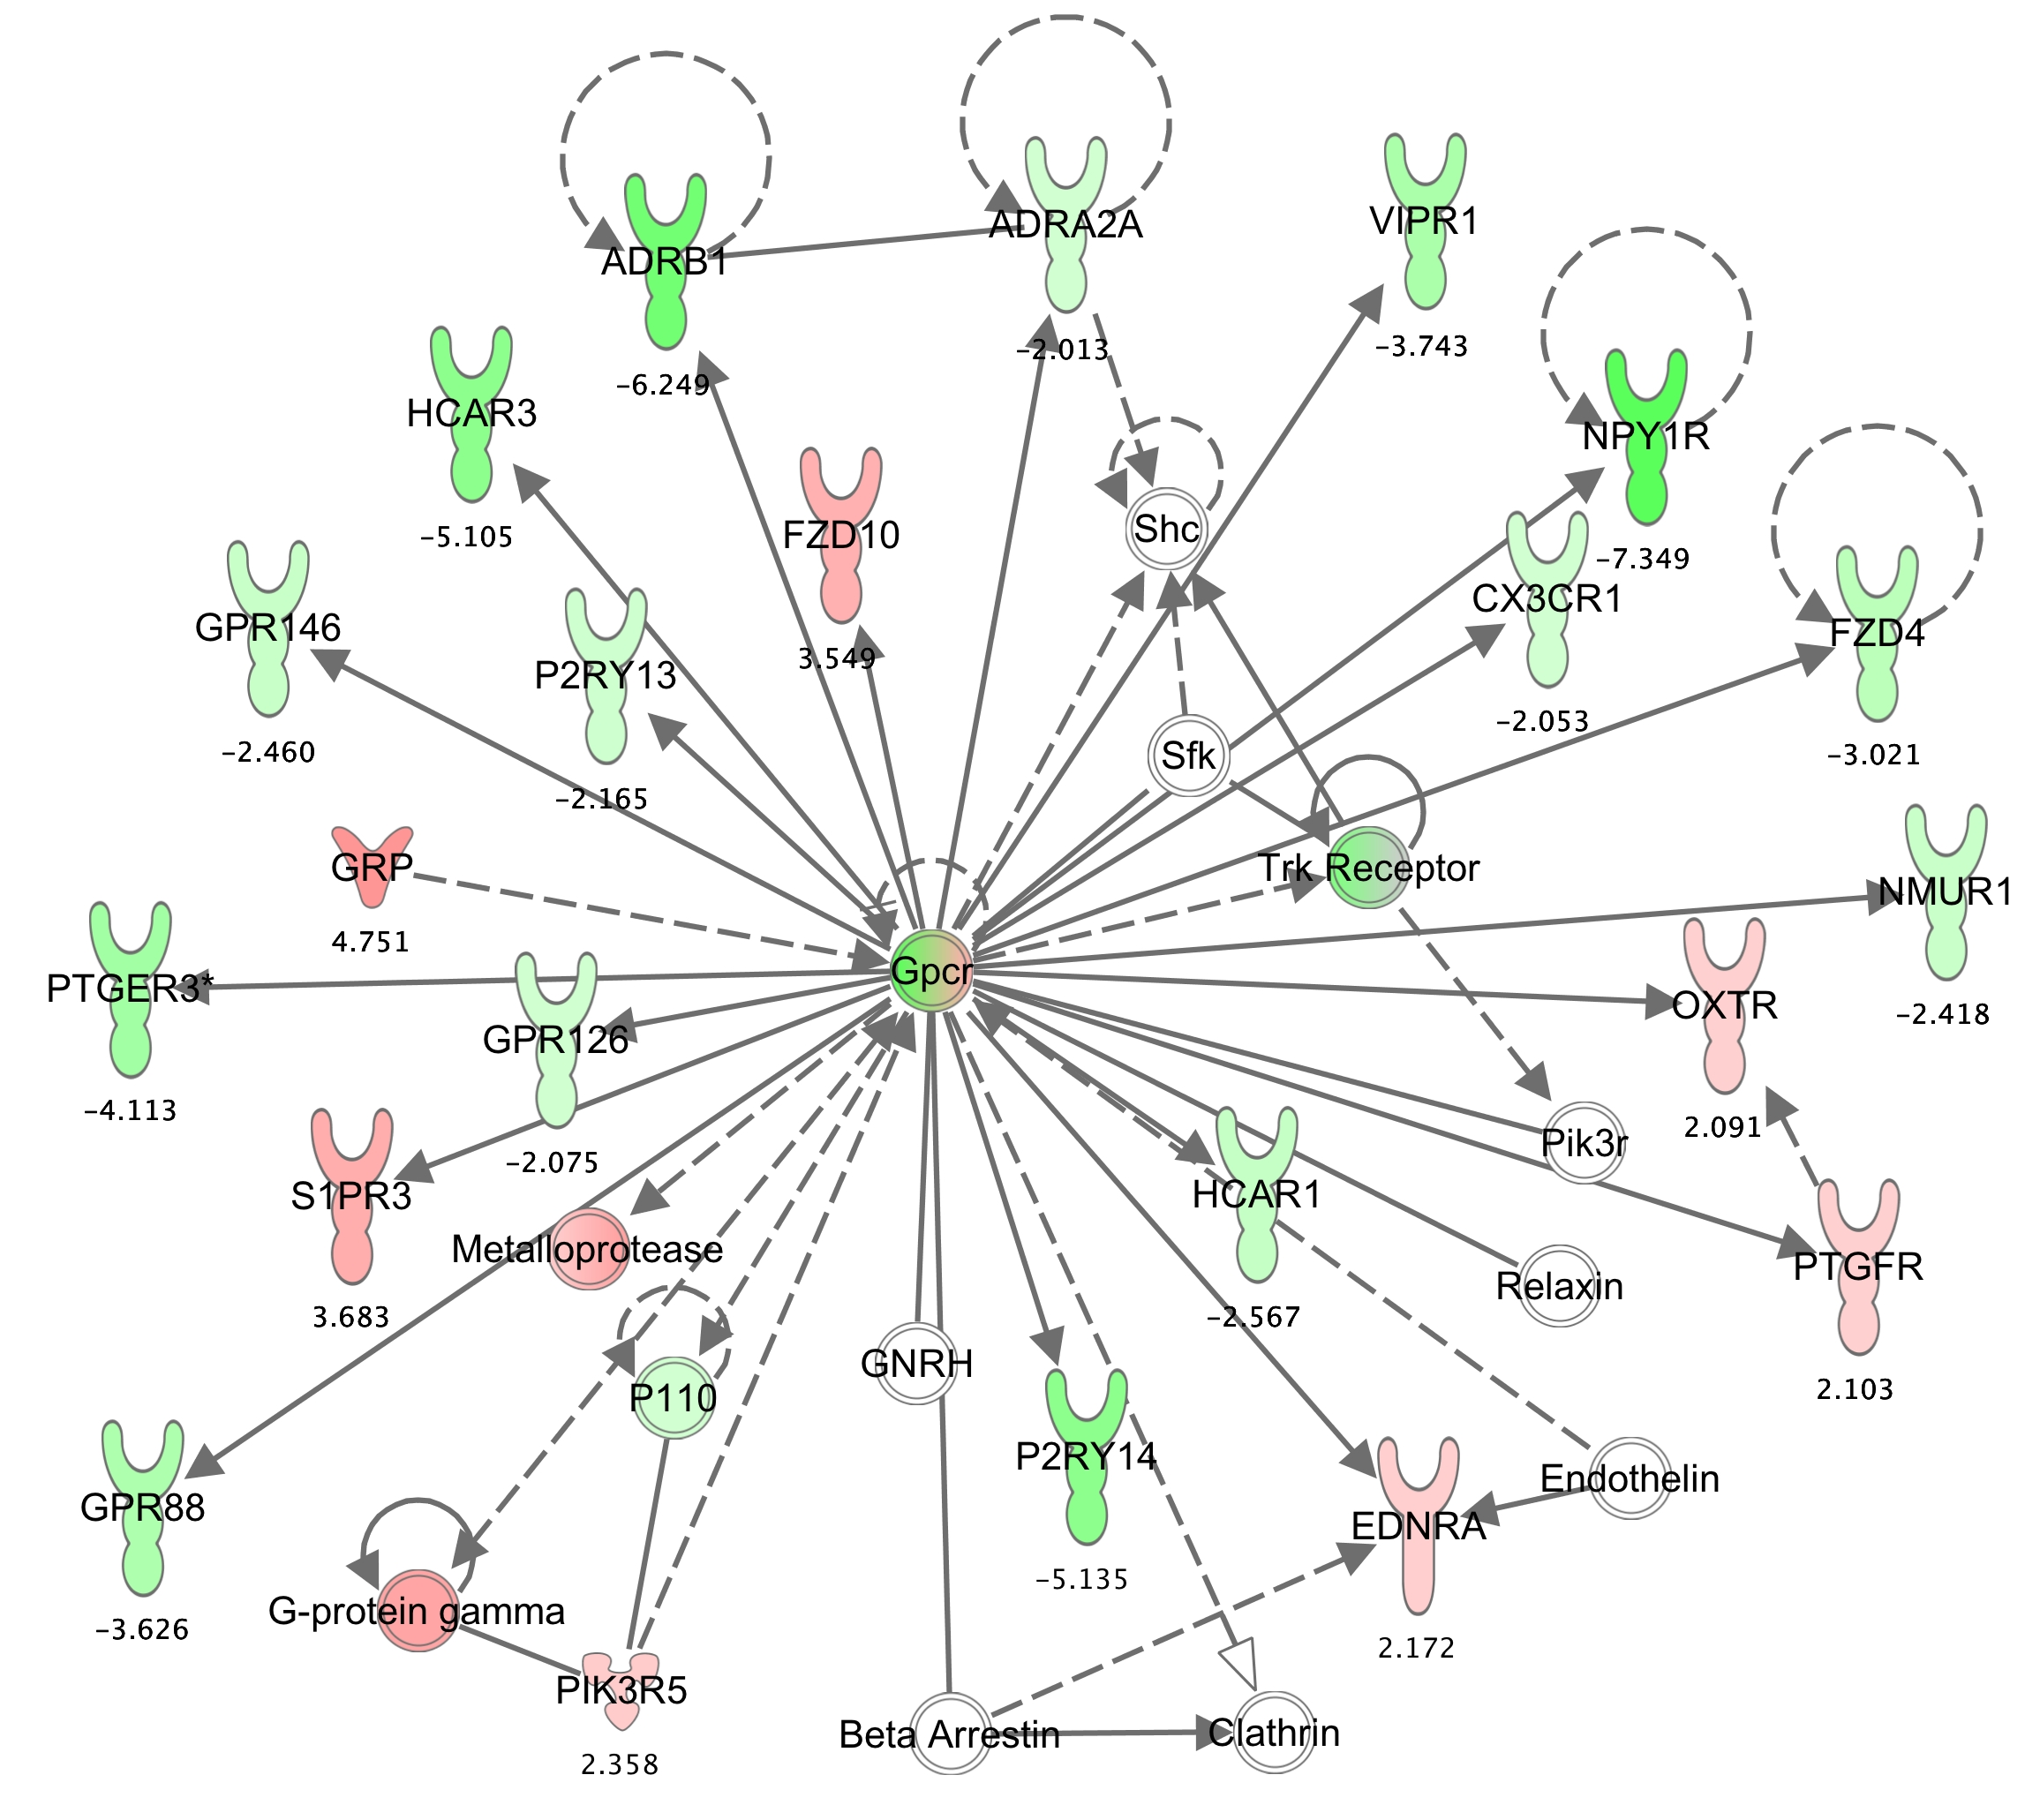
Additional File 8. A potential network of mineral metabolism in OA.
Based on microarray and IPA analyses, a network of genes related to mineral metabolism was associated with OA. The expression intensity ratios of OA-MT versus OA-LT are indicated below the gene icons. Up-regulated and down-regulated genes are highlighted in red and green respectively.

