Additional Figures

Figure S1. HIF-1α expression increases during tumor progression in the MMTV-PyMT model and confirmation of HIF-1α deletion.

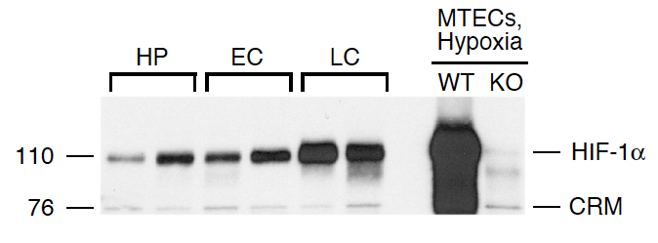

Figure S2. HIF-1α expression increases in response to EGF treatment at normoxia, and EGF prolongs HIF-1α stabilization at hypoxia.

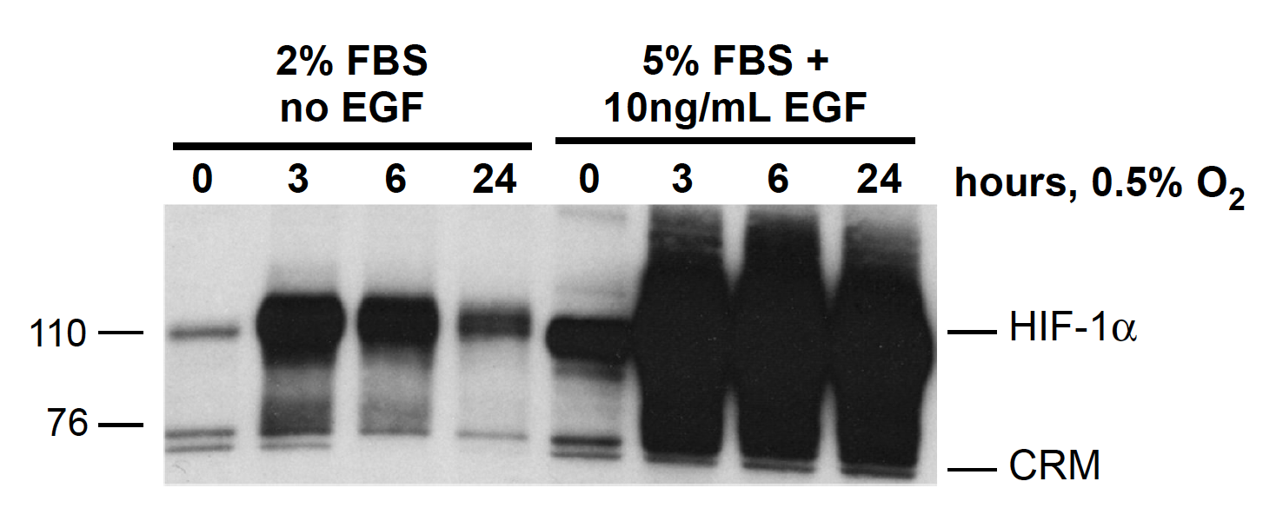

Figure S3. Histology of HIF-1α WT and KO end-stage PyMT tumors.
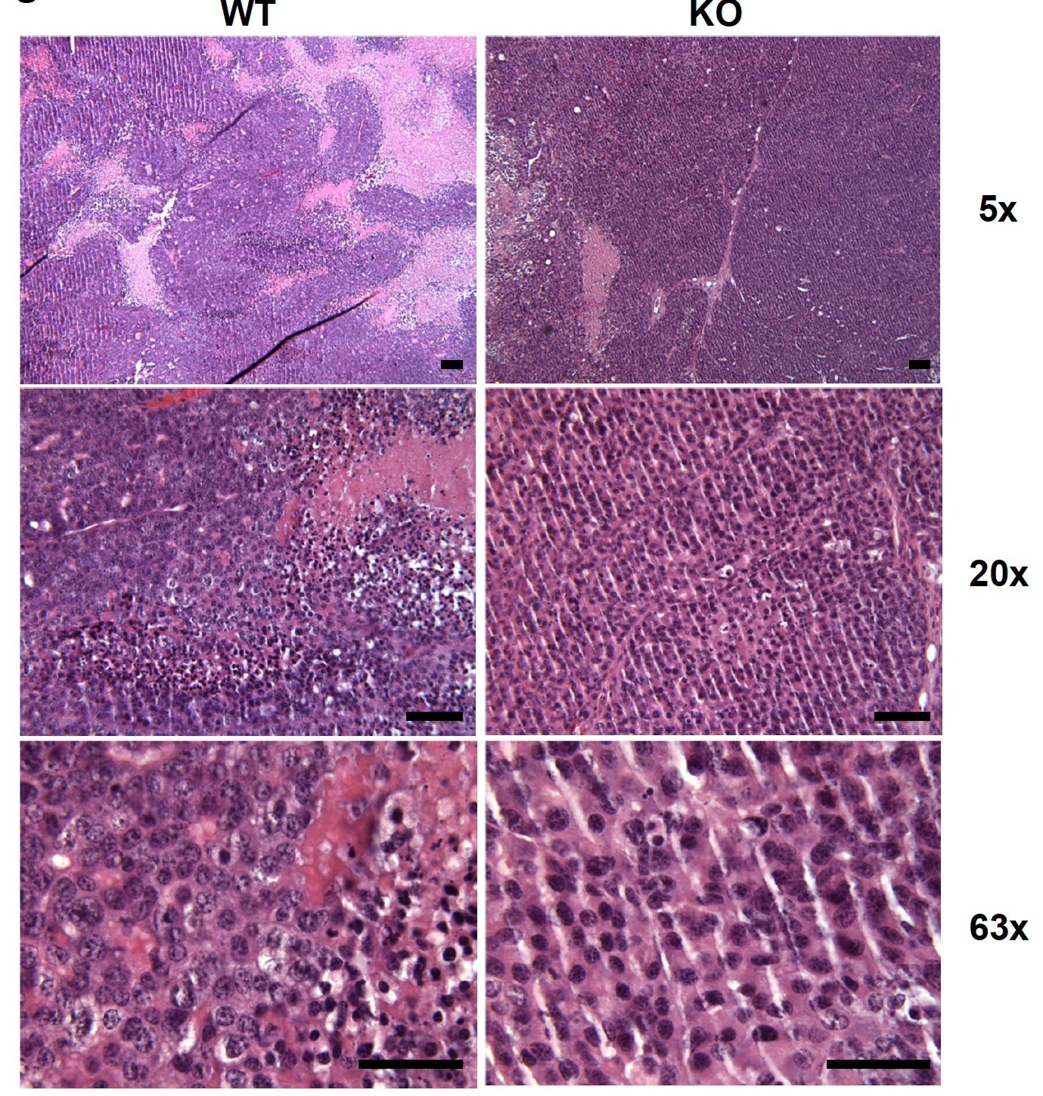

Figure S4. Ki67 and activated caspase-3 immunostaining in end-stage PyMT tumors.
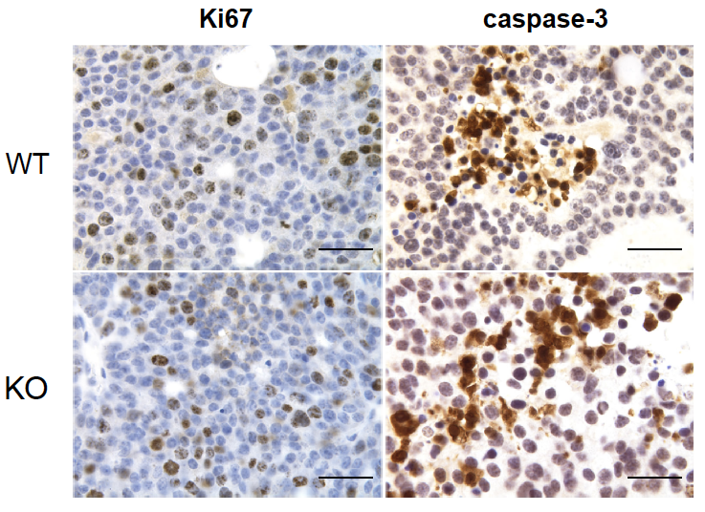

Figure S5. Expression of p63 and ERα in HIF-1α WT and KO end-stage PyMT tumors.
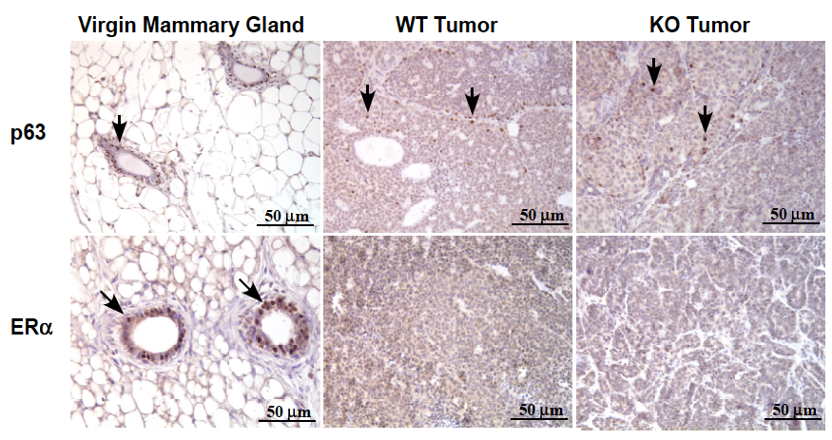

Figure S6. The mean fold-change in sphere formation efficiency (SFE) among biological replicates.
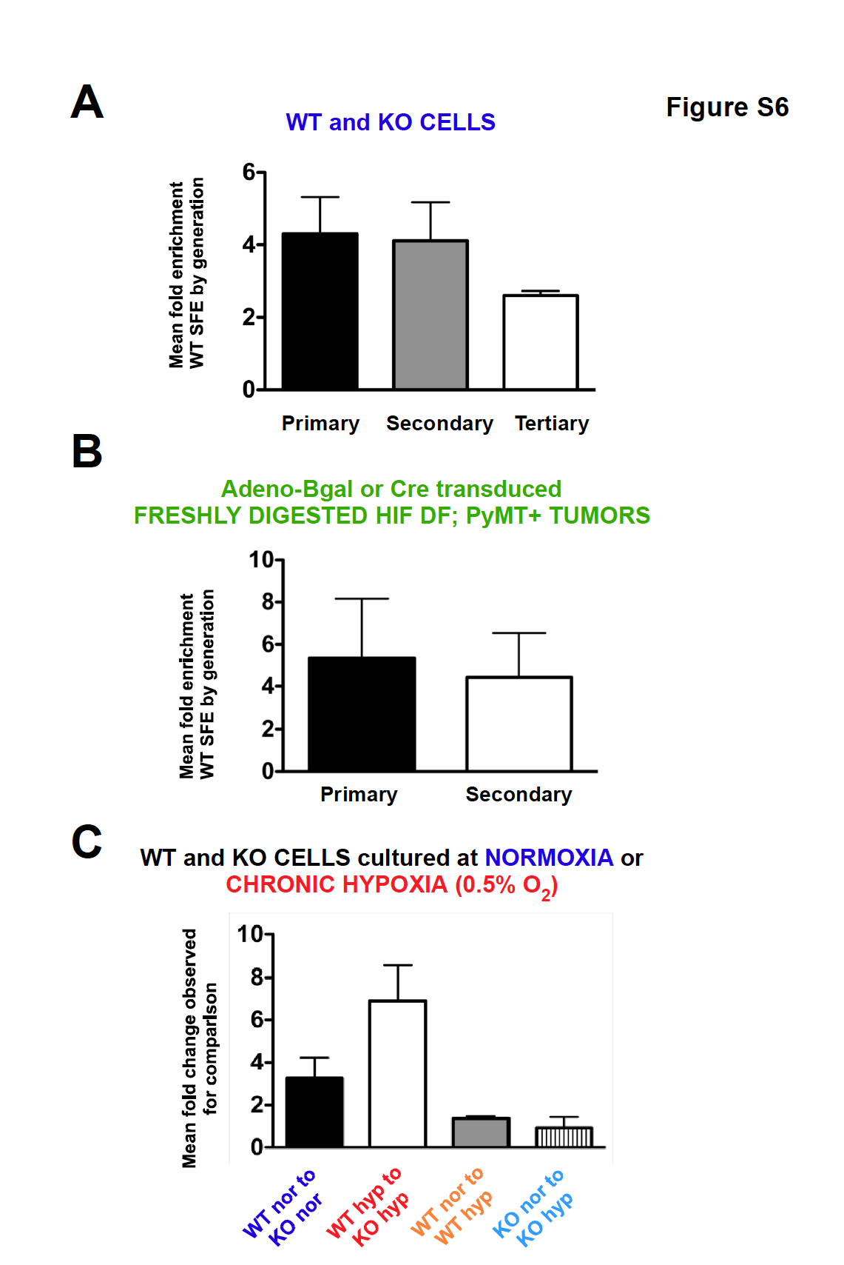

Figure S7. HIF-1α expression in tumorspheres cultured acutely or chronically at hypoxia. .
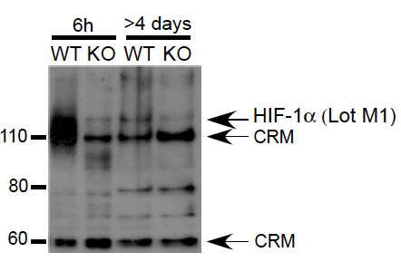

Figure S8. Gating strategy for sorting CD133^{hi} and CD133^{neg} cells from mammary tumors originating in PyMT+ transgenic femalees.
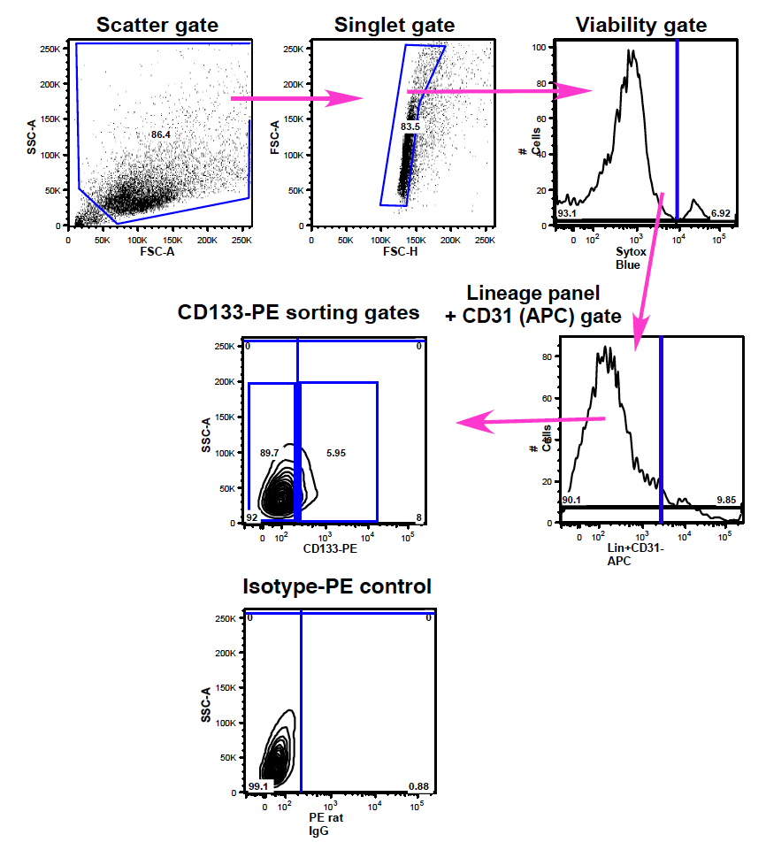

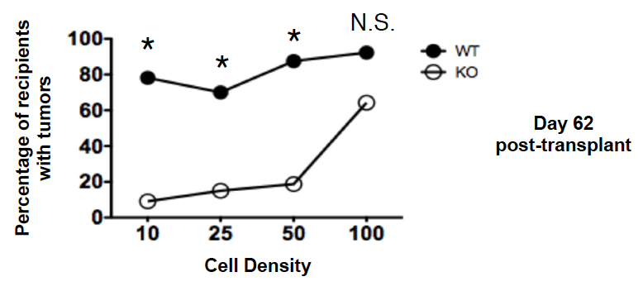
Figure S9. Comparison of WT and KO tumor-initiating potential at day 62 post-transplant.

Figure S10. Mean WT and KO tumor volume in the 200 cell and 500 cell input cohorts up to day 36 post-transplant.
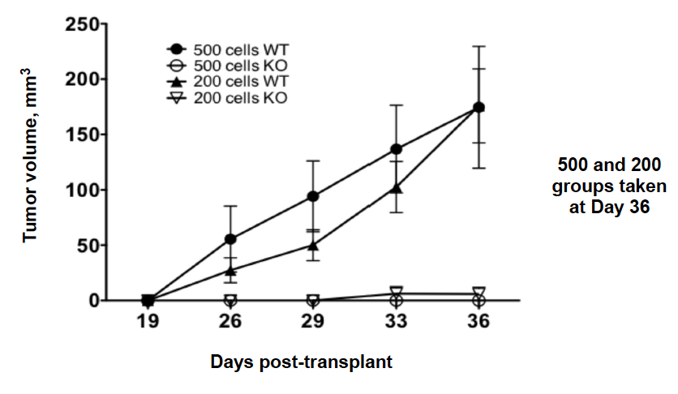

Figure S11. Mean tumor volume in the 100 cell WT and KO cohorts up to day 112 post-transplant.

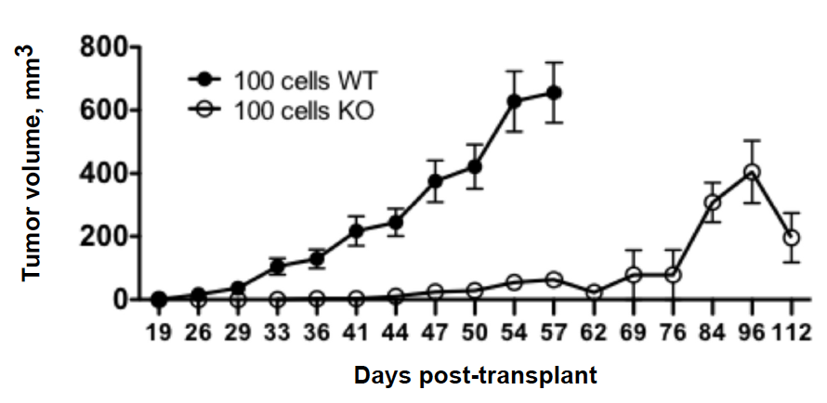

Figure S12. Mean WT and KO tumor volume in the 10, 25 and 50 cell input cohorts up to day 112 post-transplant.
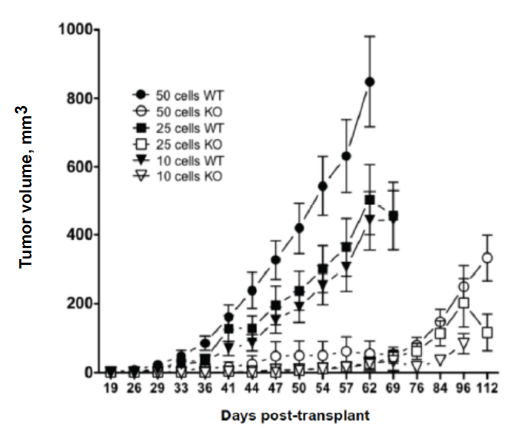

Supplementary Materials and Methods

Hyperlink to database to view digitally scanned images of whole slides
Whole slides were digitally-scanned at high resolution at either 20x or 40x magnification using the Aperio ScanScope system maintained by the Department of Pathology at the UTHSC. A public folder containing the slide images may be accessed by logging into: http://ap1400-dsr.uthsc.edu/. The user name is Seagroves and the password is Pathology (each case-sensitive). Once logged into the database, please click “all digital slides”. Individual slides may then be selected for viewing by clicking each file. Clicking the “+” sign will allow the user to digitally zoom into each field of interest at high resolution. Fields of interest are indicated by the highlighted box, which may be moved over any portion of the slide for viewing at a particular magnification. Representative end-stage WT and KO tumors stained with H&E, and WT and KO tumor slides immunostained with p63 antibodies are included in the database.
To view the scanned slides, users must first download the freely available Aperio ImageScope Viewer software (http://www.aperio.com/download-imagescope-viewer.asp); a computer running Windows OS is also required.

