Persistently high venous-to-arterial carbon dioxide differences during early resuscitation are associated with poor outcomes in septic shock

Gustavo A. Ospina-Tascón ^{1, 2}, Diego F. Bautista-Rincón ¹, Mauricio Umaña ¹, José D. Tafur ¹, Alejandro Gutiérrez ¹, Alberto F. García ¹, William Bermúdez ², Marcela Granados ¹, César Arango-Dávila ², and Glenn Hernández ³

- Intensive Care Unit, Fundación Valle del Lili, Cali, Colombia
- Universidad ICESI, Biomédica Research Group,Cali, Colombia
- Departamento de Medicina Intensiva, Pontiﬁcia Universidad Catolica de Chile. Santiago de Chile, Chile.

SUPPLEMENTARY MATERIAL

Results
Some additional results are presented below.

Figure S1a. Time-course of ScvO2 (%) during the first 24 hours for survivors and non-survivors at day-28.
Repeated measures analysis of variance, p=0.22.

Figure S1b. Time-course of SvO2 (%) during the first 24 hours for survivors and non-survivors at day-28.
Repeated measures analysis of variance, p=0.65.

Figure S2. Time-course of cardiac output (L/min) during the first 24 hours for survivors and non-survivors at day-28.
Repeated measures analysis of variance, p=0.37.

Figure S3. Scatter plot between cardiac index and Pv-aCO₂ (according to Pv-aCO₂ at T6)
Blue points: Pv-aCO₂ < 6 mmHg; Red points: Pv-aCO₂ ≥ 6 mmHg

Figure S4a. Time-course of Pv-aCO2 (mmHg) during the first 24 hours for survivors and non-survivors at day-28.
Repeated measures analysis of variance, p=0.003. Pv-aCO₂ denotes mixed-venous to arterial pCO₂ difference.

Figure S4b. Time-course of Pvc-aCO2 (mmHg) during the first 24 hours for survivors and non-survivors at day-28.
Repeated measures analysis of variance, p=0.03. Pvc-aCO₂ denotes central-venous to arterial pCO₂ difference.
Figure S5. Time-course of lactate levels (mmol/L) during the first 24 hours for survivors and non-survivors at day-28.
Repeated measures analysis of variance, p<0.0001.

Figure S1a.

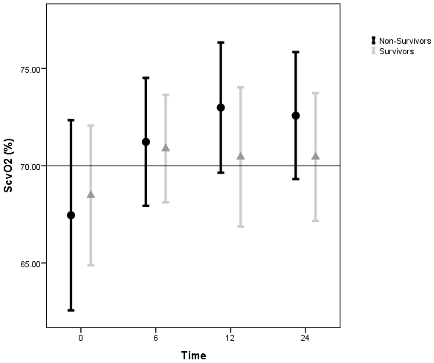

Figure S1b.

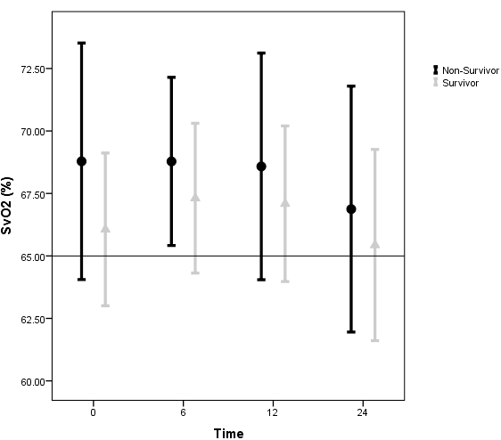

Figure S2.

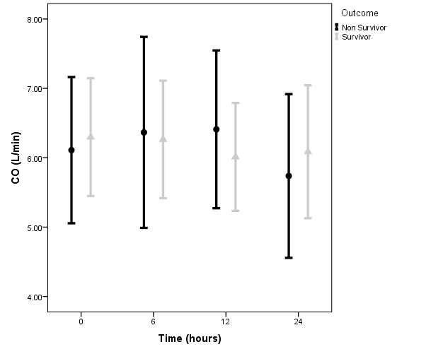

Figure S3.

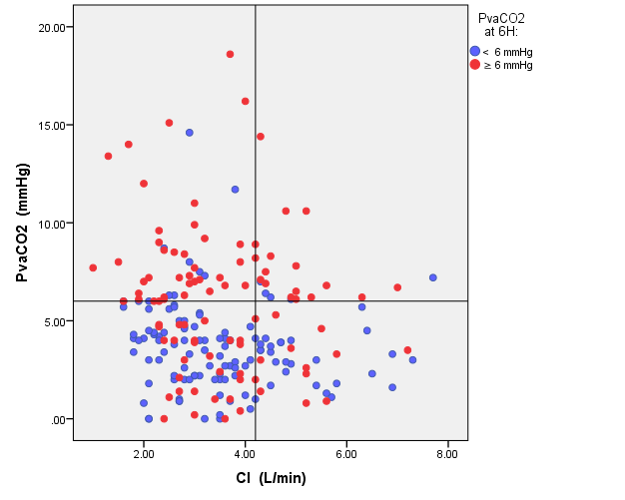

Figure S4a.

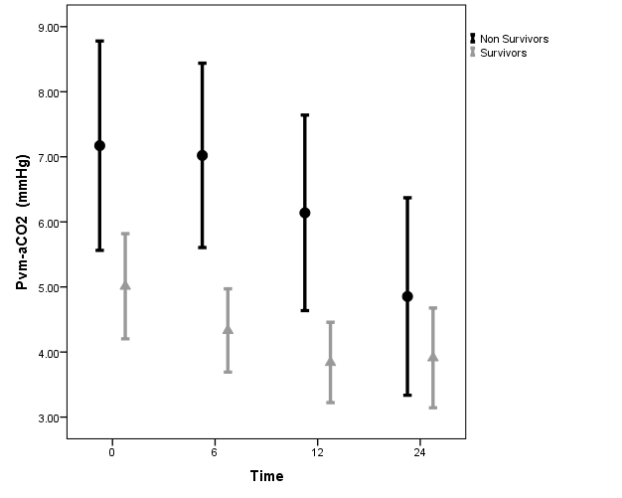

Figure S4b.

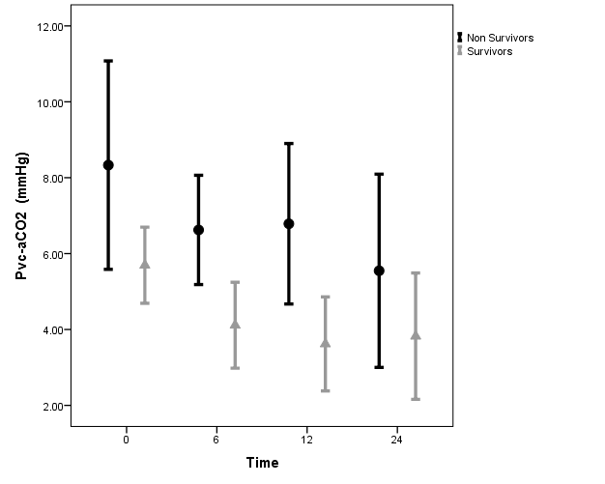

Figure S5.

