Additional Figure 4
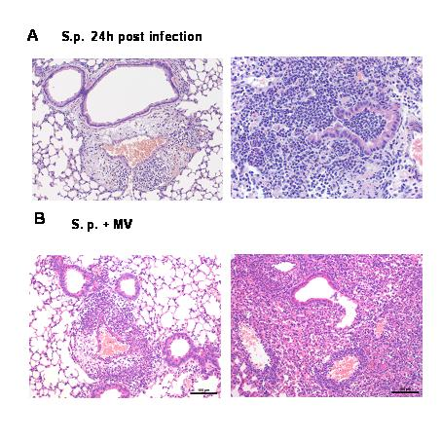

Additional Fig 4. Histologic lung pathology of pneumonia
Pneumococcal pneumonia (S.p.) was induced 24h before mechanical ventilation (MV) was performed for 6h.
(A) Images from mice 24h after infection with s.pneumoniae are shown, that display severe necrotizing bronchopneumonia affecting 40-60% of the lung. (B) Images from mice subjected to MV for 6h 24h after infection with S. pneumoniae. Again severe necrotizing bronchopneumonia was found. No changes due to MV could be dissected from the pneumonia induced severe damage of the lung parenchyma. Representative images out of 4 animals per group are shown.

