Solexa read coverage of BACs 1H13 and 8F17. GC percentage across the BACs is represented by the black line and the relative number of read hits (from 0 to 1000) by blue vertical bars.

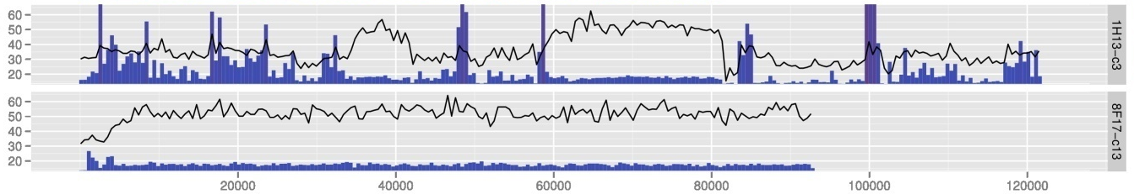
GC (%)
Distance (kbp)

