Supplementary Information for…

Assessing telomeric DNA content in pediatric cancers using whole-genome sequencing data.
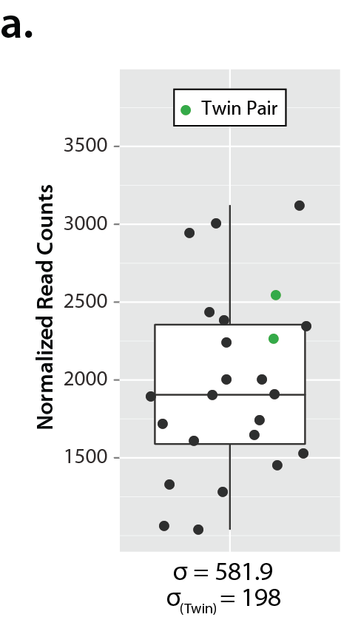

Figure S1 – Biological Reproducibility
A. Infant ALL normalized diagnostic telomere read counts including a set of twins. Both of these twins contain the same initiating MLL translocation event (data not shown) indicating that their tumors share a common clonal origin. The standard deviation telomere content in these two samples is under half of the standard deviation for the whole cohort.

