Supplemental Material for “Discriminating between disease-causing and neutral non-frameshifting micro-INDELs by support vector machines by means of integrated sequence- and structure-based features”

Huiying Zhao^{1,§}, Yuedong Yang^{1,2,§}, Hai Lin², Xinjun Zhang², Matthew Mort⁴, David N. Cooper⁴, Yunlong Liu^{2,3,*}, and Yaoqi Zhou^{1,2,}*

¹School of Informatics, Indiana University Purdue University, Indianapolis, Indiana 46202, USA
²Center for Computational Biology and Bioinformatics, Indiana University School of Medicine, Indianapolis, Indiana 46202, USA
³Department of Medical and Molecular Genetics, Indiana University School of Medicine, Indianapolis, Indiana 46202, USA
⁴Institute of Medical Genetics, Cardiff University, Heath Park, Cardiff CF14 4XN, UK

§Equal contribution.

* To whom correspondence should be addressed. Dr. Liu (Tel. 317-278-9222; Fax. 317-278-9217;
yunliu@iupui.edu); Dr. Zhou (Tel: 317-278-7674; Fax: 317-278-9201; Email: yqzhou@iupui.edu)

Table S1. Performance of individual features (Deletion)
Features |  |  |  |  | MCCª | AUC^{b} | ACC^{c}
Disorder |  |  |  | Max | 0.551 | 0.818 | 0.772
 |  |  |  | Min | 0.558 | 0.824 | 0.777
 |  |  |  | Average | 0.557 | 0.825 | 0.777
SS^{d} |  |  |  | C | 0.235 | 0.634 | 0.613
 |  |  |  | H | 0.131 | 0.595 | 0.562
 |  |  |  | E | 0.218 | 0.616 | 0.578
SS^{d} Probability and ASA |  | Max |  | C | 0.258 | 0.655 | 0.627
 |  |  |  | H | 0.218 | 0.613 | 0.6
 |  |  |  | E | 0.32 | 0.678 | 0.658
 |  |  |  | ASA^{e} | 0.302 | 0.659 | 0.648
 |  | Min |  | C | 0.185 | 0.6 | 0.585
 |  |  |  | H | 0.263 | 0.671 | 0.628
 |  |  |  | E | 0.305 | 0.658 | 0.647
 |  |  |  | ASA^{e} | 0.542 | 0.81 | 0.766
 |  | Aver |  | C | 0.256 | 0.658 | 0.624
 |  |  |  | H | 0.223 | 0.627 | 0.605
 |  |  |  | E | 0.284 | 0.632 | 0.635
 |  |  |  | ASA | 0.47 | 0.781 | 0.733
Evo^{f} | Aver |  |  | M-M | 0.234 | 0.64 | 0.617
Evo^{f} |  |  |  | M-I | 0.263 | 0.655 | 0.63
Evo^{f} |  |  |  | M-D | 0.155 | 0.584 | 0.577
Evo^{f} |  |  |  | I-M | 0.258 | 0.654 | 0.629
Evo^{f} |  |  |  | I-I | 0.256 | 0.657 | 0.628
Evo^{f} |  |  |  | D-M | 0.181 | 0.596 | 0.591
Evo^{f} |  |  |  | D-D | 0.182 | 0.605 | 0.587
Evo^{f} |  |  |  | Neff^{g} | 0.439 | 0.749 | 0.711
Evo^{f} |  |  |  | Neff_I | 0.259 | 0.668 | 0.626
Evo^{f} |  |  |  | Neff_D | 0.162 | 0.591 | 0.574
Evo^{f} | Min |  |  | M-M | 0.176 | 0.604 | 0.573
Evo^{f} |  |  |  | M-I | 0.308 | 0.676 | 0.653
Evo^{f} |  |  |  | M-D | 0.284 | 0.671 | 0.639
Evo^{f} |  |  |  | I-M | 0.261 | 0.643 | 0.625
Evo^{f} |  |  |  | I-I | 0.234 | 0.604 | 0.615
Evo^{f} |  |  |  | D-M | 0.163 | 0.577 | 0.578
Evo^{f} |  |  |  | D-D | 0.113 | 0.567 | 0.551
Evo^{f} |  |  |  | Neff^{g} | 0.449 | 0.735 | 0.719
Evo^{f} |  |  |  | Neff_I | 0.124 | 0.58 | 0.537
Evo^{f} |  |  |  | Neff_D | 0.132 | 0.581 | 0.562
Evo^{f} | Max |  |  | M-M | 0.292 | 0.651 | 0.644
Evo^{f} |  |  |  | M-I | 0.136 | 0.58 | 0.54
Evo^{f} |  |  |  | M-D | 0.116 | 0.571 | 0.526
Evo^{f} |  |  |  | I-M | 0.127 | 0.571 | 0.537
Evo^{f} |  |  |  | I-I | 0.0925 | 0.564 | 0.52
Evo^{f} |  |  |  | D-M | 0.0882 | 0.572 | 0.523
Evo^{f} |  |  |  | D-D | 0.145 | 0.579 | 0.568
Evo^{f} |  |  |  | Neff^{g} | 0.43 | 0.729 | 0.708
Evo^{f} |  |  |  | Neff_I | 0.287 | 0.709 | 0.641
Evo^{f} |  |  |  | Neff_D | 0.219 | 0.621 | 0.60
DNA Conser. |  |  | Aver |  | 0.367 | 0.742 | 0.683
 |  |  | Max |  | 0.468 | 0.781 | 0.733
 |  |  | Min |  | 0.144 | 0.561 | 0.557
Deletion length |  |  | INDEL len |  | 0.263 | 0.651 | 0.617
 |  |  | Protein Len |  | 0.134 | 0.573 | 0.567
 |  |  | Dis to head |  | 0.121 | 0.564 | 0.555
 |  |  | Dis to tail |  | 0.103 | 0.542 | 0.55
Splicing position |  |  | To head |  | 0.219 | 0.606 | 0.596
 |  |  | To tail |  | 0.24 | 0.631 | 0.612
ΔS^{h} |  |  |  |  | 0.285 | 0.676 | 0.633
ªMCC: Mathews correlation coefficient. ^{b}AUC: area under the curve. ^{c}ACC: Accuracy. ^{d}SS: predicted secondary structure. ^{e}ASA, solvent accessible surface area. ^{f}Evo: Evolutionary information generated by HHblits. ^{g}Neff: the number of effective homologous sequences aligned to residues, irrespective of residue type. ^{h}ΔS: the INDEL-induced change to the HMM match score.

Table S2. Performance of individual features (Insertion)
Features |  |  |  |  | MCCª | AUC^{b} | ACC^{c}
Disorder |  |  |  | Max | 0.546 | 0.816 | 0.772
 |  |  |  | Min | 0.556 | 0.813 | 0.777
 |  |  |  | Average | 0.545 | 0.80 | 0.772
SS^{d} |  |  |  | C | 0.321 | 0.674 | 0.657
 |  |  |  | H | 0.146 | 0.584 | 0.565
 |  |  |  | E | 0.25 | 0.817 | 0.589
SS^{d} Probability and ASA |  | Max |  | C | 0.314 | 0.688 | 0.657
 |  |  |  | H | 0.254 | 0.646 | 0.627
 |  |  |  | E | 0.349 | 0.698 | 0.674
 |  |  |  | ASA^{e} | 0.317 | 0.67 | 0.652
 |  | Min |  | C | 0.224 | 0.621 | 0.609
 |  |  |  | H | 0.317 | 0.694 | 0.652
 |  |  |  | E | 0.346 | 0.663 | 0.669
 |  |  |  | ASA^{e} | 0.501 | 0.80 | 0.605
 |  | Aver |  | C | 0.312 | 0.692 | 0.656
 |  |  |  | H | 0.328 | 0.695 | 0.66
 |  |  |  | E | 0.306 | 0.636 | 0.646
 |  |  |  | ASA^{e} | 0.454 | 0.78 | 0.724
Evo^{f} | Aver |  |  | M-M | 0.246 | 0.628 | 0.623
Evo^{f} |  |  |  | M-I | 0.182 | 0.614 | 0.588
Evo^{f} |  |  |  | M-D | 0.186 | 0.597 | 0.589
Evo^{f} |  |  |  | I-M | 0.199 | 0.619 | 0.588
Evo^{f} |  |  |  | I-I | 0.197 | 0.609 | 0.597
Evo^{f} |  |  |  | D-M | 0.208 | 0.616 | 0.602
Evo^{f} |  |  |  | D-D | 0.171 | 0.544 | 0.542
Evo^{f} |  |  |  | Neff^{g} | 0.455 | 0.747 | 0.72
Evo^{f} |  |  |  | Neff_I | 0.226 | 0.619 | 0.603
Evo^{f} |  |  |  | Neff_D | 0.178 | 0.566 | 0.579
Evo^{f} | Min |  |  | M-M | 0.15 | 0.581 | 0.544
Evo^{f} |  |  |  | M-I | 0.372 | 0.708 | 0.684
Evo^{f} |  |  |  | M-D | 0.326 | 0.667 | 0.656
Evo^{f} |  |  |  | I-M | 0.199 | 0.586 | 0.595
Evo^{f} |  |  |  | I-I | 0.16 | 0.58 | 0.574
Evo^{f} |  |  |  | D-M | 0.158 | 0.589 | 0.574
Evo^{f} |  |  |  | D-D | 0.0965 | 0.493 | 0.509
Evo^{f} |  |  |  | Neff^{g} | 0.467 | 0.751 | 0.727
Evo^{f} |  |  |  | Neff_I | 0.0782 | 0.545 | 0.508
Evo^{f} |  |  |  | Neff_D | 0.107 | 0.508 | 0.528
Evo^{f} | Max |  |  | M-M | 0.337 | 0.681 | 0.66
Evo^{f} |  |  |  | M-I | 0.123 | 0.546 | 0.513
Evo^{f} |  |  |  | M-D | 0.0926 | 0.548 | 0.509
Evo^{f} |  |  |  | I-M | 0.105 | 0.54 | 0.508
Evo^{f} |  |  |  | I-I | 0.136 | 0.572 | 0.519
Evo^{f} |  |  |  | D-M | 0.109 | 0.55 | 0.517
Evo^{f} |  |  |  | D-D | 0.152 | 0.568 | 0.551
Evo^{f} |  |  |  | Neff^{g} | 0.438 | 0.742 | 0.713
Evo^{f} |  |  |  | Neff_I | 0.232 | 0.625 | 0.614
Evo^{f} |  |  |  | Neff_D | 0.23 | 0.601 | 0.612
DNA Conser. |  |  | Aver |  | 0.422 | 0.752 | 0.709
 |  |  | Max |  | 0.453 | 0.758 | 0.727
 |  |  | Min |  | 0.234 | 0.597 | 0.585
Deletion length |  |  | INDEL len |  | 0.02 | 0.9 | 0.507
 |  |  | Protein Len |  | 0.116 | 0.532 | 0.555
 |  |  | Dis to head |  | 0.172 | 0.57 | 0.58
 |  |  | Dis to tail |  | 0.121 | 0.553 | 0.561
Splicing position |  |  | To head |  | 0.186 | 0.576 | 0.576
 |  |  | To tail |  | 0.283 | 0.651 | 0.64
ΔS^{h} |  |  |  |  | 0.303 | 0.673 | 0.629
ªMCC: Mathews correlation coefficient. ^{b}AUC: area under the curve. ^{c}ACC: Accuracy. ^{d}SS: predicted secondary structure. ^{e}ASA, solvent accessible surface area. ^{f}Evo: Evolutionary information generated by HHblits. ^{g}Neff: the number of effective homologous sequences aligned to residues, irrespective of residue type. ^{h}ΔS: the INDEL-induced change to the HMM match score.

Figure S1.

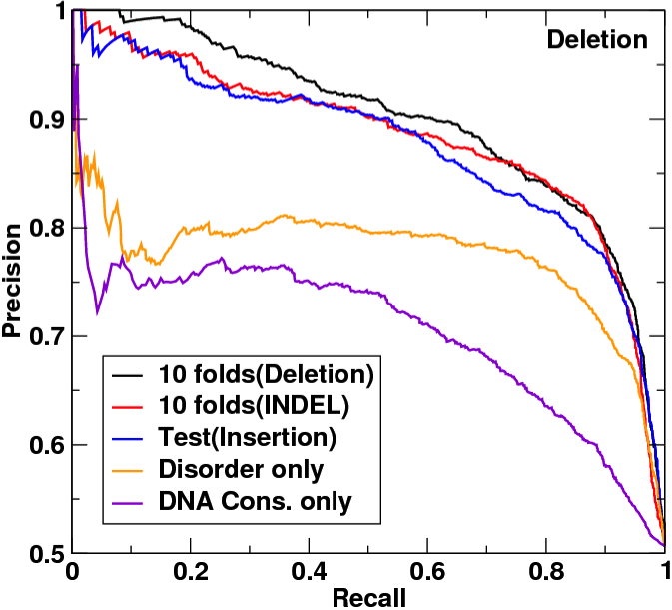
Figure S1 Precision versus recall curve for the microdeletion dataset by ten-fold cross-validation on the deletion set (black), ten-fold cross-validation on both insertions and deletions (Red), independent test by training on the microinsertions (Blue), by disorder feature only (Orange) and by DNA conservation score only (Purple) as labeled.

Figure S2
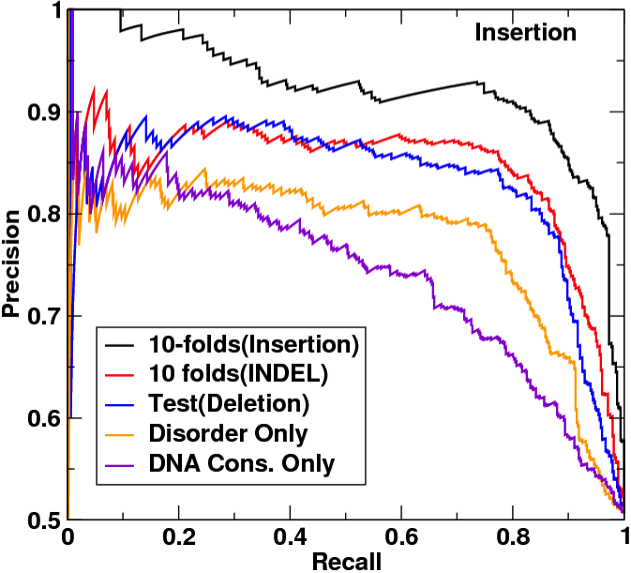
Figure S2 Precision versus recall curve for the microinsertion dataset by ten-fold cross-validation on the insertion set (black), ten-fold cross-validation on both insertions and deletions (Red), independent test by training on microdeletions (Blue), by disorder feature only (Orange) and by DNA conservation score only (Purple) as labeled.

