Supplementary Figures

Figure S1. The fraction of global genomic repeat content plotted for high abundance repeat classes among exemplar genome assemblies representing all major amniote clades.

Figure S2. The fraction of global genomic repeat content plotted for low abundance repeat classes among exemplar genome assemblies representing all major amniote clades.

Figure S3. Stacked histogram of the distribution of sequence divergence values for major classes of genomic repeats in the Western Painted Turtle genome assembly. Y axis values are percentages of the genomic fractions for each class of repeat. X axis values are the ranges of percent sequence divergence based on RepeatMasker annotation.
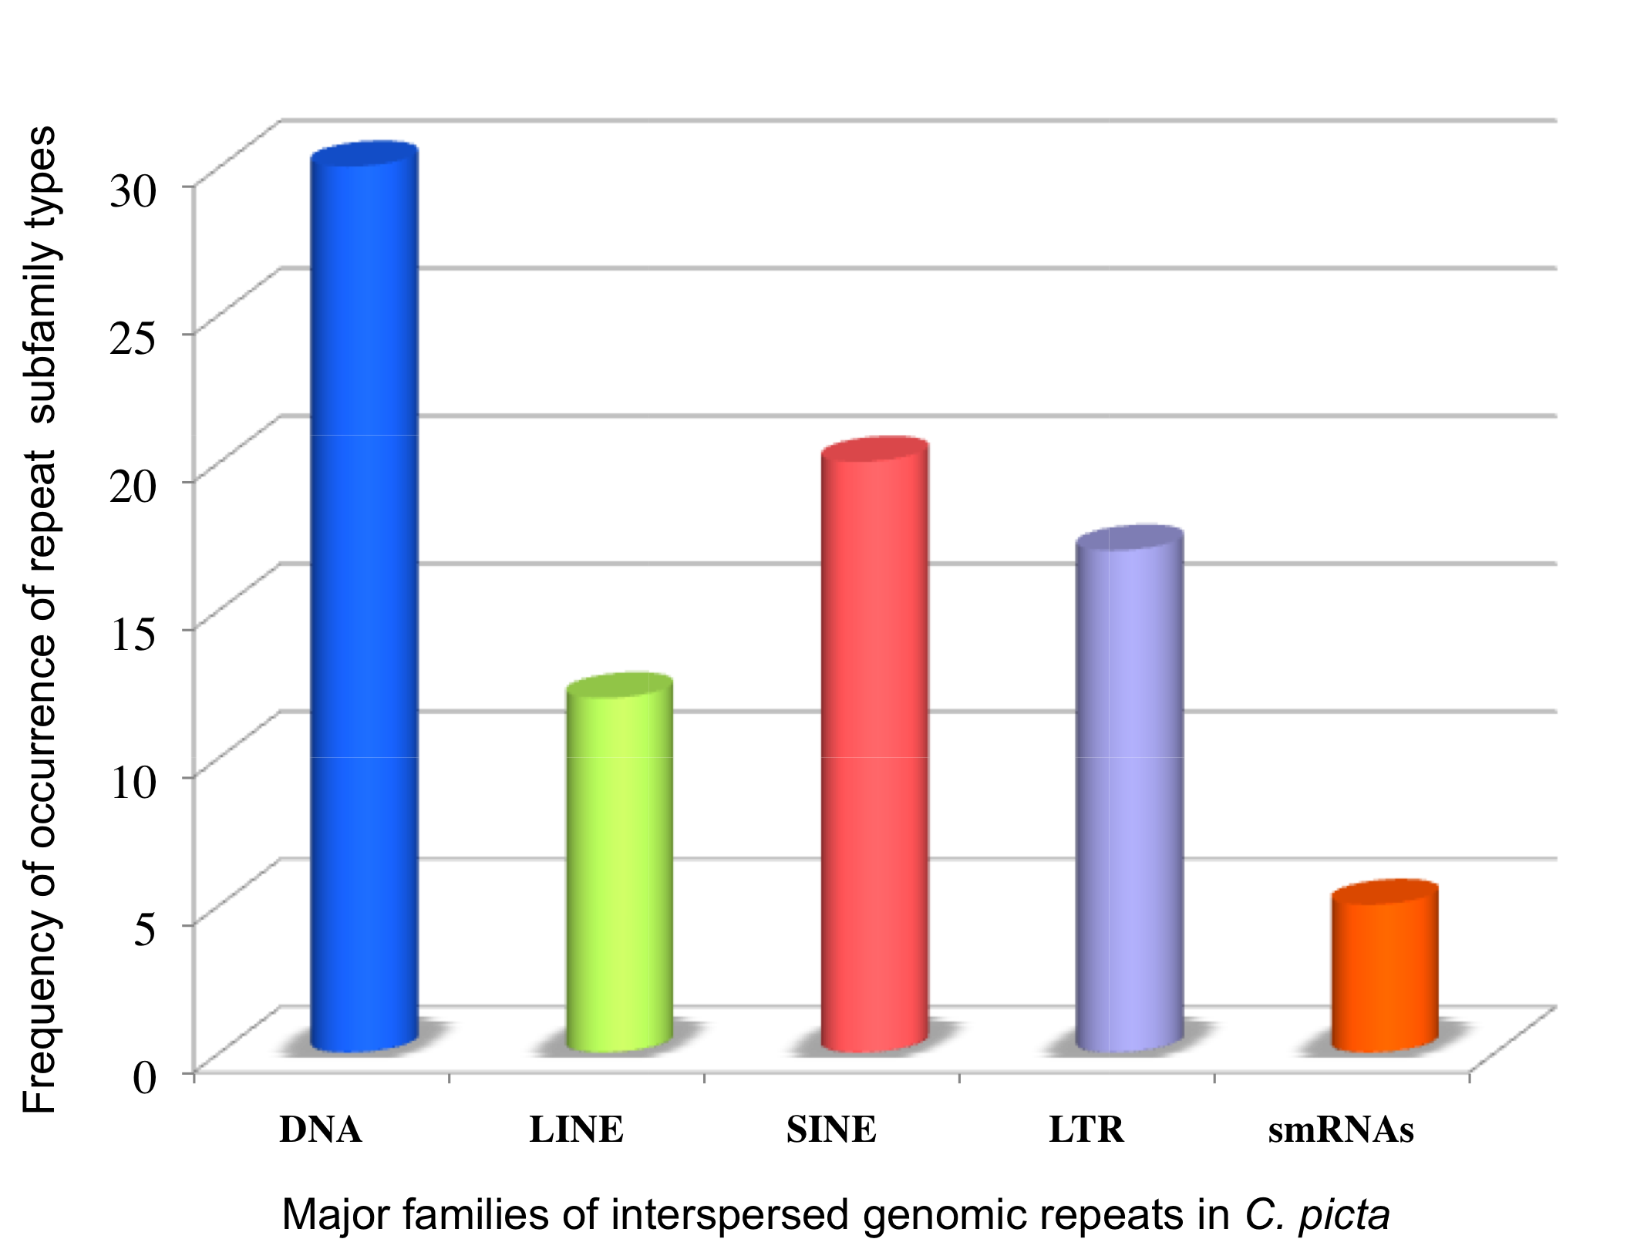

Figure S4. Frequency of occurrence of different C. picta subfamily types within major TE classes, based on RepeatMasker annotation output.

Figure S5. Divergence distributions of TEs in four exemplar amniote genome assemblies: Alligator: Alligator mississipiensis, Anolis: Anolis carolinensis, Zebra Finch: Taeniopygia guttata, Human: Homo sapiens. Y axis values are percentages of the genomic fractions for each class of repeat. X axis values are the ranges of percent sequence divergence based on RepeatMasker annotation.
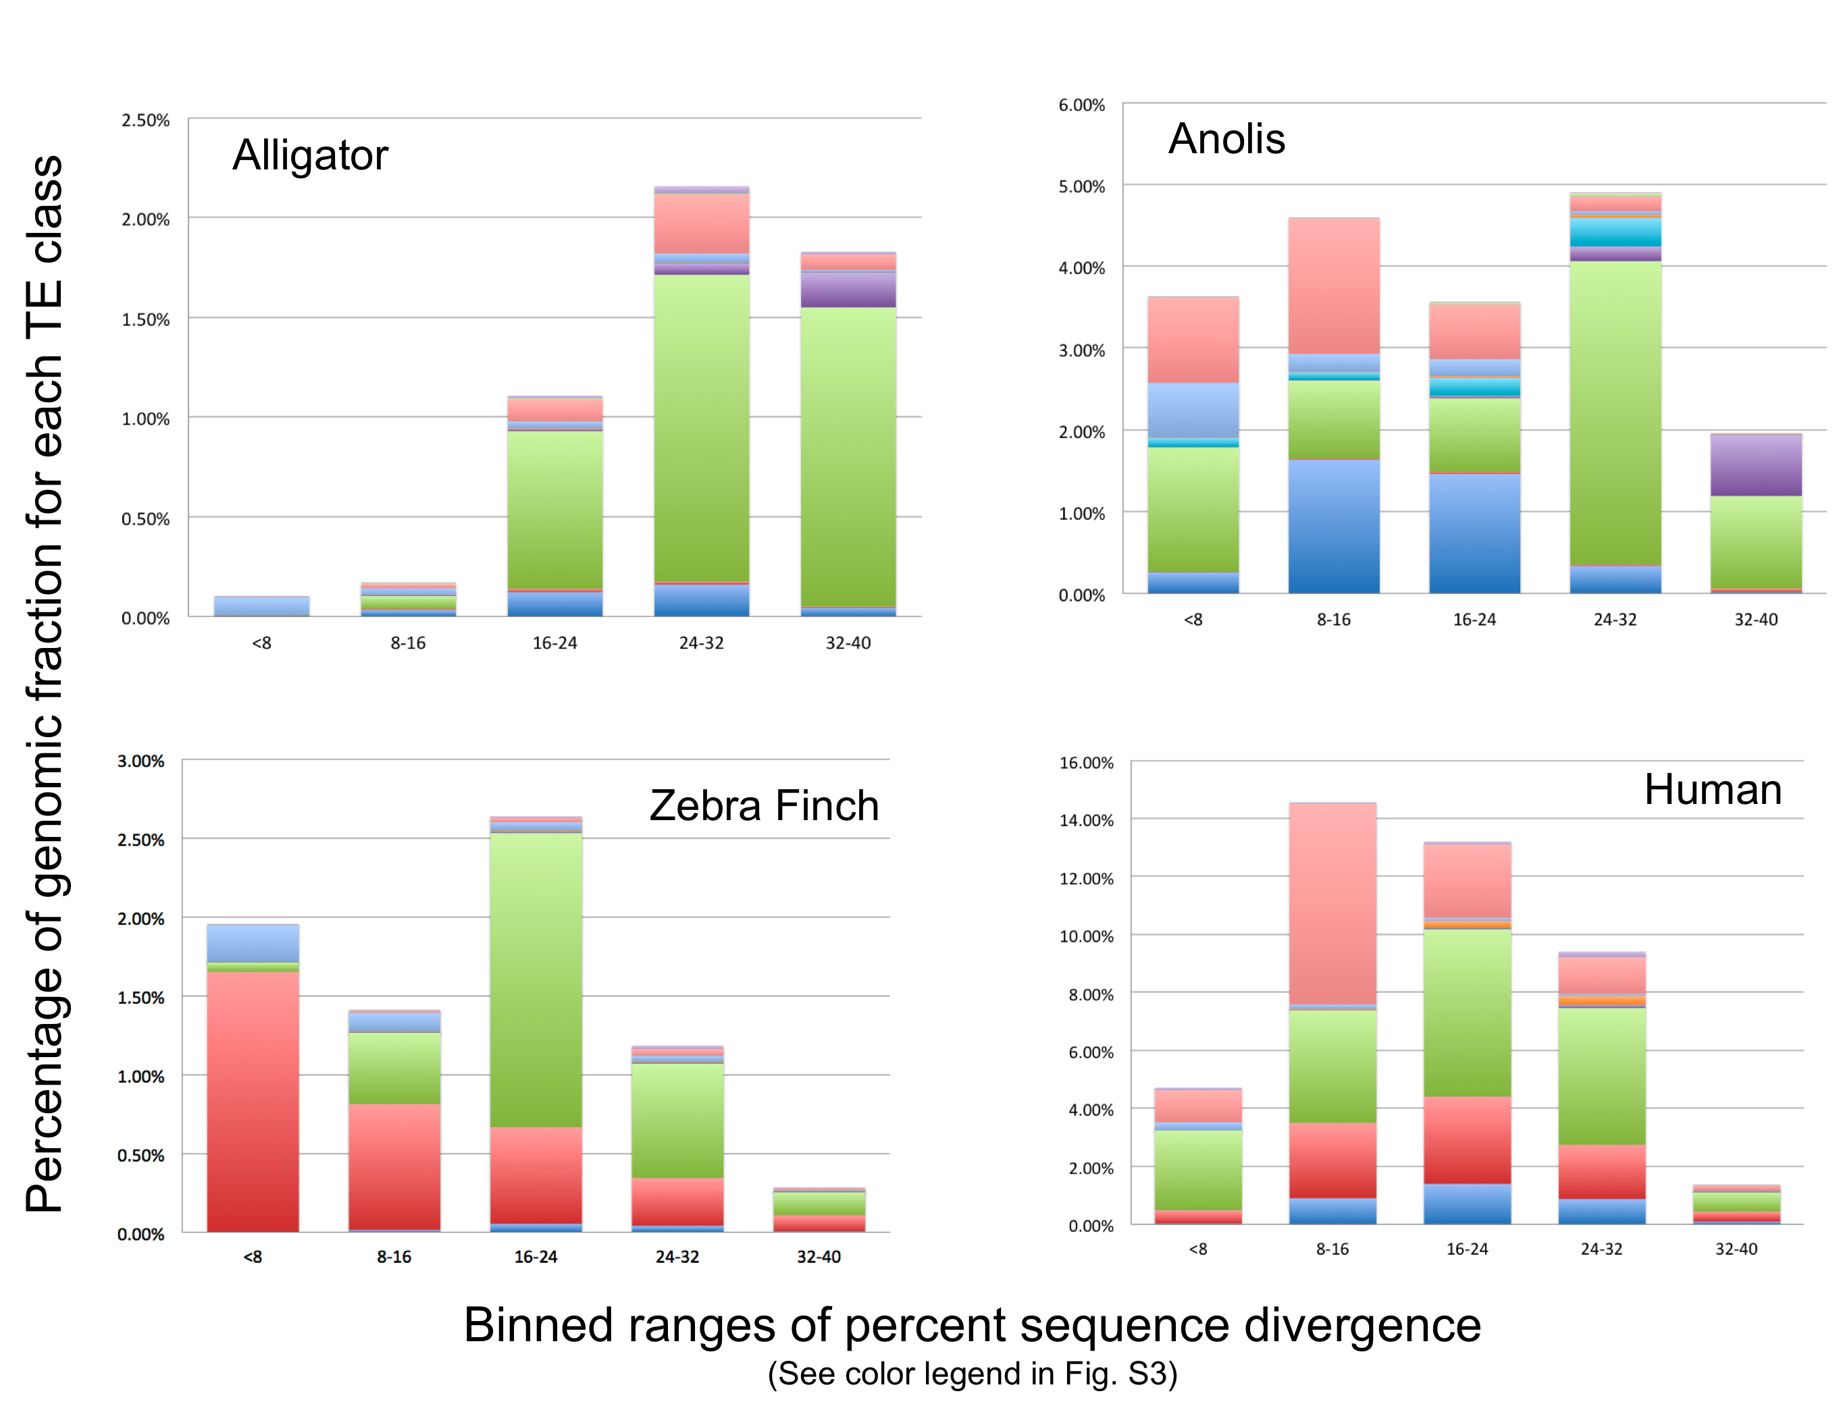
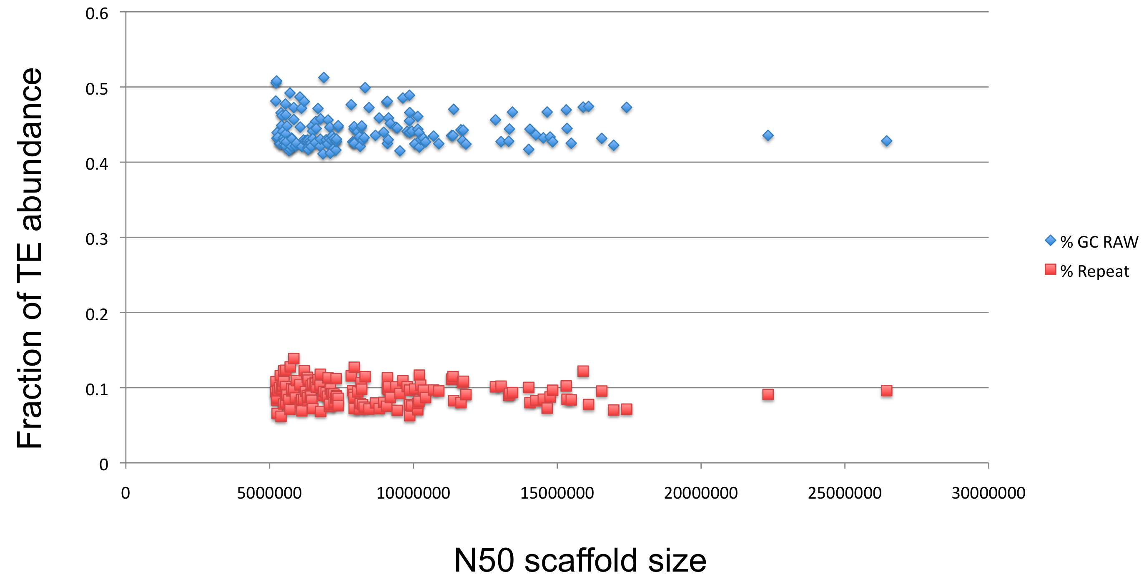

Figure S6. Percentages of TE abundance vs. G+C plotted by N50 scaffold size for the C. picta assembly.
Figure S7. Distributions of GC content in amniote genomes based on 3-kb nonoverlapping windows.

Figure S8. Genic GC (as measured by GC3) exhibits a weak but significant correlation with its flanking GC content (10-kb on each side), a pattern more in line with the lizard genome than with human or chicken. N=11,280 genes.
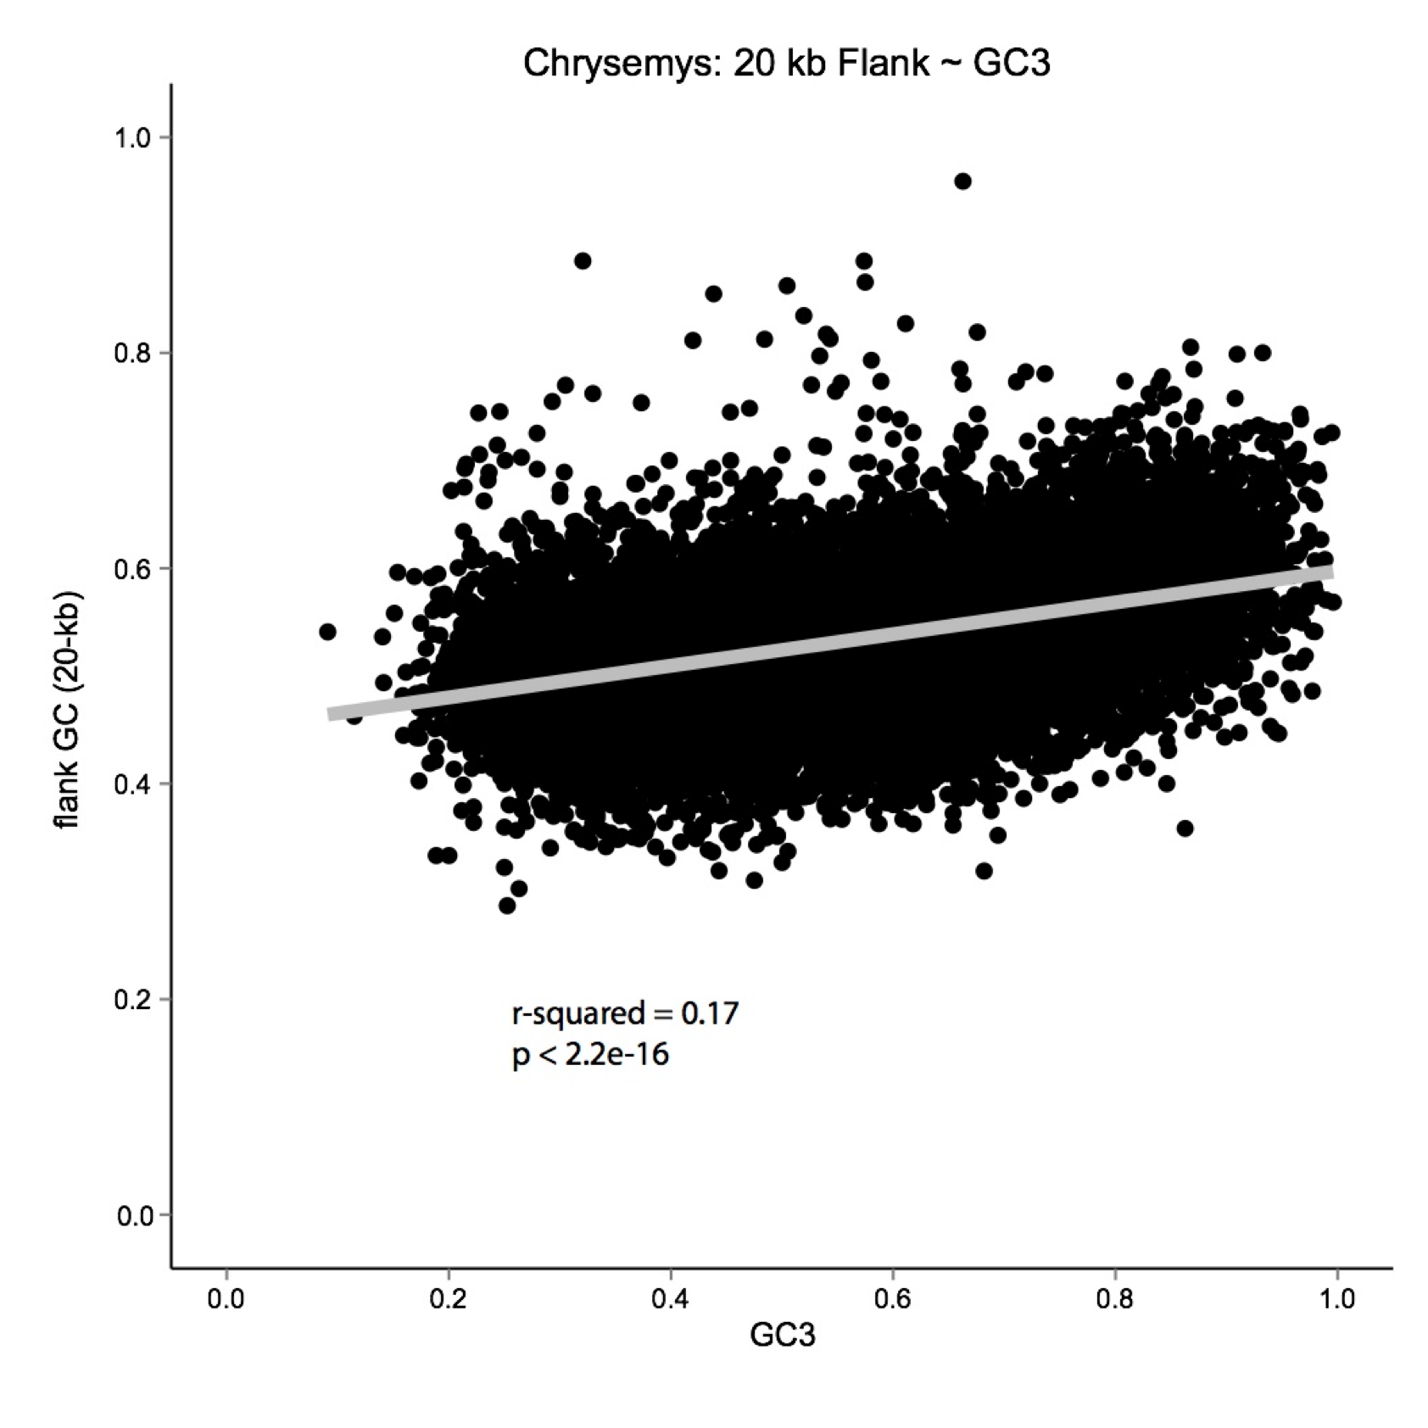

Figure S9. Amniote phylogeny with branch lengths proportional to Di,j (the divergence of GC3 between two nodes of a branch). The current GC3 and the equilibrium GC3* are also shown and demonstrate the expected continued trajectory of GC content evolution.
Figure S10. RNA-Seq read depths across three statistically upregulated genes in eight telencephalon samples. The x-axis shows the loci of the reads aligned using TopHat.
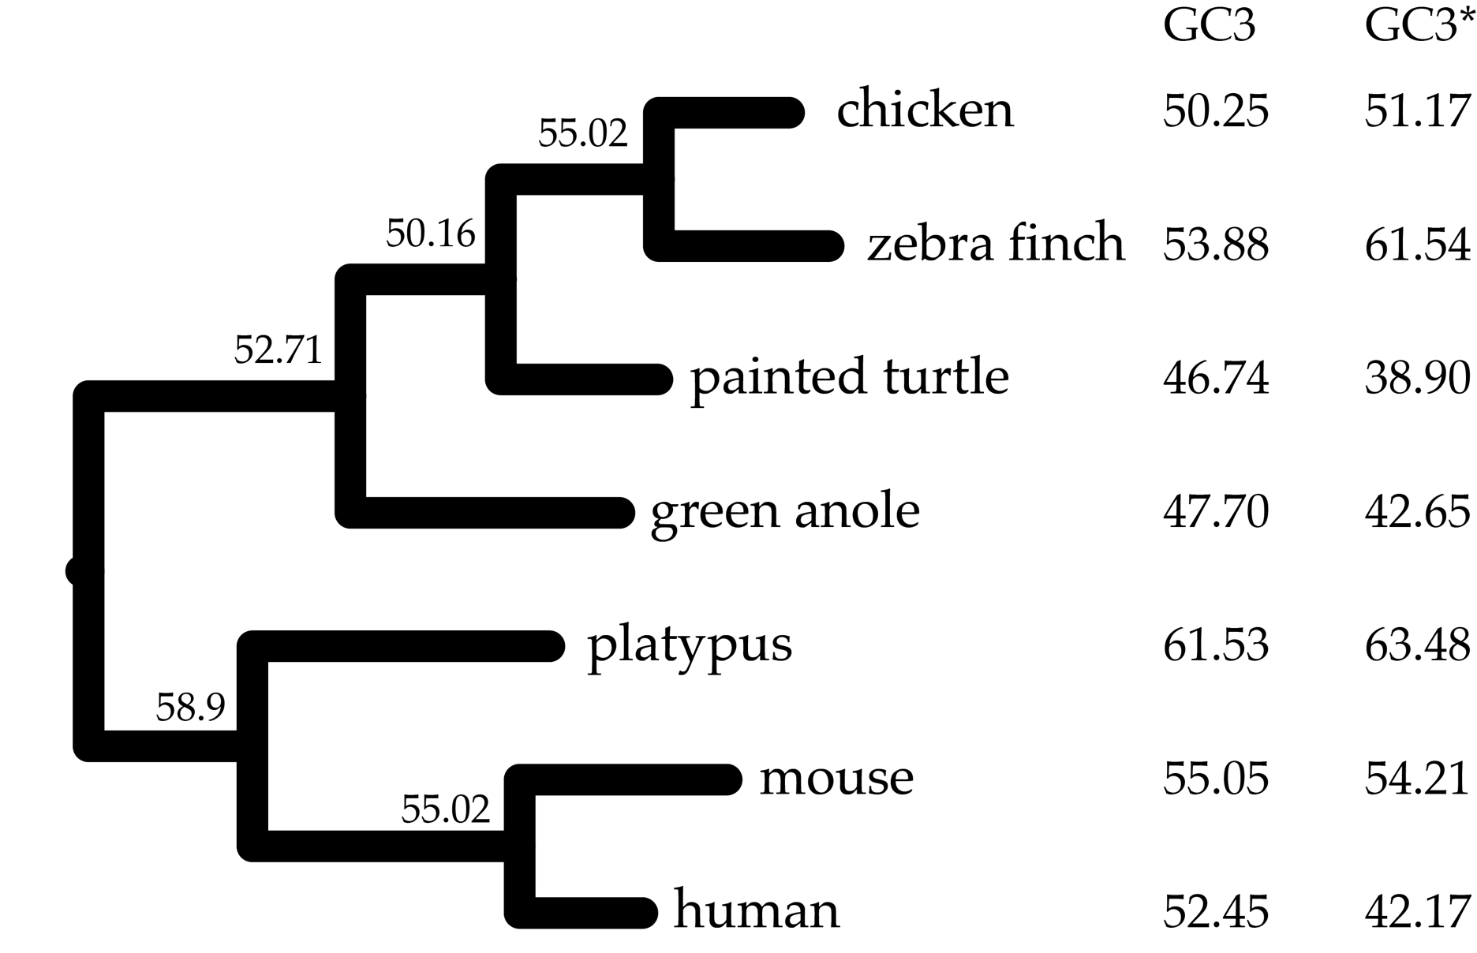
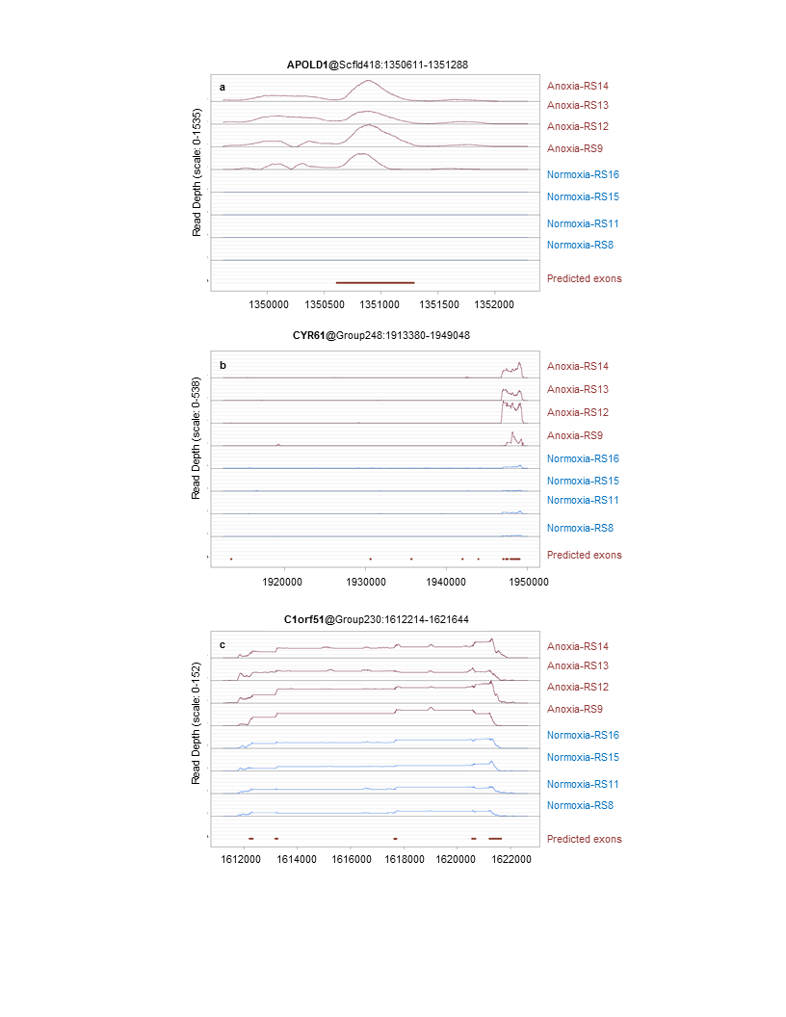

Figure S11. RNA-Seq read depths across three statistically upregulated genes in 8 ventricular samples. The x-axis shows the loci of the reads aligned using TopHat.

Figure S12. RNA-Seq read depths across three statistically downregulated genes in 8 ventricular samples. The x-axis shows the loci of the reads aligned using TopHat.
