Variants in Exons and in Transcription Factors Affect Gene Expression in Trans
Kreimer et al.

Supplementary Data File (Additional file 1)

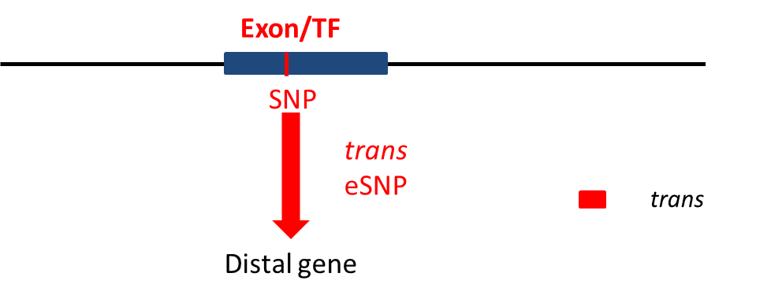
Figure S1: Illustrating the association testing between pairs of SNPs within known regulatory regions and genes: trans regulatory elements appear in red. If the regulatory element has an SNP within the boundaries of an exon or a TF then we check for nominal association (p < 0.05 denoted by a red edge) using linear regression between the minor allele count of the SNP and any gene.

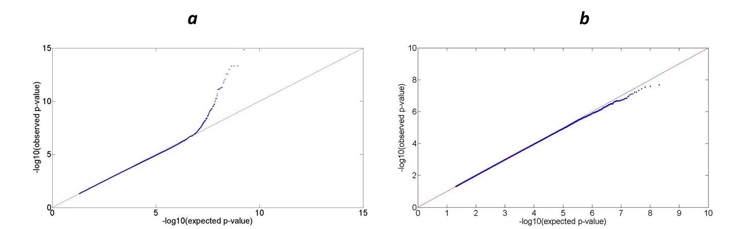

Figure S2: QQ plot for association pairs of SNPs within known regulatory regions and genes. (a) eSNPs in exons and (b) eSNPs in TFs. X-axis denotes -log 10 of the expected p-value. Y-axis denotes -log10 of the observed p-value. The red line denotes expectation by chance (Y=X).
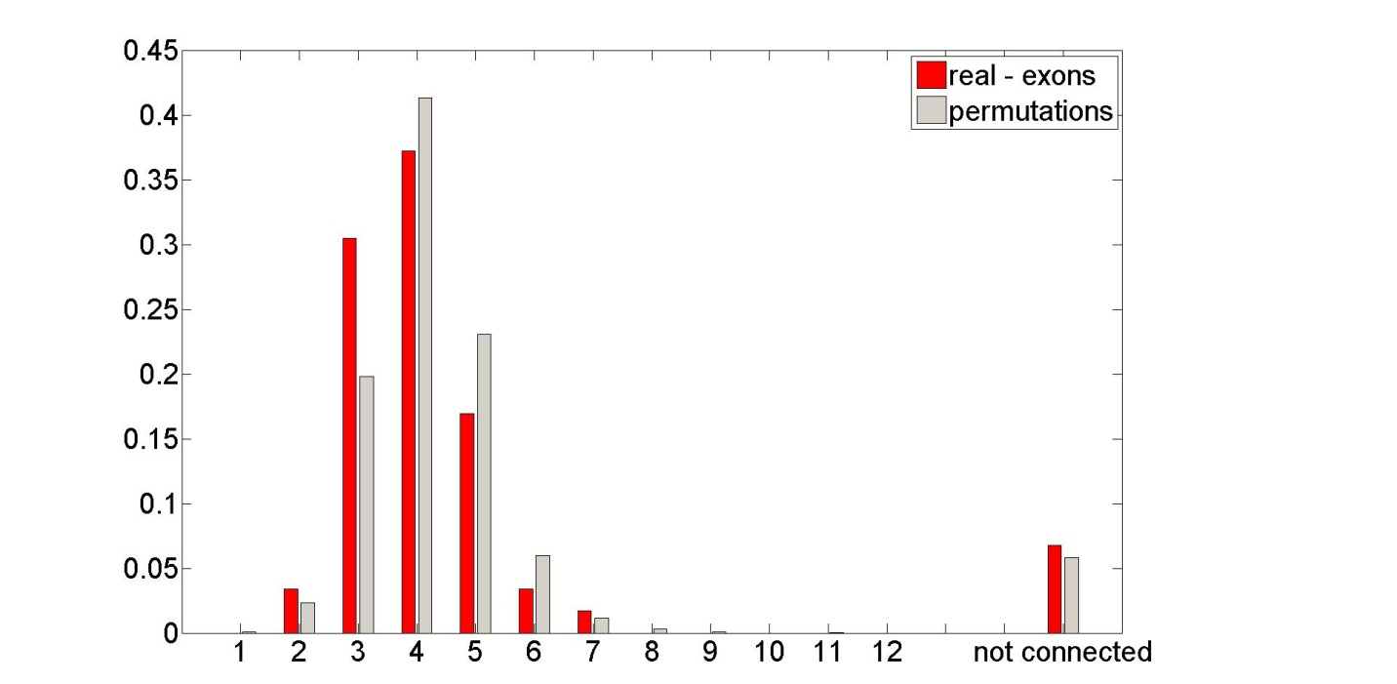
Figure S3: Histogram in percentage for the distances between pairs of exon source and target in real (red) and permuted (grey) data, for p-value=10^{-6.463}.

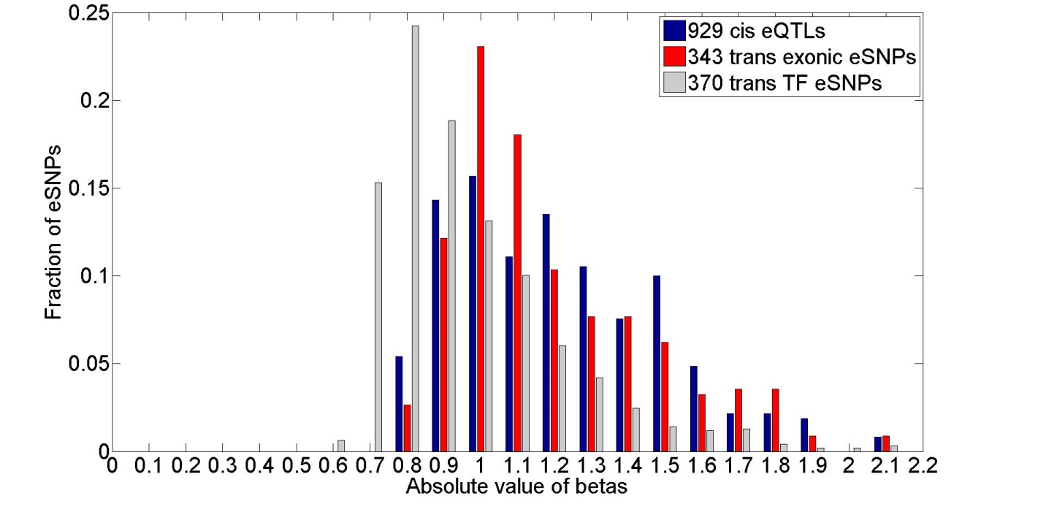

Figure S4: comparing effect sizes (absolute value of betas) between previously published 929 cis eQTLs and 343 and 370 exonic and TF trans eSNPs respectively.

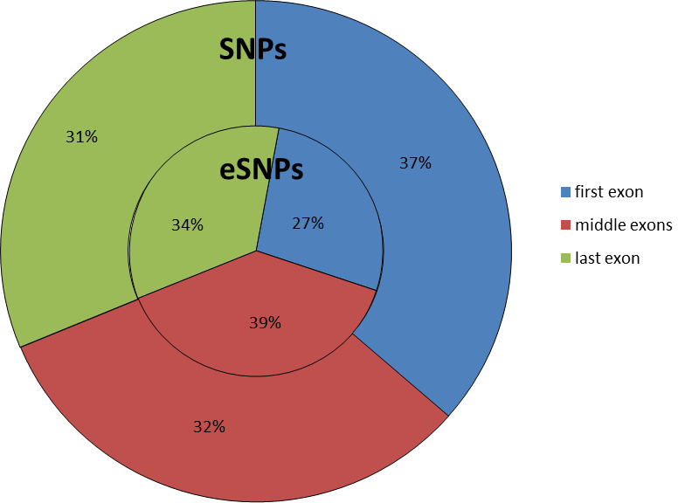
Figure S5: distribution of SNPs and trans eSNPs in exons.

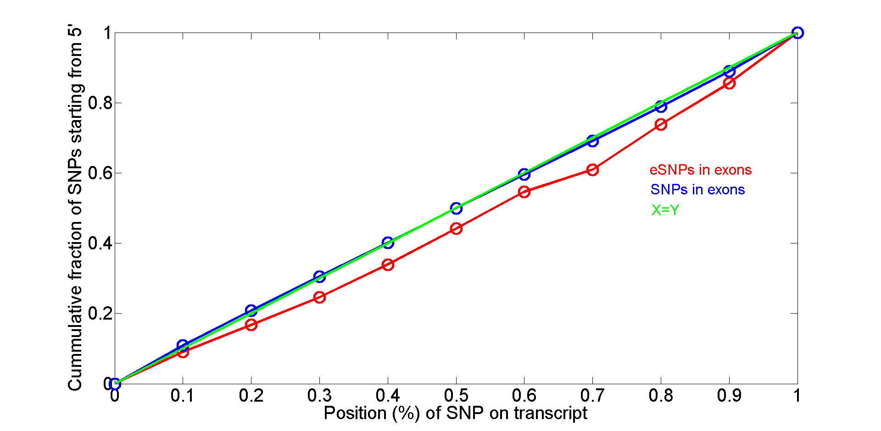

Figure S6: Cumulative fraction of the position of exonic eSNPs (red) and SNPs (blue) on the transcript (Wilcoxon rank sum test p-value between the position of exonic eSNPs and SNPs on transcript < 0.0058).
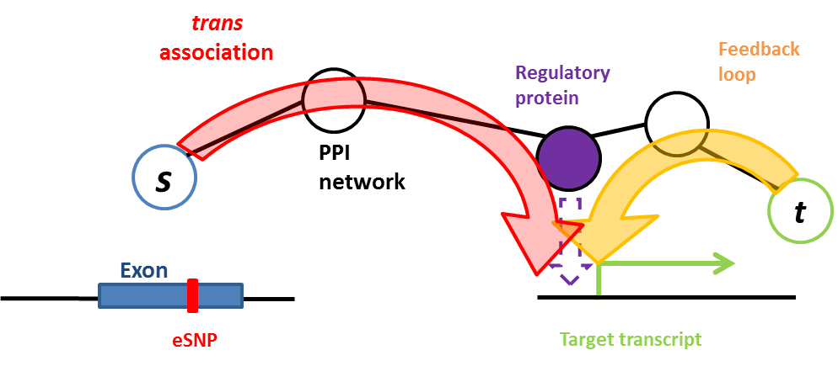

Figure S7: A path of interacting protein pairs (black circles and connectors) along the PPI network, from a source protein (blue) to the target transcript and protein (green), is consistent with concatenation of two pathways: the prefix of the path is consistent with a regulatory pathway (red), leading to some regulatory protein (purple node), that (directly or indirectly) affects expression of the target (purple arrow), thus being observed as a trans-eQTL signal. The suffix of the path may match a self feedback loop in reverse: from the target protein back to the same regulatory protein (orange arrow).

Table S1: Distribution of SNPs between regulatory elements and number of significant associations (p<0.05).

Regulatory region | Number of SNPs | Number of eSNPs associations (p < 0.05)
Exons | 95,957 | 88,267,318
TF | 29,212 | 26,824,165
Table S2: in additional file 2.
Table S3: Distances between real exon source and target and between random pairs.
Distance btw. pairs | Real – 59 pairs | Random – 18,675 pairs
2 | 2 | 431
3 | 18 | 3,701
4 | 22 | 7,723
5 | 10 | 4,308
6 | 2 | 1,118
7 | 1 | 212
28 (not connected) | 4 | 1,092

Table S4: Distribution of distances for source and target that are on the same chromosome for eSNPs in (a) exons (b) TFs.
(a)
Same chr | Distance
19 | 15002266
3 | 178621023
2 | 123847673
2 | 123623265
1 | 172680949
16 | 9843129
16 | 9841673
17 | 37168762
11 | 67193065
17 | 27955406
7 | 83684093
14 | 9357673
11 | 108362267
11 | 108387122
11 | 108386807
5 | 1278322
5 | 1336785
5 | 1367097
5 | 1359523
6 | 1437809
19 | 44903272
1 | 202997844
1 | 202973419
6 | 1468850
6 | 1443680

(b)
Same chr | Distance
2 | 64552602
1 | 204240596
1 | 204239155
1 | 204239711
2 | 36475062
1 | 39690140
1 | 127192199
1 | 127204055
1 | 39318770
1 | 228432802
1 | 35767071

Table S5: in additional file 3.
Table S6: in additional file 4.
Table S7: Units size distribution of TF source and their gene targets (units include only genes that map to an Entrez ID). We include the TF in the module.
Unit size | Number of units
2 | 35
3 | 16
4 | 8
5 | 2
6 | 2
8 | 1
10 | 2
11 | 1
17 | 1

Table S8: TF units sizes, TF source and gene targets (two or more) Entrez IDs.
Unit number | Unit size | TF source | Genes in the unit
1 | 3 | RUNX1 | CLN5, TCL1A
2 | 3 | DMRT1 | EIF3H, GPATCH8
3 | 3 | GTF2F2 | GOLGB1, ATP2C1
4 | 3 | HSF2 | ABCC1, CCDC102A
5 | 3 | NFIX | ORC2, CCDC91
6 | 3 | TCF4 | PNMT, PPHLN1
7 | 3 | TCF12 | 1-Dec, AZI2
8 | 3 | TFDP2 | SEMA6B, EXOC3L4
9 | 3 | MBTPS1 | SOCS2, PPAN
10 | 3 | MTF2 | DNAH17, BTG3
11 | 3 | ATF7IP | UNC13A, RILP
12 | 3 | PHTF2 | PPP1R16B, OTOGL
13 | 3 | TFB2M | ZNHIT1, CAMKK1
14 | 3 | TCF7L1 | KCNQ4, SETDB2
15 | 3 | GABPB2 | PSMC6, ABHD5
16 | 3 | NFXL1 | HIST1H2BB, CHEK2
17 | 4 | ATF3 | NR3C1, SNORD26, INPP5E
18 | 4 | NFYC | RBM5, CACNG4, STARD9
19 | 4 | GTF2A1L | CUL1, RNF24, LAMP3
20 | 4 | CNOT1 | PSMC2, PCGF6, THAP3
21 | 4 | WWTR1 | NFYB, FAM118B, FAM78B
22 | 4 | TRERF1 | ADPRH, DNAJC5, NBPF23
23 | 4 | BACH2 | MYO7A, SNRPD1, SIRT7
24 | 4 | TFAP2D | PLA2G6, C8orf55, TMEM159
25 | 5 | BRF1 | WWC1, GRHL1, DDX54, DDX51
26 | 5 | AKNA | TCFL5, CCT5, SLC25A39, ALG8
27 | 6 | MITF | NEDD9, ARHGAP11A, TMEM51, MAGOHB, MIR589
28 | 6 | TCF7L2 | BOK, TLE4, NOP58, NAT10, TOR3A,
29 | 8 | TEAD1 | ST3GAL3, DYNLT1, DBNL, GCNT4, PHF7, HNRNPA1L2, BTBD19
30 | 10 | STAT4 | ACO1, GNRHR, GYPC, PTRH2, MBOAT7, OBFC1, CORO6, UHMK1, PPTC7
31 | 10 | TCERG1L | SLC25A20, GATA2, ZNF3, LRPPRC, ABCA12, PCYOX1L, LBH, C16orf74, MIR1909
32 | 11 | MYT1L | APBB2, CDC25A, COL1A2, MMP7, SH3BP2, CWC27, NCAPH2, HNRPLL, ZMAT2, RPS26P6
33 | 17 | CAMTA1 | NFKBIE, QDPR, SKP1, CDK2AP1, TAOK2, GNB5, NECAP1, TMBIM4, PTRH2, VASH2, TMEM121, ZFP91, NHLRC2, H3F3C, C1orf190, SNORA81

Table S9: in additional file 5.
Table S10: in additional file 6.
Table S11: Exon paths lengths and genes in path from source to target.
Path number | Path length | Genes in path (from source to target)
1 | 3 | HLA-C, LILRB1, HLA-A
2 | 3 | HLA-C, LILRB1, HLA-G
3 | 4 | CYBA, 4687, CSNK2A1, HNRNPC
4 | 4 | DVL3, PPP2CA, TP53, DAXX
5 | 4 | GATA3, ETS1, NR3C1, COPS6
6 | 4 | HLA-DQB1, CD4, PIK3R1, AKT1
7 | 4 | PITX2, KAT5, CDK1, AMPH
8 | 4 | PTPRA, KCNA2, DLG1, PAX6
9 | 4 | RPS14, SMAD2, TSC2, MAPKAPK2
10 | 4 | TPI1, CFL1, ATXN1, KIAA2026
11 | 4 | SIP1, SNRPD2, EGFR, MET
12 | 4 | MAP4K4, ITGB1, CRKL, EPOR
13 | 4 | ERC1, YWHAG, LUC7L2, UNC119
14 | 4 | CLASP2, FEZ1, PRKCZ, GSK3A
15 | 4 | GGA3, TSG101, NR3C1, SUMO4
16 | 4 | TES, ACTN1, GRIN2A, PTPN4
17 | 4 | PSMC3IP, NR3C1, PRKDC, EIF2S2
18 | 4 | PIDD, EFEMP2, TP53, PLK3
19 | 4 | MIF4GD, UBQLN4, IMPDH2, SUMO4
20 | 4 | STK11IP, SMAD4, MAPK13, MAPKAPK3
21 | 5 | BLK, BCL2, CDK2, PRKAR1A, C2orf88
22 | 5 | DYNC1H1, YWHAG, ARAF, TH1L, FRMD5
23 | 5 | STX2, STXBP1, PRKCA, TIAM1, MAPK8IP1
24 | 5 | RBPJ, HMGB1, C14orf1, NSF, NAPG
25 | 5 | MUC4, ERBB2, PTPN18, GAB1, MAPK4
26 | 5 | MYO5A, DYNLL1, MTA1, CCNH, CDK2
27 | 5 | PIN1, CHPF, SMAD9, LNPEP, TNKS2
28 | 5 | RAB5A, TSC2, SMAD2, HDAC1, DNMT3B
29 | 5 | RAC2, CUL1, SMAD3, GGA1, M6PR
30 | 5 | ENC1, TGFBR1, FBXO34, SKP1, FBXL8
31 | 5 | MADD, PIDD, CRADD, LRIF1, RNF10
32 | 5 | NRXN1, SYT1, GOLM1, NIPSNAP3A, EPHX2
33 | 5 | PRDX6, RARA, COPS2, COPS6, WIPI2
34 | 5 | CAMKK2, CALM1, CAMK2G, GRIN2B, AP4M1
35 | 5 | MAST3, PTEN, CSNK2A2, SMURF1, NAA16
36 | 5 | PPIL2, HSP90AA1, WASL, SH3GL3, C11orf68
37 | 5 | PTRH2, AES, AR, CDC25A, PIM1
38 | 5 | DNAJB11, PTN, BCCIP, RAD51, DMC1
39 | 5 | KLHDC5, COIL, SMN1, BCL2, PPP3CA
40 | 5 | HIF3A, HIF1A, CREBBP, MED25, MED15
41 | 5 | COL18A1, KDR, SRC, PRKACA, TPH1
42 | 5 | IQCG, BAG6, SMN1, KPNB1, UBR5
43 | 6 | CSF3, CSF3R, GRB2, EPHB6, SAT1, SAT2
44 | 6 | MUC2, PLEKHM1, EIF2S2, CSNK2A1, CDK1, NES
45 | 6 | CLIP2, DYNLL1, TP53BP1, EP300, MYBL2, ZNF622
46 | 6 | PRPF4B, YWHAG, PRKCA, ITGB2, HP, C1RL
47 | 6 | BRE, GFI1B, PSMA3, CDKN1A, RAB1A, ZNF593
48 | 6 | EDEM1, CANX, SMURF2, NEK6, CDK7, GTF2H2
49 | 6 | MAML1, CREBBP, EWSR1, RALYL, ZNF408, ZNF330
50 | 6 | SEC23B, SEC24D, LMO4, MERTK, BMPR2, PDZRN3
51 | 6 | CECR2, UXT, AR, RB1, TRIM27, FXYD6
52 | 6 | FBXO30, SMAD1, MAPK1, NEK2, NDC80, SPC25
53 | 7 | EIF4EBP2, EIF4E, PML, RELA, BRCA1, PSAP, CELSR1
54 | 7 | TNKS1BP1, TNKS, FNBP1, CDC42, WAS, CIB1, IFI6,
55 | 8 | IRAK4, TRAF6, TRAF2, TCEA2, CENPT, PPCDC, DBI, TSPO

Table S12: in additional file 7.
Table S13: in additional file 8.

