(a)

Bradi2g00320.1 TATCTGTCTTTCGGATCT↓TCAGATGAACAGTTGCTAGA putative importin-α
Bradi2g47100.3 GTGTTTATTGTTGTAGGT↓TCAGATCATAGTCCAATCTG serine/threonine phosphatase
Bradi4g29680.1 TATATGTGTATATATTAT↓TCAGATCTGGGGACCTTAGT annexin-like
BRADI3G03112.1 GACCGAGAAACTTTATAT↓TCAGATGGAACTGTGCGACC WEE1-like protein kinase
Bradi1g43220.1 GCCCAAATAAGAAAACCT↓TCAGACTGACTCAACGCTGC constans-like
Bradi3g02870.1 GTCATGAACGTATTATTT↓TCAGACTAATGTTGTGAGAT premRNA splicing factor
Bradi1g31450.1 TGATATCTGTATCACCGT↓TCAGACGGTCTTGACCGTAC glutaredoxin-like
Bradi3g29750.1 GTTTTTTGCTGCATTCTT↓TCAGACCATACTGGCATTGT serine/threonine kinase
Bradi3g51650.1 CATCGGAACCGACAATTG↓TCAGACAACTTGGTTTCGAT zinc finger (CCCH domain) protein
Bradi5g18180.1 CTCATTGGGATTGGAGGG↓TCAGACCATCTACCAGAGAA STE kinases
Bradi1g38010.1 TCAGTTTTTGGAACTTTG↓TCAGACGATGAGATATACTT ribosomal protein
Bradi2g08890.1 TTCCTAGTTTCTTGACTG↓TCAGACTGCTTTCGGCTTTT shaggy-related protein kinase

(b)
Bradi4g29680
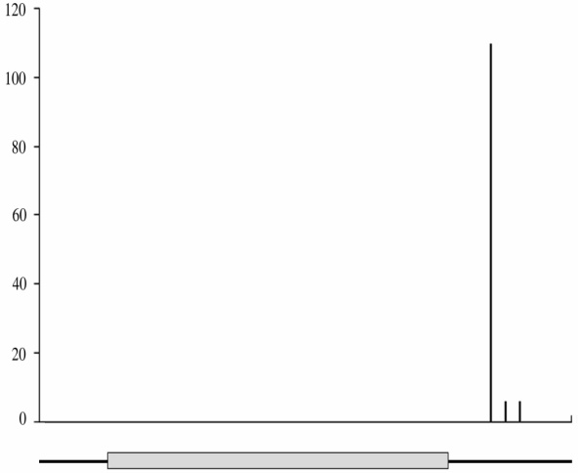
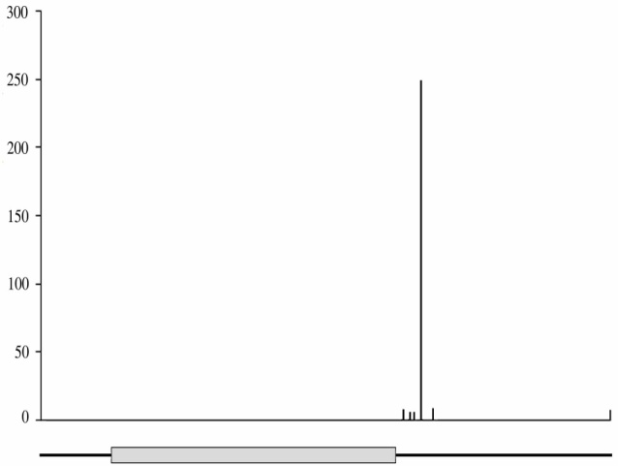
Bradi1g31450
DL2000 PCR product
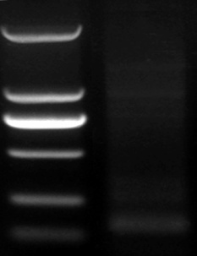
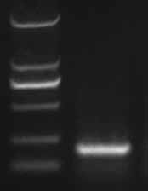
Number of reads

Number of reads
DL2000 PCR product

250 bp
100 bp
250 bp
100 bp

1/20
ATCACCGTTCAGACGGTC
19/20
TATATTATTCAGATCTG
20/20

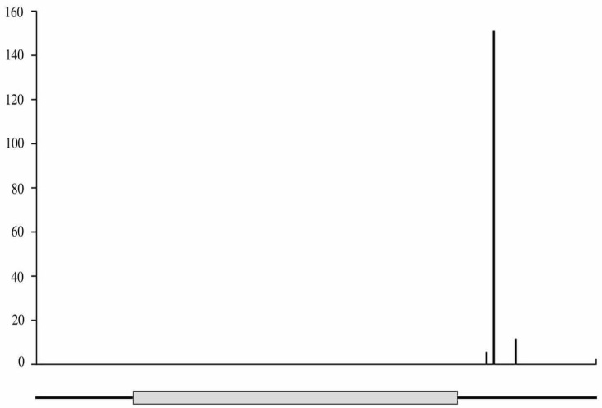
Bradi2g47100

DL2000 PCR product
Number of reads

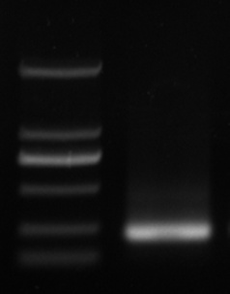

1/20
1/20
TTGTTGTAGGTTCAGATCATAGTC
250 bp
100 bp
18/20

