(a)
Decapped mRNA
(with 5’ monophosphate )
mRNA with 5’ cap structure

No PCR product formed
Gene Specific primer
Anchor
primer
Reverse transcription
and PCR amplification
Splint
Anchor
OH
m7Gppp
An
ORF
Splint
Anchor
ORF
An

Gene specific primer
Anchor primer

Reverse transcription
and PCR amplification

PCR products

(b)
- TAP + TAP
- TAP + TAP
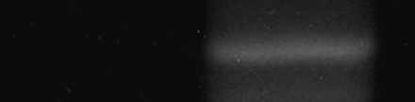

Bradi2g35600
Bradi2g24790


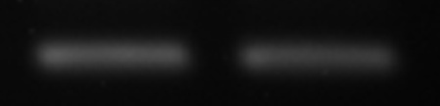
UBQ10

UBQ10

- TAP + TAP
- TAP + TAP



Bradi4g28400

Bradi3g08917

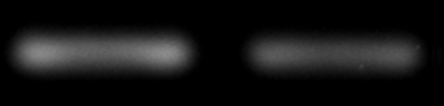
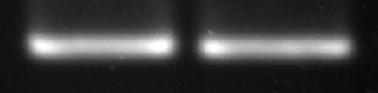
UBQ10
UBQ10

