(a)
Gene specific primer
Reverse transcription
and PCR amplification
Anchor primer
oligo(dT)
anchor
p(dT)_{12–18}
mRNA
AAAAAAAAAAAAAAAAAAA
ORF
PCR products

(b)
W C 50 bp ladder
50 bp ladder W C
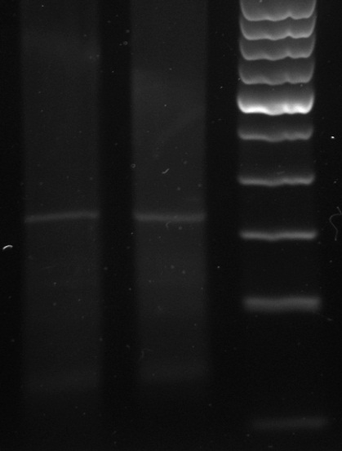
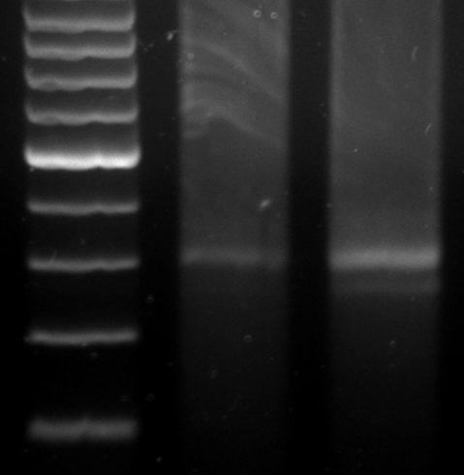

300 bp
250 bp

200 bp

150 bp

100 bp

50 bp
300 bp
250 bp

200 bp

150 bp

100 bp

50bp

Bradi2g24790
Bradi2g35600

W C 50 bp ladder
50 bp ladder W C
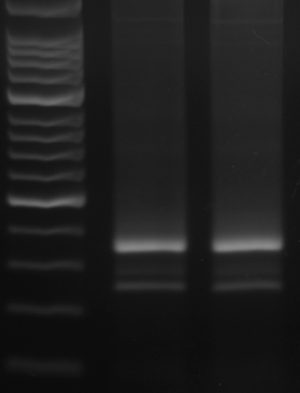
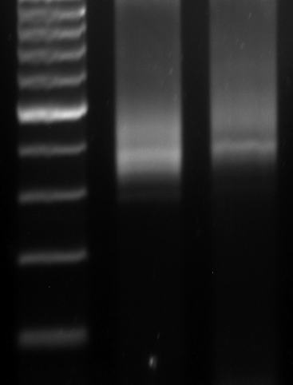

300 bp
250 bp

200 bp

150 bp

100 bp

50bp

300 bp
250 bp
200 bp

150 bp

100 bp

50bp

Bradi4g28400
Bradi1g56580

