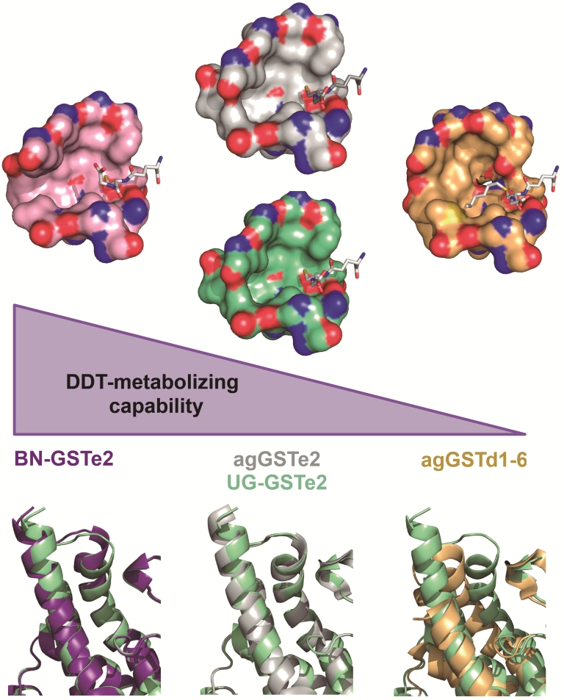
Additional file 12: Figure S7. Comparative analysis of the H-site structure of different GSTe2 alleles and agGSTd1-6. The size and shape of the site are key determinants of DDT metabolism capacity. (Top) The molecular surface representations of those residues constituting the H-site of Uganda-GSTe2 (green), Benin-GSTe2 (purple), agGSTe2 (white) and agGSTd1-6 (yellow). Oxygen and nitrogen atoms at the surface are depicted in red and blue, respectively. (Bottom) Overlays of the structures of Uganda-GSTe2 (green) with Benin-GSTe2 (purple), agGSTe2 (white) and agGSTd1-6 (yellow) showing that most differences are in the secondary structural elements related to the H-site.

