Supplementary Information

Fimasartan Reduces Neointimal Formation and Inflammation after Carotid Arterial Injury in Apolipoprotein E Knockout Mice

Short Title: Effects of Fimasartan after Carotid Arterial Injury

Jong-Ho Kim¹, I-Rang Lim¹, Hyung Joon Joo¹, Chi-Yeon Park¹, Seung-Cheol Choi¹, Han Saem Jeong¹, Soon Jun Hong^{1*}

¹Department of Cardiology, Cardiovascular Center, Korea University College of Medicine, Seoul 02841, Republic of Korea

Contents:
Supplementary Table (Table S1)
Supplementary Figure and Figure Legend (Figure S1~2)

Supplementary Table

 | Group I | Group II | Group III | Group IV | p-value
Total cholesterol  (mg/dL) | 132.64±11.59 | 135.65±19.82 | 147.48±10.72 | 134.63±1025 | 0.089
LDL/VLDL cholesterol (mg/dL) | 89.34±17.44 | 65.07±17.51 | 94.80±13.92 | 83.56±10.64 | 0.053
HDL cholesterol  (mg/dL) | 47.60±14.25 | 51.81±13.07 | 43.95±9.36 | 38.20±9.08 | 0.078
Triglycerides  (μg/dL) | 84.58±11.12 | 76.63±14.27 | 87.53±15.18 | 83.55±7.17 | 0.410

Table S1. In vitro T cell proliferation assay using CD3⁺ T cells from spleens of ApoE KO mice. (A) Representative pictures of flow cytometry 5 days after treatment without or with fimasartan to CD3⁺ T cells. (B) Quantification by measuring CFDA SE signal. Values are presented as the mean ± SD. *p < 0.05.

Supplementary Figure and Figure Legend

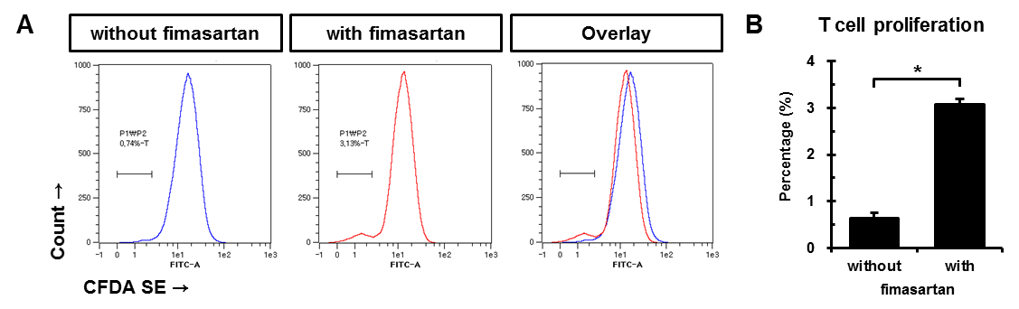
Figure S1. In vitro T cell proliferation assay using CD3+ T cells from spleens of ApoE KO mice. (A) Representative pictures of flow cytometry after 5 days of treatment without or with fimasartan to CD3⁺ T cells. (B) Quantification by measuring CFDA SE signal. Values are presented as the mean ± SD. *p < 0.05.

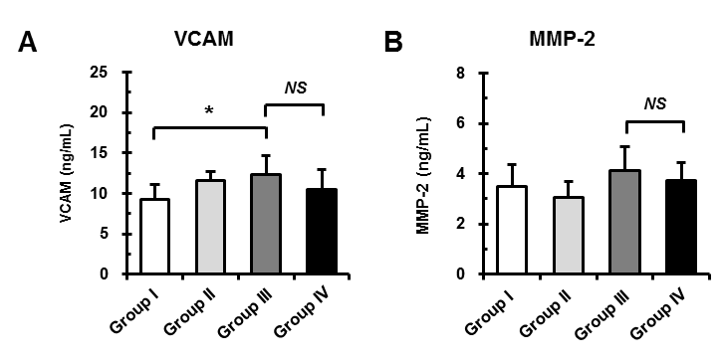
Figure S2. Effects of fimasartan on inflammatory cytokines/chemokine expression after CA injury. Plasma levels of VCAM (A) and MMP-2 (B) in peripheral blood. All experimental data are from n = 12 of ApoE KO mice in each group. Values are presented as the mean ± SD. *p < 0.05. NS, not significant.

