Table S1. Clinicopathological characteristics of CRC patients
Characteristics | Training cohort (n=432) | Validation cohort (n=547)
Sex, n
Male | 235 | 301
Female | 197 | 246
Age, y
Median | 66 | 68
Range | 31 to 89 | 22 to 97
Stage, n
Ⅰ | 89 | 31
Ⅱ | 164 | 255
Ⅲ | 130 | 202
Ⅳ | 49 | 59

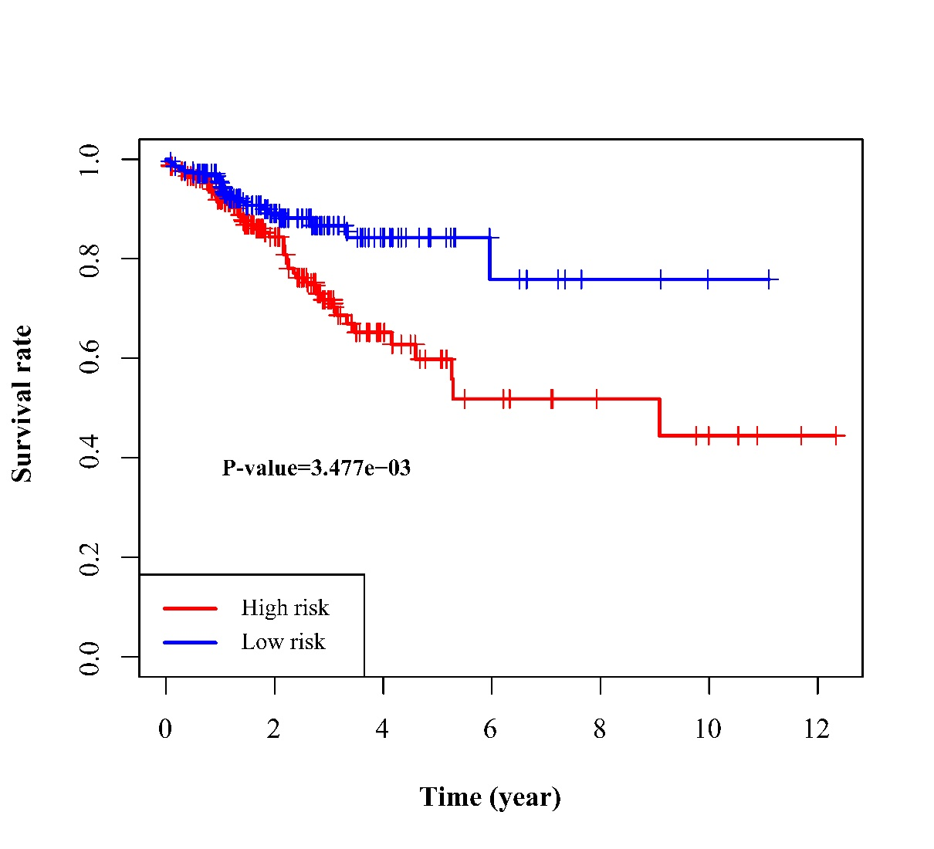
Figure S1. Survival curve of RFS in training cohort.
Red line depicted the survival of high-risk patients and blue line for low-risk patients.

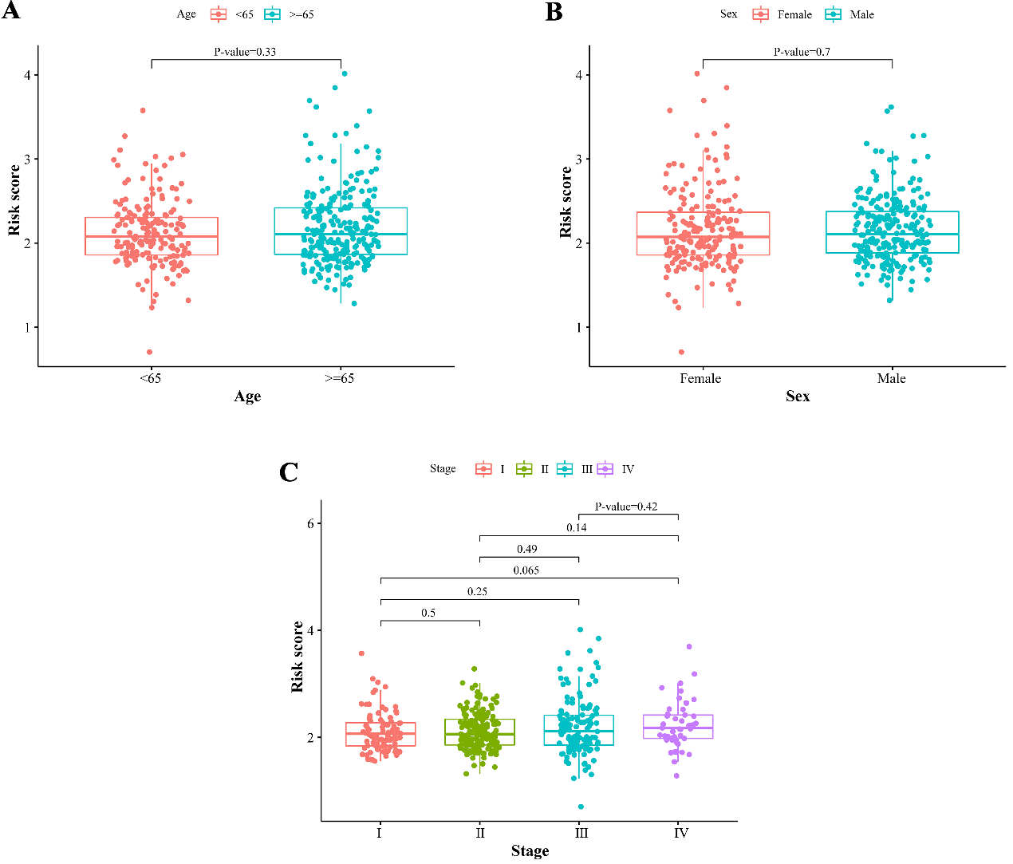
Figure S2. Correlation between the risk score in the signature and clinical variables.
(A–C) represent age, sex, TNM stage respectively.

