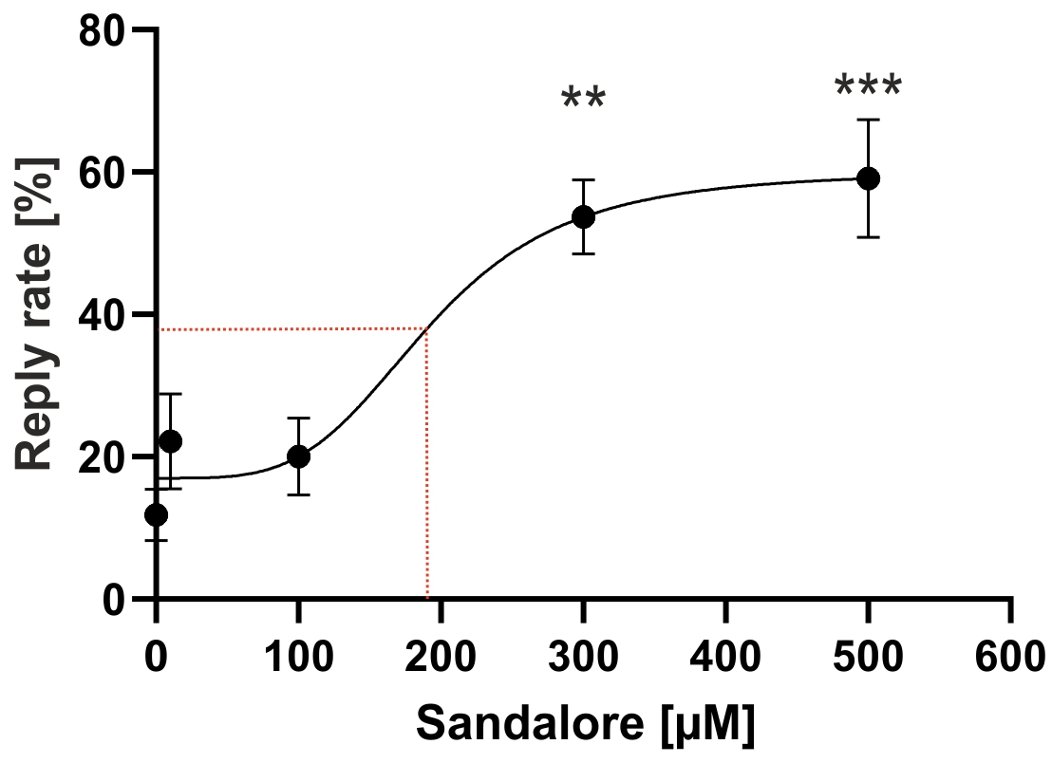
Figure S1. Sandalore increases the intracellular calcium concentration of human primary alveolar macrophages in a dose-dependent manner. The dose-response curve was fitted using Hill 3 calculation. The dotted line represents the EC₅₀ value of 190 µM. Data significance was calculated by Friedman test with post hoc" Two-stage-up method of Benjamini, Krieger, and Yekutieli" referring to the solvent control. The mean values ± SEM are shown (n=9 of three donors), **p≤0.01, and ***p≤0.001.

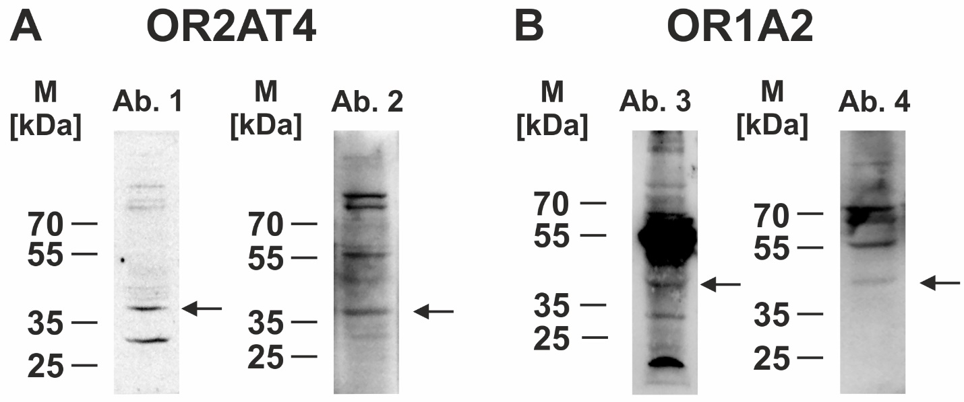
Figure S2. Comparison of custom-made and commercially available antibodies against OR2AT4 and OR1A2. Proteins of AM were prepared as given in the methods section. Custom-made affinity purified rabbit IgG polyclonal antibody (Ab.) against OR2AT4 or OR1A2 (Eurogentec; Ab 1 and 3) were compared with corresponding commercially available antibodies (Thermo Fisher Scientific, Ab. 2 and 4). Arrows indicate the OR monomers.

Table S1: Individual donor characteristics. Sex, age, diagnosed lung disease(s), smoking status, and the experimental use of the corresponding sample are listed. Non-pulmonary diseases were not considered. The severity of chronic obstructive pulmonary disease (COPD) was reported according to Standard level, I-IV. Calcium-Imaging (Ca-Img), Enzyme-linked Immunosorbent Assay (Elisa), Immunocytochemistry (ICC), non-small cell lung cancer (NSCLC), Polymerase chain reaction (PCR), Phagocytosis Assay (Phagocytosis), Western blot (WB).
Patient number | Sex | Age | Diagnosed Lung Diseases | Smoking status | Experiment used for
1 | Female | 63 | Severe asthma | Ex-Smoker | Ca-Img
2 | Male | 61 | COPD Gold IV | Active smoker | Ca-Img
3 | Female | 71 | Pulmonary space-occupying lesions | Ex-Smoker | PCR
4 | Male | 80 | COPD Gold II | Active smoker | Ca-Img
5 | Male | 70 | NSCLC, COPD Gold II | Active smoker | Ca-Img
6 | Male | 82 | Silicosis | Active smoker | Ca-Img
7 | Male | 44 | COPD Gold II | Active smoker | Ca-Img
8 | Male | 42 | Sarcoidosis | Ex-Smoker | PCR
9 | Male | 62 | Sarcoidosis | Ex-Smoker | Ca-Img
10 | Male | 69 | NSCLC | Active smoker | Ca-Img
11 | Female | 59 | Asthma-COPD-Overlap Syndrom | Active smoker | Ca-Img
12 | Male | 68 | COPD Gold III | Active smoker | WB
13 | Male | 89 | COPD Gold I, Silicosis | Active smoker | Dose response curve
14 | Male | 77 | COPD Gold III | Active smoker | WB
15 | Female | 80 | None | Never smoker | Dose response curve
16 | Male | 72 | Chronic bronchitis | Ex-Smoker | ICC
17 | Male | 54 | None | Active smoker | Dose response curve
18 | Male | 84 | Lung nodule, COPD Gold III | Unknown | Ca-Img, ICC
19 | Female | 57 | Interstitial Lung Disease | Active smoker | Ca-Img
20 | Male | 79 | COPD Gold III | Active smoker | Ca-Img
21 | Female | 85 | None | Active smoker | Ca-Img, ICC
22 | Male | 60 | Alveolitis | Ex-Smoker | Phagocytosis
23 | Male | 72 | COPD Gold III | Active smoker | Ca-Img
24 | Male | 77 | COPD Gold III, Sarcoidosis | Ex-Smoker | Phagocytosis
25 | Male | 78 | COPD Gold II, NSCLC | Active smoker | Phagocytosis
26 | Female | 63 | Space-occupying lesions | Active smoker | Elisa
27 | Male | 86 | Pneumonia | Active smoker | Elisa
28 | Male | 67 | None | Ex-Smoker | Elisa
29 | Male | 87 | COPD Gold II, Pneumonia | Ex-Smoker | Elisa
30 | Female | 54 | Asthma | Active smoker | Elisa
31 | Male | 62 | Alveolitis | Ex-Smoker | Elisa
32 | Male | 64 | COPD Gold II, Pneumonia, Space-occupying lesions | Active smoker | Elisa
33 | Female | 68 | NSCLC, COPD | Ex-Smoker | Elisa
34 | Male | 46 | Asthma | Active smoker | WB, PCR, Elisa
35 | Female | 56 | Space-occupying lesions | Ex-Smoker | Elisa
36 | Male | 50 | Asthma, Sarcoidosis, Asbestosis | Active smoker | Elisa, cAMP
37 | Female | 72 | NSCLC | Ex-Smoker | Elisa, cAMP
38 | Female | 64 | Interstitial Lung Disease, Pneumonia | Active smoker | Elisa, cAMP
39 | Male | 48 | Respiratory failure, Ex Covid, Neutrophilia | Never smoker | WB, Elisa
40 | Male | 75 | Space-occupying lesions | Ex-Smoker | Elisa
41 | Male | 52 | Space-occupying lesions | Active smoker | Elisa
42 | Male | 61 | Interstitial Lung Disease | Active smoker | cAMP
43 | Male | 39 | Lung nodule | Active smoker | Elisa
44 | Female | 56 | Chronic cough | Ex-Smoker | Elisa, cAMP
45 | Male | 62 | Interstitial Lung Disease | Active smoker | Elisa
46 | Male | 55 | Pneumonia | Active smoker | Elisa
47 | Male | 66 | COPD IV | Active smoker | ICC
48 | Male | 78 | NSCLC | Ex-Smoker | ICC
49 | Male | 66 | Pneumonia | Ex-Smoker | ICC
50 | Male | 48 | COPD | Never smoker | Elisa

