Additional file 2: Enrichment of Unique Pre-Cystic DEGs and Overlapping Cystic Differentially Expressed Genes
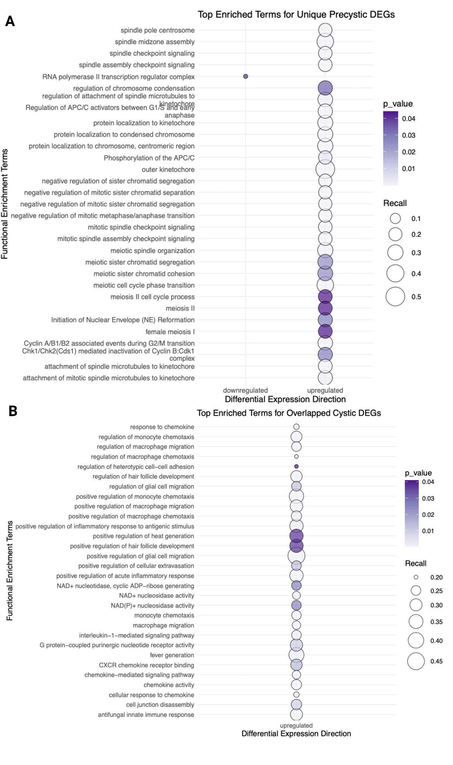

Additional file 2: Pathway Enrichment of Pre-cystic (P70) vs Cystic (P21 and P28) Kidney Differential Gene Expression Bubbleplots showing enrichment for genes uniquely differentially expressed in the A) pre-cystic data set and B) both cystic data sets, where point size is the ratio of query genes to pathway gene set size.

