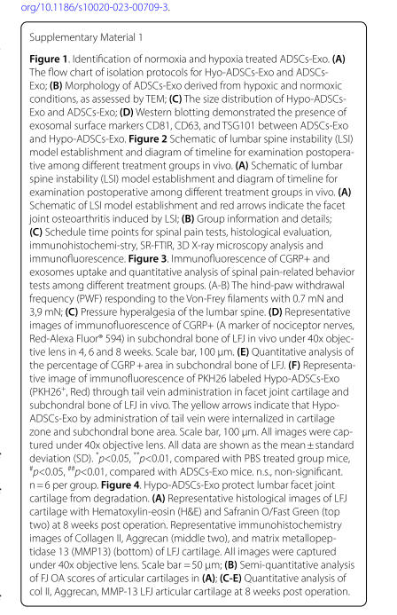
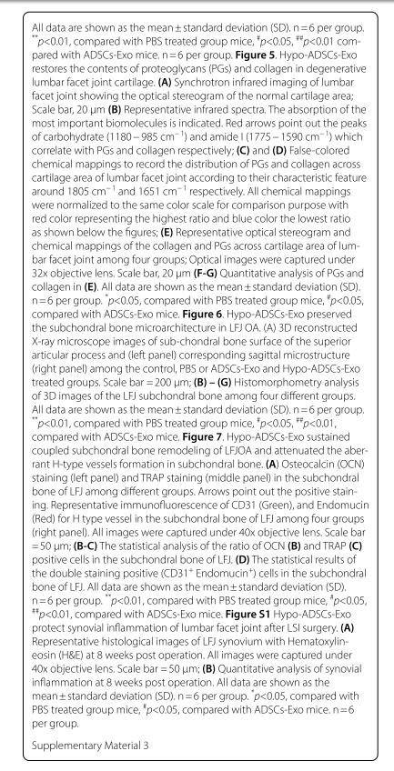

This part is not consistent with our figure legend part in Figure S1. Please correct it according to the figure legend below. Thank you.
Figure S1 Hypo-ADSCs-Exo protect synovial inflammation of lumbar facet joint after LSI surgery. (A) Representative histological images of LFJ synovium with Hematoxylin-eosin (H&E) at 8 weeks post operation. All images were captured under 40x objective lens. Scale bar=50 μm; (B) Quantitative analysis of synovial inflammation at 8 weeks post operation. All data are shown as the mean ± standard deviation (SD). n=6 per group. *p＜0.05, compared with PBS treated group mice, #p＜0.05, compared with ADSCs-Exo mice. n=6 per group.

