Supplementary materials

Table S1 Primary antibodies for Western-blots
primary antibodies | Source organism | producer | Number
USP38 | Rabbit | Proteintech | 17767-1-AP
Collagen I | Rabbit | invitrogen | PA1-26204
TGFβ1 | Rabbit | abcam | ab179695
TAK1 | Rabbit | Proteintech | 12330-2-AP
P-TAK1 (Thr 187) | Rabbit | Affinity | AF2019
p65 | Rabbit | CST | #8242S
P-p65 | Rabbit | CST | #3031S
P-IκBα | Rabbit | CST | #2859S
IκBα  CD68  iNOS  CD163 | Rabbit  Mouse  Mouse  Mouse | CST  Servicebio  Servicebio  Servicebio | #4814S  GB113109  GB11119  GB11340
GAPDH | Rabbit | CST | #5174S

Table S2 Primer sequences for qRT-PCR
Gene | Forward primer (5’ to 3’) | Reverse primer (5’ to 3’)
GAPDH | ATCATCCCTGCATCCACT | ATCCACGACGGACACATT
CD68 | ACCCGGAGACGACAATCAAC | CTTGGTGGCCTACAGAGTGG
CD163 | GGTGGACACAGAATGGTTCTTC | CCAGGAGCGTTAGTGACAGC
iNOS | GTTCTCAGCCCAACAATACAAGA | GTGGACGGTGTCGATGTCAC
IL-1β | ACAGCAAAAGTTACGGTAGCAG | ATGGGTTCCCCAATGACTTCA
IL-6 | CCTGAACCTTCCAAAGATGGC | TTCACCAGGCAAGTCTCCTCA
IL-10 | CTTACTGACTGGCATGAGGATCA | GCAGCTCTAGGAGCATGTGG

Supplementary Figure 1. USP38 cardiac conditional knockout mice construction strategy and schematic diagram

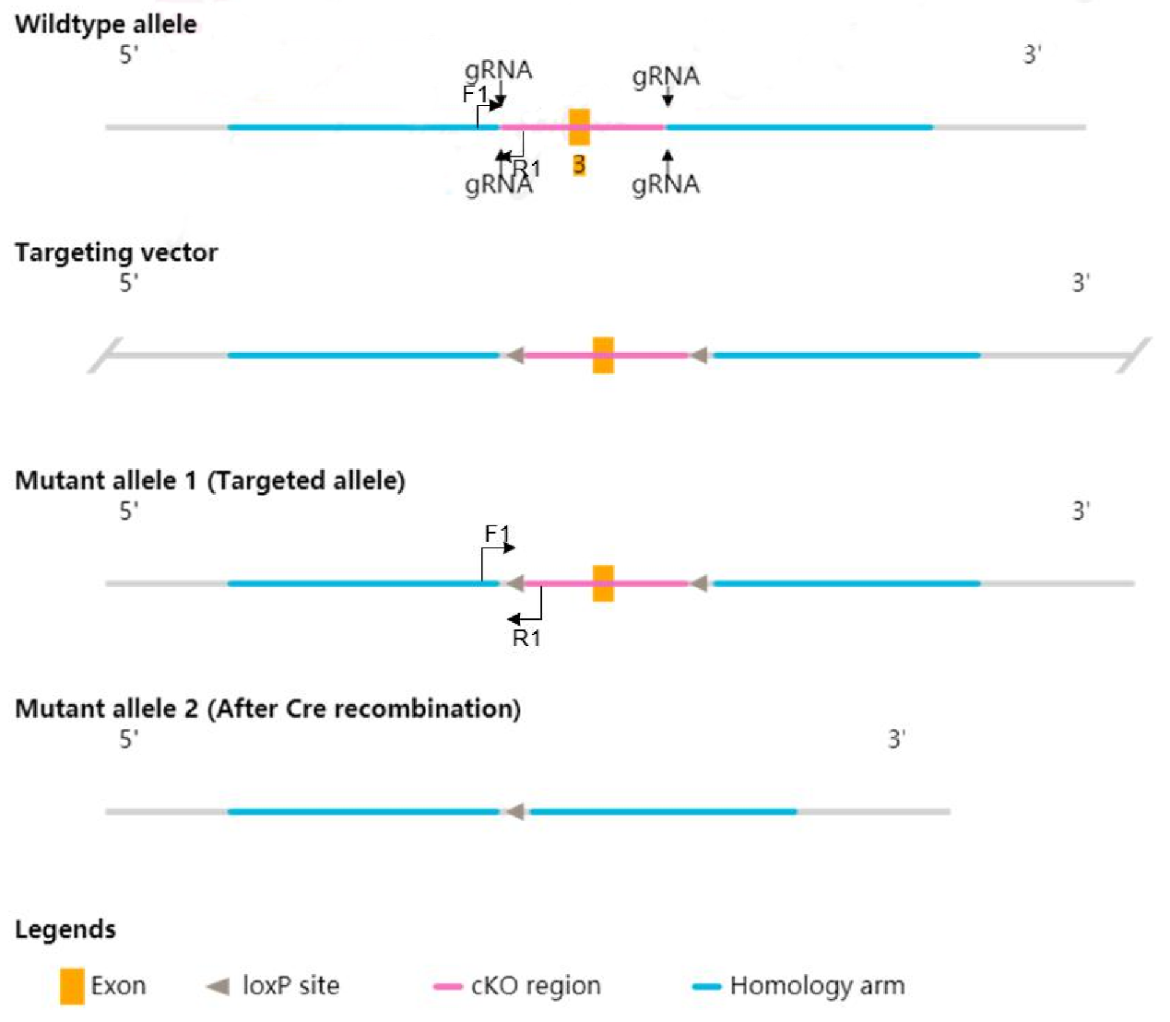

Supplementary Figure 2. USP38 cardiac-specific overexpression mice construction strategy and schematic diagram

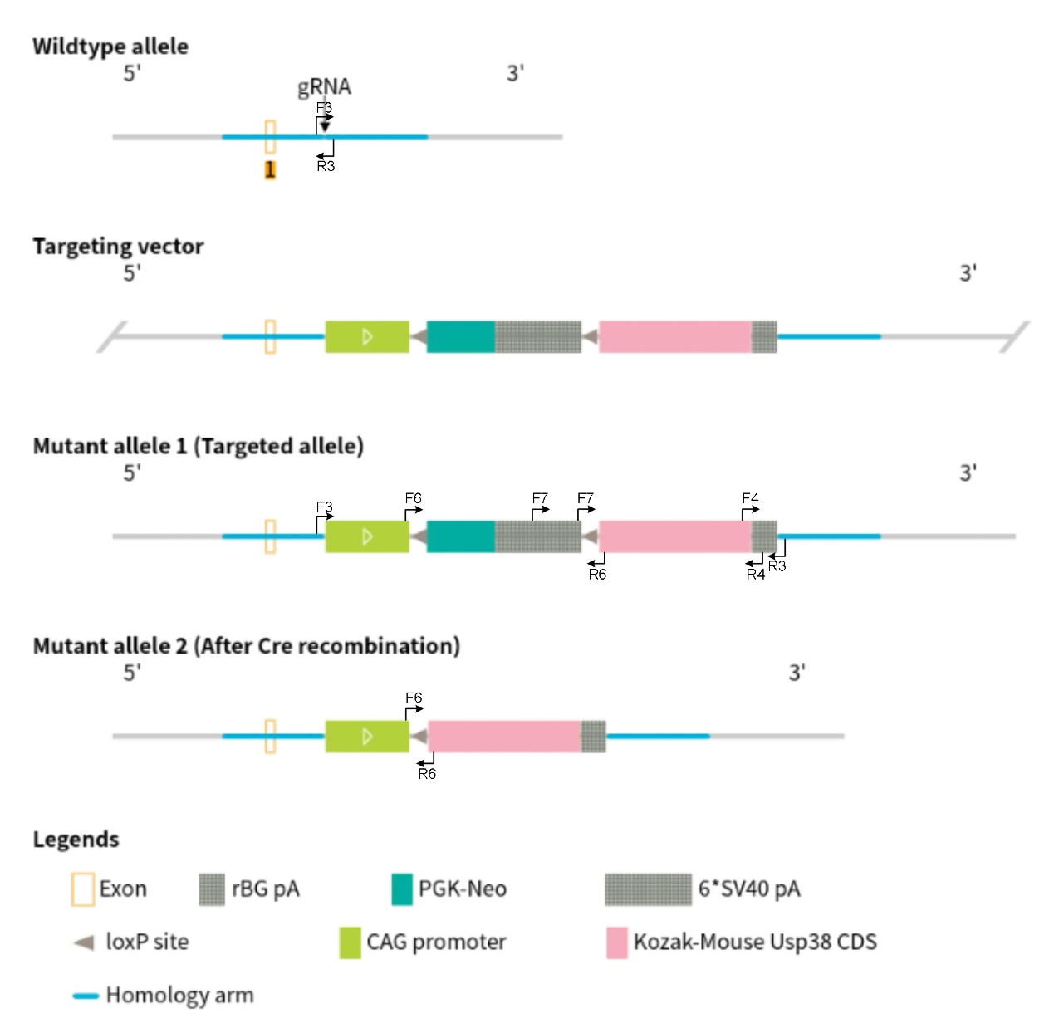

Supplementary Figure 3. Representative western blot images of USP38 in the atria from USP38-CKO (A) and USP38-TG (B) mice
Supplementary Figure 4. Effect of USP38 on atrial ion channel remodeling in mice after MI
(A and E) Representative Western blots of the ion channel proteins levels (Kv4.2, Kv4.3 and Cav1.2). (B-D) Statistical analysis of USP38-CKO on the ion channel protein expression levels at day 7 after MI (n=4). (F-H) Statistical analysis of USP38-TG on the ion channel protein levels at 7 days after MI (n=4). *P<0.05 vs. Sham group, #P<0.05 vs. Flox-MI or NTG-MI.

