Table S1. Animal grouping information
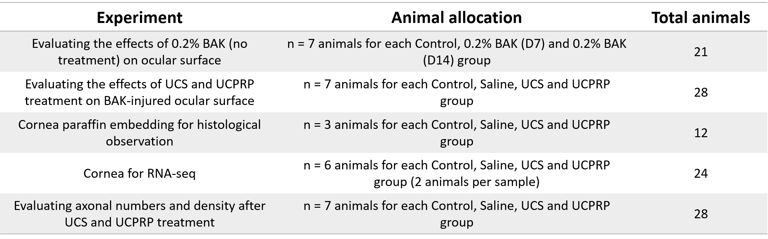

Table S2. Primer information
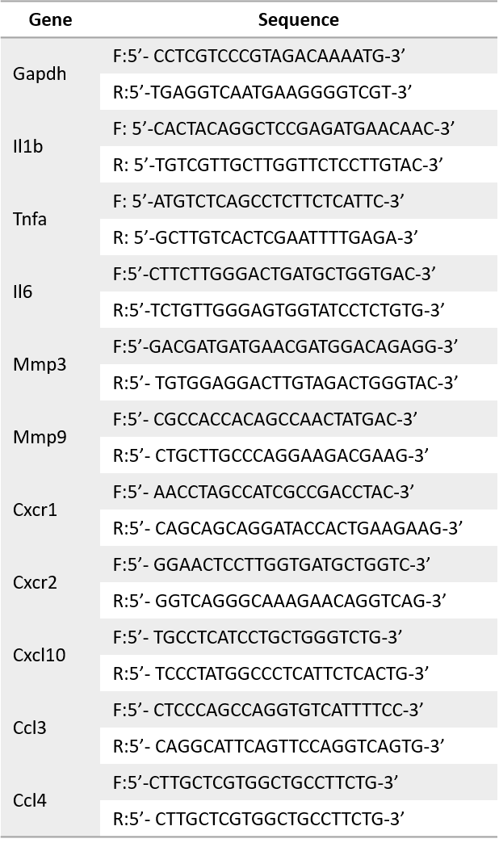

Table S3. Information and quality of RNA samples utilized in RNA-seq
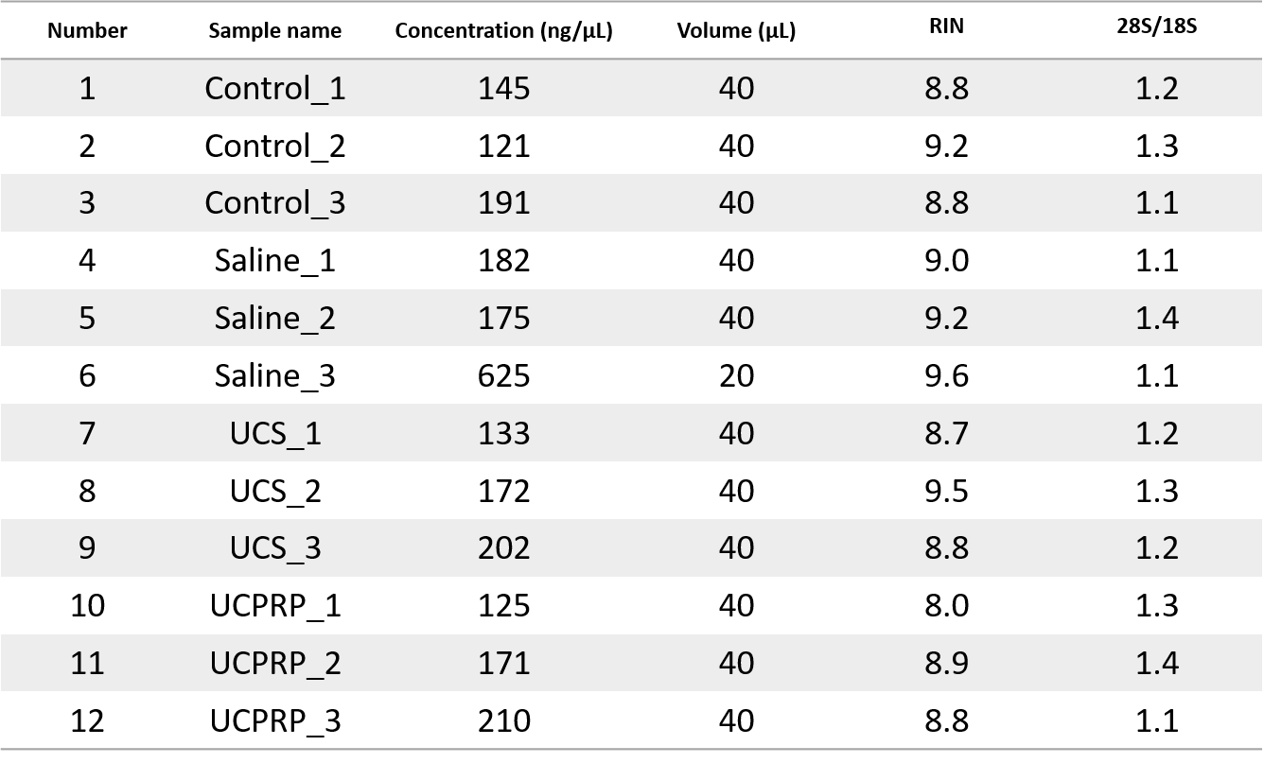

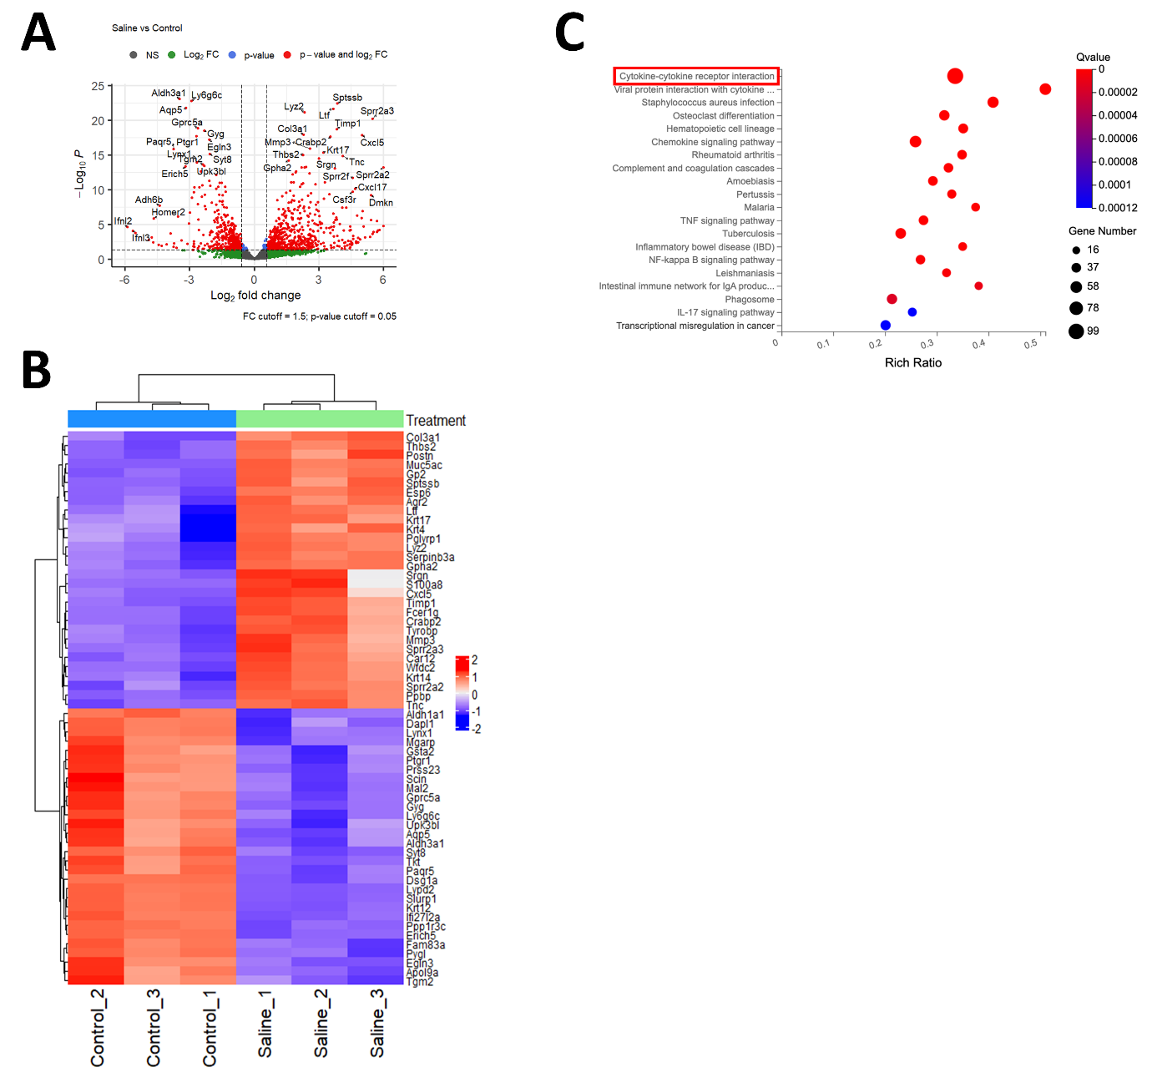
Figure S1. Notable gene changes and KEGG pathway following BAK insult. (A) Volcano plot of untreated 0.2% BAK-injured mice cornea vs normal mice cornea. (B) Heatmap of top regulated genes. (C) KEGG enrichment plot depicting the highly enriched pathways 14 days post BAK injury.
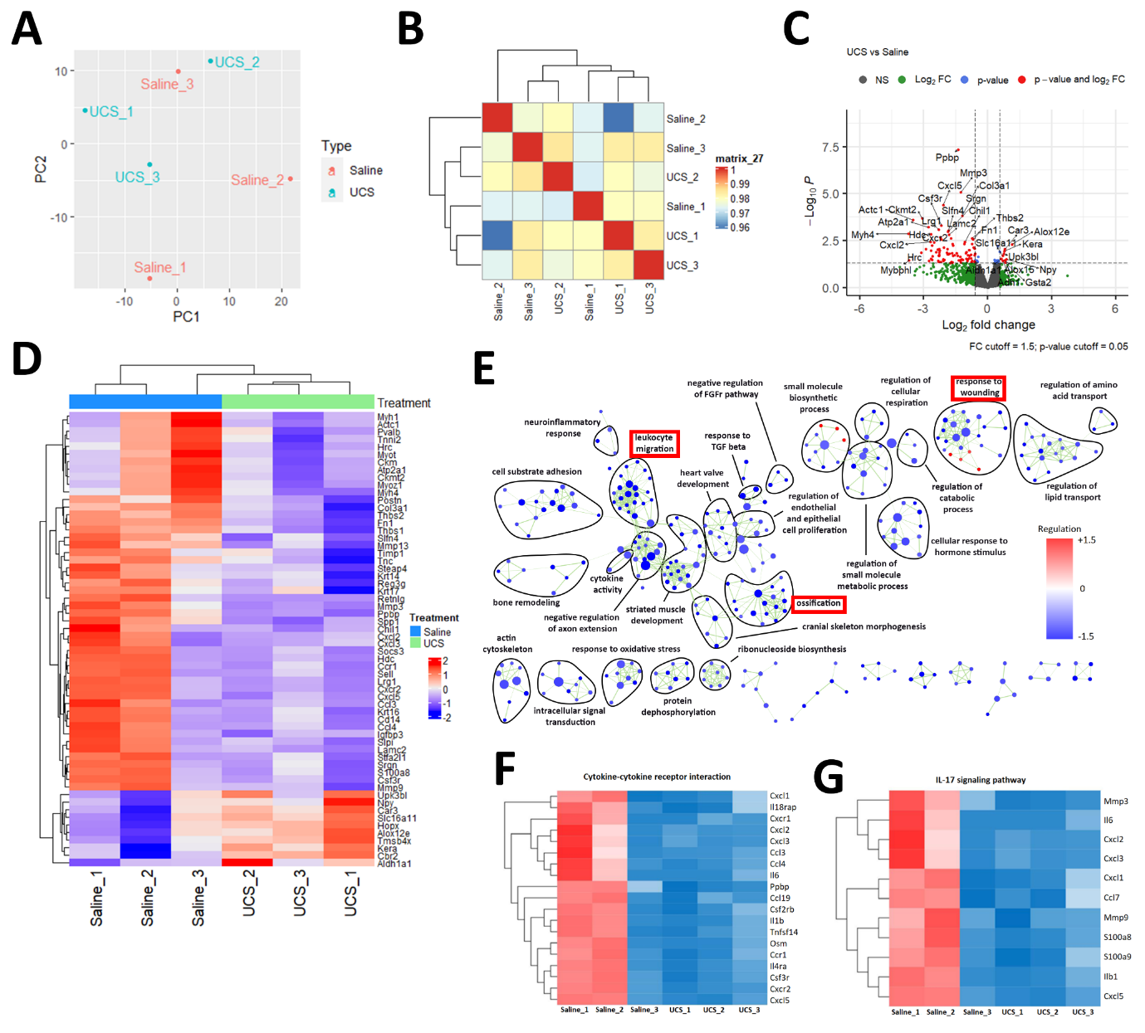
Figure S2. Detailed analysis of UCS treatment for BAK-induced corneal injury. (A) PCA and (B) correlation plots show the comparison between UCS-treated and untreated BAK-injured corneas. (C) Volcano plot and (D) heat map of the top regulated genes following UCS treatment. (E) GO pathway analysis revealed many downregulated pathways. Regulation of the genes within the cytokine-cytokine receptor interaction and IL-17 signaling pathways were presented in heatmaps (F) and (G) respectively.

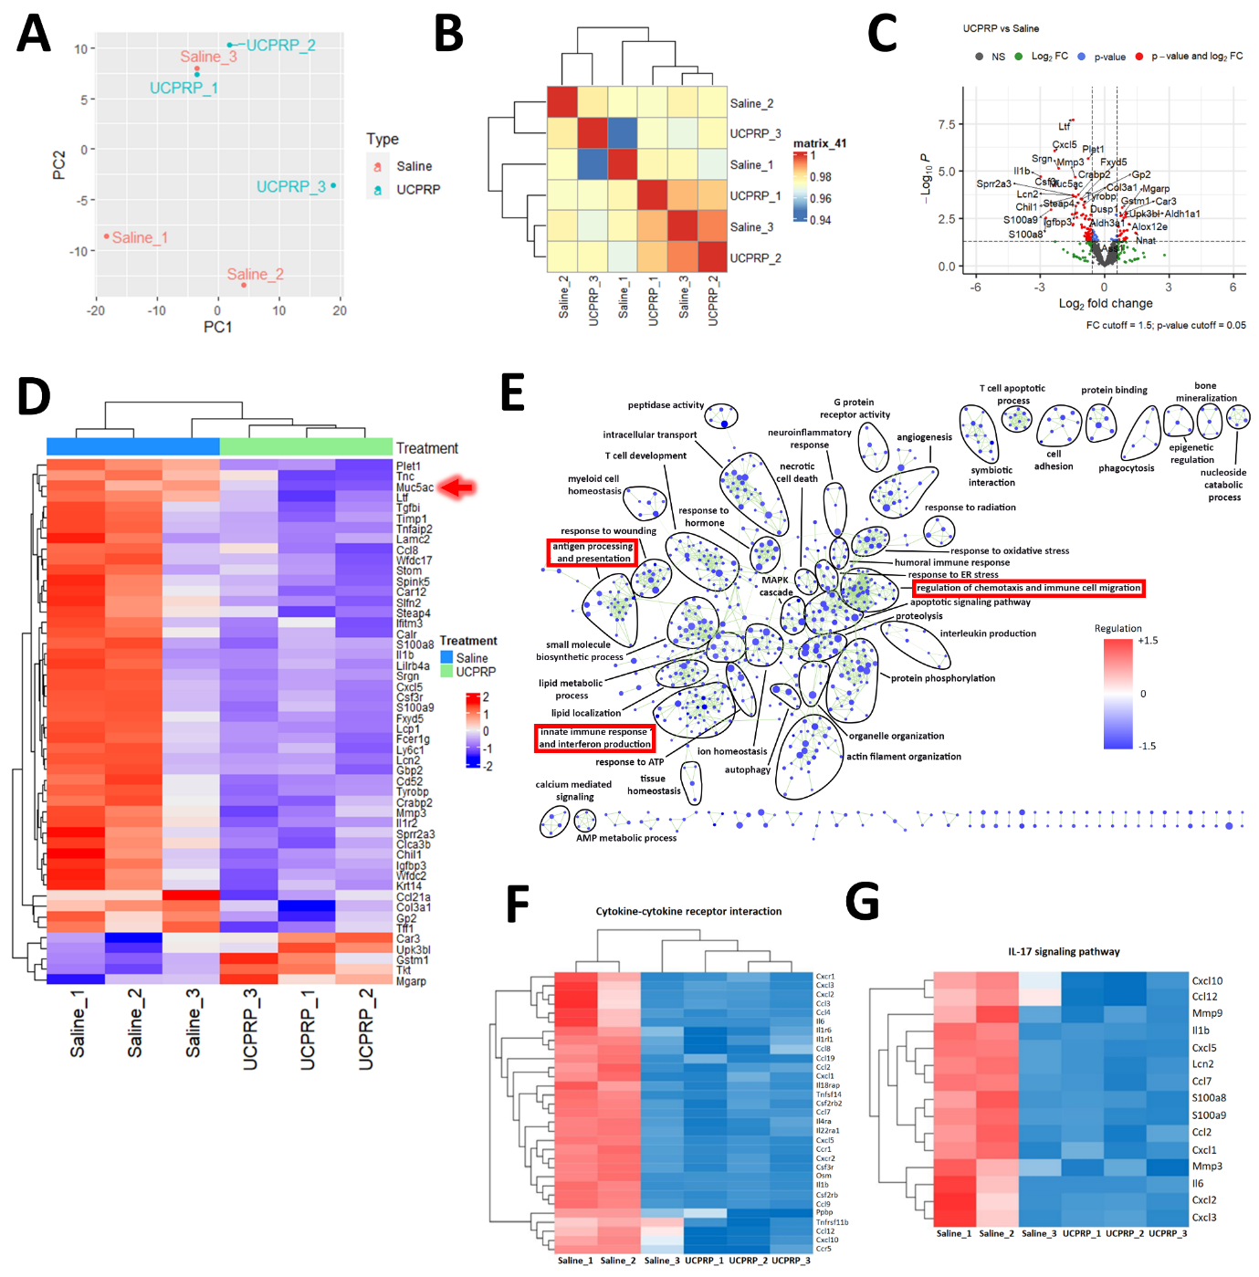
Figure S3. Detailed analysis of UCPRP treatment for BAK-induced corneal injury. (A) PCA and (B) correlation plots show the comparison between UCPRP-treated and untreated BAK-injured corneas. (C) Volcano plot and (D) heat map of the top regulated genes following UCS treatment. (E) GO pathway analysis revealed many downregulated pathways, similar to UCS treatment. Regulation of the genes within the cytokine-cytokine receptor interaction and IL-17 signaling pathways were presented in heatmaps (F) and (G) respectively.

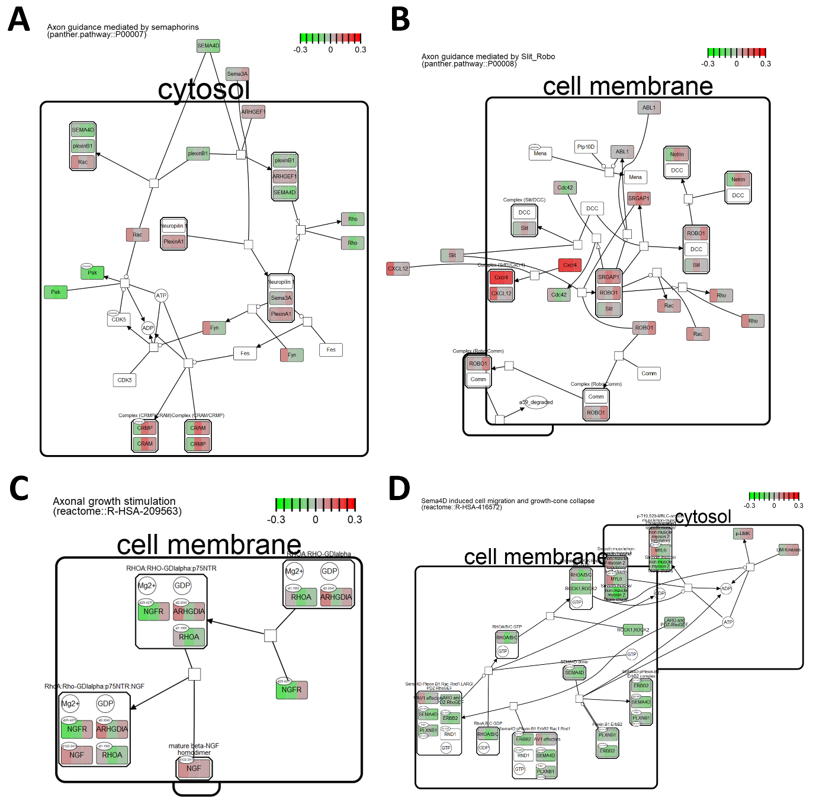
Figure S4. Axon-related Reactome pathways. Pathways that were referenced for selecting the relevant genes included (A) axon guidance mediated by semaphorins, (B) axon guidance mediated by Slit_Robo, (C) axonal growth stimulation and (D) sema4d induced cell migration and growth-cone collapse.

