Supplementary data

Integrin αVβ3 antagonist-c(RGDyk) peptide attenuates the progression of ossification of the posterior longitudinal ligament by inhibiting osteogenesis and angiogenesis

Xiangwu Geng^{1†}, Yifan Tang^{1†}, Changjiang Gu^{1†}, Junkai Zeng¹, Yin Zhao¹, Quanwei, Zhou¹, Lianshun Jia¹, Shengyuan Zhou¹*, Xiongsheng Chen¹*
¹Spine Center
Department of Orthopaedics
Changzheng Hospital
Naval Medical University (Second Military Medical University)
Shanghai 200003, P. R. China
* Correspondence: zsy32@163.com; chenxiongsheng@vip.sohu.com
† Xiangwu Geng, Yifan Tang, and Changjiang Gu contributed equally to this work.

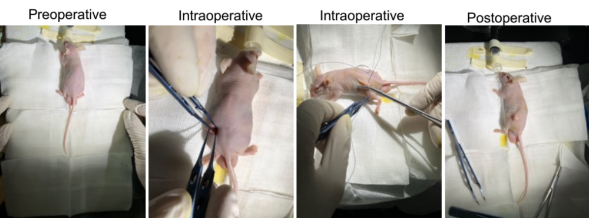
Figure S1. Preoperative, intraoperative, and postoperative images of animal models.

Figure S2. Representative picture of OPLL sample.

Figure S3. The quantification of the expression of osteogenesis-related genes was detected by western blots. All experimental data are presented as the mean value ± SD. One-way ANOVA for multiple comparisons is used in Figure S3. *p<0.05, **p<0.01, ***p<0.001.

Figure S4. siRNA Integrin αVβ3 inhibits osteogenesis by regulating the FAK/ERK1/2/Runx2 pathway. a and b Western blotting and quantitative analysis of the protein expression of the FAK/ERK1/2 pathway in LFs, including integrin αVβ3, p-FAK, FAK, p-ERK1/2, ERK1/2, and RUNX2. β-actin was selected as the internal control. All experiments were repeated three times. All experimental data are presented as the mean value ± SD. One-way ANOVA for multiple comparisons is used in (b). *p<0.05, **p<0.01, ***p<0.001.

Figure S5. Original immunoblot pictures of Fig 1 and Fig 4.

Figure S6. Original immunoblot pictures of Fig 6.

Figure S7. Original immunoblot pictures of Fig S4.

Table S1. Characteristics of patient
Group | Sex | Age | Diagnosis | Surgical level
OPLL 1 | male | 54 | OPLL | C3
OPLL 2 | male | 65 | OPLL | C5
OPLL 3 | male | 59 | OPLL | C4
OPLL 4 | female | 60 | OPLL | C5
OPLL 5 | female | 57 | OPLL | C4
OPLL 6 | male | 67 | OPLL | C5
OPLL 7 | male | 75 | OPLL | C4
OPLL 8 | female | 70 | OPLL | C4
non-OPLL 1 | male | 45 | cervical spine trauma | C4
non-OPLL 2 | male | 50 | cervical spine trauma | C3
non-OPLL 3 | male | 53 | cervical spine trauma | C4
non-OPLL 4 | female | 55 | cervical spine trauma | C4
non-OPLL 5 | female | 59 | cervical spine trauma | C4
non-OPLL 6 | male | 60 | cervical spine trauma | C5
non-OPLL 7 | male | 63 | cervical spine trauma | C4
non-OPLL 8 | female | 65 | cervical spine trauma | C5
P value | 0.654 | 0.716 | - | 0.576
OPLL: ossification of the posterior longitudinal ligament

Table S2. The sequences of qPCR primers.
Primer Name |  | Sequence（5′-3′） | Length | Gene | Gene ID | product length | Tm(℃)
αv | F | GCTGTCGGAGATTTCAATGGT | 21 | ITGAV | 3685 | 136 bp | 58.64
αv | R | TCTGCTCGCCAGTAAAATTGT | 21 | ITGAV | 3685 | 136 bp | 58.22
α3 | F | CTACCACAACGAGATGTGCAA | 21 | ITGA3 | 3675 | 102 bp | 58.59
α3 | R | CCGAAGTACACAGTGTTCTGG | 21 | ITGA3 | 3675 | 102 bp | 58.60
α2 | F | CCTTGAAGCCTATTCTGAGACTGCC | 25 | ITGA2 | 3673 | 214 bp | 63.15
α2 | R | AATTCCAGTGTTGTATGCACTTTCCC | 26 | ITGA2 | 3673 | 214 bp | 62.19
α4 | F | AGCCCTAATGGAGAACCTTGT | 21 | ITGA4 | 3676 | 167 bp | 58.72
α4 | R | CCAGTGGGGAGCTTATTTTCAT | 22 | ITGA4 | 3676 | 167 bp | 58.36
α2b | F | GTTCAACGTGTCCTCCCTCC | 20 | ITGA2B | 3674 | 194bp | 60.32
α2b | R | TGAAGAAGCCGACCTTCCAC | 20 | ITGA2B | 3674 | 194bp | 59.97
α9 | F | TCGTTCTTCGGCTACGCAG | 19 | ITGA9 | 3680 | 243 bp | 60.15
α9 | R | CCCCATCCACTCATCATCGC | 20 | ITGA9 | 3680 | 243 bp | 60.60
αL | F | GTCAGCTCATCATCCGAAACTG | 22 | FASTK | 10922 | 72 bp | 59.39
αL | R | AGACTGCAAGGTGCAGACACA | 21 | FASTK | 10922 | 72 bp | 62.19
β3 | F | AATCTCCTGTGCATCACATTTCT | 23 | ITGB3BP | 23421 | 139 bp | 58.40
β3 | R | TTCATAGCTGTCAAGATGACGTG | 23 | ITGB3BP | 23421 | 139 bp | 58.82
β4 | F | TGTCCATCCCCATCATCCCT | 20 | ITGB4 | 3691 | 106bp | 60.03
β4 | R | CCCGATGGAGAGCGTAGAAC | 20 | ITGB4 | 3691 | 106bp | 59.97
β8 | F | TGGTGCTCTCAGGAGAGGTT | 20 | ITGB8 | 3696 | 187 bp | 55.00
β8 | R | CTGGTCGTAGGTGGATGGTG | 20 | ITGB8 | 3696 | 187 bp | 60.00
ALP | F | GTGGCAACTCTATCTTTGGTCTG | 23 | ALPL | 249 | 157 bp | 59.31
ALP | R | GCCTGGTAGTTGTTGTGAGCA | 21 | ALPL | 249 | 157 bp | 60.38
RUNX2 | F | GCGCATTCCTCATCCCAGTA | 20 | RUNX2 | 860 | 176 bp | 59.89
RUNX2 | R | GGCTCAGGTAGGAGGGGTAA | 20 | RUNX2 | 860 | 176 bp | 60.03
OCN | F | AGGGCAGCGAGGTAGTGAAGAG | 22 | BGLAP | 1E+08 | 135 bp | 63.75
OCN | R | GGTCAGCCAACTCGTCACAGTC | 22 | BGLAP | 1E+08 | 135 bp | 63.34
OPN | F | GTCAAAATCTAAGAAGTTTCGCAG | 25 | SPP1 | 6696 | 153 bp | 56.86
OPN | R | CTGTCCCAATCAGAAGGCG | 19 | SPP1 | 6696 | 153 bp | 58.23
COLA1 | F | CGAAGACATCCCACCAATCA | 20 | COL1A1 | 1277 | 127 bp | 57.60
COLA1 | R | GATCACGTCATCGCACAACA | 20 | COL1A1 | 1277 | 127 bp | 58.93
β-actin | F | TAGTTGCGTTACACCCTTTCTTG | 23 | ACTB | 60 | 151 bp | 59.19
β-actin | R | TCACCTTCACCGTTCCAGTTT | 21 | ACTB | 60 | 151 bp | 59.79

Table S3. siRNA sequences.
siRNA name | Sequences (5'-3')
si-ITGαV-a | CTCTGTTGTATATCCTTCATT
si-ITGαV-b | GTGAGGTCGAAACAGGATAAA
si-ITGαV-c | CGACAGGCTCACATTCTACTT
si-ITGβ3-a | CCACGTCTACCTTCACCAATA
si-ITGβ3-b | GATGCAGTGAATTGTACCTAT
si-ITGβ3-c | CCTTAGCCTTTGTCCCAGAAT

