Supplement Information

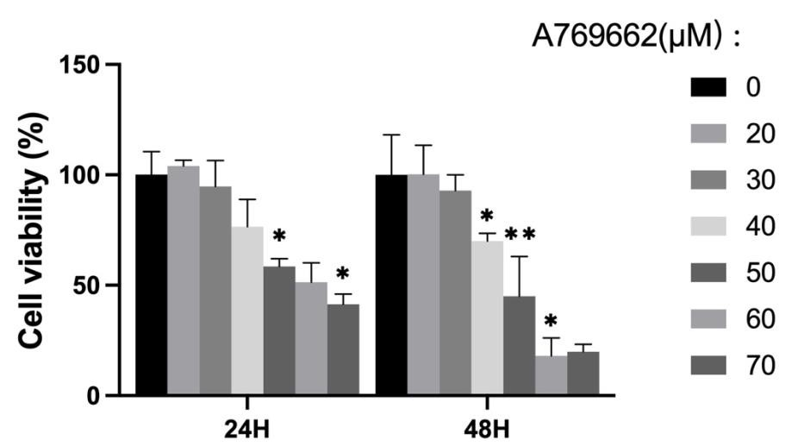

Supplement Figure S1. CCK8 analysis of SFBs treated with 0, 20, 30, 40, 50, 60 and 70µM A769662 for 24h and 48h.

