Supplementary Figure S1-5
Supplementary Figure S1
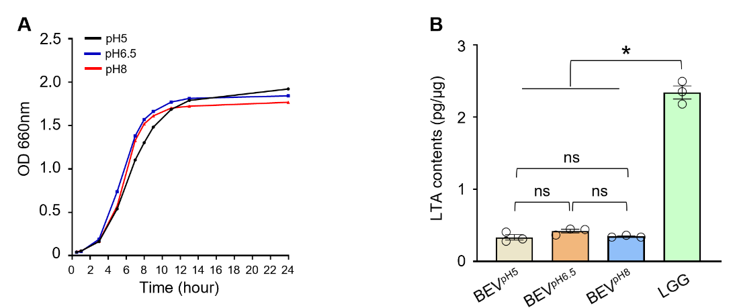

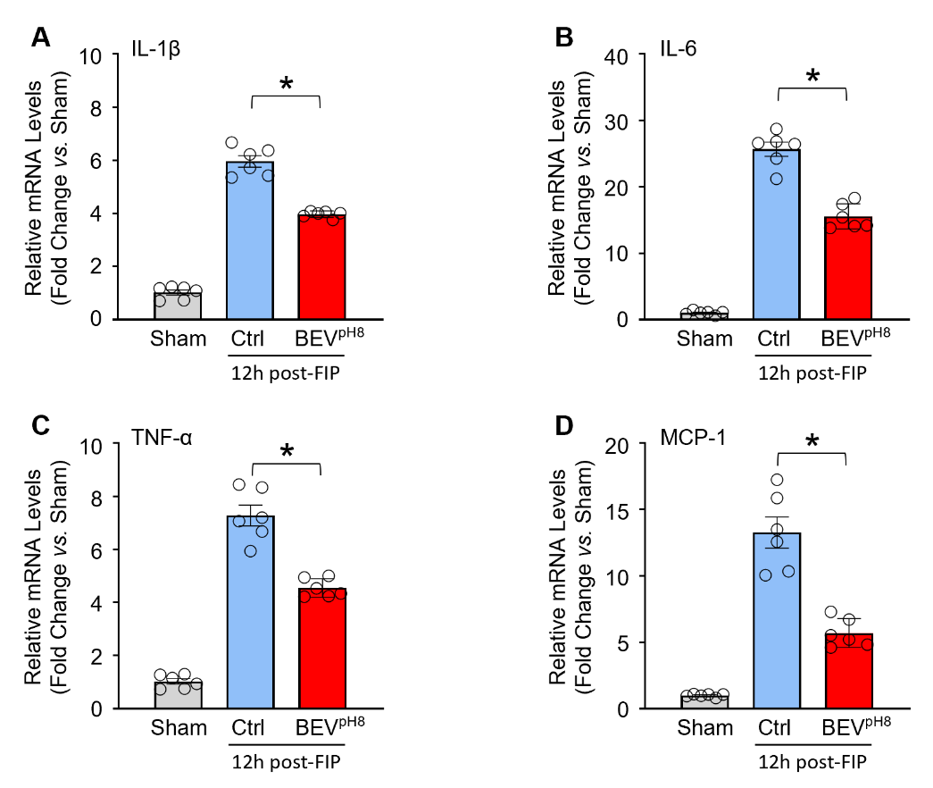
Figure S2: Relative mRNA levels of inflammatory cytokines and chemokines in lung tissues [(A): IL-1β, (B): IL-6, (C): TNF-α, (D): MCP-1] of Sham, Ctrl- and BEV^{pH8}-treated mice at 12 h post-FIP by RT-qPCR (n = 6). All results are presented as mean ± SEM and analyzed by one-way ANOVA (*p < 0.001).
Supplementary Figure S2
Figure S1: (A) Growth curves of LGG cultured in acidic, neutral, and alkaline medium. (B) LTA contents in BEVs released by LGG cultured under acidic, neutral, and alkaline conditions. All results are presented as mean ± SEM and analyzed by one-way ANOVA (*p < 0.001, ns: non-significance).
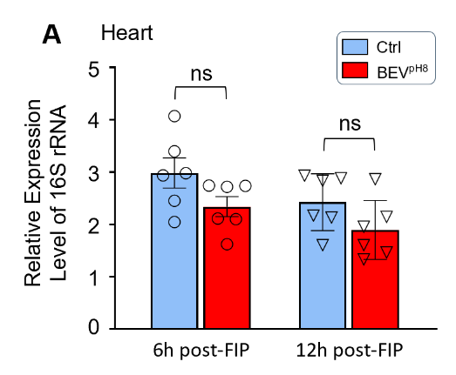
Supplementary Figure S3

Figure S3: Relative expression level of bacterial 16S rRNA in the heart collected from control- and BEV^{pH8}-treated mice at 6 h and 12 h post-FIP by RT-qPCR (n = 6). All results are presented as mean ± SEM and analyzed by 2-way ANOVA (ns: non-significance).

Supplementary Figure S4

Raw264.7 macrophages BMDMs
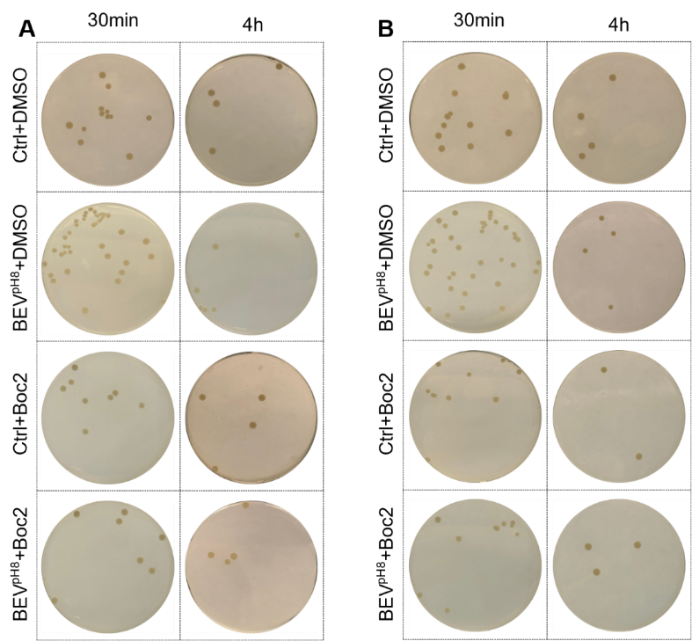

Figure S4: Representative images of gentamicin protection assay using live E. coli to detect phagocytic and bactericidal activities in Raw264.7 macrophages (A) and BMDMs (B). Gentamicin protection assay was used to detect the phagocytic and bactericidal activities upon pre-treatment of macrophages (Raw264.7 and BMDMs) with Boc2, a specific antagonist of FPR1/2, for 2 h, followed by incubation with BEV^{pH8} for 12 h. Gentamicin (100µg/ml) was added to the cell culture medium 1 h after infection with live E. coli (MOI=20). After 30 min, cell lysates were extracted with serial dilution, then plated on LB agar plates. The CFUs were measured as an indicator for phagocytosis capacity of Raw264.7 macrophages (A) and BMDMs (B). Then, CFUs were determined in lysates of Raw264.7 macrophages and BMDMs at 4 h after the addition of gentamicin to assess the number of bacteria remained within macrophages. The killing percentages of macrophages were calculated as described in the section of Materials & Methods.

Supplementary Figure S5

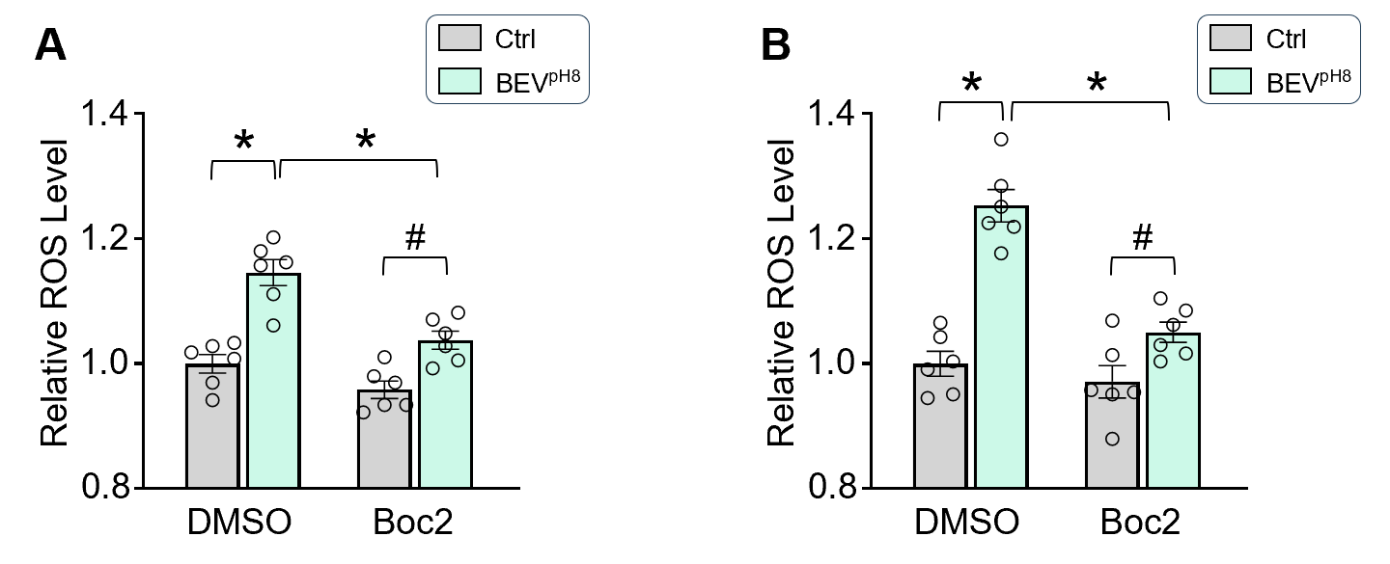
Figure S5: Raw264.7 macrophages (A) and BMDMs (B) were treated with BEV^{pH8} in the presence or absence of Boc2 for 12 h, followed by incubation with heat-inactivated E. coli for 30 min, and then ROS levels were assayed. All results are presented as mean ± SEM and analyzed by 2-way ANOVA (*p < 0.001, #p < 0.05).

