Supplemental Table 1. Sequences of the primers and TaqMan® probes.
Gene (GenBank accession) |  | Oligonucleotide sequence (5’-3’)
CAV1 (NM_001753)
Forward |  | AACGATGACGTGGTCAAGATTG
Reverse |  | TCCAAATGCCGTCAAAACTGT
TaqMan® Probe |  | FAM-TTGAAGATGTGATTGCAGAACCAGAAGGGA-TAMRA
COL1A1 (NM_000088.3)
Forward |  | CTCCCGGGCCTCAAGGTAT
Reverse |  | TTGCTCCAGAGGGACCTTGTT
TaqMan® Probe |  | FAM-TCTTCCTGGCCCCTCTGGTGAACCT-TAMRA
COL4A3 (NM_000091.4)
Forward |  | AGTGGATTGCCAGGATTTTCTG
Reverse |  | TGGTACACCGACCAGTCCGTAA
TaqMan® Probe |  | FAM-CCAGGCACCCCAGGCAATACCG-TAMRA
COL5A3 (NM_015719.4)
Forward |  | GAACAAGGAAATTTGGACCTCAAG
Reverse |  | GATTTGGAGCTGGAGTCTCTGTCT
TaqMan® Probe |  | FAM-TCCTGACTCCGCAGAGAACCAGACCTC-TAMRA
COL6A3 (NM_004369.3)
Forward |  | GACGGAGATCTGGCTGATTTACA
Reverse |  | AGATGCATTAGCCGCTCCAA
TaqMan® Probe |  | FAM-AGAACCTCCGCCAAGAAGGAGTCCGT-TAMRA
ELN (NM_000501.4)
Forward |  | TGGAGGAGTGGCAGCAAGA
Reverse |  | CTTCCGGCCACAAGCTTTC
TaqMan® Probe |  | FAM-TCGGATTGTCTCCCATTTTCCCAGGT-TAMRA
 | IL1A (NM_000575)
 | Forward |  | GTTCTGAAGAAGAGACGGTTGAGTTT
 | Reverse |  | AAGTTGTATTTCACATTGCTCAGGAA
 | TaqMan® Probe |  | FAM-CATCGCCAATGACTCAGAGGAAGAAATCA-TAMRA
IL1B (NM_000576)
Forward |  | CAGTGGCAATGAGGATGACTTG
Reverse |  | GTAGTGGTGGTCGGAGATTCGTA
TaqMan® Probe |  | FAM-TGGCCCTAAACAGATGAAGTGCTCCTTCC-TAMRA
IL6 (NM_000600)
Forward |  | GCCCTGAGAAAGGAGACATGTAAC
Reverse |  | ATCCATCTTTTTCAGCCATCTTTG
TaqMan® Probe |  | FAM-AGGCACTGGCAGAAAACAACCTGAACC-TAMRA
IL8 (NM_000584.3)
Forward |  | ACCTTTCCACCCCAAATTTATCA
Reverse |  | TTCTCAGCCCTCTTCAAAAACTTC
TaqMan® Probe |  | FAM-CCACACTGCGCCAACACAGAAATTATTGTA-TAMRA
 | IL32 (NM_001012631)
 | Forward |  | GAGACAGTGGCGGCTTATTATGA
 | Reverse |  | GGCACCGTAATCCATCTCTTTCT
 | TaqMan® Probe |  | FAM-CAGCACCCAGAGCTCACTCCTCTACTTGAA-TAMRA
 | LOX (NM_001178102.2)
 | Forward |  | ACACAGGACATCATGCGTATGC
 | Reverse |  | AACACCAGGCACTGATTTATCCA
 | TaqMan® Probe |  | FAM-TCACCGTATTAGAAGGCAAAGCAAAACTCCC-TAMRA
 | LRRC8A (NM_001127244.2)
 | Forward |  | TACCTGGACCTCAGCCACAAC
 | Reverse |  | GAGCTTCCGGCACTGGAA
 | TaqMan® Probe |  | FAM-CCAACCGGATCGAGACGCTCCC-TAMRA
 | MMP9 (NM_004994)
 | Forward |  | GCCCGGACCAAGGATACAGT
 | Reverse |  | CCCCTCAGTGAAGCGGTACA
 | TaqMan® Probe |  | FAM-ACGCGCTGGGCTTAGATCATTCCTCA-TAMRA
 | MMP14 (NM_004995.4)
 | Forward |  | CGCCATCCAGGGTCTCAA
 | Reverse |  | TTGCGAATGGCCTCGTATG
 | TaqMan® Probe |  | FAM-TCTGCATCCAGAATTAGACCCCCAAGGT-TAMRA
NLRP3 (NM_001079821.2)
Forward |  | AAGCTTCAGGTGTTGGAATTAGACA
Reverse |  | GTTGCCCAGGCTCAGCTTT
TaqMan® Probe |  | FAM-CACACTGCTGCTGGGATCTTTCCACA-TAMRA
NLRP6 (NM_138329.2)
Forward |  | TCCCTTCTTCATCCACTCTTTCAG
Reverse |  | CAGACCGCGTCAGGGAGTT
TaqMan® Probe |  | FAM-CTGAGCAGCCTCACGCTGTCCCA-TAMRA
 | PIEZO1 (NM_001142864.4)
 | Forward |  | AACCCCGTGCCCAACTTTAT
 | Reverse |  | AGCACCAGCCAGAACAGGTATC
 | TaqMan® Probe |  | FAM-CAGGTCCTACCTTGACATG-TAMRA
 | SPP1 (NM_000582)
 | Forward |  | CATCCAGTACCCTGATGCTACAGA
 | Reverse |  | GGCCTTGTATGCACCATTCAA
 | TaqMan® Probe |  | FAM-ACATCACCTCACACATGGAAAGCGAGGA-TAMRA
 | SIRT1 (NM_012238.5)
 | Forward |  | ATAGAGCCTCACATGCAAGCTCTAG
 | Reverse |  | CTGTGCCAATCATAAGATGTTCCT
 | TaqMan® Probe |  | FAM-ACTGGACTCCAAGGCCACGGATAGGTC-TAMRA
 | TLR4 (NM_003266)
 | Forward |  | CTGCGTGGAGGTGGTTCCTA
 | Reverse |  | CAGGTCCAGGTTCTTGGTTGAG
 | TaqMan® Probe |  | FAM-TTTCTACAAAATCCCCGACAACCTCCCCT-TAMRA
TNF (NM_000594)
Forward |  | CCCCAGGGACCTCTCTCTAATC
Reverse |  | ACATGGGCTACAGGCTTGTCA
TaqMan® Probe |  | FAM-CCTCTGGCCCAGGCAGTCAGATCAT-TAMRA
rCav1 (NM_031556)
Forward |  | ACGACGACGTGGTCAAGATTG
Reverse |  | AGACAGCAAGCGGTAAAACCAA
TaqMan® Probe |  | FAM-TGCGGAACCAGAAGGGACACACAGTTT-TAMRA
rCol1a1 (NM_053304)
Forward |  | TGTATCACCAGACGCAGAAGTCA
Reverse |  | GCTGATTTCTCATCATAGCCATAGG
TaqMan® Probe |  | FAM-CCCCTGGTCTTGGAGGAAACTTTGCTTC-TAMRA
 | rIl1b (NM_031512)
 | Forward |  | ACAGAACATAAGCCAACAAGTGGTATT
 | Reverse |  | GTGGGTGTGCCGTCTTTCAT
 | TaqMan® Probe |  | FAM-CAAGGAGAGACAAGCAACGACAAAATCCC-TAMRA
rNlrp3 (NM_001191642.1)
Forward |  | GTTTTCCCAGACCCTCATGTTG
Reverse |  | AGAGACCTCGGCAGAAGCTAGAG
TaqMan® Probe |  | FAM-CTTCCAGACTGGTGAACTGCTGCCTCA-TAMRA
 | rNlrp6 (NM_134375.3)
 | Forward |  | CCAAATGCAAGGTGCAGACA
 | Reverse |  | CACAATGACCAGGTAGTGGATCAC
 | TaqMan® Probe |  | FAM-CAGGATACAGATGCCTGGCCTCCAAGA-TAMRA
 | rPiezo1 (NM_001077200.2)
 | Forward |  | CGTCACCGTCATCATCTCTAAGAAT
 | Reverse |  | TGGATGACCCAGCAGAAGTTG
 | TaqMan® Probe |  | FAM- TGTTGTCGCTCCTGTCCTGTGTCTTCG-TAMRA
CAV1, caveolin 1; COL, collagen; ELN, elastin; IL, interleukin; LOX, lysyl oxidase; LRRC8A/SWELL1, leucine rich repeat containing 8 VRAC subunit A, MMP, matrix metallopeptidase; NLRP, nucleotide-binding oligomerization domain, leucine rich repeat and pyrin; PIEZO1, piezo type mechanosensitive ion channel component 1; SPP1, osteopontin; TLR4, toll-like receptor-4; TNF, tumor necrosis factor-α.

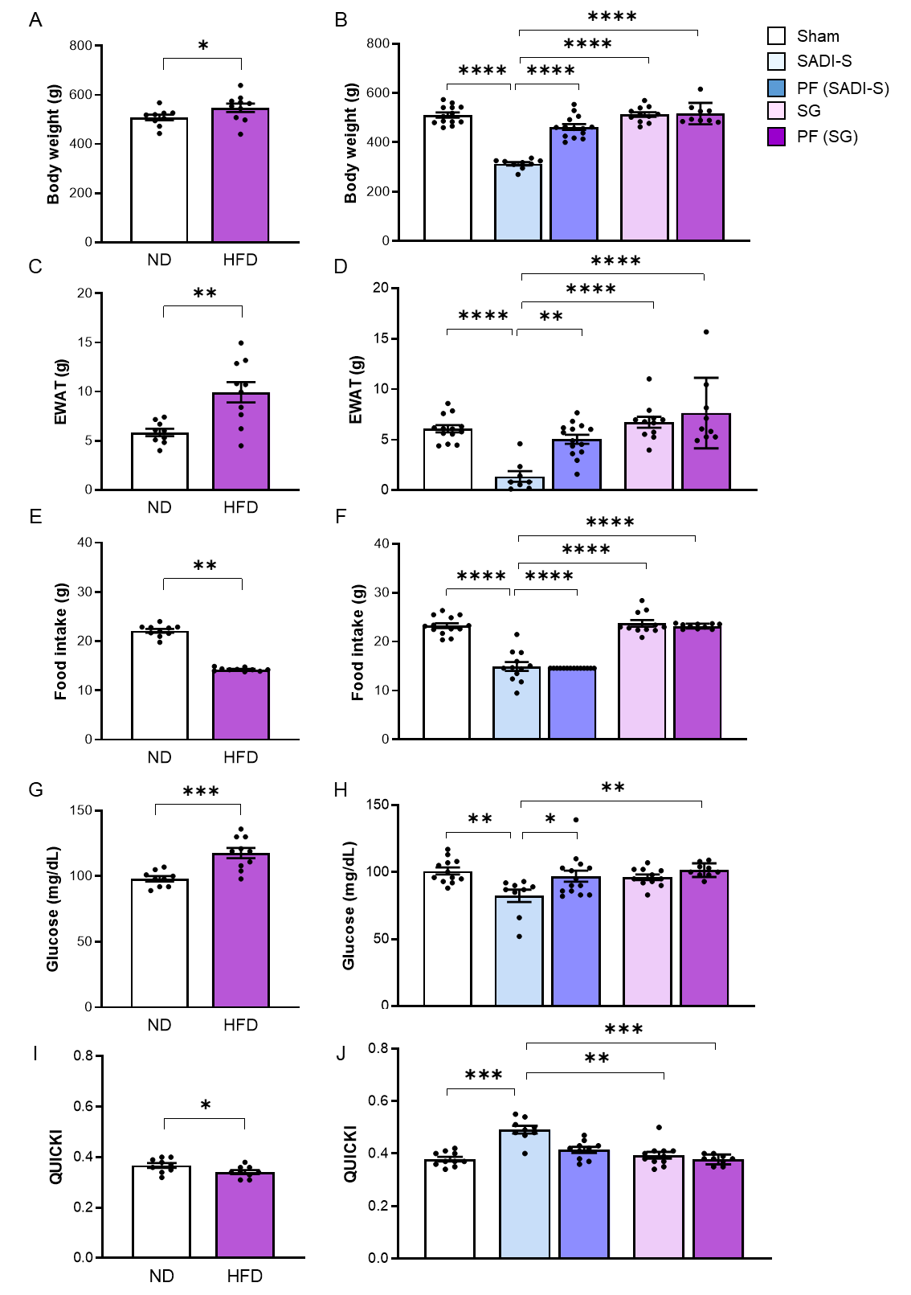
Supplemental Fig 1. Body weight, epididymal white adipose tissue (EWAT) weight, food intake, glucose levels and quantitative insulin sensitivity check index (QUICKI) from rats fed a normal diet (ND) or a high-fat diet (HFD) and after being submitted to sham surgery, single anastomosis duodeno-ileal bypass with sleeve gastrectomy (SADI-S), sleeve gastrectomy (SG) and pair-fed (PF). Differences between groups were analyzed by unpaired two-tailed Student’s t test as well as by one-way ANOVA followed by Tukey’s tests. *P<0.05, **P<0.01, ***P<0.001 and ****P<0.0001.

