Figure S1. (a) ADAM19 gene expression levels in the skin of HC, SSc-non-ILD, and SSc-ILD in the GENISOS (GSE58095) cohort. HC, n = 43; Non-ILD, n = 36; ILD, n = 23. (b-c) Correlation between ADAM19 gene expression levels and DLco and FVC in the GENISOS (GSE58095) cohort. Correlation analysis was performed by Spearman’s method. HC, healthy controls; SSc, systemic sclerosis; ILD, interstitial lung disease. Data are represented as mean ± SEM. *, P < 0.05, ***, P < 0.001. ****, P < 0.0001.
Figure S2. (a) Volcano plots displaying ADAM19 and fibrosis-related genes (ACTA2, COL1A1, COL1A2, and FN1) expression in wound healing at weeks 1, 2, 3, 4, 5, 6, 8 (GSE124161). (b) Time course expression of ADAM19 and fibrosis-related genes (ACTA2, COL1A1, COL1A2, and FN1) in wound healing (GSE124161).

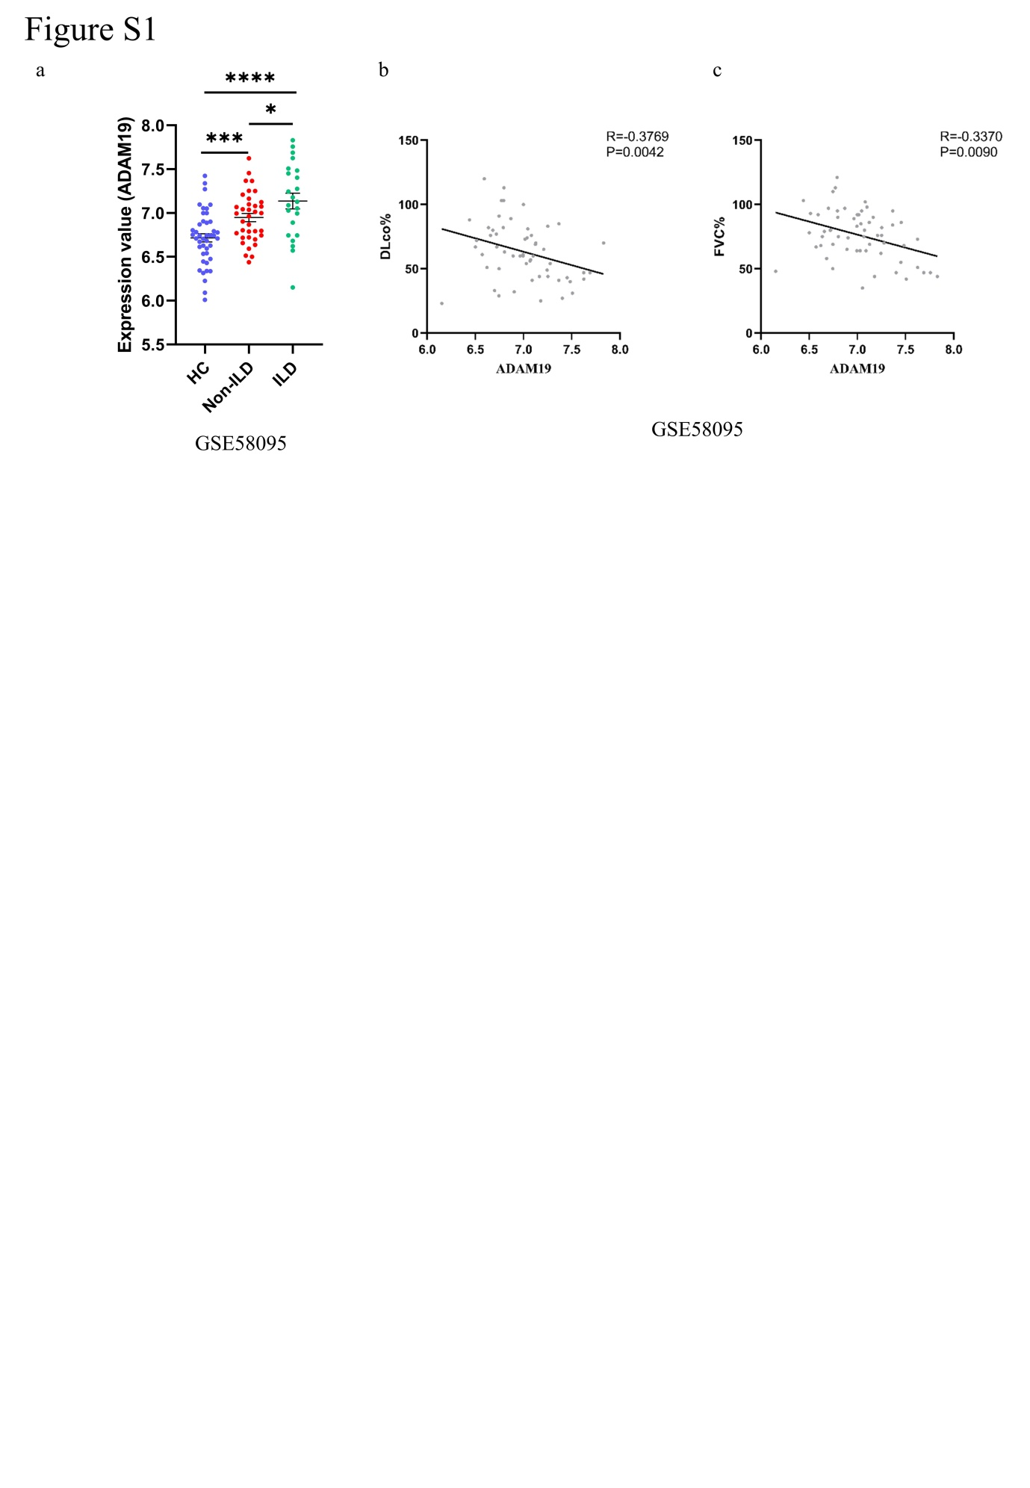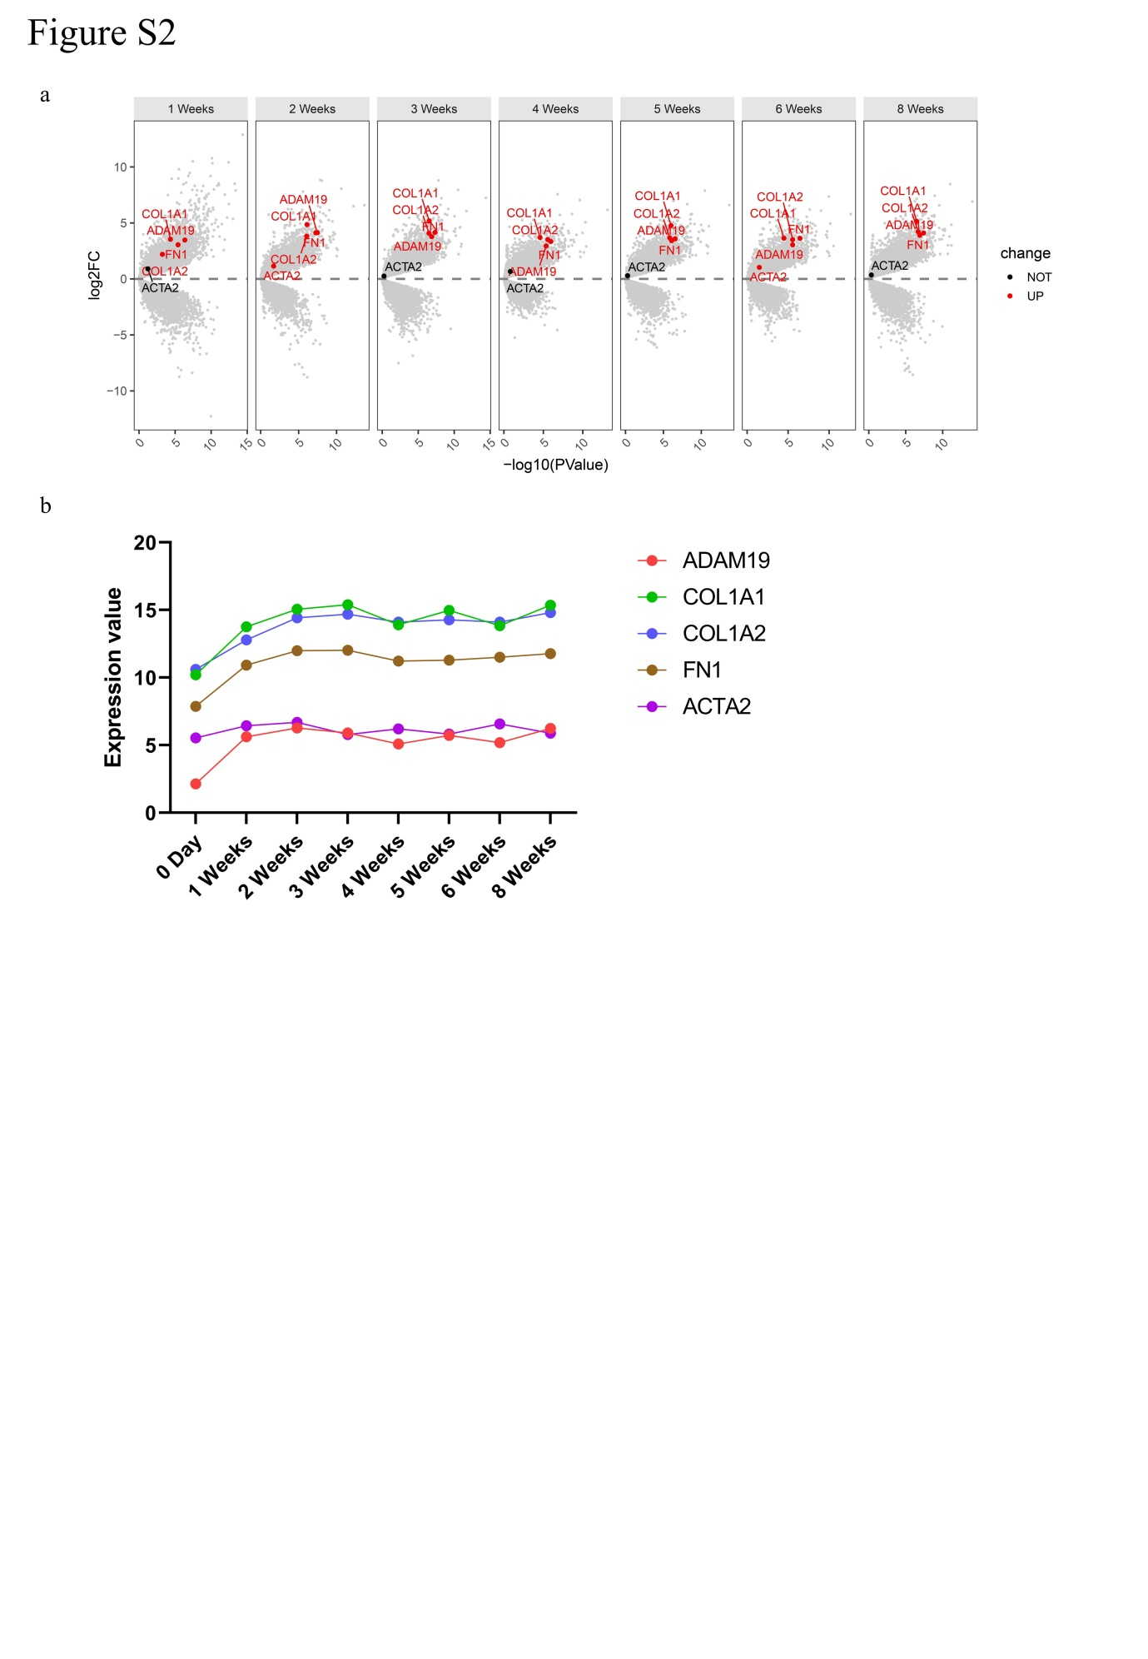
Figure S3. (a) ADAM19 gene expression in fibroblasts subpopulations of skin tissues of HC and SSc patients (GSE138669). HC, healthy controls; SSc, systemic sclerosis.
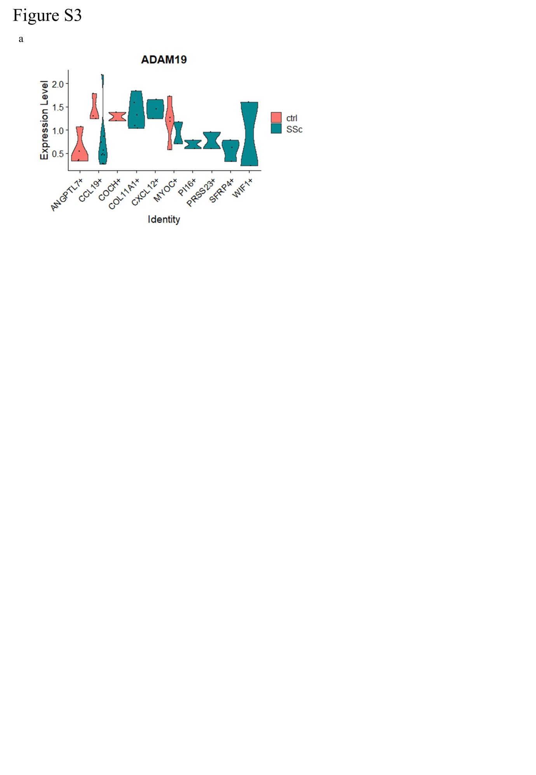
Figure S4. (a) Suppressed TGF-β related pathways in GSEA between TGF-β stimulated human primary dermal fibroblasts isolated from HC transfected with ADAM19 siRNA and negative control siRNA (Si ADAM19 TGF-β VS Si NC TGF-β). GSEA, Gene Set Enrichment Analysis; HC, healthy controls.
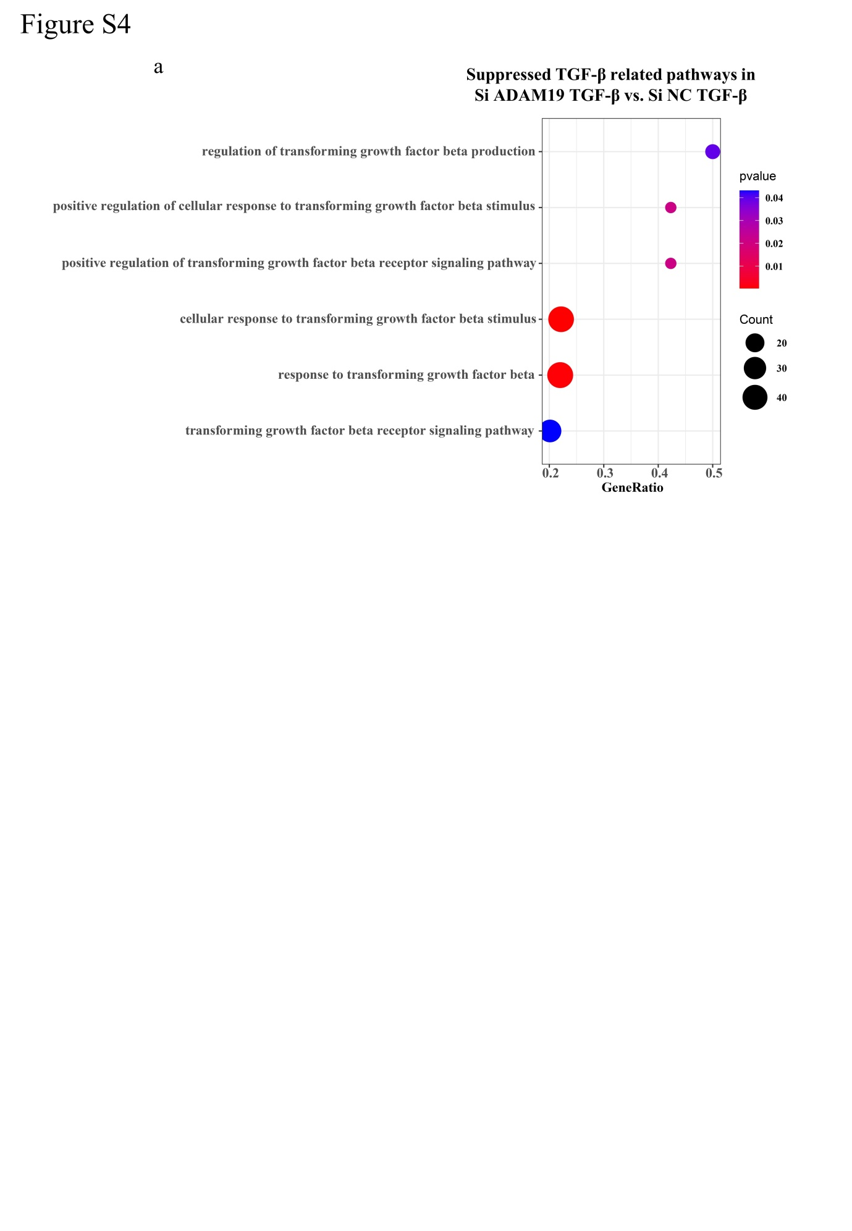 Supplementary Tables
Supplementary Table 1: The clinical characteristics of SSc patients
Patient characteristics (n=6)
Female | 83.3 %
Age (median and range) | 42 years (20 – 64)
disease duration (median and range) | 18 months (3-36)
2013 ACR/EULAR criteria fulfilled | 100 %
dcSSc | 50 %
SSc-ILD | 83.33 %
mRSS (median and range) | 12.5 (4-24)
PAH | 0 %
RP | 66.67 %
Ischemic ulcers at the time of biopsy | 16.67 %
History of ischemic ulcers | 50.0 %
Autoantibodies  ANAs  Anti-topoisomerase autoantibodies | 100 %  66.67 %

Supplementary Table 2: Primer sequences
Primer | Species | Sequence
ADAM19 forward | Human | 5’- CGAGAAGGTGAATGTGGCAGGA -3’
ADAM19 reverse | Human | 5’- AGCTCTGACACTGGATCTTCCC - 3’
ADAM19 forward | Mouse | 5’- GTGCCTCACTTACCAGGAACAG -3’
ADAM19 reverse | Mouse | 5’- GGACTGCACTTCCTGTATTGGC -3’
ACTA2 forward | Human | 5’- CTATGCCTCTGGACGCACAACT -3’
ACTA2 reverse | Human | 5’- CAGATCCAGACGCATGATGGCA -3’
ACTA2 forward | Mouse | 5’- TGCTGACAGAGGCACCACTGAA -3’
ACTA2 reverse | Mouse | 5’- CAGTTGTACGTCCAGAGGCATAG -3’
COL1A1 forward | Human | 5’- GATTCCCTGGACCTAAAGGTGC -3’
COL1A1 reverse | Human | 5’- AGCCTCTCCATCTTTGCCAGCA -3’
COL1A1 forward | Mouse | 5’- CCTCAGGGTATTGCTGGACAAC -3’
COL1A1 reverse | Mouse | 5’- CAGAAGGACCTTGTTTGCCAGG -3’
COL1A2 forward | Human | 5’- CCTGGTGCTAAAGGAGAAAGAGG -3’
COL1A2 reverse | Human | 5’- ATCACCACGACTTCCAGCAGGA -3’
COL1A2 forward | Mouse | 5’- TTCTGTGGGTCCTGCTGGGAAA -3’
COL1A2 reverse | Mouse | 5’- TTGTCACCTCGGATGCCTTGAG -3’
FN1 forward | Human | 5’- ACAACACCGAGGTGACTGAGAC -3’
FN1 reverse | Human | 5’- GGACACAACGATGCTTCCTGAG -3’
FN1 forward | Mouse | 5’- CCCTATCTCTGATACCGTTGTCC -3’
FN1 reverse | Mouse | 5’- TGCCGCAACTACTGTGATTCGG -3’
NRG1 forward | Human | 5’- GATTCCTACCGAGACTCTCCTC -3’
NRG1 reverse | Human | 5’ – TGGAAGGCATGGACACCGTCAT -3’
GAPDH forward | Human | 5’- GTCTCCTCTGACTTCAACAGCG -3’
GAPDH reverse | Human | 5’- ACCACCCTGTTGCTGTAGCCAA -3’
GAPDH forward | Mouse | 5’- CATCACTGCCACCCAGAAGACTG -3’
GAPDH reverse | Mouse | 5’- ATGCCAGTGAGCTTCCCGTTCAG -3’

