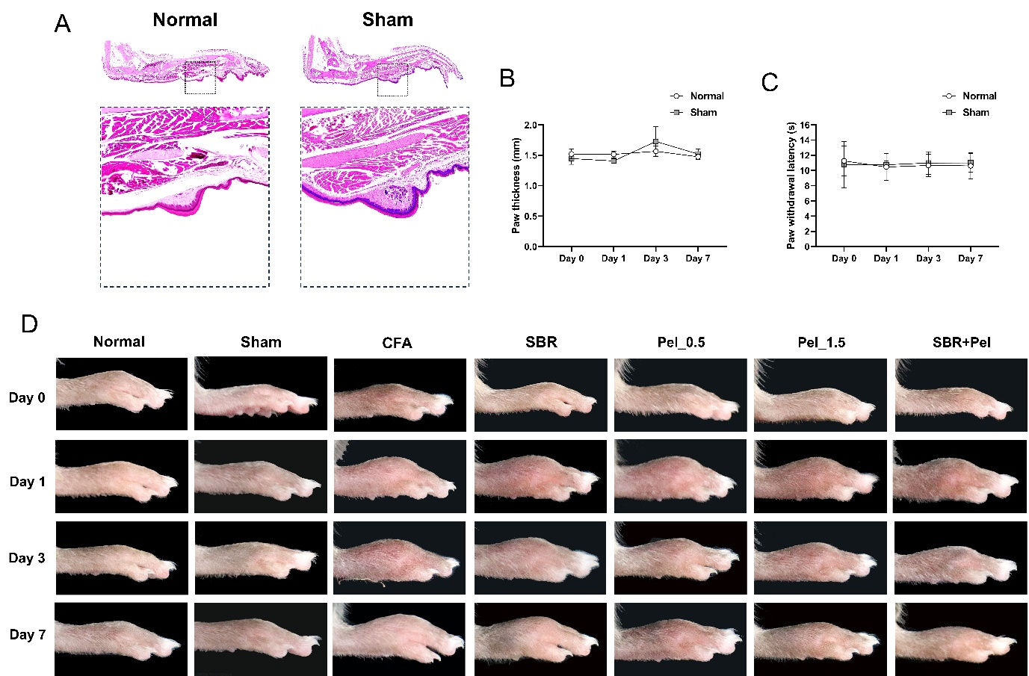Figure S1. (A) Representative H&E images of the normal and sham groups, illustrating the morphology of the paw tissue. (B) Quantitative graph of paw thickness (mm) measured on days 0, 1, 3, and 7 in the normal and sham groups. (C) Quantitative assessment of paw withdrawal latency (s) measured by von Frey test on days 0, 1, 3, and 7 in the normal and sham groups. (D) Time-course images of paw edema in each group. Representative images of the paw on days 0, 1, 3, and 7 are shown to illustrate the progression and reduction of edema over time. Data are expressed as means ± standard errors of the mean.

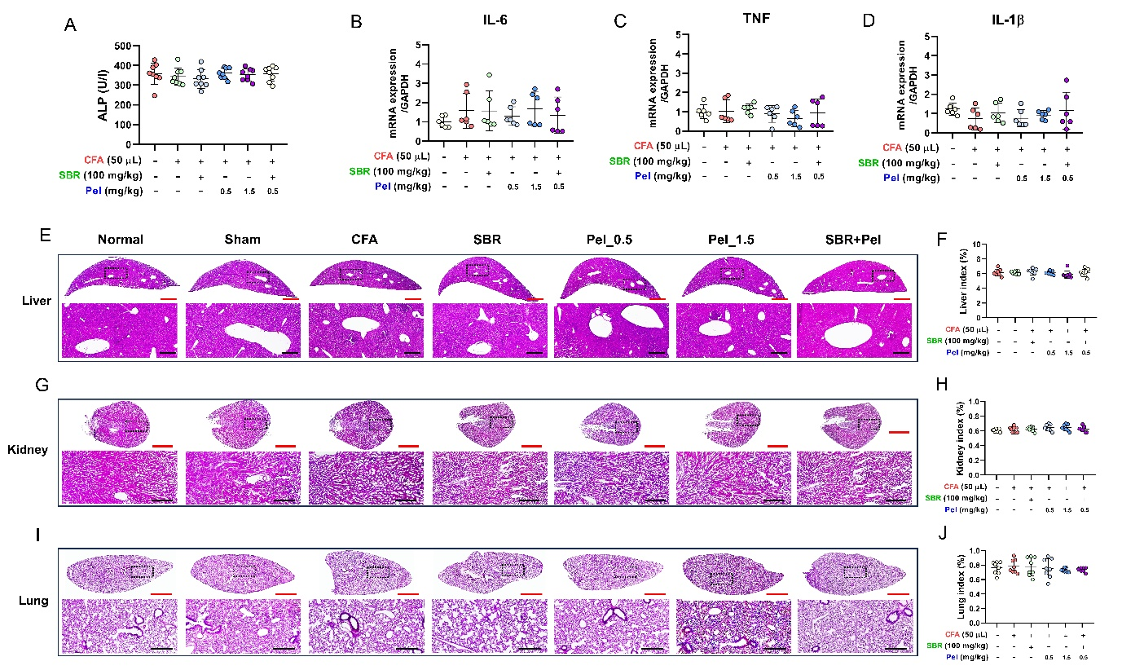Figure S2. Hepatotoxicity and histopathological assessment of liver, kidney, and lung tissues. (A) Graphs displaying serum ALP levels in each group. (B-D) Relative mRNA expression levels of liver pro-inflammatory cytokines: IL-6 (B), TNF-α (C), and IL-1β (D), analyzed by real-time PCR. (E) Representative H&E-stained images of liver tissue from each group, illustrating histopathological features. (F) Liver index (%) calculated as (liver weight/body weight) × 100. (G) Representative H&E-stained images of kidney tissue from each group (H) Kidney index (%) calculated as (kidney weight/body weight) × 100. (I) Representative H&E-stained images of lung tissue from each group. (J) Lung index (%) calculated as (lung weight/body weight) × 100. Red Scale bar = 2 mm. Black Scale bar = 400 μm. Data are expressed as means ± standard errors of the mean.

