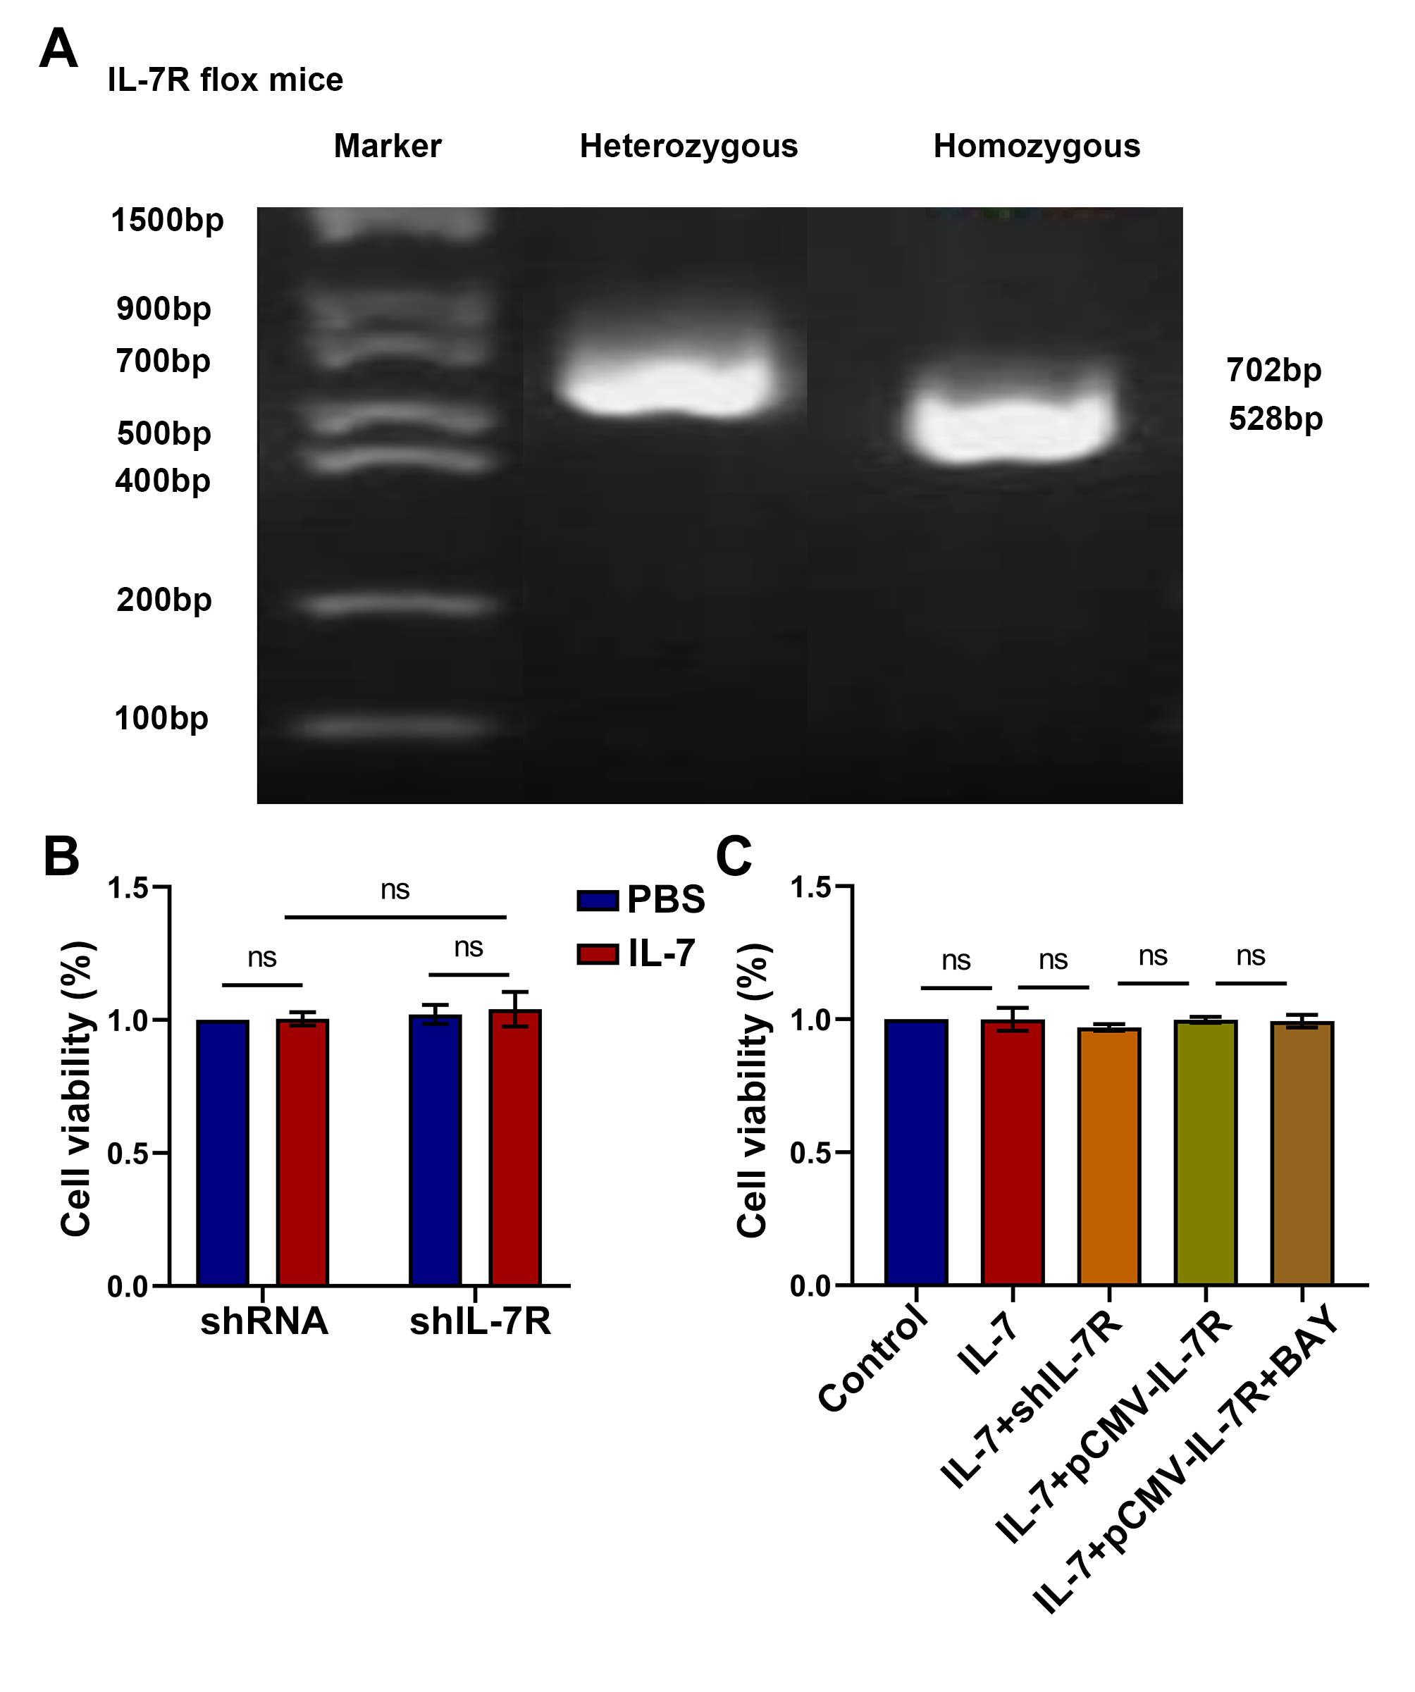
Figure S1. (A) Genotyping of IL-7R knockout mice. Detection of wild-type (WT) and IL-7R ^{flox/flox} strands. The expected PCR results are as follows: IL-7R ^{flox/flox} (homozygous) =702 bp, WT = 528 bp; (B) The viability of RAW264.7 cells was detected by CCK-8 assay; (C) The viability of RAW264.7 cells was detected by CCK-8 assay.
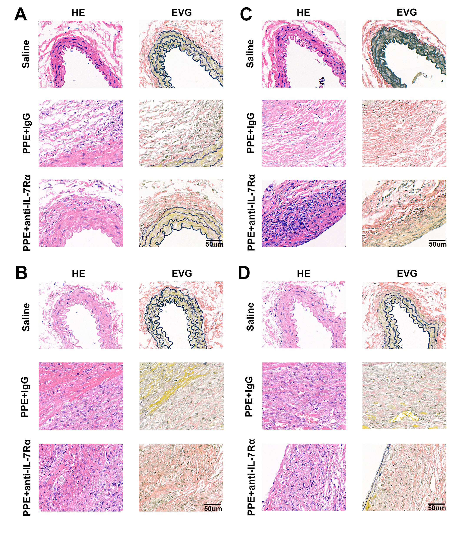
Figure S2. (A-D) Bright-field images of the same regions with HE and EVG staining of double immunofluorescence CD31 (A), α-SMA (B), CD3 (C), and CD68 (D) in Figure 2, , scale bar = 50 μm.

