Supplementary Information

Cytoplasmic HMGB1 promotes the activation of JAK2-STAT3 signaling and PD-L1 expression in breast cancer

Ju-Young Han^{1,2}, Woo Joong Rhee^{1,3,**}, Jeon-Soo Shin^{1,2,3,*}

¹Department of Microbiology, Yonsei University College of Medicine, Seoul 03722, South Korea
²Brain Korea 21 FOUR Project for Medical Science, Yonsei University College of Medicine, Seoul 03722, South Korea
³Institute for Immunology and Immunological Diseases, Yonsei University College of Medicine, Seoul 03722, South Korea

*Correspondence: jsshin6203@yuhs.ac (J.-S.S.)
Department of Microbiology, Yonsei University College of Medicine, 50-1 Yonsei-ro Seodaemun-gu, Seoul 03722, South Korea.
Tel: +82-2-2228-1816; Fax +82-2-392-7088; Email: jsshin6203@yuhs.ac

**Correspondence: wjrhee@yuhs.ac (W.J.R.)
Department of Microbiology, Yonsei University College of Medicine, 50-1 Yonsei-ro Seodaemun-gu, Seoul 03722, South Korea.
Tel: +82-2-2228-0794; Fax +82-2-392-7088; Email: wjrhee@yuhs.ac

Supplementary Figure S1. HMGB1 dimer in the cytoplasm enhances STAT3 phosphorylation in MDA-MB-231 cells. MDA-MB-231 cells were transfected with Myc-HMGB1 and Myc-(HMGB1)₂, followed by nuclear and cytoplasmic fractionation, and p-STAT3 expression was analyzed using Western blotting.

Supplementary Figure S2. HMGB1 regulates the expression of PD-L1 through the STAT3 signaling in 4T1 cells. (A, B) Immunoblots representing the expression of p-STAT3, STAT3, and PD-L1 in 4T1 cells transfected with empty vector or Myc-HMGB1 plasmid (A) or siCtrl or siHMGB1 (B). (C) Immunoblots representing the expression of p-STAT3 STAT3, and PD-L1 in 4T1 cells transfected with empty vector or Myc-HMGB1 plasmid, followed by treatment with Stattic for 16 h. For all data, n = 3 samples per group.

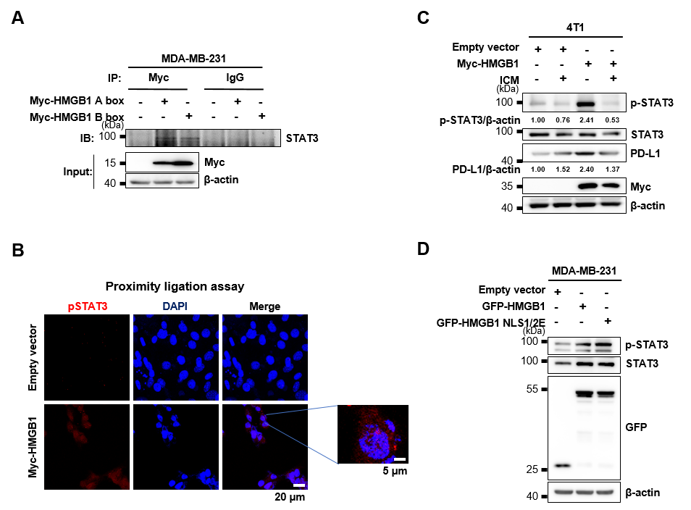Supplementary Figure S3. Localization of HMGB1 influences its interaction with STAT3 and promotion of phosphorylation. (A) Myc-tagged HMGB1 A box and B box were overexpressed in MDA-MB-231 cells, and IP was performed to determine whether A box and B box bind to STAT3. (B) MDA-MB-231 cells were transfected with Myc-HMGB1, and the localization of p-STAT3 and HMGB1 was confirmed by PLA assay. (C) Immunoblots representing the expression of p-STAT3, STAT3, and PD-L1 in 4T1 cells transfected with empty vector or Myc-HMGB1 plasmid, followed by treatment with ICM for 6 h. For all data, n = 3 samples per group. (D) Western blot showing p-STAT3 levels upon expression of GFP-HMGB1 NLS1/2E, which contains the substitution of serine residues with glutamic acid within the NLS to mimic phosphorylation for HMGB1 cytoplasmic translocation.

Supplementary Figure S4. Estimation plots for mouse tumor volumes. (A–G) Estimation plots for mouse tumor volumes between E/V-Ctrl vs. H-Ctrl (A), E/V-Ctrl vs. E/V-ICM (B), E/V-Ctrl vs. E/V-Stattic (C), E/V-ICM vs. E/V-Stattic (D), H-Ctrl vs. H-ICM (E), H-Ctrl vs. H-Stattic (F), and H-ICM vs. H-Stattic (G) groups. (H) Estimation plot for mouse tumor volumes between siCtrl vs. siHMGB1 groups. n = 8 mice per group for all comparisons. E/V, empty vector; H, HMGB1 overexpression.

