Supplementary Information

Context-Specific Applications of CARM1 Inhibitors:
Functional Profiles of EZM2302 and TP-064

Yena Cho^{1,2} and Yong Kee Kim^{1,2,}*

¹Muscle Physiome Research Center and Research Institute of Pharmaceutical Sciences, Sookmyung Women’s University, Seoul 04310, Republic of Korea
²College of Pharmacy, Sookmyung Women’s University, Seoul 04310, Republic of Korea

*Correspondence to: Yong Kee Kim, Ph.D., E-mail: yksnbk@sookmyung.ac.kr, Tel: +82-2-2077-7688, Fax.: +82-2-710-9871

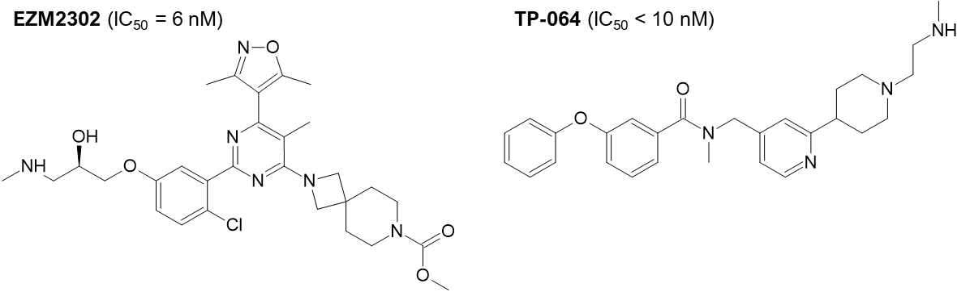
Fig. S1. Chemical structures of CARM1 inhibitors.

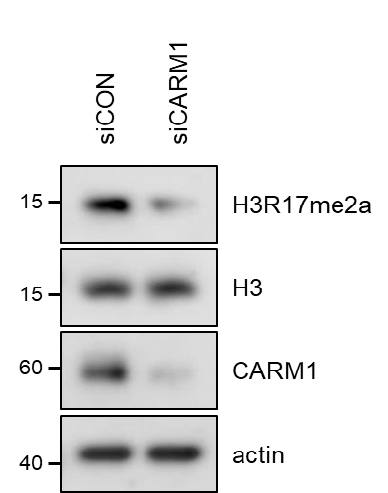
Fig. S2. Western blot analysis of H3R17me2a levels after CARM1 knockdown. After incubation with CARM1 siRNA for 72 h, cell lysates were prepared and analyzed for H3R17me2a levels by western blotting.

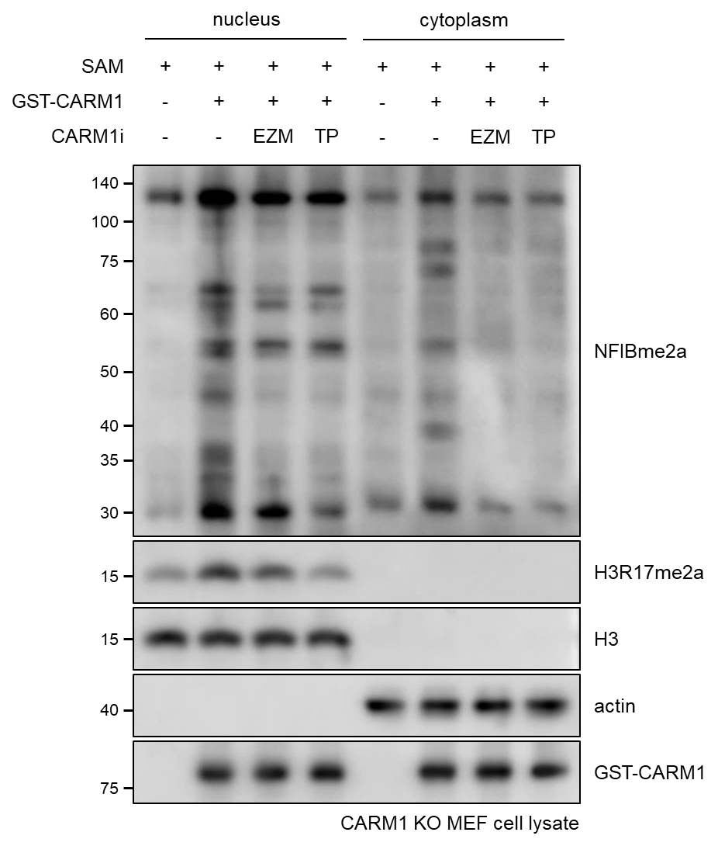
Fig. S3. In vitro methylation assay of nuclear and cytoplasmic fractions from CARM1 KO MEFs. CARM KO MEF cell lysates were fractionated into nuclear and cytoplasmic components. Each fraction was incubated in vitro with 1 μM SAM and GST-CARM1 protein in the presence or absence of CARM1 inhibitors (10 nM) for 1 h at 37 °C. Methylation levels in the nuclear and cytoplasmic fractions were assessed by western blot using NFIBme2a and H3R17me2a antibodies.

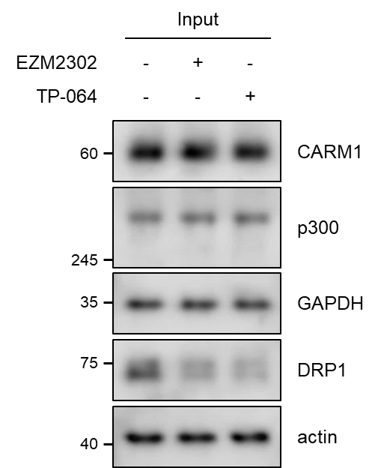
Fig. S4. Western blot analysis of p300, GAPDH, and DRP1 levels after CARM1 inhibitor treatment. After treatment with CARM1 inhibitors (1 μM, 72 h), cell lysates were prepared and subjected to immunoprecipitation using anti-p300, anti-GAPDH, or anti-DRP1 antibodies. The expression levels of p300, GAPDH, and DRP1 were examined by western blotting as input controls for Fig. 1E.
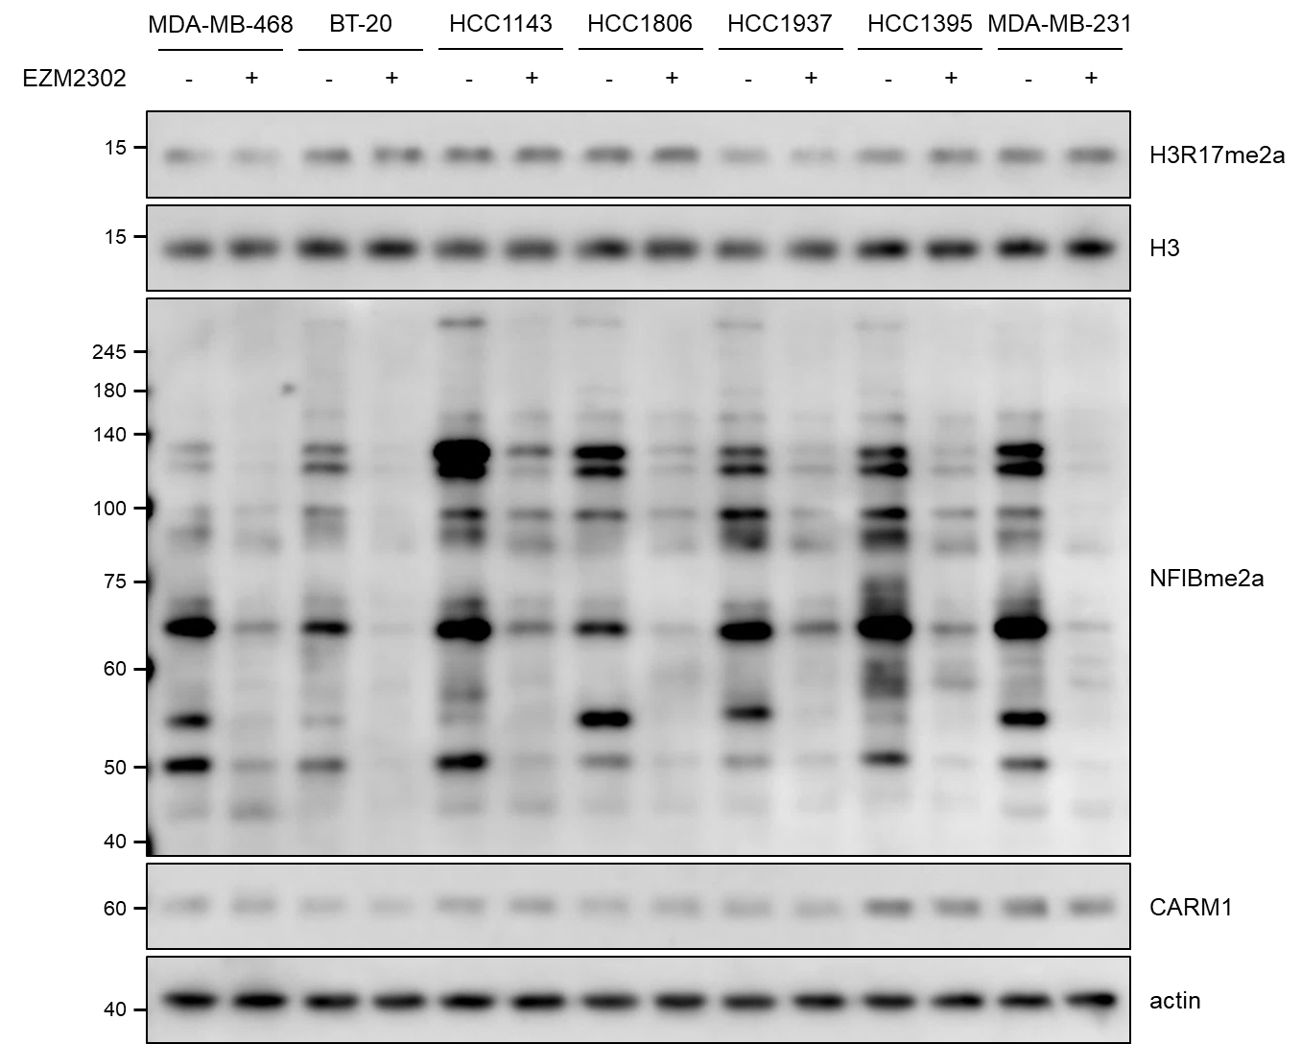
Fig. S5. Western blot analysis of histone and CARM1 substrate methylation after EZM2302 treatment in various breast cancer cell lines. After treatment with EZM2302 (1 μM, 72 h), cell lysates were prepared and analyzed for H3R17me2a and pan-CARM1 substrate methylation levels by western blotting.

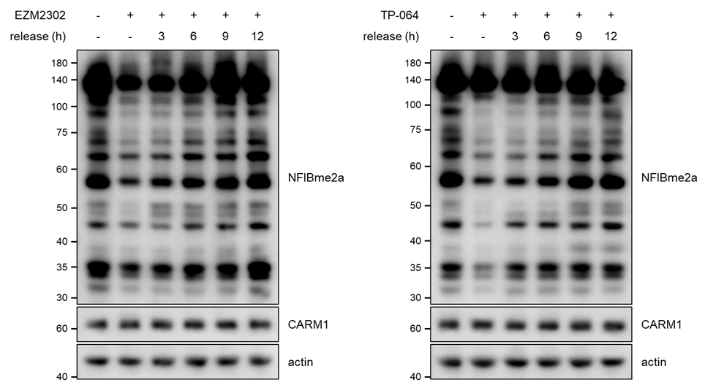
Fig. S6. Time-course analysis of reversible recovery of CARM1 activity after treatment with EZM2302 and TP-064. MEF cells were treated with EZM2302 or TP-064 for 24 h, followed by incubation in fresh medium for the indicated time periods. CARM1 substrate levels were then analyzed by western blotting.

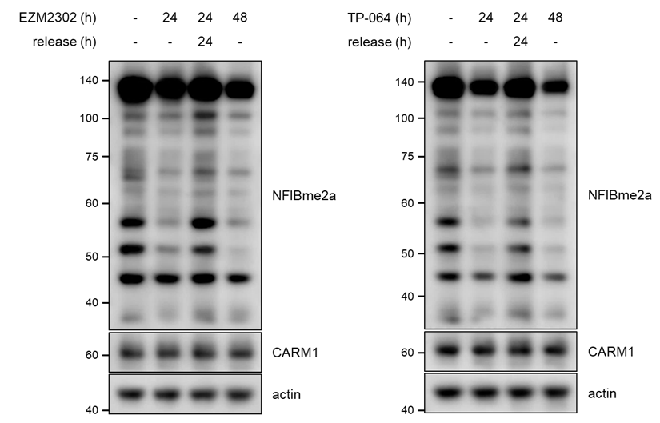
Fig. S7. Reversible recovery of CARM1 activity after treatment with EZM2302 and TP-064. HEK293T cells were treated with EZM2302 or TP-064 for 24 h, followed by an additional 24 h incubation in fresh medium. CARM1 substrate levels were then analyzed by western blotting.

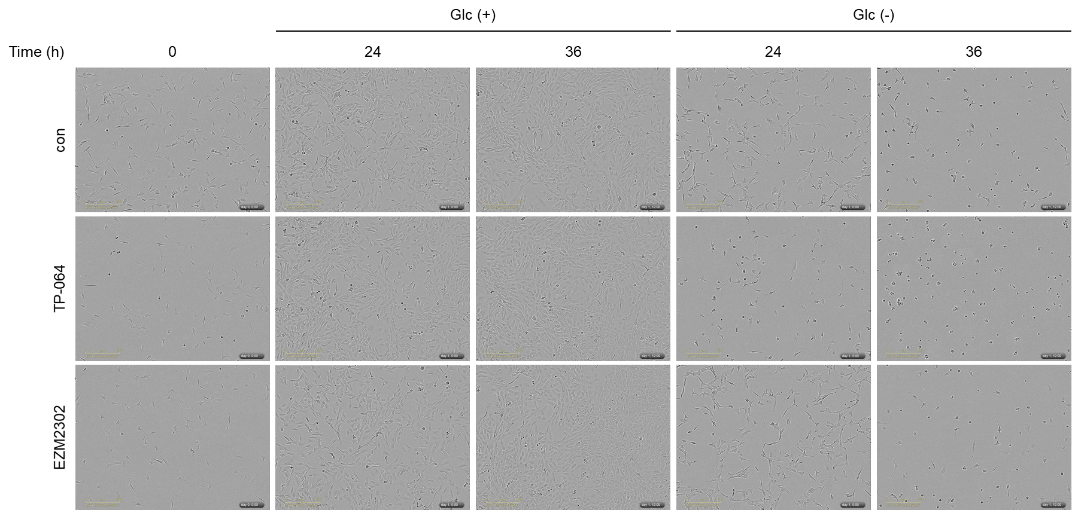
Fig. S8. Representative live cell images. MEF cells pretreated with TP-064 or EZM2302 were incubated in media with or without glucose for the indicated time periods. Relative cell growth was quantified and shown in Fig. 3F.

