Supplemental Figure 1:
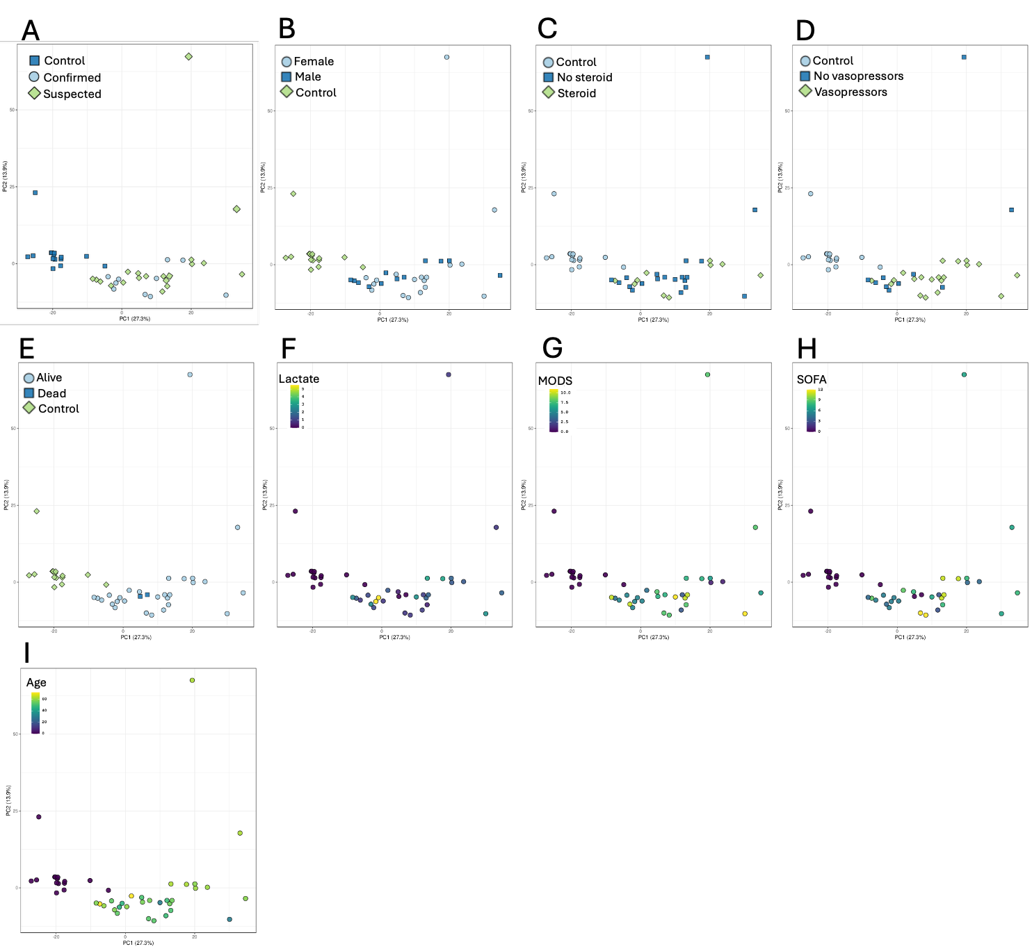

Supplemental Figure 1. Principal component analysis of the sepsis proteome stratified by clinical variables. Principal component analysis (PCA) of normalized plasma proteomic data demonstrating the distribution of sepsis samples according to clinical characteristics. Panels display the same PCA embedding as shown in the primary analysis but with samples annotated by (A) microbiologically confirmed versus suspected sepsis, (B) sex, (C) corticosteroid use, (D) vasopressor use, (E) mortality, (F) lactate, (G-H) illness severity scores, and (I) age. These analyses demonstrate that the apparent clustering observed in the PCA plot is not driven by microbiological confirmation status or by major demographic or treatment-related variables. Samples are shown for healthy controls, sepsis ICU Day 1, and sepsis ICU Day 3.

Supplemental Figure 2:

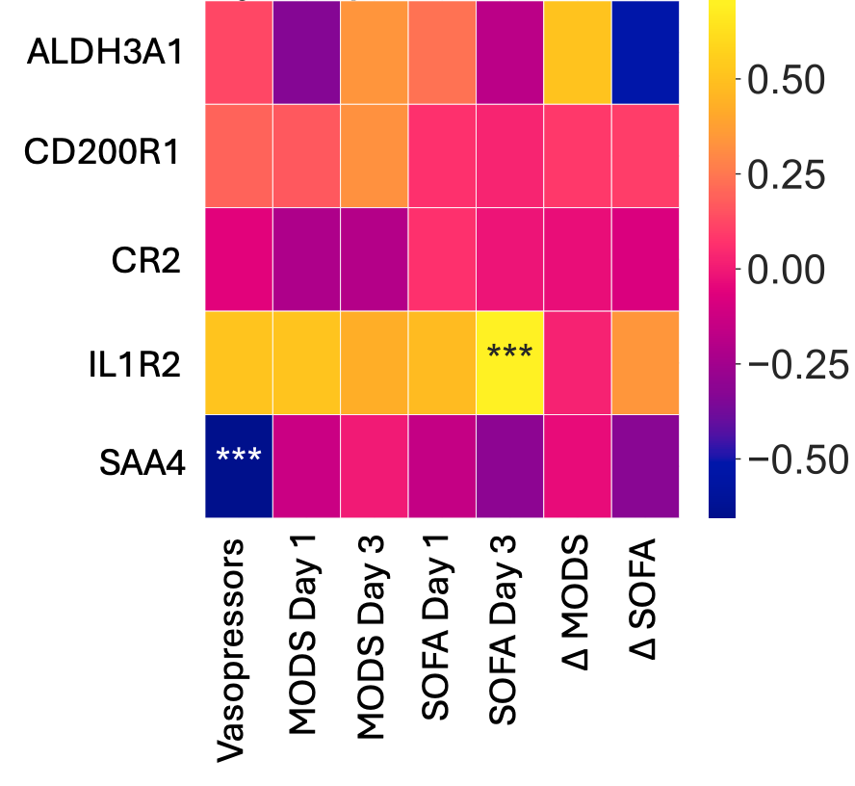

Supplemental Figure 2. Correlation of temporally dynamic proteins with clinical outcomes in sepsis patients. Correlation analyses examining relationships between the five proteins (y-axis) demonstrating significant temporal changes between ICU Day 1 and Day 3 (ALDH3A1, CR2, CD200R1, IL1RL2, and SAA4) and clinical parameters (x-axis). Associations were evaluated using Pearson correlation with clinical variables including SOFA score, MODS score, vasopressor use, and other markers of organ dysfunction. SAA4 demonstrated a significant inverse correlation with vasoactive medication use, while IL1RL2 was significantly correlated with SOFA scores on ICU Day 3. The remaining proteins did not demonstrate significant associations with the evaluated clinical parameters.

