Supplementary Table 1: Detailed information about cases which showed discordance between primary pathology reports and central pathology re-review reports (see also Supplementary Figure 1).
Primary diagnosis | Diagnosis after central pathology re-review | n (%) | Total
TaLG (n=63) | Mixed LG + HG | 17 (27%) | 17 (27%)
TaHG (n=41) | TaLG with low tumor load | 7 (17%) | 12 (29.2%)
TaHG (n=41) | TaLG with high tumor load | 3 (7.3%) | 12 (29.2%)
TaHG (n=41) | Only Tis | 2 (4.9%) | 12 (29.2%)
T1HG (n=139) | TaLG with low tumor load | 2 (1.4%) | 61 (43.9%)
T1HG (n=139) | TaHG with low tumor load | 21 (15.1%) | 61 (43.9%)
T1HG (n=139) | TaHG with high tumor load | 14 (10.1%) | 61 (43.9%)
T1HG (n=139) | Mixed TaHG + T1HG | 24 (17.3%) | 61 (43.9%)
Total (n=264) |  |  | 90 (34.1%)
All values are given as n (%).

LG: low grade, HG: High grade.

Supplementary Table 2: Adjuvant intravesical treatment status of BCG-indicated tumors.
Treatment | T1HG tumors  n=33 | TaHG tumors  n=16 | Tis tumors  n=5 | All HR tumors  n=54
BCG induction planned | 31  (93.9%) | 13  (81.3%) | 3  (60%) | 47  (87%)
BCG induction received | 26  (78.8%) | 12  (75%) | 3  (60%) | 41  (75.9%)
Adequate BCG induction | 26  (78.8%) | 11  (68.5%) | 3  (76.3%) | 40  (74%)
BCG maintenance planned | 23  (69.7%) | 11  (68.5%) | 0  (60%) | 34  (63%)
BCG maintenance received | 22  (66.6%) | 10  (62.5%) | 0  (0%) | 32  (59.3%)
Adequate BCG maintenance | 21  (63.6%) | 10  (62.5%) | 0  (0%) | 31  (57.4%)
All values are given as n (%).

BCG: Bacillus Calmette-Guérin, HG: High grade, HR: High-risk.

Supplementary Figure 1: The flowchart of patient selection and inclusion. A) Study cohort selection, B) Subgroup reconstruction. Following central pathology re-review, discordance with the original diagnosis was identified in a subset of cases, primarily involving reassignment of tumor stage and/or grade. These discordant cases are indicated in the boxes between the “Screened” and “RNA extracted” steps. Cases with discordant diagnoses and sufficient tumor load (indicated in bold) were reclassified according to central review and included in the appropriate subgroups, whereas cases with insufficient tumor load were excluded from further analysis, irrespective of concordance status.
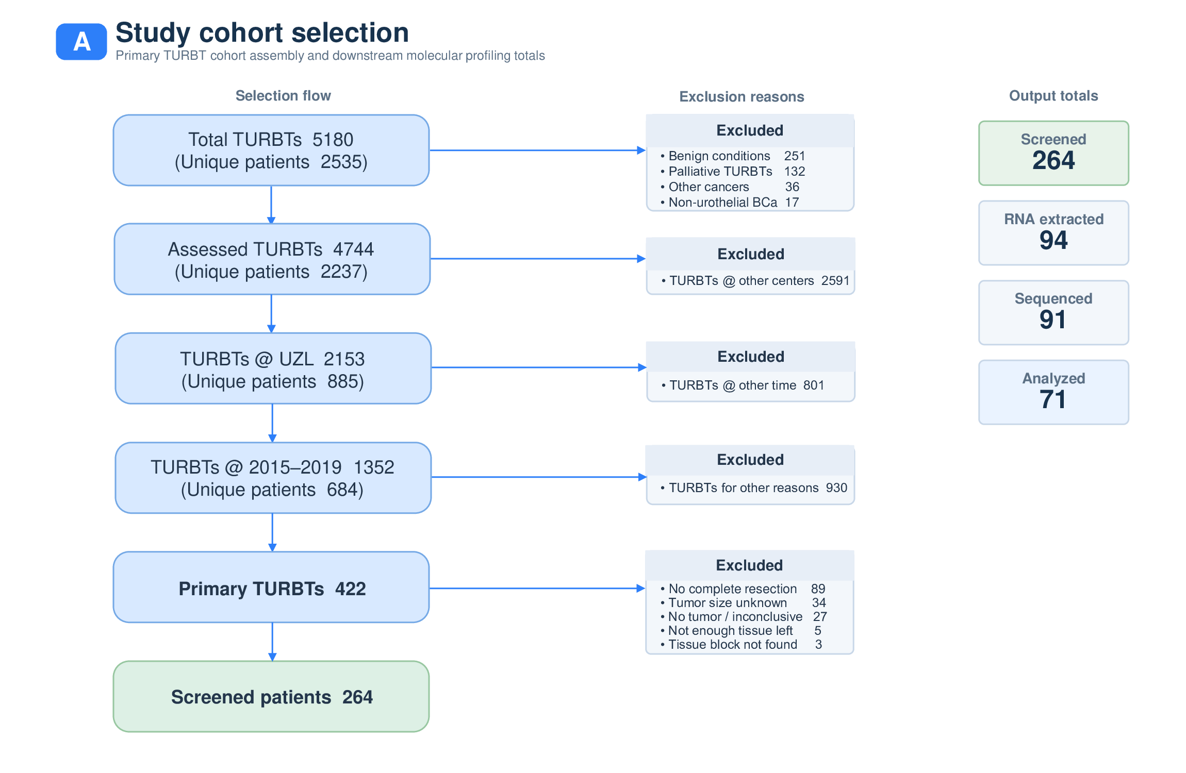

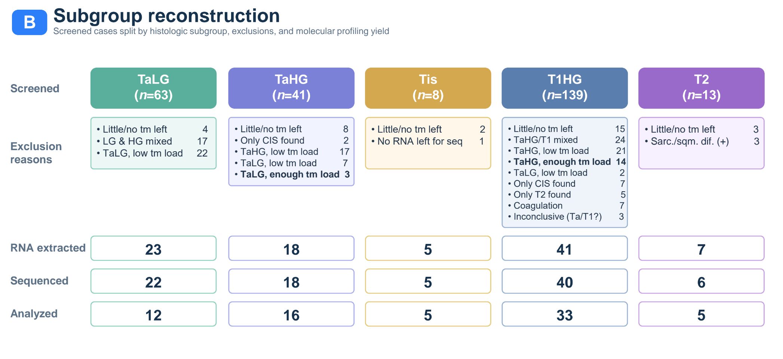

Supplementary Figure 2: Overview of molecular and clinical associations in patients with A) progression, B) recurrence, and C) recurrence or death within two years.
Top panels: Differentially upregulated or downregulated biological hallmark pathways in ≤T1 tumors, identified by gene set enrichment analysis (GSEA) and ranked by normalized enrichment score. Significance is indicated by –log₁₀(q-value).
Middle panels: Transcriptomic subclassification of Ta/Tis and T1 tumors using four molecular frameworks: UROMOL2021, BRS, Lund Taxonomy 2023, and Consensus MIBC subtypes. q-values are from the chi-square test and Benjamini–Hochberg corrected.
Bottom panels: Kaplan–Meier overall survival (OS) curves for all patients. Log-rank p-values are indicated, and numbers at risk are shown below each plot.

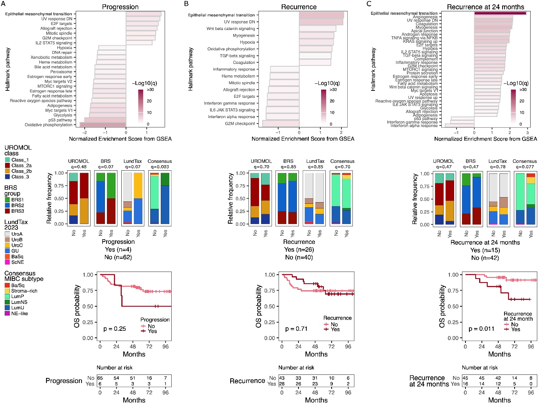

Supplementary Figure 3: Phenotypic scores were calculated for patients who experienced progression (top left panel), recurrence (middle left panel), and recurrence or death within two years (bottom left panel). A significant difference was detected only for the stromal phenotype in the progression cohort (q=0.05). The corresponding immune-cell fractions, quantified with quanTIseq, are shown in the right panels; none of these comparisons reached statistical significance. Box plots display the median (center line), interquartile range (IQR, box), and 1.5 × IQR whiskers; individual points represent outliers. Reported q-values are Benjamini–Hochberg false discovery rate-adjusted Wilcoxon rank-sum p-values.

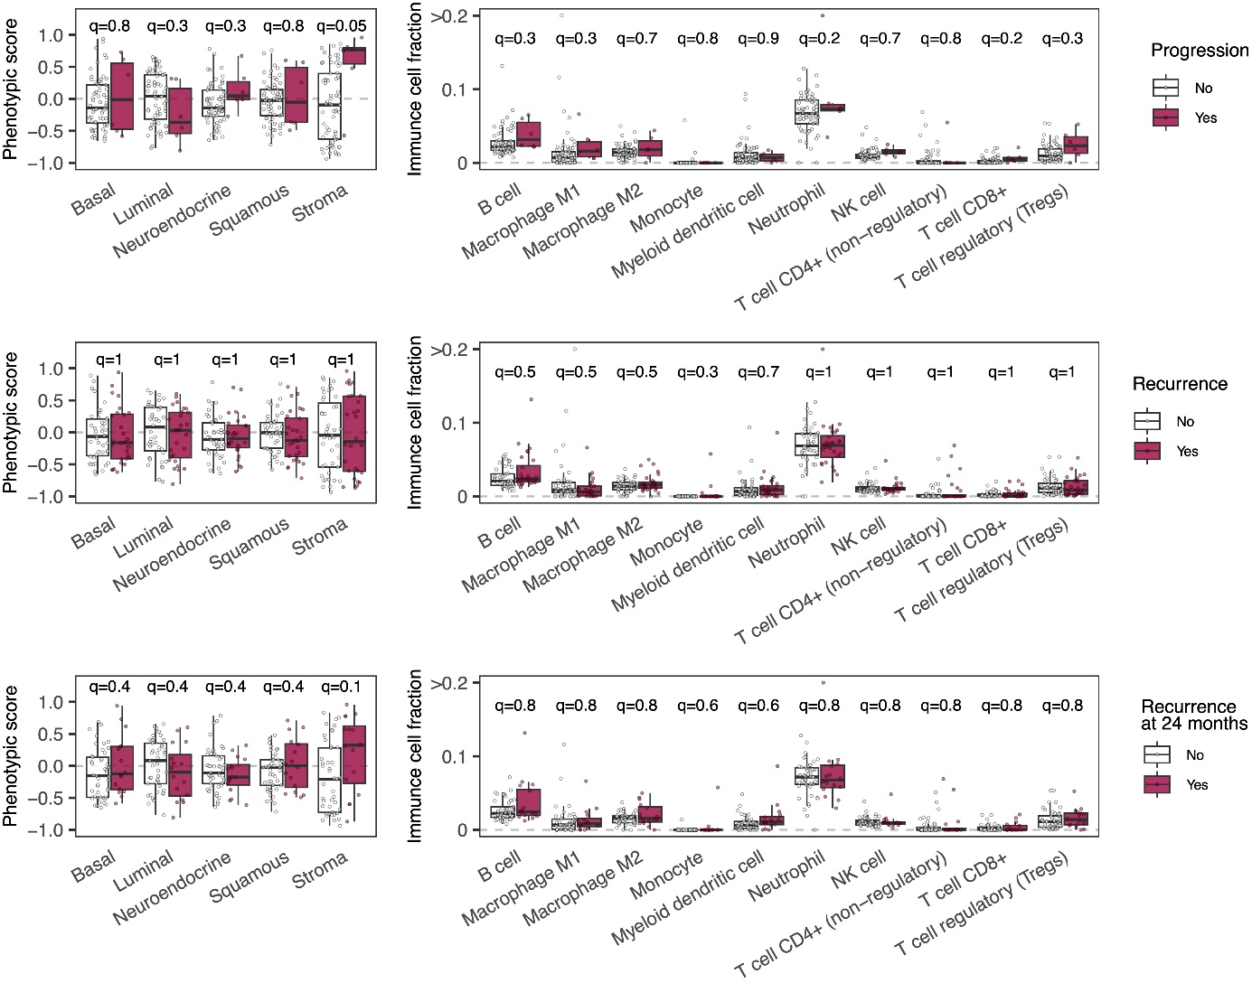

Supplementary Figure 4:
Left panel: Differentially upregulated or downregulated biological hallmark pathways in tumors with early recurrences (≤24 months), identified by gene set enrichment analysis (GSEA) and ranked by normalized enrichment score. Significance is indicated by –log₁₀(q-value).
Middle panel: Transcriptomic subclassification of tumors with early vs. late recurrence using four molecular frameworks: UROMOL2021, BRS, Lund Taxonomy 2023, and Consensus MIBC subtypes. q-values are from chi-square test (Benjamini–Hochberg corrected).
Right panel: T-stage, EORTC, and CUETO recurrence risks, and age distribution of tumors with early vs. late recurrence.

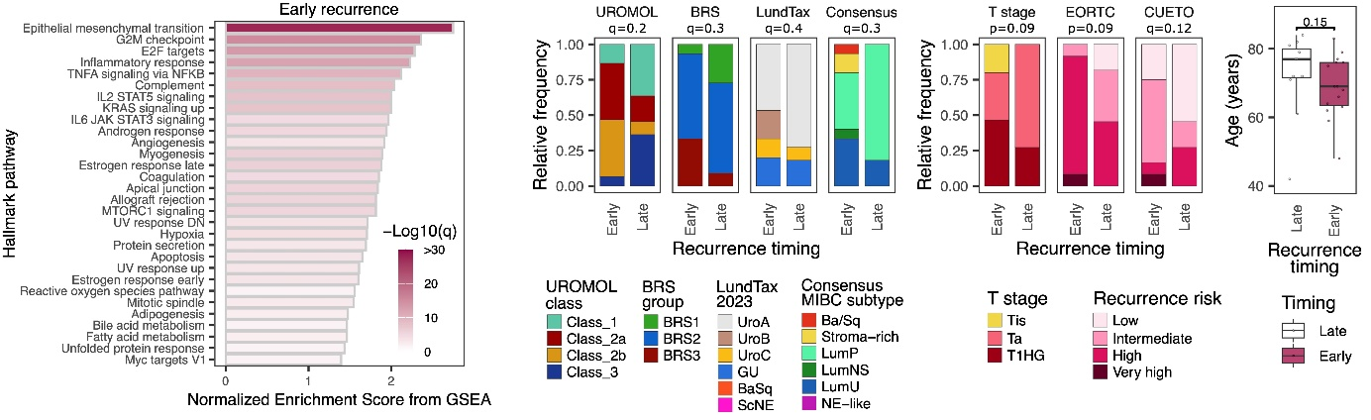

Supplementary Figure 5: A) FAP expression across tumor stages in the Leuven cohort (Kruskal–Wallis test). The T2 group consists of 5 patients from the same cohort, as described in Table 1. Sample sizes (n) for each group are indicated in the figure explicitly and are also shown as dots for individual samples. B) Comparison of FAP expression in patients with progression, recurrence, recurrence at 24 months cut-off, and death. Q-values were adjusted using the Benjamini–Hochberg false discovery rate method.

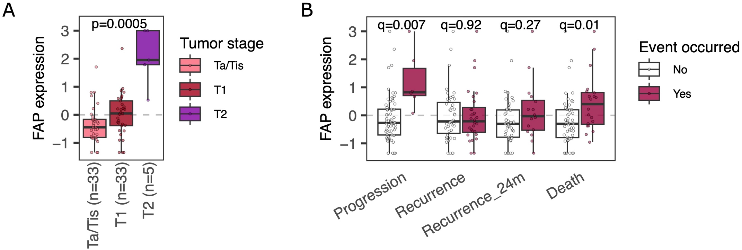

Supplementary Figure 6: Kaplan–Meier curves for overall (OS), cancer-specific (CSS), recurrence-free (RFS), and progression-free (PFS) survivals for FAP-high and FAP-low tumors in all Leuven cohort patients (n=71). Kaplan–Meier survival curves were compared with the log-rank test.

