Supplemental Data

Single-cell profiling reveals that PDK4 and impaired VEGF-C/VEGFR3 signaling drive lymphatic endothelial cell dysfunction in the diabetic heart

Yufeng Yan¹†, Xunuo Wang¹†,Congfei Zhu², Zihao Jiang¹, Jing Wang¹,Junjie He², Lei Xu², Xiaobin Zhou², Qing Ge¹*, Zuoying Hu¹*, Guangfeng Zuo¹*

Table S1. Primary antibodies used for Western Blotting
Antibody | Working dilution | Catalog No. | Supplier | RRID
PDK4 | WB: 1:1000 | 12949-1-AP | Proteintech | AB_2161499
β-actin | WB: 1:5000 | 66009-1-Ig | Proteintech | AB_2687938
VEGFC | WB: 1:1000 | 22601-1-AP | Proteintech | AB_2879132

Table S2. Sequences of siRNA
PDK4 | Sequences
SiRNA-1 | 5'-GACCGCCUCUUUAGUUACATT- 3'
SiRNA-1 | 5'-UGUAACUAAAGAGGCGGUCTT- 3'
SiRNA-2 | 5'-CUCCCAGUCUUUAACAAGUTT-3'
SiRNA-2 | 5'-ACUUGUUAAAGACUGGGAGTT- 3'
SiRNA-3 | 5'-GCCUUUGAGUGUGCAAAGATT- 3'
SiRNA-3 | 5'-UCUUUGCACACUCAAAGGCTT- 3'

Table S3. Markers of all cell types
celltype | geneName | reference
B_cells | Cd79a | Article
B_cells | Cd79b | Article
B_cells | Cd19 | Article
B_cells | Ms4a1 | PMID:32795101;PMID:33296652
Cardiomyocytes | Ttn | PMID:32795101
Cardiomyocytes | Myh6 | PMID:33296652
Endocardial_cells | Npr3 | PMID:32795101
Endothelial_cells | Pecam1 | PMID:32795101
Endothelial_cells | Cdh5 | PMID:33296652
Endothelial_cells | Flt1 | Article
Epicardial_cells | Msln | PMID:32795101;PMID:33296652
Fibroblasts | Dcn | Article
Fibroblasts | Col1a1 | Article
Fibroblasts | Col1a2 | Article
Fibroblasts | Pdgfra | PMID:32795101;PMID:33296652
Immune | Ptprc | PMID:32795101
Macrophages | Csf1r | Article
Macrophages | C1qa | Article
Macrophages | Ms4a7 | Article
Macrophages | Fcgr1 | PMID:32795101
Macrophages | Adgre1 | PMID:33296652
Neutrophils | S100a8 | Article
Neutrophils | S100a9 | PMID:32795101;PMID:33296652
Neutrophils | Csf3r | Article
NK_cells | Ncr1 | PMID:32795101
NK_cells | Nkg7 | Article
NK_cells | Klrd1 | Article
Pericytes | Pdgfrb | PMID:32795101
Pericytes | Kcnj8 | PMID:33296652
Pericytes | Cald1 | Article
Pericytes | Rgs5 | Article
Schwann_cells | Cdh19 | Article
Schwann_cells | Sox10 | Article
Schwann_cells | Plp1 | PMID:32795101;PMID:33296652
Smooth_muscle_cells | Myl9 | Article
Smooth_muscle_cells | Tagln | Article
Smooth_muscle_cells | Acta2 | PMID:32795101
Smooth_muscle_cells | Myh11 | PMID:33296652
T_cells | Cd3d | Article
T_cells | Trac | Article
T_cells | Cd3e | PMID:32795101
T_cells | Cd3g | PMID:33296652

TableS4. Comparison of cell cluster proportions between Control and DCM groups.
cell_group | Ctrl number | Ctrl proportion | DCM number | DCM proportion | pvalue
Total | 29900 | 100% | 31848 | 100% | -
0 | 3853 | 12.89% | 4739 | 14.88% | 0.04344
1 | 3697 | 12.36% | 3675 | 11.54% | 0.23295
2 | 2761 | 9.23% | 4151 | 13.03% | 3.00E-04
3 | 3426 | 11.46% | 2569 | 8.07% | 0.00053
4 | 2494 | 8.34% | 2081 | 6.53% | 0.02222
5 | 1837 | 6.14% | 1925 | 6.04% | 0.45798
6 | 1375 | 4.60% | 1328 | 4.17% | 0.27732
7 | 1337 | 4.47% | 1364 | 4.28% | 0.40802
8 | 1136 | 3.80% | 1301 | 4.09% | 0.33301
9 | 994 | 3.32% | 1283 | 4.03% | 0.15304
10 | 960 | 3.21% | 1311 | 4.12% | 0.08348
11 | 669 | 2.24% | 637 | 2% | 0.31648
12 | 444 | 1.48% | 742 | 2.33% | 0.03876
13 | 510 | 1.71% | 498 | 1.56% | 0.37366
14 | 496 | 1.66% | 474 | 1.49% | 0.33588
15 | 209 | 0.70% | 664 | 2.08% | 0.00034
16 | 466 | 1.56% | 276 | 0.87% | 0.03508
17 | 489 | 1.64% | 247 | 0.78% | 0.01165
18 | 303 | 1.01% | 385 | 1.21% | 0.29559
19 | 313 | 1.05% | 301 | 0.95% | 0.38411
20 | 266 | 0.89% | 343 | 1.08% | 0.29639
21 | 341 | 1.14% | 237 | 0.74% | 0.12113
22 | 208 | 0.70% | 227 | 0.71% | 0.48051
23 | 252 | 0.84% | 159 | 0.50% | 0.11361
24 | 332 | 1.11% | 59 | 0.19% | 0.00036
25 | 99 | 0.33% | 228 | 0.72% | 0.06864
26 | 166 | 0.56% | 124 | 0.39% | 0.24192
27 | 101 | 0.34% | 114 | 0.36% | 0.45951
28 | 108 | 0.36% | 81 | 0.25% | 0.28669
29 | 83 | 0.28% | 91 | 0.29% | 0.47328
30 | 96 | 0.32% | 75 | 0.24% | 0.31346
31 | 46 | 0.15% | 74 | 0.23% | 0.29592
32 | 14 | 0.05% | 37 | 0.12% | 0.23033
33 | 10 | 0.03% | 41 | 0.13% | 0.16566
34 | 9 | 0.03% | 7 | 0.02% | 0.39424

TableS5. Comparison of cell cluster proportions between Control and DCM groups.
cell_group | Ctrl number | Ctrl number | DCM number | DCM proportion | pvalue
Total | 29900 | 100% | 31848 | 100% | -
B_cells | 108 | 0.36% | 81 | 0.25% | 0.2861
Cardiomyocytes | 4706 | 15.74% | 6940 | 21.79% | 1.00E-05
Endocardial_cells | 3996 | 13.36% | 3641 | 11.43% | 0.0439
Endothelial_cells | 5859 | 19.60% | 6740 | 21.16% | 0.11906
Epicardial_cells | 209 | 0.70% | 664 | 2.08% | 0.00035
Fibroblasts | 6574 | 21.99% | 6957 | 21.84% | 0.457
LowQuality_cell | 1136 | 3.80% | 1301 | 4.09% | 0.33006
Macrophages | 4351 | 14.55% | 3024 | 9.50% | 1.00E-05
Macrophages_and_Neutrophils | 489 | 1.64% | 247 | 0.78% | 0.01153
NK_and_T_cells | 466 | 1.56% | 276 | 0.87% | 0.03452
Pericytes | 1688 | 5.65% | 1629 | 5.11% | 0.25322
Schwann_cells | 110 | 0.37% | 121 | 0.38% | 0.47191
Smooth_muscle_cells | 208 | 0.70% | 227 | 0.71% | 0.4792

TableS6.Comparison of cell Endothelial cluster proportions between Control and DCM groups

cell_group | Ctrl_number | Ctrl_ _proportion | DCM _number | DCM proportion | pvalue
Totlal | 5859 | 100% | 6740 | 100%
0 | 1987 | 33.91% | 2831 | 42% | 0.02828
1 | 1638 | 27.96% | 1826 | 27.09% | 0.4489
2 | 1478 | 25.23% | 1318 | 19.55% | 0.03078
3 | 571 | 9.75% | 565 | 8.38% | 0.37046
4 | 90 | 1.54% | 76 | 1.13% | 0.33306
5 | 58 | 0.99% | 67 | 0.99% | 0.42623
6 | 10 | 0.17% | 17 | 0.25% | 0.30835
7 | 12 | 0.20% | 13 | 0.19% | 0.43239
8 | 7 | 0.12% | 16 | 0.24% | 0.27364
9 | 8 | 0.14% | 11 | 0.16% | 0.37098

TableS7. Comparison of cell Endothelial subpopulation proportions between Control and DCM groups
cell_group | Ctrl number | Ctrl proportion | DCM  number | DCM proportion | pvalue
Total | 5859 | 100% | 6740 | 100%
Arterial_ECs | 1648 | 28.13% | 1843 | 27.34% | 0.46037
Capillary_ECs | 2006 | 34.24% | 2860 | 42.43% | 0.02784
Lymphatic_ECs | 661 | 11.28% | 641 | 9.51% | 0.33902
Mixed_ECs | 66 | 1.13% | 78 | 1.16% | 0.45147
Venous_ECs | 1478 | 25.23% | 1318 | 19.55% | 0.03213

TableS8. Comparison of lymphatic endothelial cell subpopulation identified in control and DCM mouse hearts
cell_group | Ctrl_number | Ctrl_proportion | DCM_number | DCM_proportion | pvalue
toal | 661 | 100.00% | 641 | 100.00% | -
0 | 272 | 41.15% | 261 | 40.72% | 0.4839
1 | 184 | 27.84% | 199 | 31.05% | 0.3764
2 | 83 | 12.56% | 67 | 10.45% | 0.3778
3 | 37 | 5.60% | 32 | 4.99% | 0.4092
4 | 22 | 3.33% | 35 | 5.46% | 0.2853
5 | 26 | 3.93% | 16 | 2.50% | 0.3363
6 | 25 | 3.78% | 12 | 1.87% | 0.3015
7 | 5 | 0.76% | 14 | 2.18% | 0.2798
8 | 7 | 1.06% | 5 | 0.78% | 0.3266

Table S9. Comparison of proliferative index among LEC subclusters between control and diabetic (DCM) hearts

Cluster | ctrl |  |  | DCM |  |  | p value
Cluster | Prolif_Index | Prolif_Count | Total_Cells | Prolif_Index | Prolif_Count | Total_Cells | p value
Total | 45.1 | 298 | 641 | 39.2 | 251 | 641 | 0.032946
0 | 52.57353 | 143 | 272 | 39.4636 | 103 | 261 | 0.003092
1 | 51.63043 | 95 | 184 | 46.73367 | 93 | 199 | 0.358286
2 | 32.53012 | 27 | 83 | 31.34328 | 21 | 67 | 1
3 | 18.91892 | 7 | 37 | 21.875 | 7 | 32 | 0.773702
4 | 31.81818 | 7 | 22 | 25.71429 | 9 | 35 | 0.763439
5 | 30.76923 | 8 | 26 | 43.75 | 7 | 16 | 0.511281
6 | 28 | 7 | 25 | 25 | 3 | 12 | 1
7 | 60 | 3 | 5 | 35.71429 | 5 | 14 | 0.602683
8 | 14.28571 | 1 | 7 | 60 | 3 | 5 | 0.222222

Fig. S1 Evaluation of cardiac injury.
(A) Representative Doppler echocardiographic images (EF%) and quantification of ratio between early and late mitral diastolic waves (E/A ratio) (n=6). (B) Representative images of H&E, WGA and Masson’s trichrome staining of cardiac tissues .Scale bars, 1 mm for H&E; 50μm for WGA; 1 mm and 0.05MM for Masson’s trichrome staining. (C) Quantification of cardiac fibrosis area in Masson’s trichrome staining.n = 6.(D) Quantification of myocyte area in WGA staining.n = 6.(E) Continuous body weight detection of Control and DCM mice (n=6).(F) Intraperitoneal glucose tolerance test (GTT) of Control and DCM mice (n=6). (G) Insulin Tolerance Test (ITT) of Control and DCM mice (n=6). Significance was assessed by the Student t test. *p < 0.05, **p < 0.01, ***p < 0.001, ****p < 0.0001, ns, not significant.

Fig. S2 Characterization assessment of individual cell cluster.
(A)Heat map displaying the top 10 differentially expressed genes in each ECs cluster.
Certain genes (e.g., Reln, Mmrn1, and Cp) appear multiple times on the x-axis. These genes were independently identified as top differentially expressed markers for multiple adjacent lymphatic endothelial cell (LEC) sub-clusters by the "One vs. Rest" algorithm.(B)Representation of key genes defining diverse vascular types within each subcategory (arterial: "Efnb2", "Sema3g"; venous: "Ephb4", "Nr2f2"; Capillary: "Btnl9","Cd36"; lymphatic: "Lyve1", "Prox1").

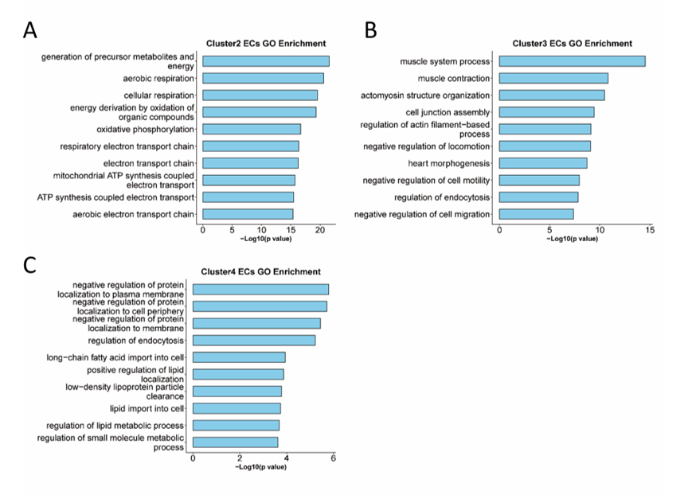
Fig. S3 A-B.GO analysis of differentially expressed genes between DCM and control groups within each endothelial cell cluster(2,3 and 4).

Fig.S4 The heatmap shows the top 5 genes with the largest fold changes between 3 cluster and 4 cluster ECs.

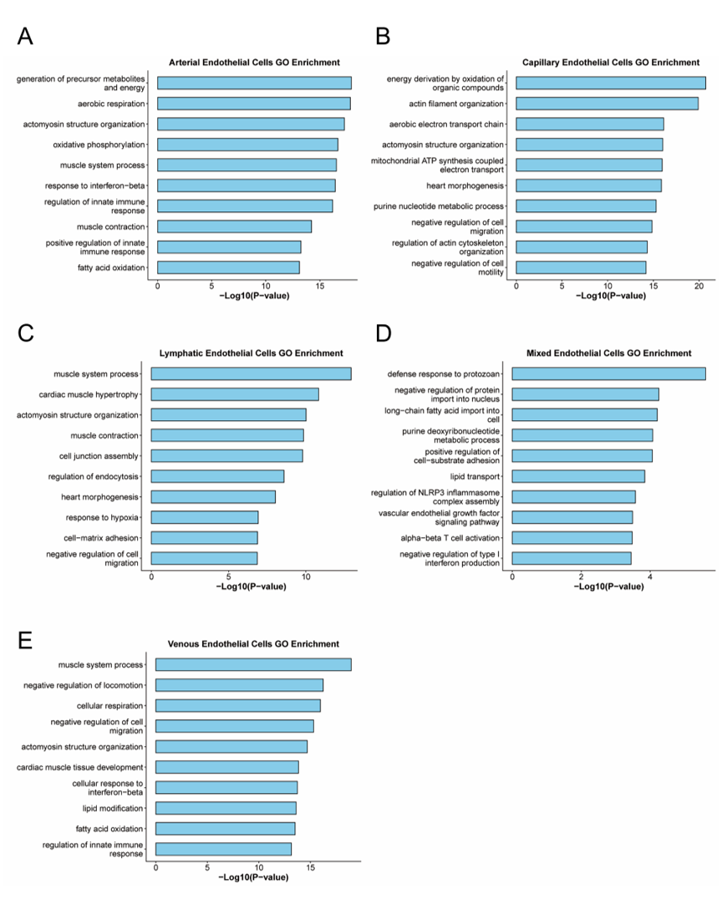
Fig. S5 GO analysis of differentially expressed genes between DCM and control groups within each endothelial cell.

Fig.S6 RNA velocity analysis of endothelial cells.(A) Streamline plot and (B) PAGA velocity graph predicting the dynamic transitions between EC subtypes.

Fig.S7 Pseudotime trajectory and lineage branching analysis of endothelial cells (ECs) in Ctrl and DCM groups (A–E) Single-cell trajectory reconstruction. (A) Cell distribution along the pseudotime axis. (B) Comparison of cell distribution on the trajectory between the Ctrl and DCM groups. (C) Localization of major EC subtypes (CECs, AECs, VECs, LECs, MECs) along the developmental trajectory. D. Nine states (States 1–9) identified on the basis of trajectory Nr2f2,Prox1, Re). (M) Branch point analysis. Cells were classified into Pre‑branch, State 1, and State 2.

Fig. S8 Gene Dynamics and Functional Enrichment at the Trajectory Branch Point.
The heatmap displaying different blocks of differentially expressed genes along the pseudo time trajectories of the first branch. In terms of cell type, Gray denotes the pre-brance state, which is state1, Red signifies state2, and Blue indicates state3. Biological process (BP) enrichment for the identified gene clusters.

Fig.S9 Transcription Factor Regulatory Networks Across EC Subtypes.(A)Heatmap of the top 10 regulons based on AUC scores. The color scale indicates the regulon activity (AUC score) in each cell. (B) Heatmap of the top 10 regulons based on Regulon Specificity Scores (RSS). This heatmap highlights the most specific regulons for each endothelial subpopulation.

Fig.S10 Landscape of Intercellular Communication and Vegfr3 Expression in the Heart. (A–B) Heatmaps of global intercellular communication across cell types. These panels illustrate the interaction strengths among major cardiac cell populations in both the Control and DCM groups. (A) Number of interactions.(B) Weight/strength of interactions. The color gradient from blue to red indicates an increase in interaction frequency or intensity. (C) Comparative heatmap of the number of interactions among ECs subpopulations. (D) Comparative heatmap of interaction weights among ECs subpopulations. (E) Violin plots integrated with scatter plots show the mRNA expression levels of Vegfr3 in different cell clusters. (F) Comparison of global Vegfr3 expression between Control and DCM groups. (G) Specificity of Vegfr3 expression among ECs subpopulations. (H) Disease-state comparison of Vegfr3 expression specifically in endothelial cells.

Fig.S11 Incoming and outgoing communication patterns of ECs. A:Incoming communication patterns of ECs. (B) Outgoing communication patterns of ECs.

Fig.S12 Representative Western blot and quantification of Vegfc protein levels in LECs of Vegfc protein levels in control and DCM heart.(n=6) Significance was assessed by Student’s t test. *p < 0.05, **p < 0.01, ***p < 0.001, ****p < 0.0001, ns, not significant.

Fig.S13 GO analysis of differentially expressed genes between DCM and control groups within LEC subclusters.

Fig.S14 Proliferation index of LECs. (A) Comparison of the global proliferation index of LECs between the control and DCM groups. (B) Proliferation index of individual LEC subclusters (Clusters 0–8) in the control versus DCM groups. Statistical significance was assessed using Fisher's exact test. *p < 0.05, **p < 0.01, ***p < 0.001, ****p < 0.0001, ns, not significant.

Fig.S15 Immunofluorescence staining for LYVE1 (green) in cardiac tissues. The left panel shows representative images, and the right panel quantifies LYVE1⁺ tube-like lymphatic vessels. Statistical significance was assessed using Student’s t-test. *p < 0.05, **p < 0.01, ***p < 0.001, ****p < 0.0001, ns, not significant.

Fig.S16 Expression profiling of canonical markers across LEC subclusters.(A) Dot plot illustrating the expression patterns of selected canonical marker genes across the nine LEC subclusters (Clusters 0–8). The size of the dot corresponds to the percentage of cells expressing the specific gene, while the color gradient represents the average expression level within each cluster.(B) Stacked violin plots displaying the expression distribution of key identifying markers across the individual LEC subclusters.

Fig.S17 Analysis of key transcription factor regulons across cell clusters using SCENIC. (A) Heatmap of Regulon Activity Scores (AUC). Heatmap displays the top 5 representative regulons for each cell cluster (indexed 0-8). The color scale represents the Z-score normalized Area Under the Curve (AUC) values, where red indicates high regulon activity and blue indicates low activity within the corresponding cluster.(B) Heatmap of Regulon Specificity Scores (RSS) highlights the most specific transcription factors for each cluster. The color intensity (blue) reflects the RSS magnitude, identifying candidate master regulators that define the unique transcriptomic identity of each specific cell population.

Fig.S18 PDK4 expression in control and DCM hearts across all major cardiac cell types. A .Violin plots show PDK4 transcript levels in each cell population of control (Ctrl) and DCM hearts. B. Violin plots show PDK4 expression levels in arterial (AECs), capillary (CECs), venous (VECs), lymphatic (LECs), and mixed (MECs) endothelial cells from Ctrl and DCM groups.

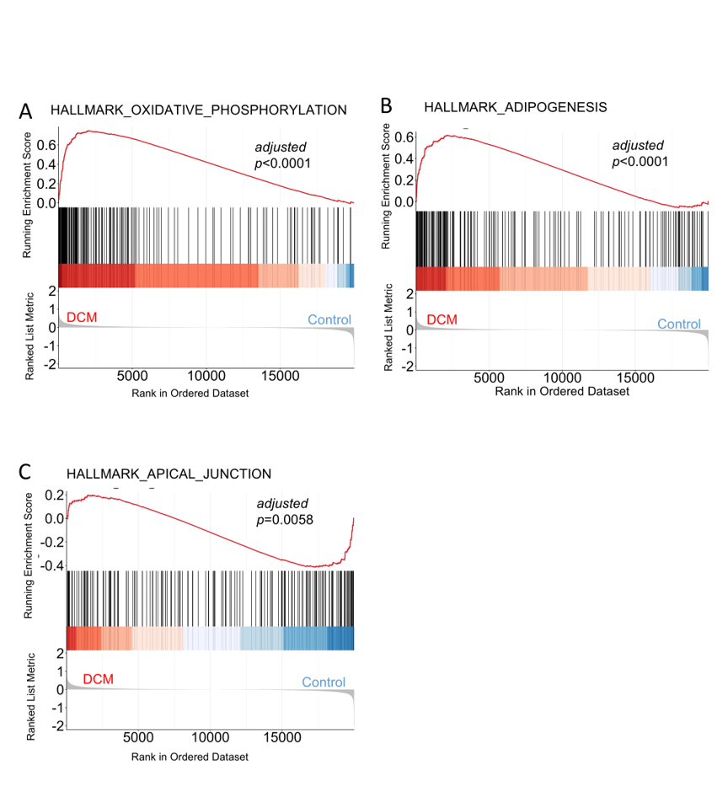
Fig.S19 GSEA Hallmarks in LECs: Gene Set Enrichment Analysis showing significant enrichment of Hallmark pathways including Oxidative Phosphorylation, Adipogenesis, and Apical Junction in the DCM group vs. Control.

Fig.S20 Representative Western blot and quantification of PDK4 protein levels in LECs following HG and HG+PA treatments (n=6). Significance was assessed by One‑way ANOVA with Tukey's post hoc test. *p < 0.05, **p < 0.01, ***p < 0.001, ****p < 0.0001, ns, not significant.

Fig.S21 Confirmation of siRNA-mediated Pdk4 knockdown and plasmid-mediated overexpression efficacy.A . Western blot analysis of Pdk4 protein levels in lymphatic endothelial cells treated with small interfering RNA（n=3)B. Western blot analysis of Pdk4 protein levels in lymphatic endothelial cells transfected with the Pdk4 overexpression plasmid(n=3).A: One‑way ANOVA with Tukey's post hoc test.B: Student’s t‑test. *p < 0.05, **p < 0.01, ***p < 0.001, ****p < 0.0001, ns, not significant.

Fig.S22 Representative Western blot and quantification of PDK4 protein level. (Cells were treated with exogenous VEGF-C (10ng/ml) in the presence or absence of Dovitinib (1μm) (n=6).One‑way ANOVA with Tukey's post hoc test. *p < 0.05, **p < 0.01, ***p < 0.001, ****p < 0.0001, ns, not significant.

