Chronic fructose intake disrupts extracellular ATP–pyrophosphate homeostasis and increases susceptibility to aortic calcification

Alicia Flores-Roco^{1,2}, Ricardo Villa-Bellosta^{1,2,3,*}

¹ Metabolic Homeostasis and Vascular Calcification Research Laboratory. Center for Research in Molecular Medicine and Chronic diseases (CiMUS). Campus Vida. University of Santiago de Compostela. 15782 Santiago de Compostela, Spain.
²Health Research Institute of Santiago de Compostela (IDIS), Travesia da Choupana S/N, 15706 Santiago de Compostela, Spain
³Department of Biochemistry and Molecular Biology. University of Santiago de Compostela. 15782 Santiago de Compostela, Spain

*Correspondence:

Ricardo Villa-Bellosta, Ph.D. Metabolic Homeostasis and Vascular Calcification Research Laboratory. Center for Research in Molecular Medicine and Chronic Diseases (CiMUS). Campus Vida. University of Santiago de Compostela. Avenida de Barcelona S/N, 15782 Santiago de Compostela, Spain. E-mail: ricardo.villa@usc.es

Supplementary Figures and Legends

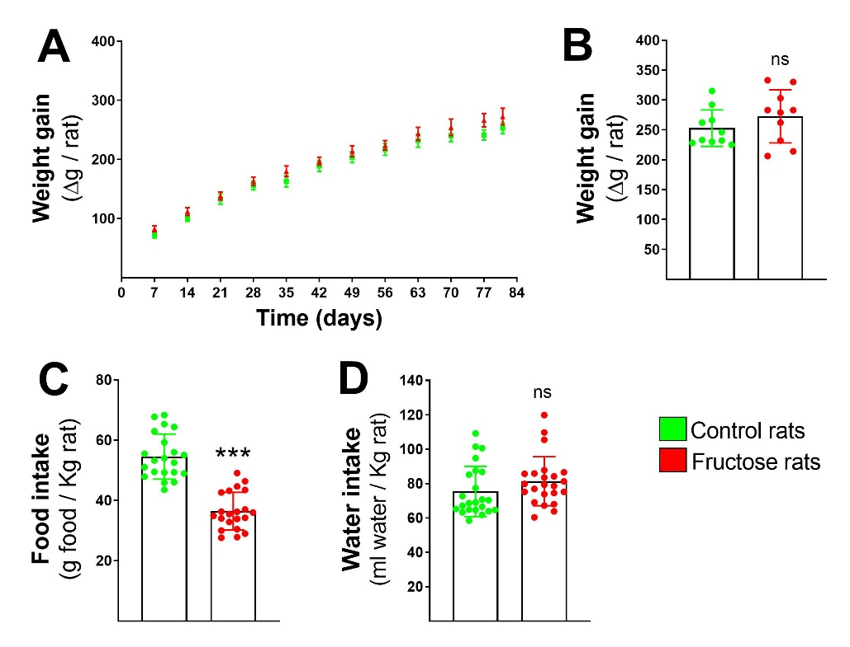

Supplementary Figure 1. Normal body weight with high fructose diet. A) Body weight. B) Weight gain during treatment, represented as the difference between final weight and baseline weight (Δg). Daily intake of food (C) and fresh water (D) during the treatment. Data are presented as bar graphs (mean ± SD) with individual data points overlaid (n=10). Statistical analyses were performed using Student’s t-test (B, C) or Mann-Whitney U test (D), with asterisks indicating significant differences at ***P < 0.001.

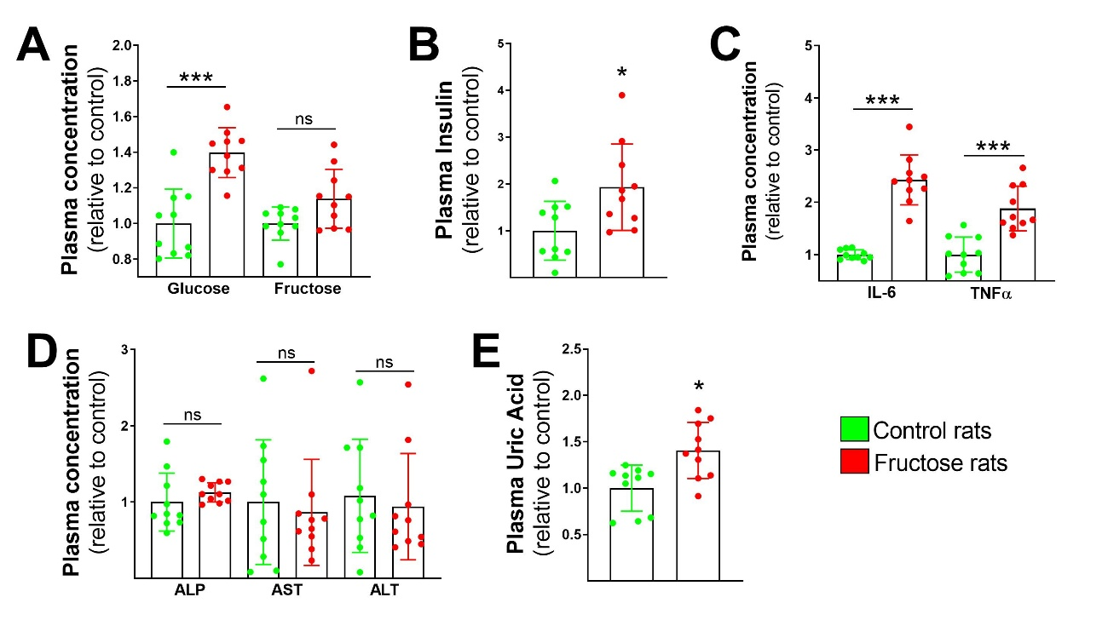
Supplementary Figure 2. Biochemical parameters in normal rats and rats treated with high fructose. A) Plasma levels of glucose and fructose. B) Plasma insulin levels. C) Plasma levels of IL-6 and TNF-α. D) Activities of ALP, AST, and ALT enzymes. E) Plasma uric acid levels. Data are presented as bar graphs (mean ± SD) with individual data points overlaid (n=10). Statistical analyses were performed using Student’s t-test (A glucose, B, C, D ALP and E) or Mann-Whitney U test (A fructose, D AST and D ALT), with asterisks indicating significant differences at *P < 0.05; ***P < 0.001.

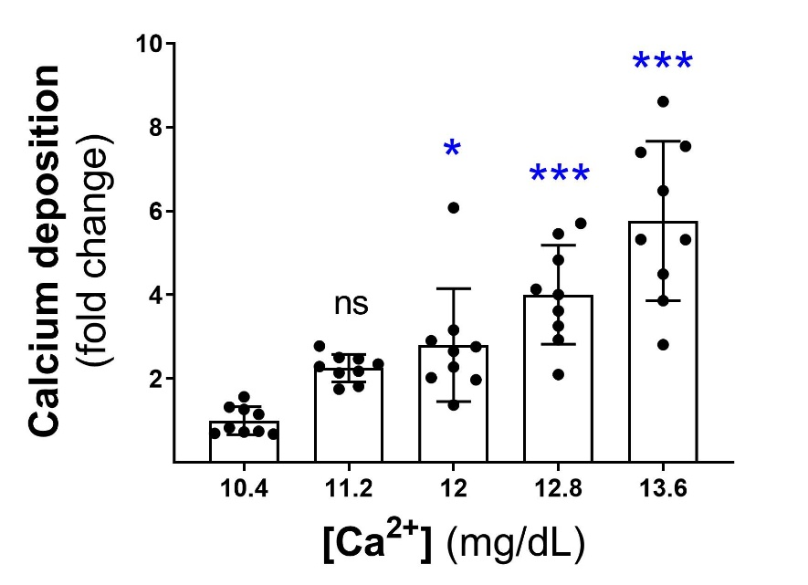
Supplementary Figure 3. Calcium-dependent increase in calcium deposition.
Calcium deposition (expressed as fold change) increased progressively with rising extracellular calcium concentrations ([Ca²⁺]: 10.4, 11.2, 12.0, 12.8, and 13.6 mg/dL). Data are presented as bar graphs (mean ± SD) with individual data points overlaid (n=9). Statistical analyses were performed using Kruskal-Wallis test and Dunn´s multiple comparisons test, with asterisks indicating significant differences at *P < 0.05; ***P < 0.001; ns: no significant differences.

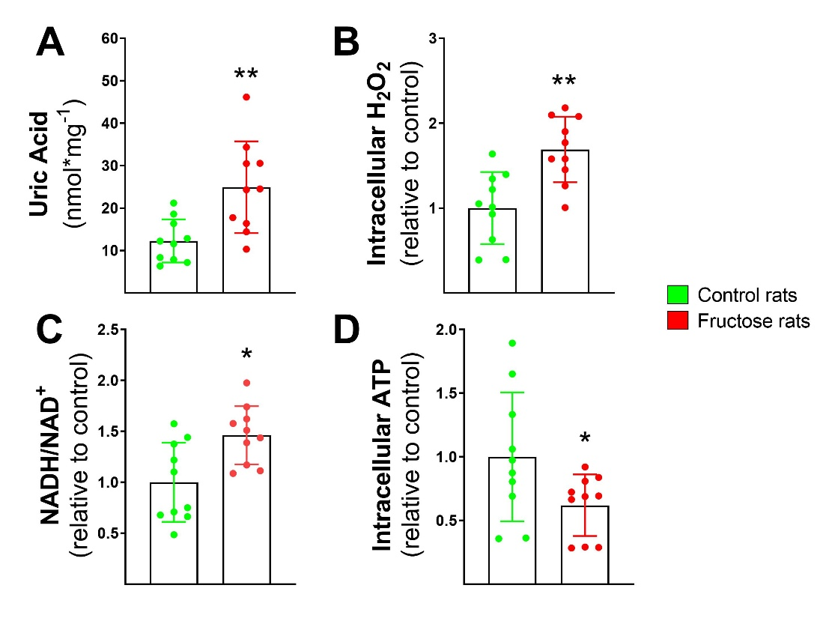
Supplementary Figure 4. High-fructose diet alters hepatic redox status and impairs ATP synthesis. Uric Acid concentration (A), H₂O₂ concentration (B); NADH/NAD⁺ ratio (C), and ATP concentration (D) in liver homogenates obtained from treated and untreated rats. Data are presented as bar graphs (mean ± SD) with individual data points overlaid (n=10). Statistical analyses were performed using Student’s t-test (A, B, C) or Mann-Whitney U test (D), with asterisks indicating significant differences at *P < 0.05; **P < 0.01.

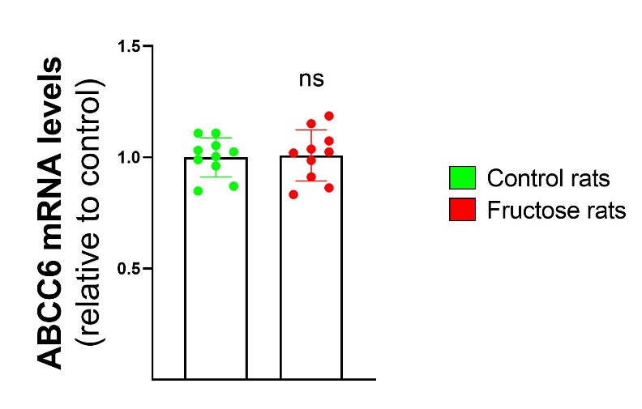

Supplementary Figure 5. Hepatic ABCC6 expression in control and fructose-fed rats. Relative mRNA levels of ABCC6 in liver tissue from control rats (green) and rats fed a high-fructose diet (red). Data are presented as mean ± SD, with individual data points overlaid (n=10). Statistical analyses were performed using Student’s t-test. No significant differences were observed between groups (ns, not significant).

