Additional file

The “chi-chi” of Ginkgo biloba grows downward with horizontally curving tracheids having compression-wood-like features

Seiichi Higuchi¹, Dan Aoki*¹, Yasuyuki Matsushita^{1,2}, Masato Yoshida¹, Sachie Yagami¹, Kazuhiko Fukushima¹
* Correspondence: aoki.dan@nagoya-u.jp
¹ Graduate School of Bioagricultural Sciences, Nagoya University, Nagoya, 464-8601, Japan
² present address, Institute of Agriculture, Tokyo University of Agriculture and Technology, Tokyo, 183-8509, Japan

Contents

Fig. S1 The elder G. biloba tree in Kitakanegasawa (a natural monument).

Fig. S2 Latent buds and hollows of the chi-chi.

Fig. S3 Photomicrographs of the latent bud in the tip of sample E.

Fig. S4 Sample A before cut underpart.

Fig. S5 FE-SEM micrographs of the cell wall of the chi-chi sample.

Fig. S6 SEM micrographs of the swirls.

Fig. S7 Cross-sectional consecutive screen movie of the sample C by X-ray μCT.
is separately uploaded as Supplementary Information 2.

Table S1 Lignin content and yields of thioacidolysis monomeric products.

Table S2 Yields of thioacidolysis dimeric products.

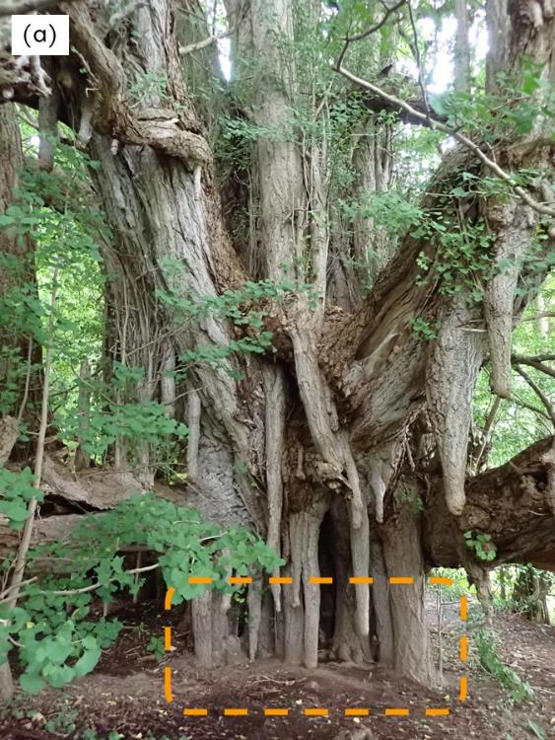
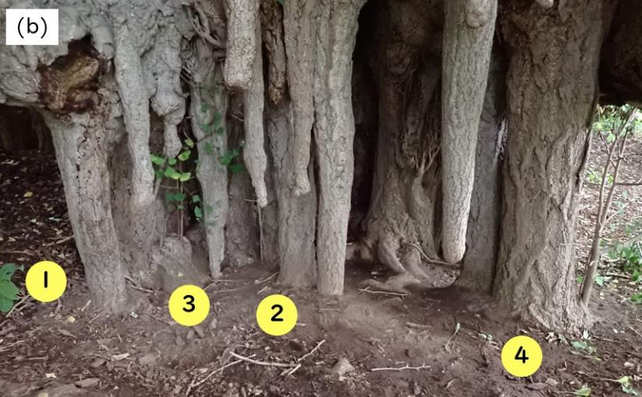
Fig. S1 An example of a G. biloba tree in Kitakanegasawa (a natural monument).
(a) The chi-chi growing situation. (b) An enlarged area of the zone outlined by the orange rectangular area in (a). Nos. 1, 2, 3, and 4 are assignments for the following images. (c) The generation of roots from the chi-chi Nos. 1 and 2; the generation of branches and leaves from the chi-chi No 3. The chi-chi No. 4 is the largest one having a widening trunk shape and generating a shoot. The location is (40°44′57″ N, 140°5′22″ E).
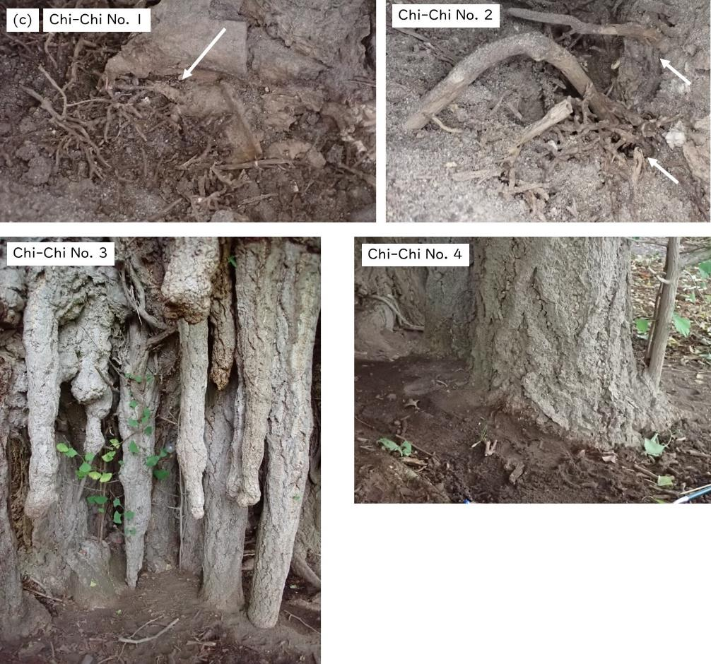
(Fig. S1 continued)

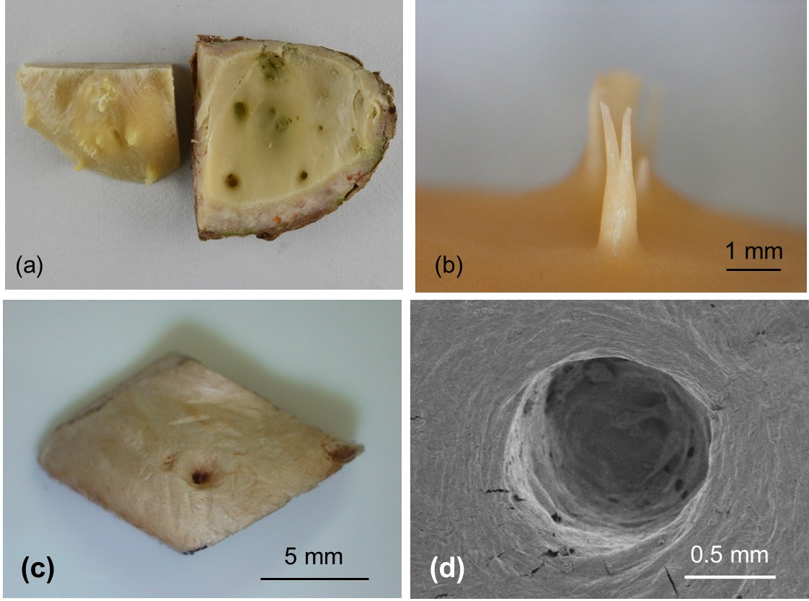
Fig. S2 Latent buds and hollows of the chi-chi.
(a) Debarked tip of the sample E. Latent buds on the wood and hollows inside the bark.
(b) Latent bud of the chi-chi.
(c) The hollow of the wood of sample C. The latent buds are diminished after debarking and drying because it is a parenchymatous tissue.
(d) The hollow of the chi-chi bark of sample C. The hollow is estimated as a housing for the latent bud at the tip of sample C.

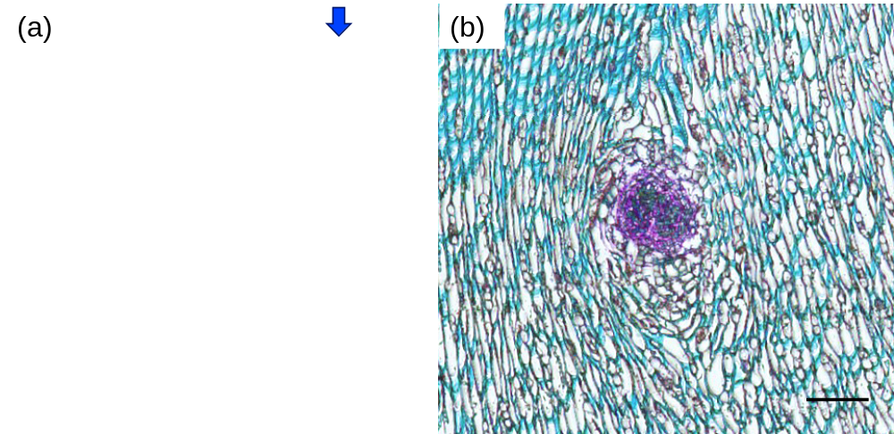
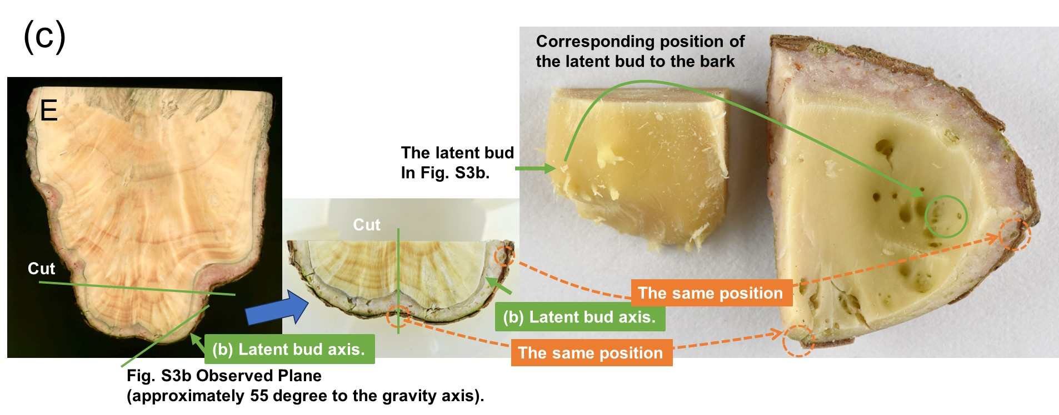
Fig. S3 Photomicrographs of the latent bud in the tip of sample E.
(a) A longitudinal section (3 µm-thick), scale bar is 1 mm. The latent bud tissue was fragile and not completely preserved in the sectioning procedures. The blue arrow suggests the fragment of the latent bud.
(b) A section (5 µm-thick) perpendicular to the latent bud axis, scale bar is 200 µm, obtained from the different position of the sample E. The nearest tracheids around the latent buds show a curving state.
(c) The schematic illustration how to prepare the observation plane of (b).

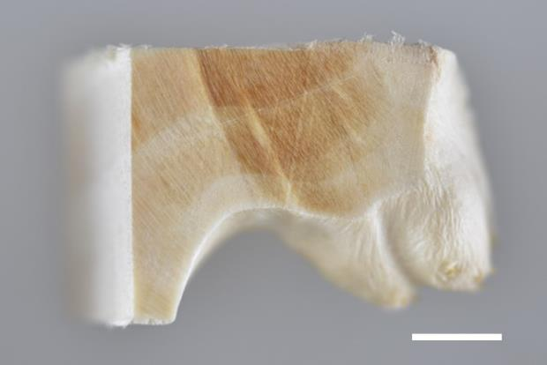
Fig. S4 Sample A before cut underpart.
There were bulges under the bark. Scale bar; 5 mm.

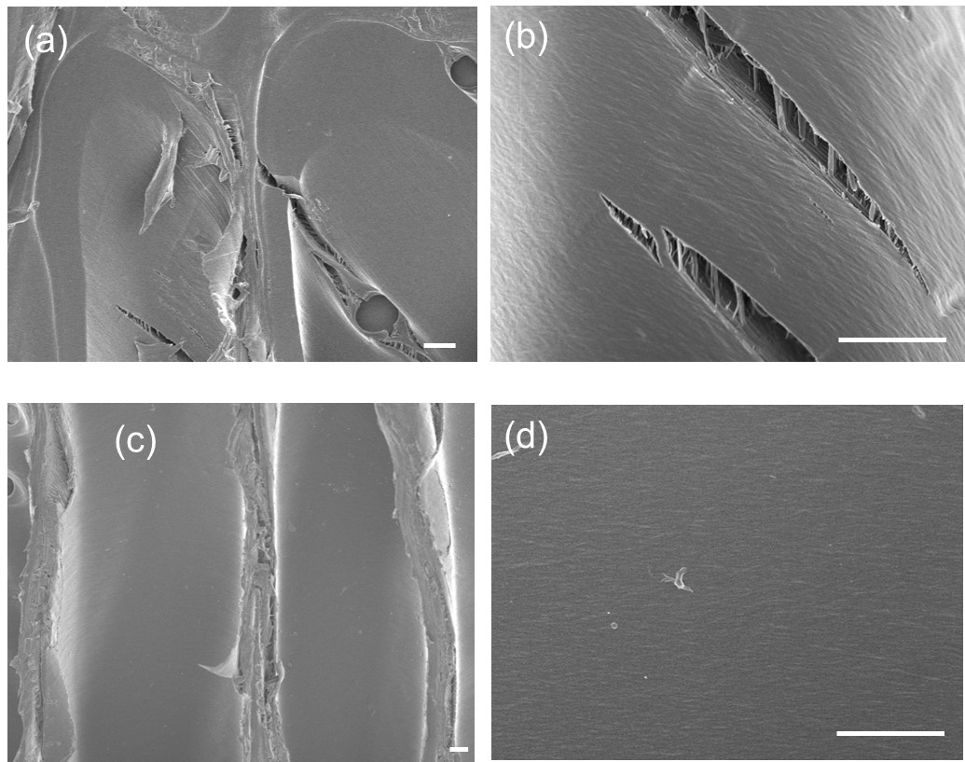
Fig. S5 FE-SEM micrographs of the cell wall of the chi-chi sample.
SEM micrographs of (a,b) the chi-chi sample A-2 in Fig. 3b and (c,d) the upper part of chi-chi sample B having the vertically oriented tracheids. Scale bars; 3 µm.

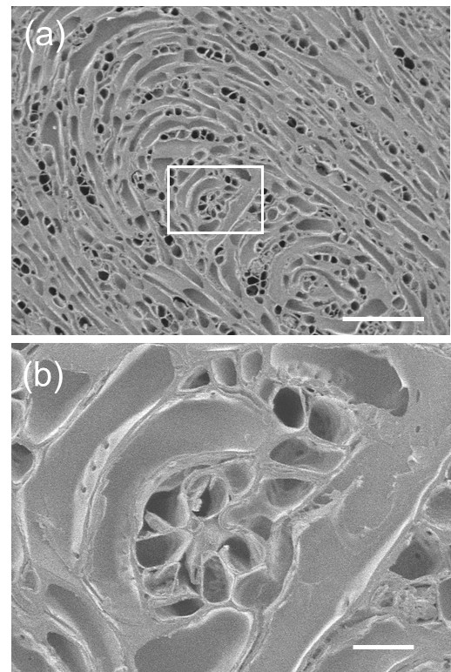
Fig. S6 SEM micrographs of the swirls.
(a) SEM micrograph of the swirl in a horizontal plane at 30 mm from the tip of the chi-chi (sample C). Scale bar; 200 µm. (b) An enlarged image of the zone outlined by the white rectangular area in (a). Scale bar; 25 µm.

Fig. S7 Cross-sectional consecutive screen movie of the sample C by X-ray μCT.
is separately uploaded as Additional file 2.

Table S1 Lignin content and yields of thioacidolysis monomeric products.
Samples |  | Lignin %* |  | G-unit** |  | H-unit**
 |  | avg. | s.d. | avg. | s.d. | avg. | s.d.
Lateral  shoots | Upper part | 30.8 | 0.6 | 424 | 15 | 10 | 5
Lateral  shoots | Lower part | 35.6 | 1.5 | 390 | 28 | 51 | 5
chi-chi | A-1 | - | - | 554 | 39 | 34 | 6
 | A-3 | - | - | 509 | 77 | 29 | 7
 | B | - | - | 396 | 30 | trace | -
No. 1 | Da | 31.4 | 0.6 | 288 | 35 | trace | -
 | Db | 31.9 | 0.5 | 468 | 10 | trace | -
 | Dc | 32.0 | 0.4 | 369 | 27 | trace | -
No. 5 | Dd | 31.4 | 0.6 | 449 | 14 | trace | -
 | De | 30.7 | 1.3 | 422 | 21 | trace | -
 | Df | 31.5 | 0.4 | 406 | 38 | trace | -
No. 9 | Dg | 33.4 | 0.3 | 451 | 39 | trace | -
 | Dh | 32.4 | 0.2 | 450 | 11 | 16 | 2
 | Di | 29.7 | 0.4 | 406 | 13 | trace | -
No. 13 | Dj | 33.4 | 0.4 | 476 | 11 | 16 | 3
 | Dk | 33.7 | 1.0 | 447 | 11 | 19 | 2
No. 17 | Dl | 30.8 | 0.2 | 434 | 24 | 12 | 2
* Evaluated by acetyl bromide method.
** Yields of thioacidolysis monomeric products (μmol/g-sample).
Values are obtained for the chi-chi (A-1, A-3, B, and separated D samples) and the lateral shoot (upper and lower parts) samples. Averages (avg.) and standard deviations (s.d.) are calculated by 3 sets of analyses. Chi-chi sample codes are illustrated in Figs. 2–4.

Table S2 Yields of thioacidolysis dimeric products.
(μmol/g-sample) |  |  | 5-5' | 4-O-5' | β-1' | β-5' | β-β'
lateral shoot |  | upper | 11.01 | 2.45 | 17.87 | 14.18 | 0.01
 |  | lower | 7.45 | 1.70 | 16.37 | 13.43 | 1.15
chi-chi | No. 1 | Da | 5.49 | 1.31 | 14.99 | 12.63 | 0.89
 |  | Db | 11.15 | 2.41 | 16.62 | 15.31 | 0.16
 |  | Dc | 7.41 | 1.77 | 19.56 | 16.93 | 0.34
 | No. 5 | Dd | 9.00 | 1.95 | 14.90 | 12.82 | 0.63
 |  | De | 9.89 | 1.81 | 16.56 | 12.42 | 0.31
 |  | Df | 8.47 | 1.94 | 16.43 | 12.60 | 0.20
 | No. 9 | Dg | 8.08 | 1.49 | 17.87 | 13.82 | 0.33
 |  | Dh | 8.78 | 1.64 | 14.34 | 10.24 | 0.54
 |  | Di | 8.54 | 1.56 | 15.79 | 10.41 | 0.19
 | No. 13 | Dj | 9.07 | 1.79 | 17.49 | 11.48 | 0.39
 |  | Dk | 10.84 | 2.12 | 17.62 | 11.37 | 0.31
 | No. 17 | Dl | 4.21 | 0.90 | 12.75 | 10.53 | 0.31
Averages (avg.) are calculated by 3 sets of analyses. Disk numbers are illustrated in Fig. 4.

