Additional file 2

The “chi-chi” of Ginkgo biloba grows downward with horizontally curving tracheids having compression-wood-like features

Seiichi Higuchi¹, Dan Aoki*¹, Yasuyuki Matsushita^{1,2}, Masato Yoshida¹, Sachie Yagami¹, Kazuhiko Fukushima¹
* Correspondence: aoki.dan@nagoya-u.jp
¹ Graduate School of Bioagricultural Sciences, Nagoya University, Nagoya, 464-8601, Japan
² present address, Institute of Agriculture, Tokyo University of Agriculture and Technology, Tokyo, 183-8509, Japan

Contents

Fig. S7 Cross-sectional consecutive screen movie of the sample C by X-ray μCT.

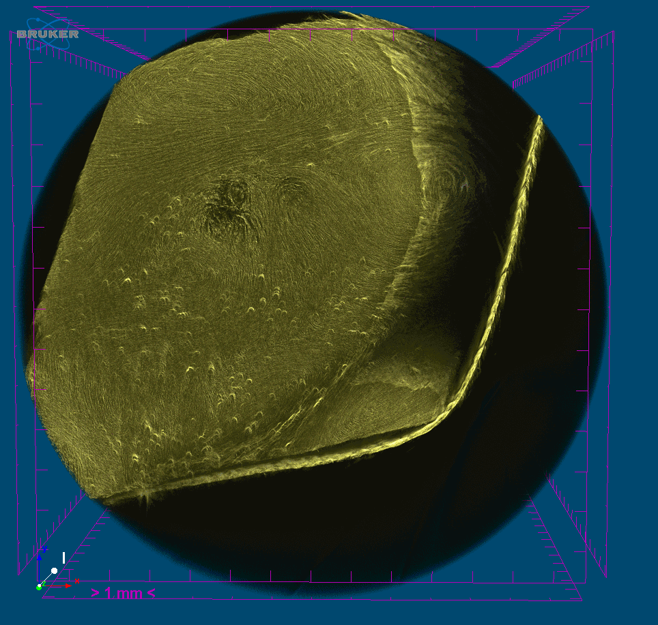
Fig. S7 Cross-sectional consecutive screen movie of the sample C by X-ray μCT.

