Effects of Arabidopsis thaliana cell walls on dehydrogenative polymers growth reaction using recombinant cationic cell-wall-peroxidase

Naofumi Matsuhisa^{1,3}, Koki Fujita², Adi Setyo Purnomo⁴ Kengo Shigetomi^{5*} and Yuji Tsutsumi^{2*}

1, Department of Agro-Environmental Sciences, Graduate School of Agriculture, Kyushu University, 744 Motooka Nishi-Ku, Fukuoka, 819-0395, Japan
2, Faculty of Agriculture, Kyushu University, 744 Motooka Nishi-Ku, Fukuoka, 819-0395, Japan
3, Graduate School of Agriculture, Hokkaido University, Kita-9, Nishi-9, Kita-ku, Sapporo 060-8589, Japan
4, Department of Chemistry, Faculty of Science and Data Analytics, Institut Teknologi Sepuluh Nopember (ITS), Kampus ITS Sukolilo, Surabaya, 60111, Indonesia
5, Research Faculty of Agriculture, Hokkaido University, Kita-9, Nishi-9, Kita-ku Sapporo 060-8589, Japan
*Corresponding authors: sgtm@agr.hokudai.ac.jp Tel: ＋81-011-706-2818
y-tsutsu@agr.kyushu-u.ac.jp Tel: ＋81-092-802-4664

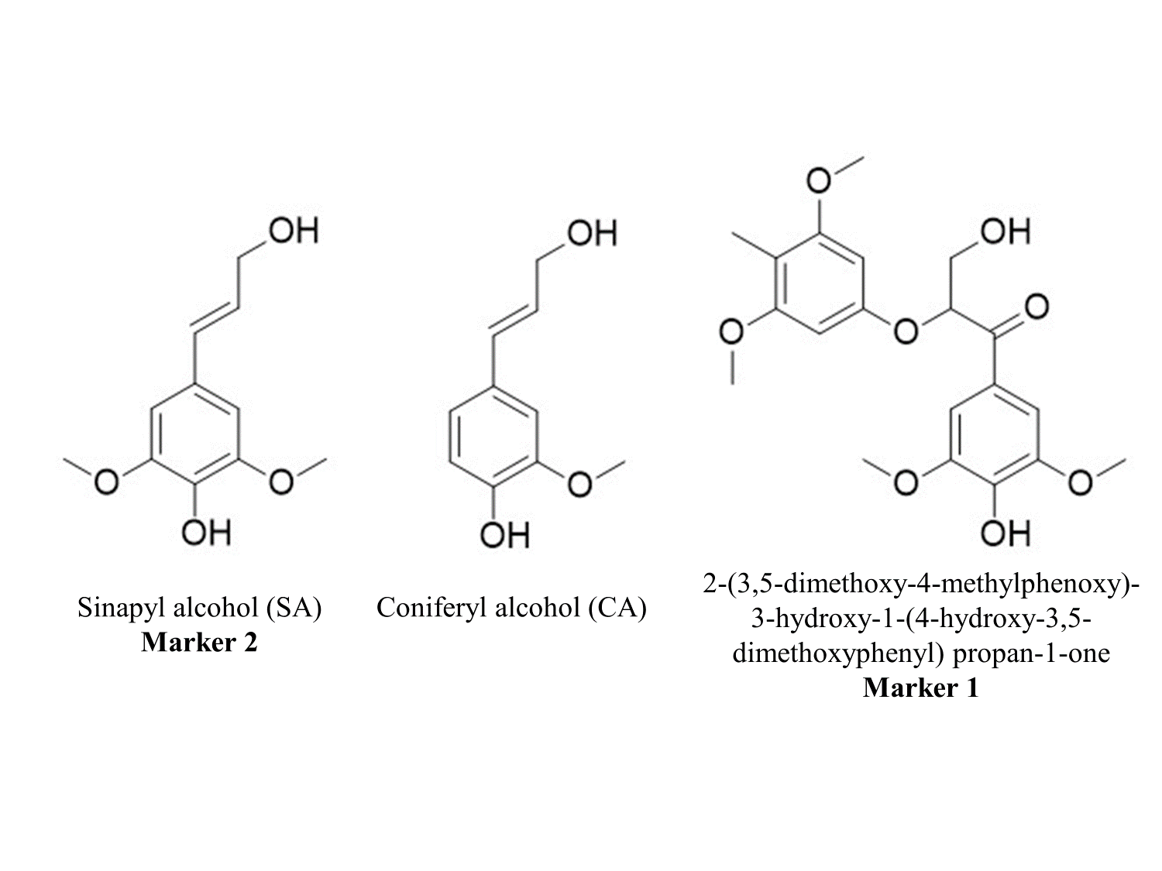
Figure S1: Structure of lignin monomers and 2-(3,5-dimethoxy-4-methylphenoxy)-3-hydroxy-1-(4-hydroxy-3,5-dimethoxyphenyl) propan-1-one

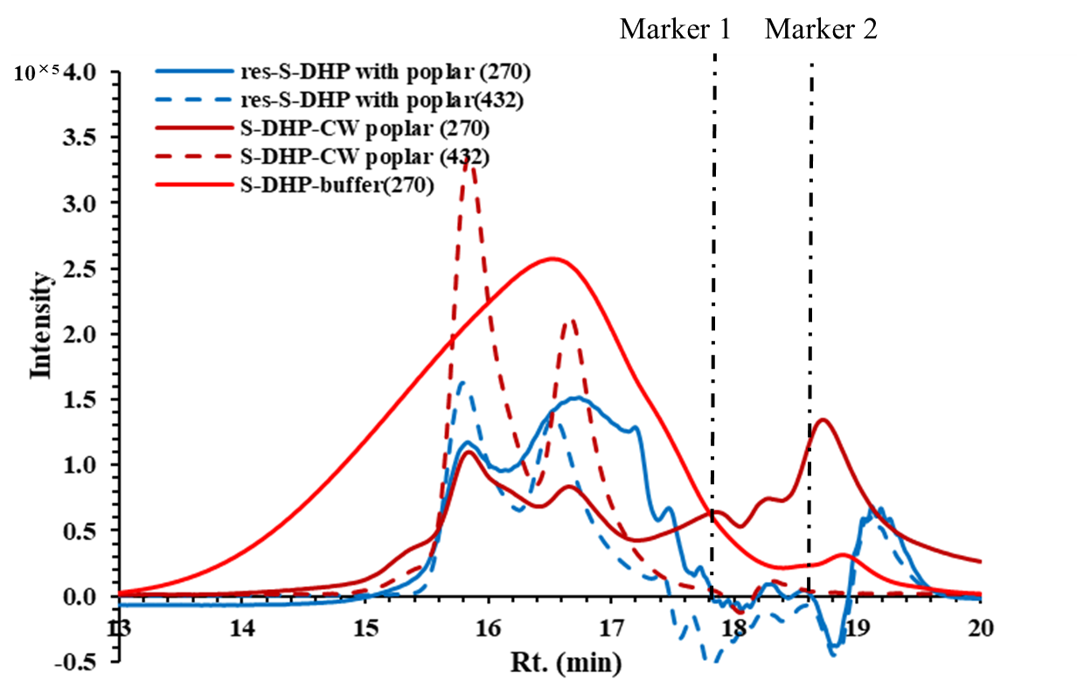
Figure S2: Molecular weight distribution diagrams of res-S-DHP with poplar and S-DHP-CW poplar
blue line: res S-DHP with poplar at 270 nm, blue dotted line: res S-DHP with poplar at 432 nm, brown line: S-DHP-CW poplar at 270 nm, brown dotted line: S-DHP-CW poplar at 432 nm, red line: S-DHP-buffer at 270 nm. Markers 1 and 2 indicate retention times of 2-(3,5-dimethoxy-4-methylphenoxy)-3-hydroxy-1-(4-hydroxy-3,5-dimethoxyphenyl) propan-1-one and SA monomer, respectively

