Supplementary material
Mechanically Tough, Transparent, Low Dielectric, and Mesoporous Nanocellulose Cryogels Formed via Osmotically Tuned Swelling of Dense Nanocellulose Assembly

Shun Ishioka*, Takaaki Kasuga, Ami Mizui, Yintong Huang, Hirotaka Koga, Masaya Nogi

SANKEN (The Institute of Scientific and Industrial Research), The University of Osaka, 8-1 Mihogaoka, Ibaraki, Osaka, 567-0047, Japan

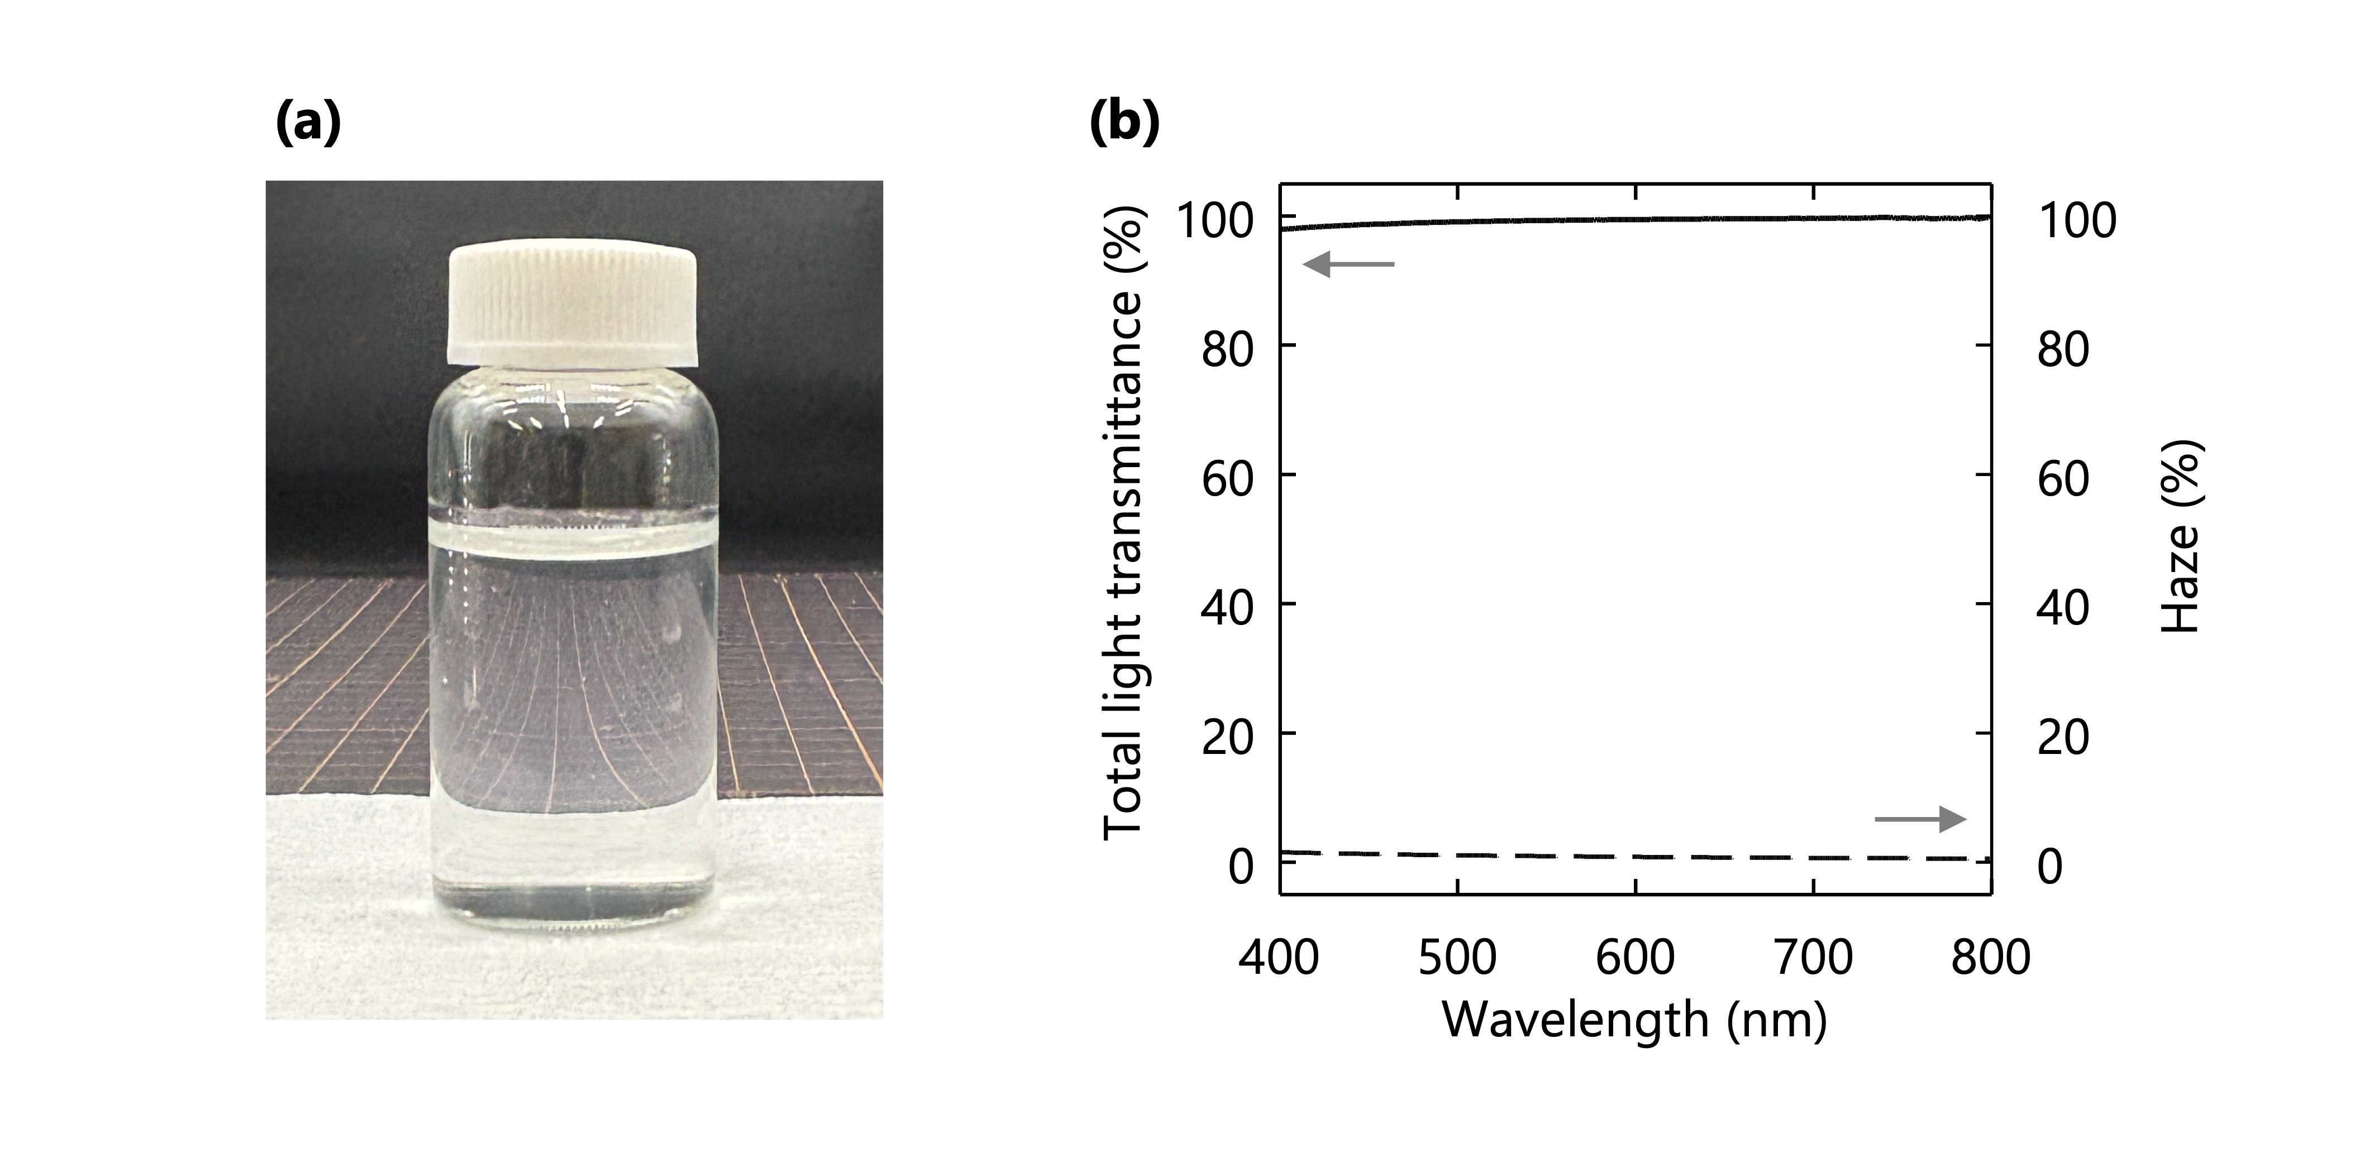
Fig S1 Optical properties of the CNF dispersion. a Appearance of the 0.55 % (w/w) CNF dispersion. b Total light transmittance spectrum and haze value of dispersion after dilution to 0.2% (w/w)
Total and diffusive light transmittances were measured using a UV−6600i Plus (Shimadzu, Japan) equipped with an ISR-603 integrating sphere attachment (Shimadzu, Japan), and then the haze values were calculated from the total and diffusive light transmittances. For the measurement, the dispersion was loaded into poly(methyl methacrylate) cell (316-0471, Kartell) with an optical path length of 10 mm. Distilled water was used for the blank measurement.
The total light transmittance and haze value were approximately 99.5% and 0.8%, respectively, at a wavelength of 600 nm. These values were comparable to those of a dispersion of phosphorylated CNFs with a width of 3–4 nm at the same concentration and optical path length [29], evaluated over the visible light region. The result in Fig. S1b indicates that the CNFs in dispersion used for sheet formation were highly disintegrated.

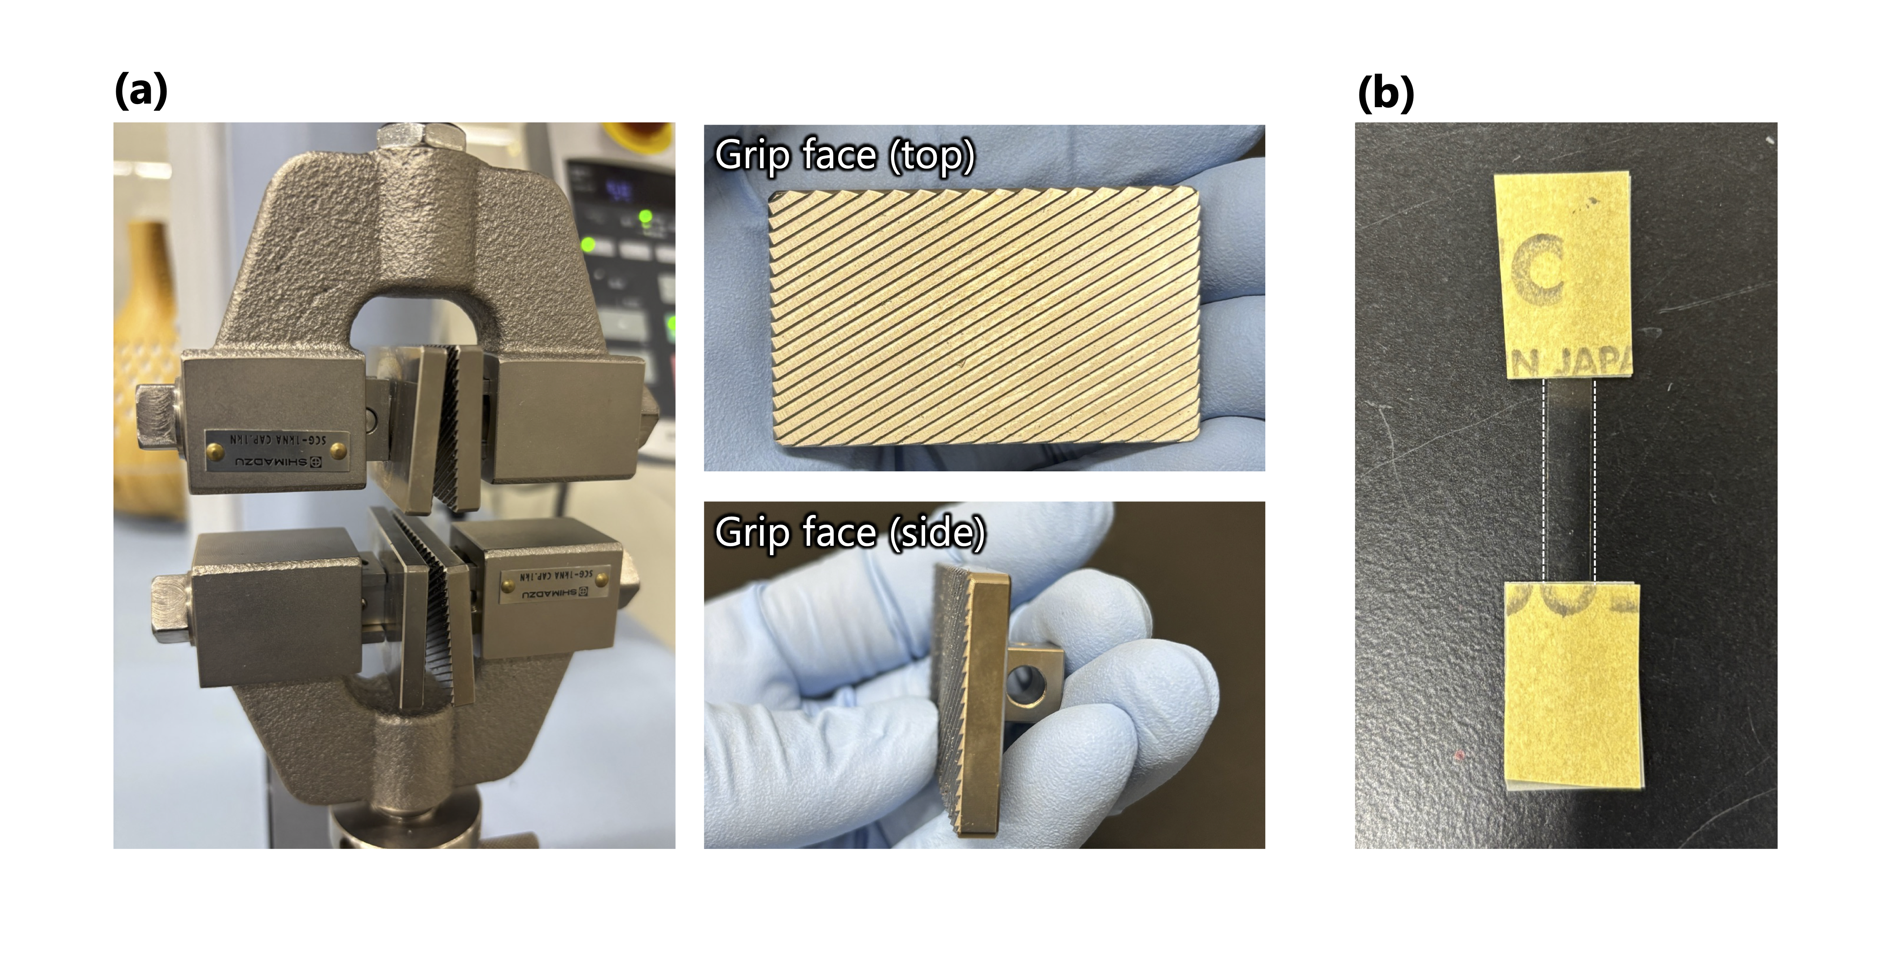Fig S2 Experimental setup of tensile test. a Grip and grip face. b Specimen

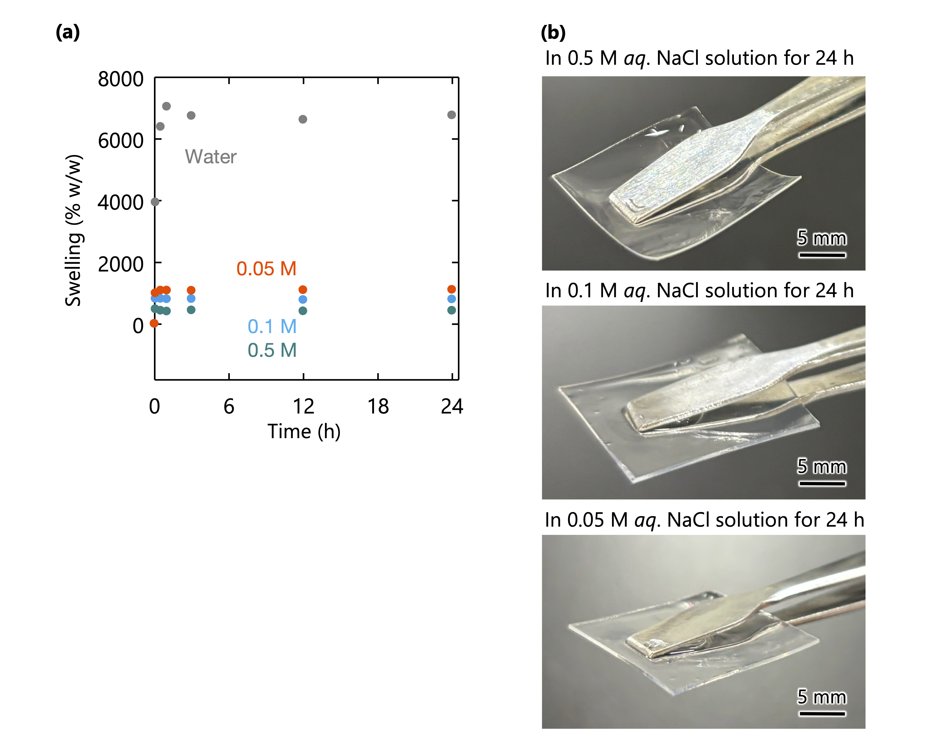
Fig. S3 a Swelling (NaCl solution or water absorption) of dense CNF sheets. b Appearance of the hydrogels swollen in 0.5, 0.1, and 0.05 M aq. NaCl solution for 24 h

The weights of swollen CNF sheets were measured after immersing them in water or aq. NaCl solution for 5 min, 30 min, 1 h, 3 h, 12 h, and 24 h. The weight-based swelling in Fig. S1a was calculated as follows:
$$Swelling = \frac{W_{wet}-W_{dry}}{W_{dry}}×100$$
where W_{wet} and W_{dry} are the weight in swollen and dry states, respectively.

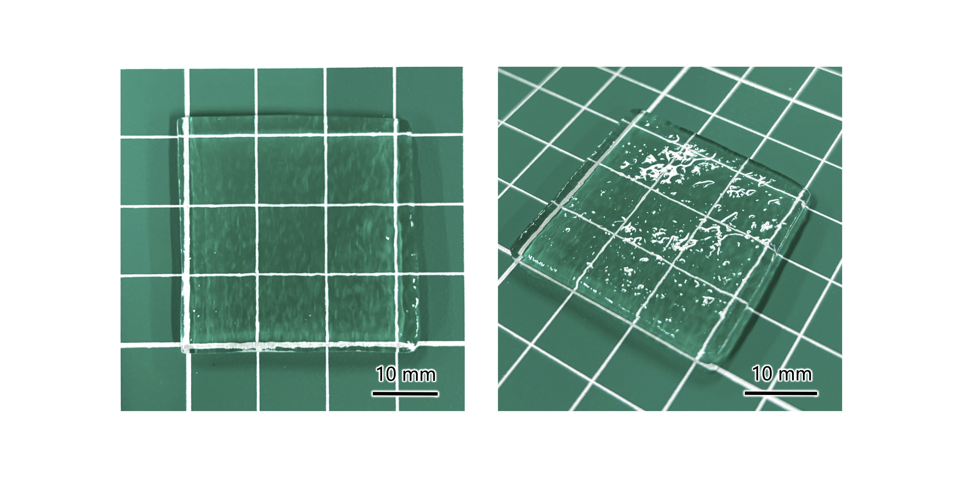
Fig. S4 Appearance of the hydrogel swollen in distilled water for 3 h. The CNF concentration in the resulting CNF hydrogel was approximately 0.4% (w/v), and the surface heterogeneities were observed

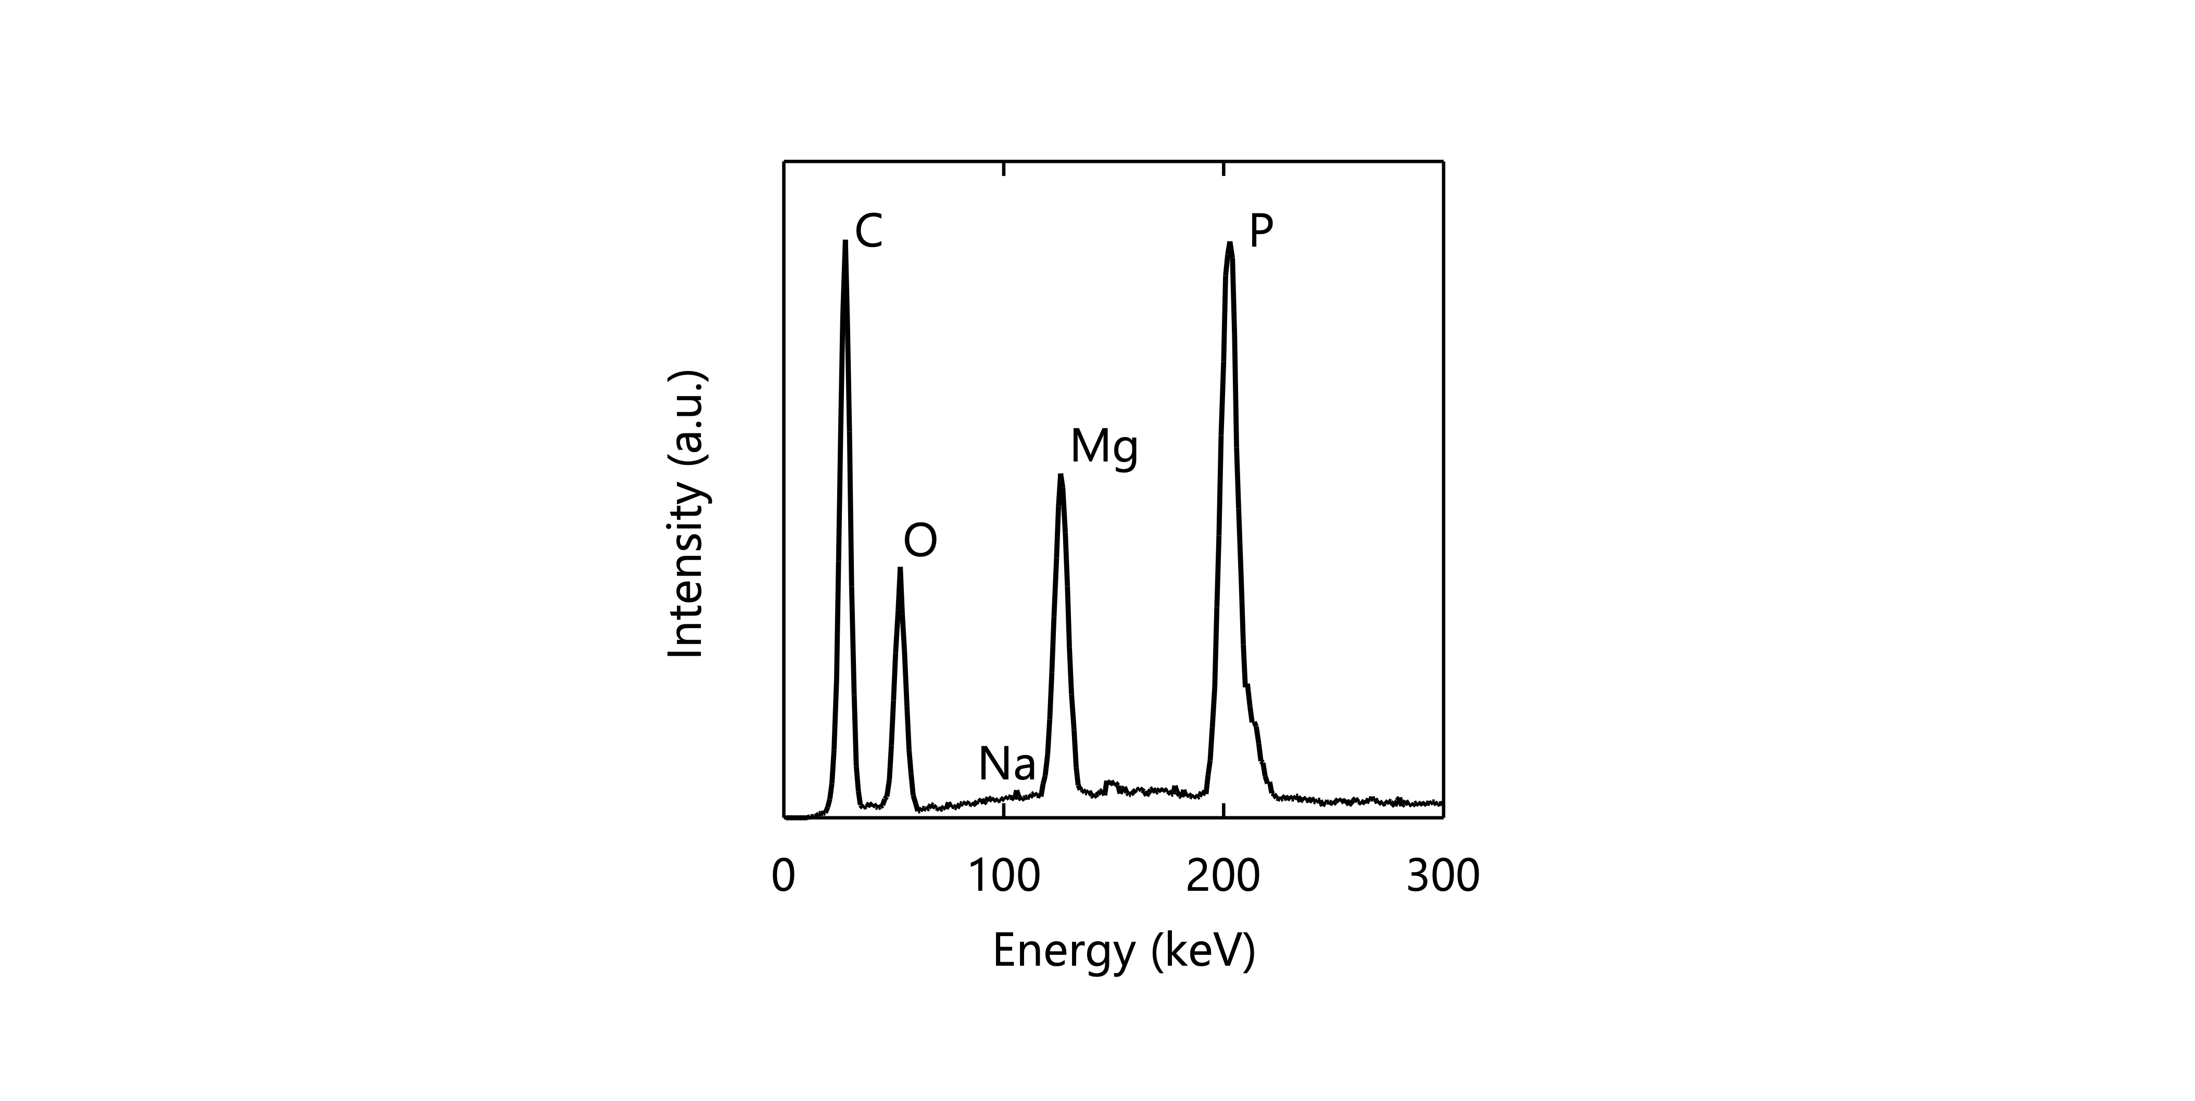
Fig. S5 Energy dispersive X-ray spectra of the CNF gels after counterion exchange and washing

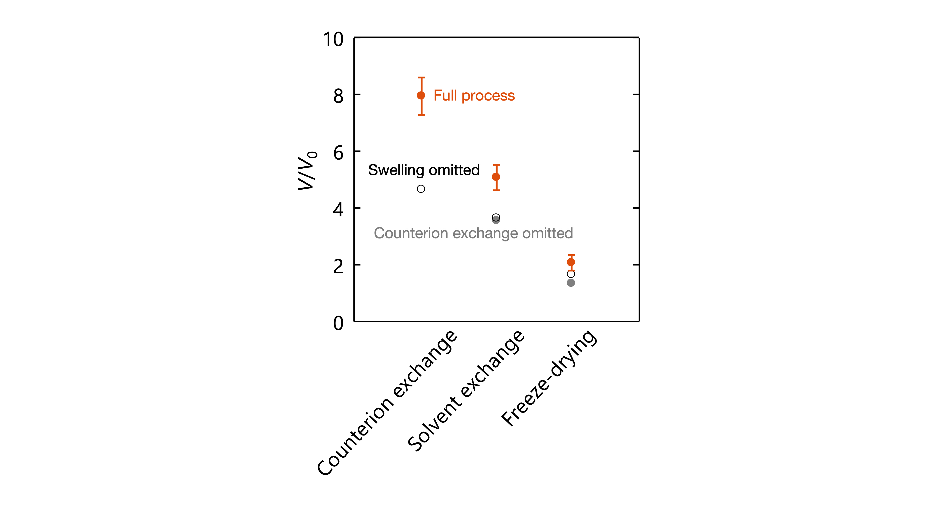
Fig. S6 V/V₀ of the CNF sheets through control processes in which either the swelling or counterion exchanging was omitted, based on the procedure using 0.05 M NaCl solution in Fig. 2 (full process)

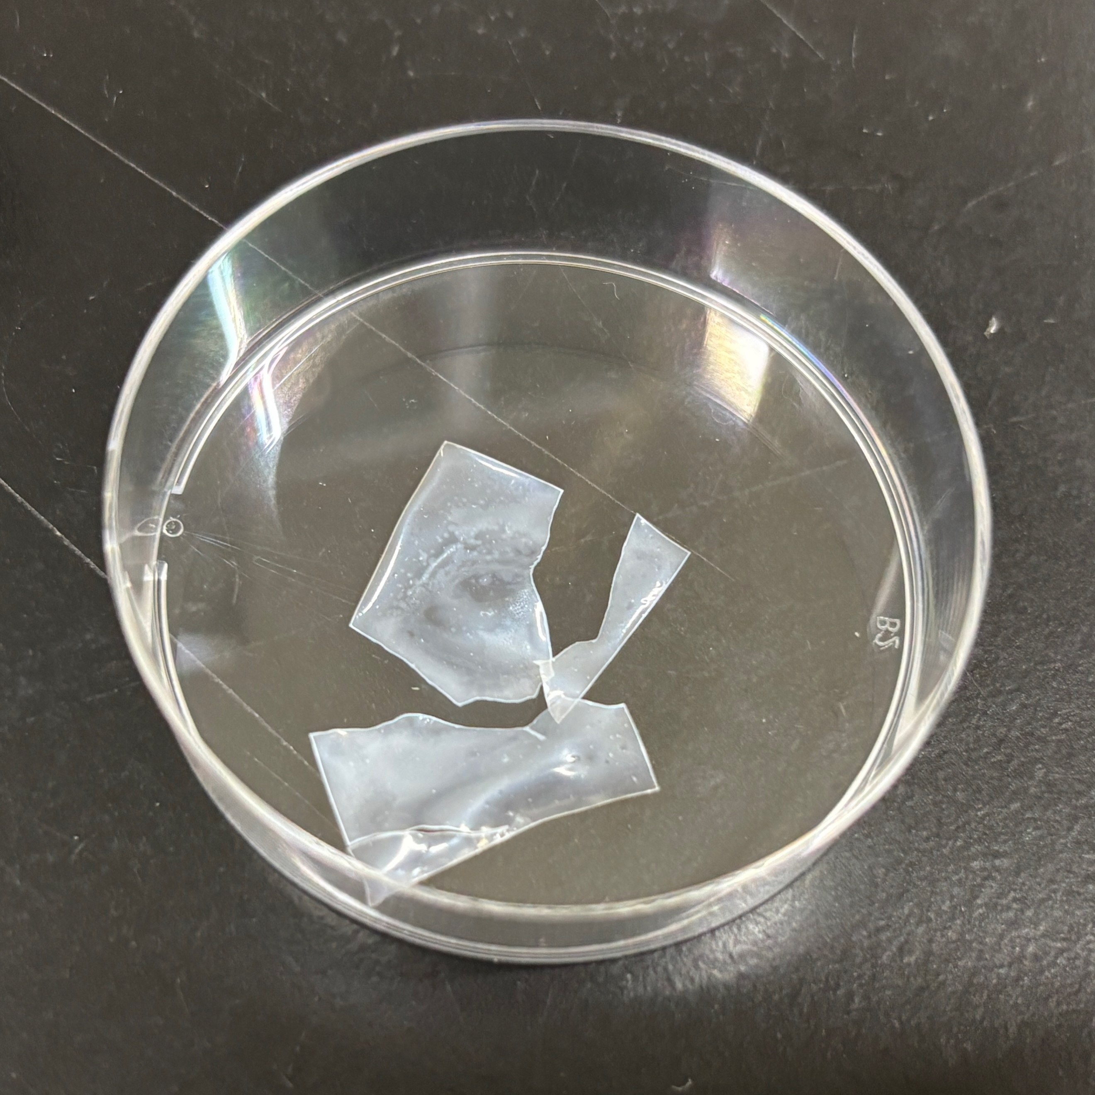
Fig. S7 Fractured cryogel prepared via freeze-drying using 30% (w/w) TBA/water mixture

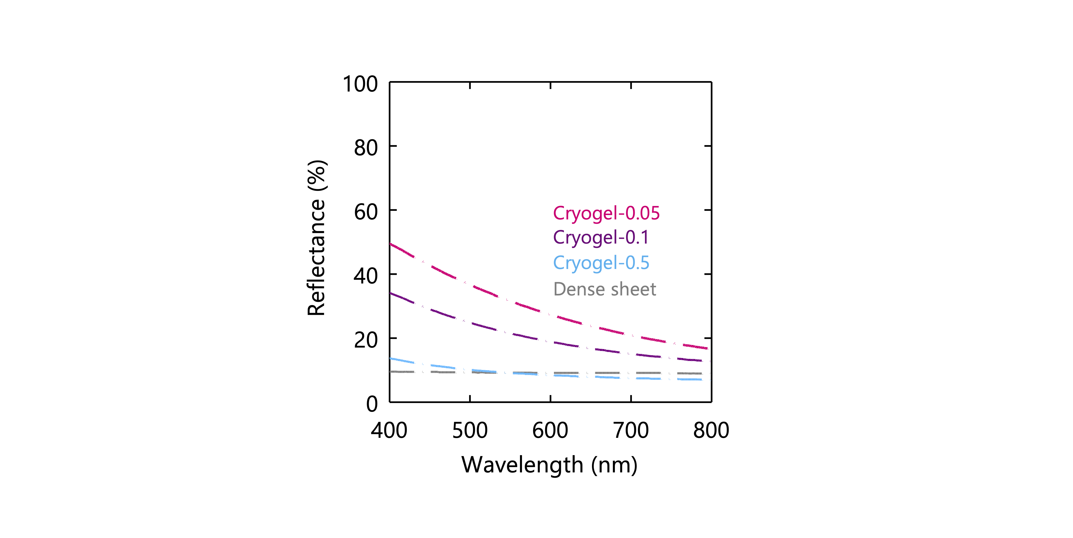
Fig. S8 Reflectance of the CNF cryogels and the dense sheet (for reference)

