Trends Pain – Supplementary Materials – February 10, 2020
Authors: Guido D, Raggi A, Mellor B, Moneta MV, Sanchez-Niubo A, Tyrovolas S, Giné-Vázquez I, Haro JM, Chatterji S, Bobak M, Prince M, Ayuso-Mateos JL, Arndt H, Scherbov S, Koupil I, Bickenbach J, Koskinen S, Tobiasz-Adamczyk B, Gheno I, Panagiotakos D, Leonardi M. Manuscript Title: Pain rates in general population for the period 1991-2015 and 10-years prediction: result from a multi-continent age-period-cohort analysis. Journal: The Journal of Headache and Pain

Table S1 – Presence of pain symptom for males aged 31-100 for five-year age group, period 1991-2015 in the ATHLOS dataset
Age groups | 31-35 | 36-40 | 41-45 | 46-50 | 51-55 | 56-60 | 61-65 | 66-70 | 71-75 | 76-80 | 81-85 | 86-90 | 91-95 | 96-100 | Total
Periods
1991-1995 | 1 | 4 | 15 | 81 | 800 | 915 | 516 | 158 | 175 | 118 | 65 | 21 | 7 | 0 | 2876
1996-2000 | 70 | 86 | 116 | 197 | 700 | 1385 | 1263 | 798 | 692 | 580 | 385 | 215 | 59 | 11 | 6557
2001-2005 | 10 | 39 | 127 | 1099 | 3457 | 3874 | 3984 | 3877 | 2372 | 1802 | 1082 | 462 | 140 | 18 | 22343
2006-2010 | 140 | 221 | 342 | 1533 | 5150 | 6304 | 5894 | 6048 | 5430 | 3773 | 2160 | 869 | 281 | 50 | 38195
2011-2015 | 110 | 155 | 365 | 1374 | 5036 | 6790 | 7140 | 6336 | 5303 | 4243 | 2659 | 1069 | 252 | 38 | 40870
Total | 331 | 505 | 965 | 4284 | 15143 | 19268 | 18797 | 17217 | 13972 | 10516 | 6351 | 2636 | 739 | 117 | 110841

Table S2 – Male population aged 31-100 for five-year age group, period 1991-2015 in the ATHLOS dataset
Age groups | 31-35 | 36-40 | 41-45 | 46-50 | 51-55 | 56-60 | 61-65 | 66-70 | 71-75 | 76-80 | 81-85 | 86-90 | 91-95 | 96-100 | Total
Periods
1991-1995 | 4 | 19 | 58 | 332 | 3645 | 3844 | 2271 | 708 | 843 | 613 | 320 | 134 | 38 | 3 | 12832
1996-2000 | 303 | 316 | 361 | 599 | 2665 | 5270 | 5157 | 3498 | 2889 | 2188 | 1377 | 718 | 184 | 34 | 25559
2001-2005 | 56 | 127 | 384 | 3168 | 9939 | 10399 | 10885 | 10810 | 7126 | 5150 | 2975 | 1271 | 383 | 65 | 62738
2006-2010 | 440 | 600 | 940 | 4198 | 13210 | 15282 | 13480 | 14314 | 12795 | 8842 | 4923 | 2207 | 629 | 117 | 91977
2011-2015 | 368 | 433 | 1141 | 4440 | 11965 | 15429 | 15756 | 13567 | 11515 | 8388 | 5061 | 2026 | 502 | 73 | 90664
Total | 1171 | 1495 | 2884 | 12737 | 41424 | 50224 | 47549 | 42897 | 35168 | 25181 | 14656 | 6356 | 1736 | 292 | 283770

Table S3 – Presence of pain symptom for females aged 31-100 for five-year age group, period 1991-2015 in the ATHLOS dataset
Age groups | 31-35 | 36-40 | 41-45 | 46-50 | 51-55 | 56-60 | 61-65 | 66-70 | 71-75 | 76-80 | 81-85 | 86-90 | 91-95 | 96-100 | Total
Periods
1991-1995 | 11 | 50 | 131 | 450 | 1305 | 1281 | 456 | 90 | 237 | 200 | 99 | 61 | 15 | 1 | 4387
1996-2000 | 99 | 145 | 252 | 534 | 1452 | 2075 | 1806 | 1166 | 1133 | 1087 | 972 | 534 | 192 | 39 | 11486
2001-2005 | 53 | 149 | 550 | 2589 | 5256 | 5610 | 5556 | 5460 | 3964 | 3003 | 2049 | 1005 | 343 | 82 | 35669
2006-2010 | 480 | 659 | 894 | 3437 | 8200 | 9381 | 9103 | 9655 | 8761 | 6708 | 3865 | 1926 | 635 | 139 | 63843
2011-2015 | 224 | 322 | 866 | 2991 | 8386 | 10482 | 10875 | 9344 | 8800 | 6955 | 4942 | 2270 | 676 | 125 | 67258
Total | 867 | 1325 | 2693 | 10001 | 24599 | 28829 | 27796 | 25715 | 22895 | 17953 | 11927 | 5796 | 1861 | 386 | 182643

Table S4 – Female population aged 31-100 for five-year age group, period 1991-2015 in the ATHLOS dataset
Age groups | 31-35 | 36-40 | 41-45 | 46-50 | 51-55 | 56-60 | 61-65 | 66-70 | 71-75 | 76-80 | 81-85 | 86-90 | 91-95 | 96-100 | Total
Periods
1991-1995 | 68 | 179 | 537 | 1680 | 4467 | 4354 | 1602 | 397 | 953 | 791 | 387 | 197 | 52 | 12 | 15676
1996-2000 | 385 | 512 | 773 | 1785 | 4449 | 6442 | 5995 | 3621 | 3445 | 3172 | 2504 | 1410 | 510 | 113 | 35116
2001-2005 | 208 | 519 | 1596 | 6409 | 12669 | 12714 | 12893 | 12594 | 8758 | 6679 | 4685 | 2291 | 801 | 183 | 82999
2006-2010 | 1023 | 1385 | 2019 | 7502 | 17130 | 18367 | 16780 | 17767 | 16001 | 12045 | 7229 | 3927 | 1371 | 316 | 122862
2011-2015 | 568 | 827 | 2343 | 7192 | 16371 | 19446 | 19139 | 16092 | 14404 | 10999 | 7373 | 3463 | 1138 | 250 | 119605
Total | 2252 | 3422 | 7268 | 24568 | 55086 | 61323 | 56409 | 50471 | 43561 | 33686 | 22178 | 11288 | 3872 | 874 | 376258

Table S5 – Presence of pain symptom for males aged 31-100 for five-year age group, period 1992-2015 (non-aggregated years) in the ATHLOS dataset
Age group | 31-35 | 36-40 | 41-45 | 46-50 | 51-55 | 56-60 | 61-65 | 66-70 | 71-75 | 76-80 | 81-85 | 86-90 | 91-95 | 96-100 | Total
Period
1992 | 0 | 2 | 11 | 56 | 408 | 401 | 194 | 54 | 26 | 16 | 13 | 5 | 1 | 0 | 1187
1993 | 1 | 0 | 0 | 3 | 51 | 50 | 32 | 4 | 8 | 4 | 3 | 1 | 0 | 0 | 157
1994 | 0 | 2 | 4 | 22 | 341 | 464 | 289 | 92 | 17 | 6 | 1 | 0 | 0 | 0 | 1238
1995 | 0 | 0 | 0 | 0 | 0 | 0 | 1 | 8 | 124 | 92 | 48 | 15 | 6 | 0 | 294
1996 | 1 | 1 | 3 | 15 | 146 | 394 | 328 | 127 | 92 | 77 | 87 | 46 | 13 | 2 | 1332
1997 | 0 | 0 | 0 | 1 | 6 | 14 | 6 | 3 | 0 | 0 | 0 | 0 | 0 | 0 | 30
1998 | 0 | 4 | 8 | 35 | 231 | 450 | 376 | 271 | 266 | 226 | 117 | 64 | 23 | 5 | 2076
1999 | 0 | 0 | 0 | 1 | 15 | 13 | 13 | 13 | 10 | 3 | 3 | 0 | 0 | 0 | 71
2000 | 69 | 81 | 105 | 145 | 302 | 514 | 540 | 384 | 324 | 274 | 178 | 105 | 23 | 4 | 3048
2001 | 7 | 24 | 37 | 104 | 464 | 396 | 326 | 318 | 209 | 158 | 77 | 51 | 13 | 3 | 2187
2002 | 3 | 5 | 21 | 76 | 419 | 598 | 791 | 653 | 453 | 369 | 236 | 126 | 26 | 2 | 3778
2003 | 0 | 1 | 38 | 434 | 709 | 880 | 818 | 692 | 216 | 182 | 100 | 38 | 10 | 2 | 4120
2004 | 0 | 8 | 26 | 444 | 1478 | 1582 | 1693 | 1745 | 1058 | 803 | 482 | 183 | 67 | 8 | 9577
2005 | 0 | 1 | 5 | 41 | 387 | 418 | 356 | 469 | 436 | 290 | 187 | 64 | 24 | 3 | 2681
2006 | 2 | 4 | 61 | 400 | 1018 | 1284 | 1277 | 1560 | 1313 | 881 | 545 | 222 | 72 | 9 | 8648
2007 | 124 | 193 | 223 | 682 | 2558 | 2751 | 2337 | 2138 | 1762 | 1086 | 622 | 229 | 80 | 18 | 14803
2008 | 4 | 10 | 15 | 216 | 535 | 891 | 870 | 1051 | 878 | 612 | 351 | 136 | 46 | 6 | 5621
2009 | 6 | 10 | 19 | 29 | 164 | 282 | 276 | 290 | 351 | 296 | 185 | 85 | 21 | 5 | 2019
2010 | 4 | 4 | 24 | 206 | 875 | 1096 | 1134 | 1009 | 1126 | 898 | 457 | 197 | 62 | 12 | 7104
2011 | 80 | 109 | 246 | 747 | 2712 | 3291 | 3274 | 2630 | 2202 | 1712 | 1092 | 438 | 90 | 19 | 18642
2012 | 8 | 17 | 27 | 104 | 897 | 1313 | 1548 | 1565 | 1360 | 1125 | 628 | 264 | 70 | 12 | 8938
2013 | 0 | 3 | 68 | 466 | 1270 | 1829 | 1900 | 1609 | 1353 | 1077 | 748 | 277 | 65 | 3 | 10668
2014 | 1 | 2 | 3 | 21 | 84 | 165 | 229 | 283 | 198 | 185 | 98 | 40 | 11 | 2 | 1322
2015 | 21 | 24 | 21 | 36 | 73 | 192 | 189 | 249 | 190 | 144 | 93 | 50 | 16 | 2 | 1300
Total | 331 | 505 | 965 | 4284 | 15143 | 19268 | 18797 | 17217 | 13972 | 10516 | 6351 | 2636 | 739 | 117 | 110841
Table S6 – Male population aged 31-100 for five-year age group, period 1992-2015 (non-aggregated years) in the ATHLOS dataset
Age group | 31-35 | 36-40 | 41-45 | 46-50 | 51-55 | 56-60 | 61-65 | 66-70 | 71-75 | 76-80 | 81-85 | 86-90 | 91-95 | 96-100 | Total
Period
1992 | 1 | 10 | 39 | 234 | 1927 | 1777 | 846 | 251 | 163 | 113 | 107 | 63 | 11 | 2 | 5544
1993 | 1 | 0 | 3 | 17 | 268 | 230 | 130 | 25 | 39 | 35 | 31 | 19 | 2 | 0 | 800
1994 | 2 | 9 | 16 | 81 | 1450 | 1836 | 1293 | 400 | 73 | 24 | 5 | 0 | 0 | 0 | 5189
1995 | 0 | 0 | 0 | 0 | 0 | 1 | 2 | 32 | 568 | 441 | 177 | 52 | 25 | 1 | 1299
1996 | 2 | 6 | 12 | 52 | 628 | 1755 | 1577 | 614 | 450 | 351 | 322 | 176 | 35 | 9 | 5989
1997 | 0 | 0 | 1 | 3 | 17 | 63 | 54 | 18 | 7 | 0 | 0 | 0 | 0 | 0 | 163
1998 | 7 | 13 | 36 | 161 | 923 | 1776 | 1593 | 1288 | 1156 | 849 | 484 | 236 | 74 | 11 | 8607
1999 | 0 | 0 | 3 | 3 | 73 | 54 | 54 | 53 | 53 | 25 | 7 | 1 | 0 | 0 | 326
2000 | 294 | 297 | 309 | 380 | 1024 | 1622 | 1879 | 1525 | 1223 | 963 | 564 | 305 | 75 | 14 | 10474
2001 | 43 | 73 | 112 | 369 | 1513 | 1242 | 946 | 810 | 571 | 405 | 182 | 96 | 20 | 6 | 6388
2002 | 4 | 18 | 63 | 321 | 1392 | 1887 | 2506 | 2209 | 1639 | 1248 | 774 | 370 | 84 | 17 | 12532
2003 | 0 | 3 | 116 | 1146 | 2093 | 2265 | 2107 | 1764 | 685 | 474 | 240 | 110 | 30 | 7 | 11040
2004 | 9 | 31 | 78 | 1203 | 3934 | 3918 | 4345 | 4650 | 3099 | 2278 | 1307 | 503 | 177 | 25 | 25557
2005 | 0 | 2 | 15 | 129 | 1007 | 1087 | 981 | 1377 | 1132 | 745 | 472 | 192 | 72 | 10 | 7221
2006 | 9 | 14 | 208 | 1177 | 2828 | 3251 | 3107 | 3926 | 3182 | 2099 | 1279 | 573 | 151 | 28 | 21832
2007 | 373 | 506 | 535 | 1561 | 5621 | 5711 | 4604 | 4113 | 3146 | 2014 | 1071 | 379 | 119 | 21 | 29774
2008 | 24 | 33 | 67 | 697 | 1624 | 2454 | 2218 | 2759 | 2337 | 1570 | 946 | 472 | 135 | 19 | 15355
2009 | 23 | 30 | 50 | 88 | 424 | 742 | 651 | 768 | 1154 | 853 | 571 | 247 | 58 | 15 | 5674
2010 | 11 | 17 | 80 | 675 | 2713 | 3124 | 2900 | 2748 | 2976 | 2306 | 1056 | 536 | 166 | 34 | 19342
2011 | 258 | 281 | 753 | 2457 | 6476 | 7516 | 7159 | 5552 | 4688 | 3287 | 1969 | 768 | 153 | 26 | 41343
2012 | 43 | 67 | 100 | 315 | 2773 | 3729 | 4369 | 4177 | 3770 | 2815 | 1675 | 678 | 199 | 32 | 24742
2013 | 1 | 8 | 216 | 1536 | 2263 | 3298 | 3198 | 2500 | 2039 | 1523 | 964 | 383 | 94 | 7 | 18030
2014 | 3 | 8 | 12 | 55 | 250 | 463 | 609 | 750 | 544 | 470 | 264 | 108 | 28 | 6 | 3570
2015 | 63 | 69 | 60 | 77 | 203 | 423 | 421 | 588 | 474 | 293 | 189 | 89 | 28 | 2 | 2979
Total | 1171 | 1495 | 2884 | 12737 | 41424 | 50224 | 47549 | 42897 | 35168 | 25181 | 14656 | 6356 | 1736 | 292 | 283770

Table S7 – Presence of pain symptom for females aged 31-100 for five-year age group, period 1992-2015 (non-aggregated years) in the ATHLOS dataset
Age group | 31-35 | 36-40 | 41-45 | 46-50 | 51-55 | 56-60 | 61-65 | 66-70 | 71-75 | 76-80 | 81-85 | 86-90 | 91-95 | 96-100 | Total
Period
1992 | 6 | 27 | 70 | 268 | 616 | 576 | 89 | 13 | 18 | 13 | 9 | 3 | 1 | 0 | 1709
1993 | 1 | 3 | 12 | 17 | 68 | 65 | 16 | 5 | 8 | 3 | 1 | 0 | 0 | 0 | 199
1994 | 4 | 20 | 49 | 163 | 619 | 638 | 342 | 9 | 3 | 0 | 0 | 0 | 0 | 0 | 1847
1995 | 0 | 0 | 0 | 2 | 2 | 2 | 9 | 63 | 208 | 184 | 89 | 58 | 14 | 1 | 632
1996 | 2 | 11 | 32 | 100 | 388 | 599 | 477 | 64 | 144 | 151 | 207 | 112 | 39 | 11 | 2337
1997 | 0 | 0 | 1 | 0 | 14 | 19 | 13 | 3 | 0 | 0 | 0 | 0 | 0 | 0 | 50
1998 | 3 | 20 | 48 | 148 | 486 | 643 | 556 | 434 | 418 | 377 | 304 | 173 | 57 | 16 | 3683
1999 | 0 | 0 | 3 | 8 | 24 | 23 | 17 | 14 | 14 | 13 | 7 | 3 | 1 | 0 | 127
2000 | 94 | 114 | 168 | 278 | 540 | 791 | 743 | 651 | 557 | 546 | 454 | 246 | 95 | 12 | 5289
2001 | 30 | 66 | 201 | 425 | 851 | 726 | 569 | 480 | 311 | 237 | 125 | 63 | 20 | 8 | 4112
2002 | 2 | 16 | 63 | 230 | 692 | 909 | 1014 | 911 | 726 | 612 | 463 | 262 | 80 | 16 | 5996
2003 | 15 | 27 | 128 | 823 | 1202 | 1203 | 1084 | 871 | 389 | 278 | 161 | 63 | 21 | 10 | 6275
2004 | 4 | 32 | 128 | 939 | 2035 | 2237 | 2364 | 2344 | 1797 | 1310 | 910 | 472 | 160 | 36 | 14768
2005 | 2 | 8 | 30 | 172 | 476 | 535 | 525 | 854 | 741 | 566 | 390 | 145 | 62 | 12 | 4518
2006 | 3 | 16 | 184 | 924 | 1739 | 2082 | 2269 | 2490 | 2072 | 1514 | 1004 | 487 | 160 | 28 | 14972
2007 | 439 | 567 | 522 | 1350 | 3621 | 3729 | 3140 | 3043 | 2491 | 1777 | 992 | 423 | 119 | 22 | 22235
2008 | 6 | 9 | 45 | 537 | 1049 | 1433 | 1514 | 1754 | 1476 | 1132 | 642 | 395 | 144 | 29 | 10165
2009 | 19 | 30 | 50 | 73 | 267 | 446 | 432 | 522 | 721 | 604 | 360 | 155 | 51 | 12 | 3742
2010 | 13 | 37 | 93 | 553 | 1524 | 1691 | 1748 | 1846 | 2001 | 1681 | 867 | 466 | 161 | 48 | 12729
2011 | 157 | 200 | 525 | 1638 | 4126 | 4798 | 4599 | 3687 | 3377 | 2632 | 1957 | 929 | 253 | 31 | 28909
2012 | 34 | 43 | 97 | 309 | 1825 | 2319 | 2692 | 2375 | 2357 | 1820 | 1218 | 495 | 193 | 50 | 15827
2013 | 3 | 32 | 197 | 957 | 2124 | 2819 | 2974 | 2547 | 2426 | 1891 | 1402 | 664 | 172 | 36 | 18244
2014 | 1 | 5 | 4 | 34 | 156 | 263 | 322 | 379 | 315 | 319 | 173 | 77 | 24 | 6 | 2078
2015 | 29 | 42 | 43 | 53 | 155 | 283 | 288 | 356 | 325 | 293 | 192 | 105 | 34 | 2 | 2200
Total | 867 | 1325 | 2693 | 10001 | 24599 | 28829 | 27796 | 25715 | 22895 | 17953 | 11927 | 5796 | 1861 | 386 | 182643
Table S8 – Female population aged 31-100 for five-year age group, period 1992-2015 (non-aggregated years) in the ATHLOS dataset
Age group | 31-35 | 36-40 | 41-45 | 46-50 | 51-55 | 56-60 | 61-65 | 66-70 | 71-75 | 76-80 | 81-85 | 86-90 | 91-95 | 96-100 | Total
Period
1992 | 36 | 90 | 294 | 968 | 2166 | 2007 | 386 | 89 | 111 | 93 | 86 | 44 | 7 | 3 | 6380
1993 | 4 | 14 | 46 | 99 | 305 | 222 | 65 | 24 | 46 | 33 | 20 | 11 | 6 | 0 | 895
1994 | 28 | 74 | 196 | 610 | 1987 | 2122 | 1116 | 53 | 7 | 0 | 0 | 0 | 0 | 0 | 6193
1995 | 0 | 1 | 1 | 3 | 9 | 3 | 35 | 231 | 789 | 665 | 281 | 142 | 39 | 9 | 2208
1996 | 13 | 57 | 115 | 408 | 1298 | 2099 | 1776 | 244 | 525 | 506 | 578 | 327 | 106 | 30 | 8082
1997 | 1 | 1 | 4 | 17 | 33 | 70 | 52 | 4 | 0 | 0 | 0 | 0 | 0 | 0 | 182
1998 | 21 | 74 | 179 | 584 | 1489 | 2079 | 1928 | 1475 | 1363 | 1234 | 859 | 480 | 174 | 44 | 11983
1999 | 0 | 2 | 9 | 31 | 73 | 65 | 53 | 58 | 59 | 29 | 17 | 5 | 2 | 0 | 403
2000 | 350 | 378 | 466 | 745 | 1556 | 2129 | 2186 | 1840 | 1498 | 1403 | 1050 | 598 | 228 | 39 | 14466
2001 | 123 | 205 | 468 | 1005 | 1814 | 1511 | 1185 | 941 | 622 | 462 | 223 | 111 | 33 | 10 | 8713
2002 | 14 | 75 | 246 | 741 | 2086 | 2538 | 2887 | 2565 | 1965 | 1641 | 1283 | 685 | 205 | 48 | 16979
2003 | 35 | 88 | 373 | 1866 | 2787 | 2675 | 2421 | 1880 | 827 | 562 | 328 | 144 | 44 | 13 | 14043
2004 | 28 | 111 | 407 | 2371 | 4852 | 4799 | 5254 | 5352 | 3833 | 2899 | 2072 | 1041 | 392 | 85 | 33496
2005 | 8 | 40 | 102 | 426 | 1130 | 1191 | 1146 | 1856 | 1511 | 1115 | 779 | 310 | 127 | 27 | 9768
2006 | 17 | 71 | 460 | 2044 | 3726 | 4118 | 4230 | 4819 | 3911 | 2808 | 1926 | 1046 | 383 | 69 | 29628
2007 | 880 | 1078 | 1078 | 2620 | 6771 | 6417 | 5182 | 4789 | 3666 | 2577 | 1467 | 615 | 177 | 36 | 37353
2008 | 25 | 49 | 136 | 1182 | 2322 | 2982 | 2934 | 3459 | 2896 | 2131 | 1369 | 871 | 328 | 77 | 20761
2009 | 61 | 90 | 119 | 168 | 634 | 942 | 828 | 1149 | 1701 | 1350 | 835 | 402 | 135 | 36 | 8450
2010 | 40 | 97 | 226 | 1488 | 3677 | 3908 | 3606 | 3551 | 3827 | 3179 | 1632 | 993 | 348 | 98 | 26670
2011 | 393 | 490 | 1424 | 3941 | 8171 | 8935 | 8165 | 6443 | 5493 | 4096 | 2833 | 1386 | 409 | 83 | 52262
2012 | 92 | 139 | 284 | 813 | 4328 | 5211 | 5665 | 4880 | 4656 | 3556 | 2269 | 983 | 404 | 105 | 33385
2013 | 12 | 89 | 519 | 2217 | 3155 | 4155 | 4056 | 3331 | 3069 | 2326 | 1685 | 801 | 224 | 48 | 25687
2014 | 2 | 13 | 26 | 104 | 384 | 631 | 721 | 837 | 641 | 591 | 310 | 162 | 55 | 9 | 4486
2015 | 69 | 96 | 90 | 117 | 333 | 514 | 532 | 601 | 545 | 430 | 276 | 131 | 46 | 5 | 3785
Total | 2252 | 3422 | 7268 | 24568 | 55086 | 61323 | 56409 | 50471 | 43561 | 33686 | 22178 | 11288 | 3872 | 874 | 376258

Table S9. Results of the age period cohort models
Priors distributions | Males  (DIC=650.6) | Females  (DIC=723.8)
Prior and dependence type of the age random effect | Log-gamma (1, 0.00005)  RW2 | Log-gamma (1, 0.00005)  RW2
Prior and dependence type of the period random effect | Log-gamma (1, 0.00005)  RW2 | Log-gamma (1, 0.00005)  RW2
Prior and dependence type of the cohort random effect | Log-gamma (1, 0.00005)  RW2 | Log-gamma (1, 0.00005)  RW2
Prior and dependence type of the overdispersion random effect | Log-gamma (1, 0.005)  IID | Log-gamma (1, 0.005)  IID
 | Rate Ratio  (mean; median) | Rate Ratio  (mean; median)
Age effects (α)
31-35 | 0.939  0.937 | 0.851  0.849
36-40 | 0.925  0.924 | 0.870  0.869
41-45 | 0.908  0.907 | 0.891  0.890
46-50 | 0.893  0.892 | 0.914  0.913
51-55 | 0.890  0.889 | 0.940  0.939
56-60 | 0.898  0.897 | 0.966  0.965
61-65 | 0.912  0.912 | 0.991  0.991
66-70 | 0.934  0.934 | 1.018  1.018
71-75 | 0.973  0.973 | 1.047  1.046
76-80 | 1.032  1.031 | 1.076  1.075
81-85 | 1.100  1.099 | 1.101  1.100
86-90 | 1.168  1.166 | 1.121  1.120
91-95 | 1.237  1.235 | 1.136  1.134
96-100 | 1.307  1.304 | 1.147  1.145
Period effects (β)
1991-1995 | 0.615  0.615 | 0.598  0.598
1996-2000 | 0.738  0.738 | 0.732  0.731
2001-2005 | 0.921  0.920 | 0.903  0.903
2006-2010 | 1.074  1.070 | 1.081  1.078
2011-2015 | 1.184  1.184 | 1.198  1.198
2016-2020 (prediction) | 1.306  1.305 | 1.328  1.327
2021-2025 (prediction) | 1.440  1.438 | 1.472  1.471
Cohort effects (γ)
1891-1900 | 0.800  0.798 | 0.921  0.919
1901-1910 | 0.891  0.889 | 0.953  0.950
1911-1920 | 0.985  0.984 | 0.985  0.984
1921-1930 | 1.085  1.083 | 1.043  1.042
1931-1940 | 1.197  1.196 | 1.100  1.100
1941-1950 | 1.272  1.272 | 1.116  1.116
1951-1960 | 1.224  1.223 | 1.076  1.076
1961-1970 | 1.047  1.045 | 1.002  1.001
1971-1980 | 0.900  0.898 | 0.947  0.945
1981-1990 (prediction) | 0.772  0.771 | 0.897  0.895
Note. DIC: Deviance Information Criterion; RW2: Random walk prior of second order. IID: Independent and identically distributed.
Figure S1. Estimated effects of age, period and cohort in rate ratio terms by gender
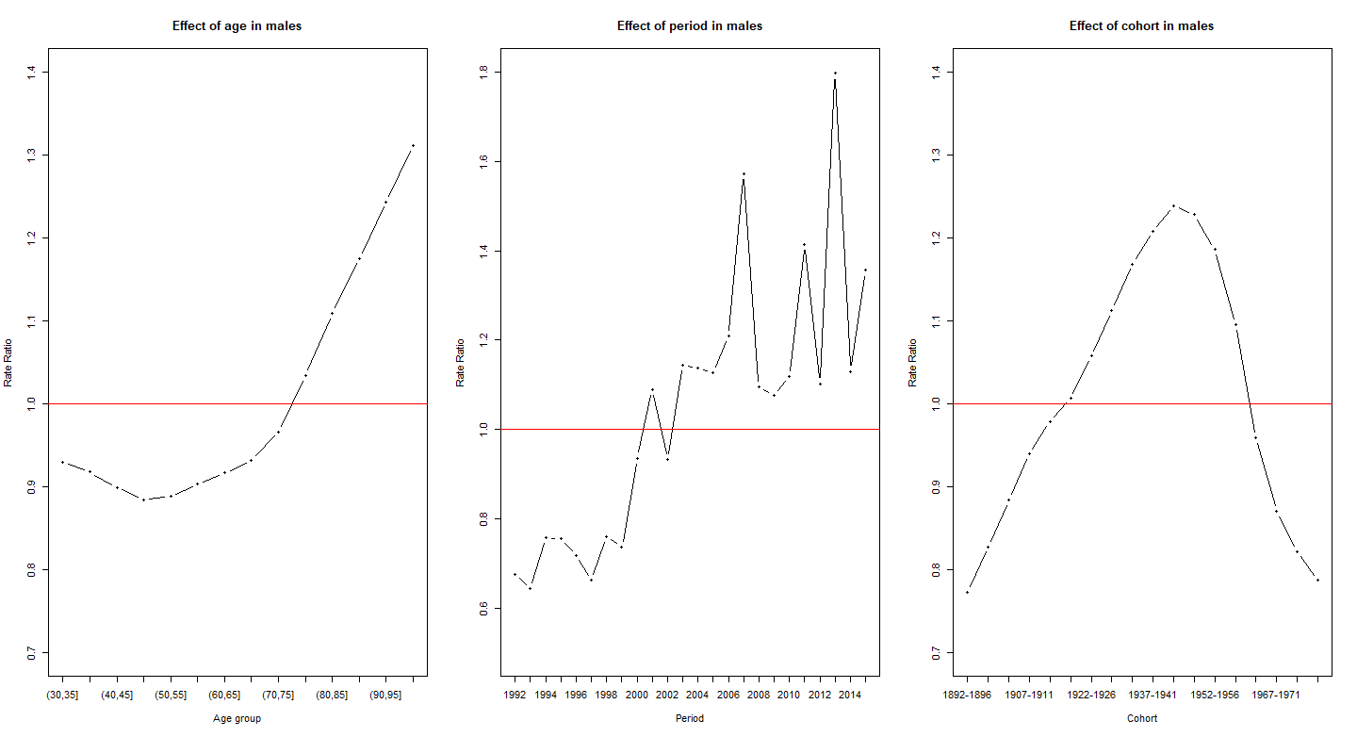
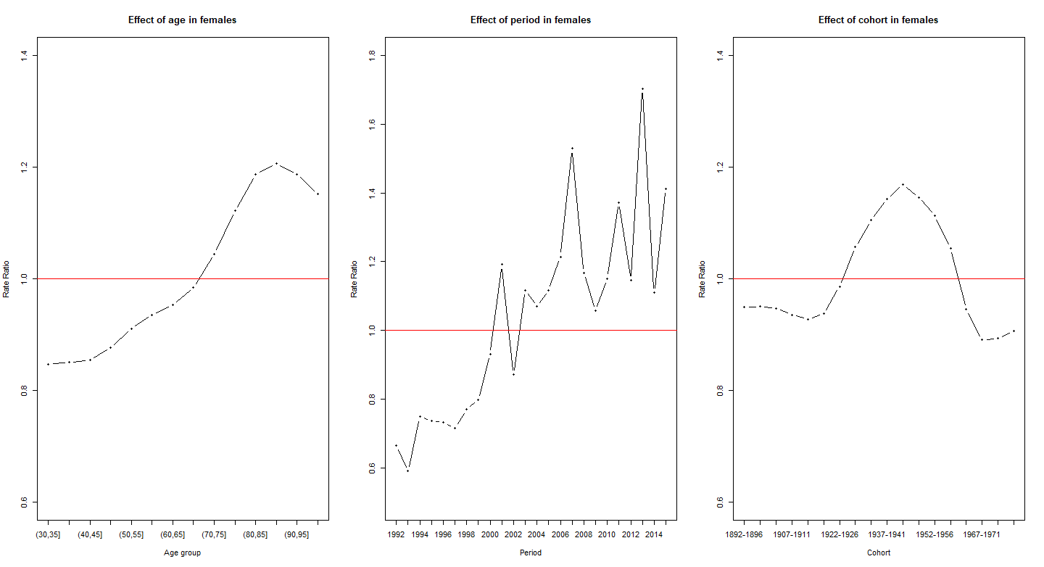
Note. The red line indicates rate ratio=1, i.e., the mean effects of age, period and cohort in rate ratio terms are equal to one. In this way age groups, periods and cohorts are comparable to that reference.

